WELCOME to the THREE RING CIRCUS!!! https://www.youtube.com/watch?v=8LQftYK2n8o
RING ONE  Mid-term Exam make up  Move to center ring  Star, Jennifer, Arianna, Aaron, Bryson H., John L., Marcus | CENTER RING  Video notes make up  intro to rxns: https://www.youtube.com/watch?v=iUdU3I0zZGk (8:21)  types of rxns: https://www.youtube.com/watch?v=TX6BYceUSL0 (5:10)  balancing chemical rxns: https://www.youtube.com/watch?v=RnGu3xO2h74 (14:27)  You will have class time to use a blank sheet of copier paper and write out notes from the three videos to formulate your scientific model of chemical reactions. You can ask the class leader to replay any part of the three videos.  Your model should include definitions, examples, pictures, diagrams, equations, and anything of significance.  Understand that the quiz on this will be relatively detailed so you should pay close attention to everything about the videos and plan to watch them multiple times.  Take 15 q. video quiz....  Score 90% or better...  Move to ring 3 as a spectator!!!  Anyone without the notes from Wed, 3/6 | RING THREE  Take video quiz (15 q)  Score 90% or better....  You are now a Nanobot Rodeo Clown! Get your clown nose, timer, nanobot and instructions from the Ringmaster and have at it!  You lucky CLOWNS!!

RODEO CLOWN INSTRUCTIONS: Each team member reads this aloud to the team!Each team of 2 will be required to run their nanobot through the maze and judge precision/accuracy. You MAY NOT do any reassembling to any of the models but you may hold a flap to the side for nanobot passage if it is not too much work. If the nanobot takes more than 30 seconds for any passage or is completely blocked, simply put an "X" in the time box for that model. You will also be judging if the math sequence is readable without moving anything as well as correct. Answer yes/no in those boxes:
Model owner's first name and last initial _______________________ neatness/creativity score _______
Moles to liters time | seconds
Moles to liters accuracy
Moles to liters visibility (yes/no)
Moles to grams time
Moles to grams accuracy
Moles to grams visibility
Moles to particles time
Moles to particles accuracy
Moles to particles visibility
Grams to moles time
Grams to moles accuracy
Grams to moles visibility
Liters to moles time
Liters to moles accuracy
Liters to moles visibility
Particle to moles time
Particle to moles accuracy
Particle to moles visibility
OVERALL AVERAGE BY THIS CLOWN TEAM:
CLOWN SIGNATURES required at the bottom of this page for certification of data.
moles/grams and grams/moles: ______________ seconds
liters/moles and moles/liters: _______________seconds
particles/moles and moles/particles: ___________seconds
particles/moles and moles/particles: ___________seconds
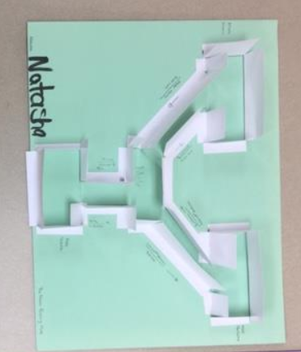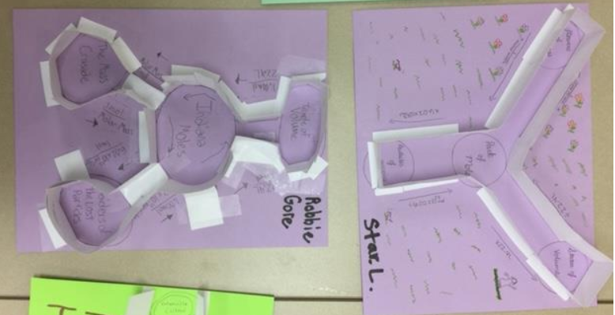
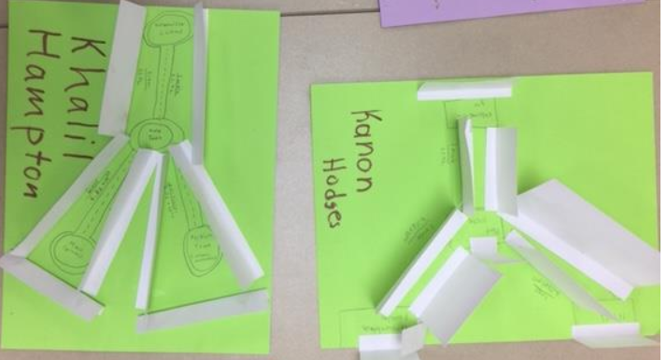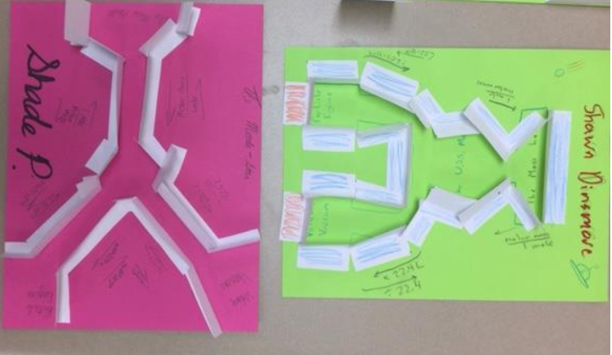
----------------
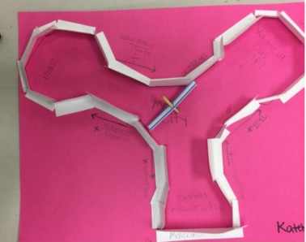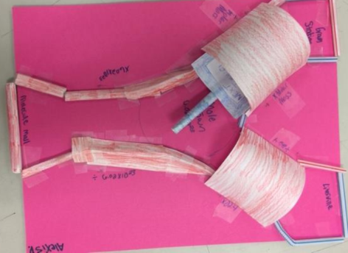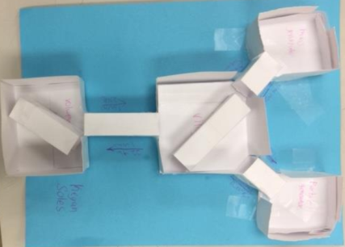
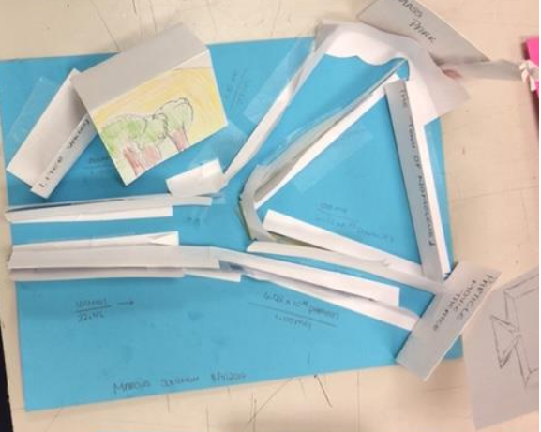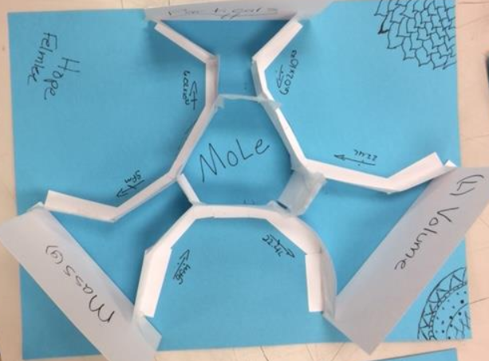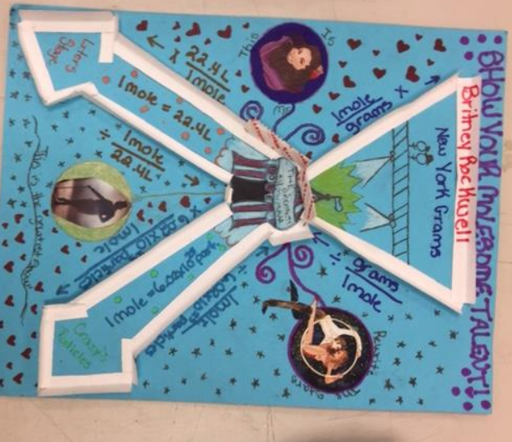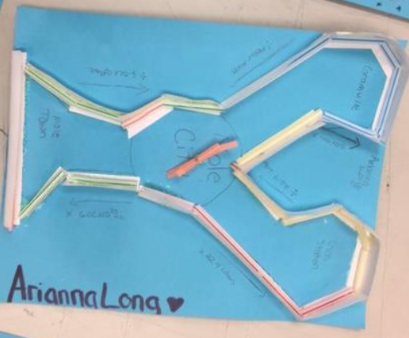
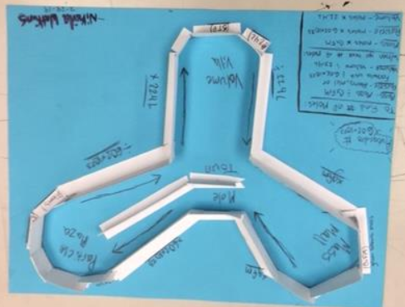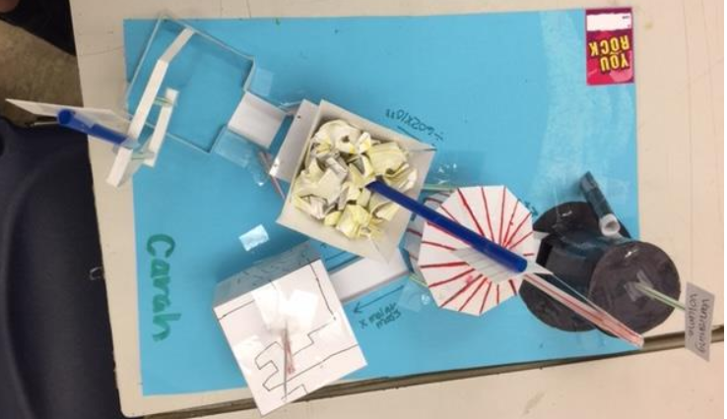
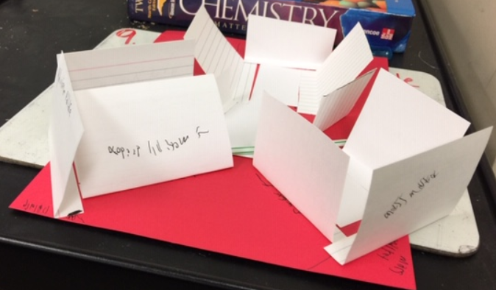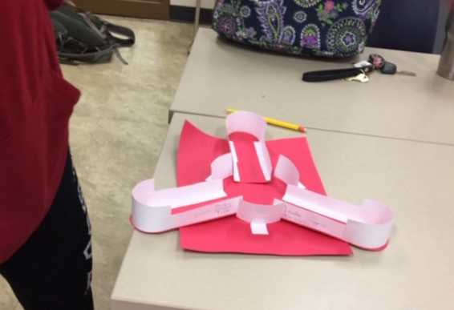

Video QUIZ- Chemical reactions Clown name__________________________________
1) Why don't Hydrogen molecules and Oxygen molecules combine when put in a room temperature box together?

2) What are the chemicals called BEFORE the reaction takes place?

3) Name ONE thing that qualifies something as a chemical reaction.

In the space below, name the five main types of reactions and give a chemical equation example for each:
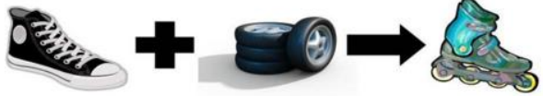
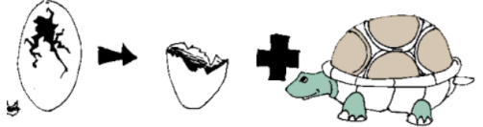
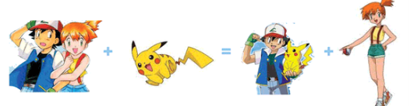
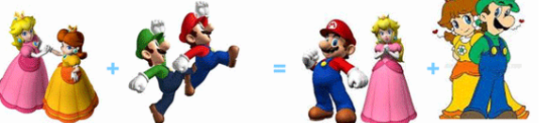
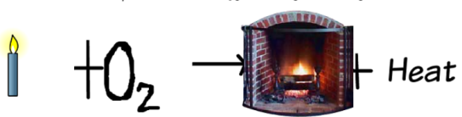

14 & 15) Balance the following chemical equations:
