**Biology Weekly Planner** Week of 9/5/17

Bio.1.1 Understand the relationship between the structures and functions of cells and their organelles.

|  |  |  |  |  |
| --- | --- | --- | --- | --- |
| Day | **Objective** | **Essential question** | **Activities** | **Handouts/*Homework** |
| Mon 9/4 | LABOR DAY | LABOR DAY | LABOR DAY | LABOR DAY |
| Tues  9/5 | Students will understand cell function | What are cells and how do they work? | -notes: cells structure and function, microscope, plant/animal cell coloring | VOTE!!!!  As always, study 20 minutes. |
| Wed | Students will understand osmosis and diffusion | How does osmosis and diffusion work in cells? | -musical clicker review  -cell transport video  -notes | <https://www.youtube.com/watch?v=dPKvHrD1eS4>  -Finish pgs 6 and 7!!! |
| Thur | Students will describe the parts and function of the cell | What are the structures in cells and what do they do? | -clickers  -finish notes on organelles  -Finish drawings | -Plant/animal cell diagram  -TEST CORRECTIONS DUE FRI |
| Fri  9/8 | Students will describe the parts and function of the cell | What are the structures in cells and what do they do? | QUIZ!! Cells  Activity/presentation ☺ | CELL CITY #1-10 is DUE MONDAY!! |

9/5/17 Tuesday

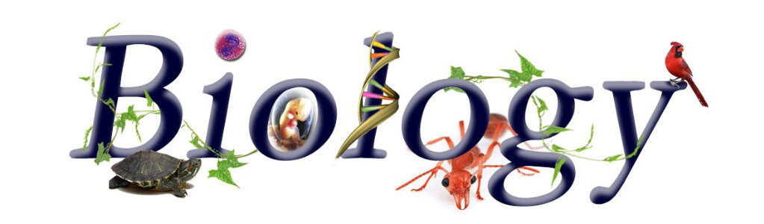



Nesmith room 206 Ms. Evans

-New teams

-Hand in electronics/phones

-Take BOTH labs, webquest, fold together, make SURE your name is showing on the front and hand in

-Notes= cell transport

9/6/17 Wednesday





Nesmith room 206 Ms. Evans

-Turn off and Hand in electronics

-Musical clicker questions

-Membranes and transport video (10 mins)

-Notes: osmosis and diffusion

COMPLETE Pgs 6-7 with your TEAM! ☺ What you do not finish is for homework.

* TEST corrections: 1) Write out in full sentences OR write the answer then the question! 2) Provide a reason for your answer 3) If you believe it should have been right, prove it.
* 9/7/17 Thursday
* 



* Nesmith room 206 Ms. Evans

-Hand in electronics

-Team review of osmosis/diffusion problems

-Notes: Cell structures and functions

-Finish plant/animal cell diagrams

-Work on test corrections

* 9/8/17 Friday
* 



* Nesmith room 206 Ms. Evans
* -quick review

-Turn in cell phones and electronics- Fold written test corrections INSIDE your plant/animal coring picture, make sure name is on it and put in basket!!

-Pop quiz!

-Project introduction: CELL CITY #1-10 is DUE MONDAY!!

RUBRIC WILL BE POSTED NEXT TO OUR SWIMMING JELLYFISH 😊

KIDS- We do not know what is going to happen early next week so please plan on staying in touch via schoology and bookmark our website.