**Biology Weekly Planner** Week of 9/25/17

**Bio.3.1** Explain how traits are determined by the structure and function of DNA. Bio.3.1.1 Explain the double-stranded, complementary nature of DNA as related to its function in the cell. Bio.3.1.2 Explain how DNA and RNA code for proteins and determine traits. Bio.3.1.3 Explain how mutations in DNA that result from interactions with the environment (i.e. radiation and chemicals) or new combinations in existing genes lead to changes in function and phenotype.

|  |  |  |  |  |
| --- | --- | --- | --- | --- |
| Day | **Objective** | **Essential question** | **Activities** | **Handouts/*Homework** |
| Mon 9/25 | Students will describe the structure and function of DNA. | What is DNA and how does it work? | -Overview activity: DNA  -Notes: DNA  -coloring sheet1? | DNA introduction  <file:///E:/2017FALL/Week%208/intro%20to%20DNA.pdf>  HW= Study #1-21 |
| Tues  9/26 | Students will describe the structure and function of DNA. | What is DNA and how does it work? | Lab- making DNA models  Notes: DNA | DNA models  LOOK OVER PPT- on website  <https://www.youtube.com/watch?v=_POdWsii7AI> |
| Wed | Students will describe the structure and function of DNA. | What is DNA and how does it work? | LAB- DNA  TEAM captains= watch time and resources!! | DNA notes  FINISH slides #1-19 tonight!!! |
| Thur | Students will describe the structure and function of DNA. | What is DNA and how does it work? | DNA grade sheet  Amino acids and codes  Finish notes | <https://www.youtube.com/watch?v=h5mJbP23Buo> protein synthesis |
| Fri  9/29 | Students will describe the structure and function of DNA. | What is DNA and how does it work? |  | TEST- 9/29 |

9/25/17 Monday

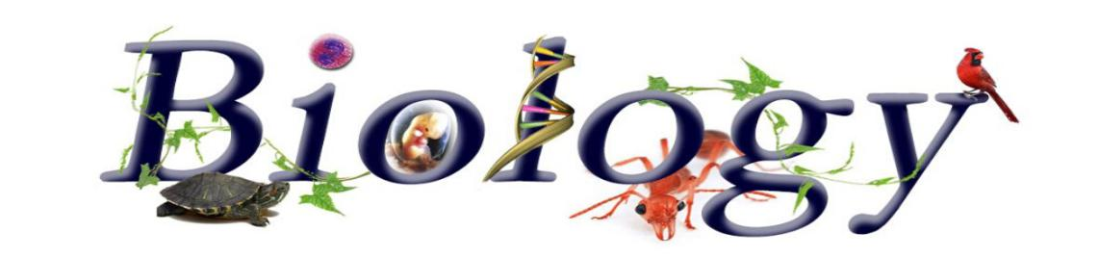



Nesmith room 206 - BACK TO TEAMS!

-hand in electronics/cell phone, fold and hand in test corrections

-Notes: DNA

-coloring page?

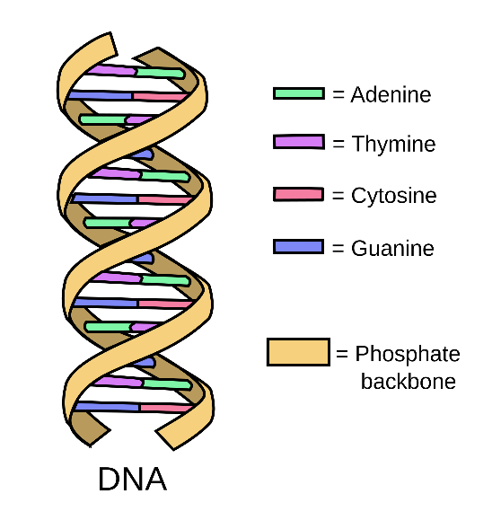

9/26/17 Tuesday





Nesmith room 206 -

-hand in electronics/cell phone and any make up work

-Amoeba sisters video notes, Structure of DNA video notes

- Get quiz back

-Team captain assignments- 1 per table

-Lab!!!!!

-

|  |  |  |  |  |
| --- | --- | --- | --- | --- |
| 1E | 8A | 15C | 22B | 29D |
| 2C | 9C | 16A | 23D | 30A |
| 3A | 10B | 17D | 24A | 31C |
| 4C | 11 skip | 18B | 25B | 32B |
| 5A | 12D | 19A | 26C | 33D |
| 6B | 13E | 20B | 27B | 34A |
| 7C | 14B | 21D | 28C | XXXXXXX |

9/27/17 Wednesday





Nesmith room 206 -

-hand in electronics/cell phone and any make up work

- finish DNA model

-Slides 1-19

9/28/17 Thursday

  
-hand in electronics/cell phone and any make up work



- Grade DNA models!!

Notes: coding

DNA to DNA= apples in the tree, car in the garage

DNA to mRNA= Trees still give apples but the apples get an an umbrella to go play in the rain. URACIL

Protein synthesis wrap up

