+

Weekly Planner: All science week of 4.8.19 

**Objectives for the week**: Bio.1.2.3 Explain how specific cell adaptations help cells survive in particular environments (focus on unicellular organisms). Chm.2.1.5 Explain the relationships between pressure, temperature, volume, and quantity of gas both qualitative and quantitative.

|  |  |  |
| --- | --- | --- |
| Day | Honors Biology | Honors Chemistry |
| Mon 4.8 | TEST  -Notes: Health and disease  HW= Read ch 19 <https://cnx.org/contents/s8Hh0oOc@15.1:RW2ZTUre@6/Introduction> | TEST  -Notes: Thermochemistry  HW= read 9.1 and 9.2 <https://cnx.org/contents/RTmuIxzM@9.1:yirnyhGF@4/Introduction> |
| Tues  4.9  STUDY BUDDIES! | EOC review 2.1 - complete up to #50… as always WRITE OUT and explain ☺ | READ handout on ch 17  Complete #1-24, write out and/or show all work and units! ☺ |
| Wed 4.10  STUDY BUDDIES! | DARWIN documentary-  *HW= Finish up to #80 write out!! | 0d98fe06 flipgrid CCCA  *HW= show work/units for #9-14 |
| Thurs  4.11 | Socraevic presentations IMMUNOLOGY lab  <https://www.hhmi.org/biointeractive/immunology-virtual-lab>  *HW= Finish up to #100 write out!! Finish WARM UPS for this week! | Thermochemistry and heat calculations.  *HW= do #1,3,5 for each page of handout. Finish WARM UPS for this week! Show all work and units! |
| Friday 4.12 | **BIO Students voted for test to be Monday.**  **-Go over HW**  **-Socreavic questioning: EOC obj 2.1**  [**https://vimeo.com/87922317**](https://vimeo.com/87922317) | **Students voted for test to be Monday.**  **-Go over HW**  **-Paradigm lab… ice** |

[**https://secure.everyaction.com/Ry41x6ZhO0aL0gfbn3VjPQ2**](https://secure.everyaction.com/Ry41x6ZhO0aL0gfbn3VjPQ2)

Warm up activities!

Monday 4.8.19- https://evansccca.weebly.com/

|  |  |
| --- | --- |
| **BIO Warm up:**  Turn OFF your cell phone and put in bin 😊  **What do the following do for us?** | **CHEM warm up**  Turn OFF your cell phone and put in bin 😊  Fill in the UNITS for each ideal gas constant:  0.0821  8.31 |

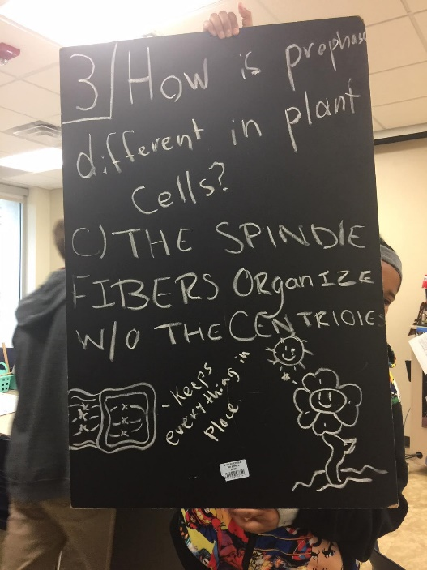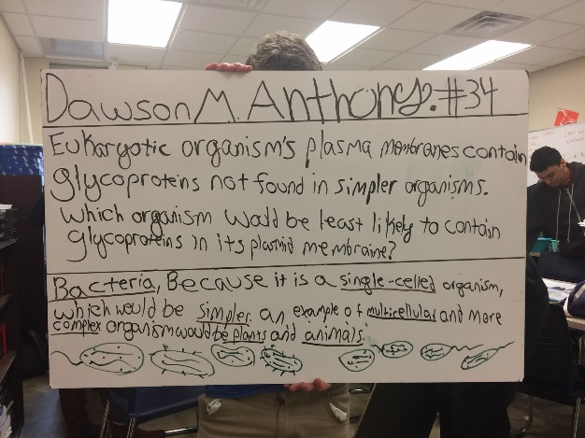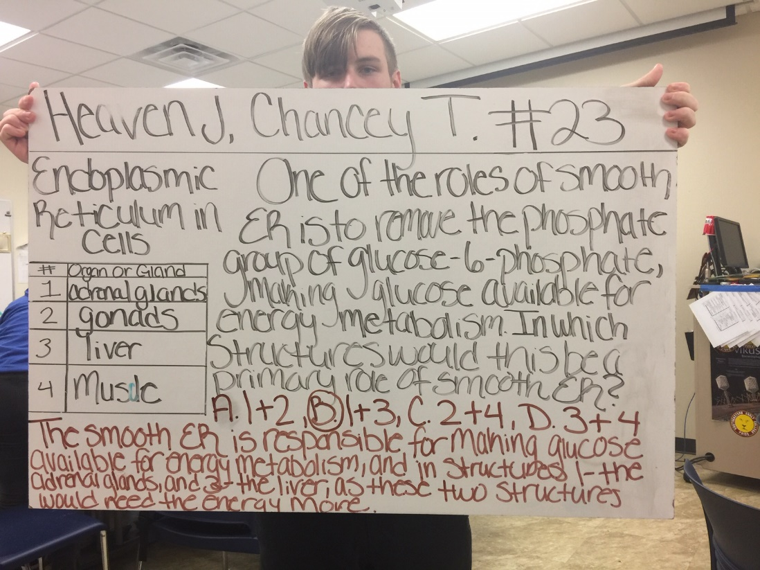

Adrenal glands give off hormones to trigger metabolism in organs

Gonads produce sperm

Liver metabolizes waste and produces enzymes

Muscle uses oxygen to metabolize ATP into energy cells use to do work

Tuesday 4.9.19- https://evansccca.weebly.com/

|  |  |
| --- | --- |
| **BIO Warm up:**  Turn OFF your cell phone and put in bin 😊  **1) Name and describe the purines.**  **2) Name and describe the pyrimidines.** | **CHEM warm up**  Turn OFF your cell phone and put in bin 😊  The permanent gases in air we exhale are roughly 78% nitrogen, 16% oxygen (we retain only a small amount), and the rest is mostly carbon dioxide.  **What is the mole fraction of each gas?** |

Wednesday 4.10.19- https://evansccca.weebly.com/

|  |  |
| --- | --- |
| **BIO Warm up:**  Turn OFF your cell phone and put in bin 😊  **If a movie were called GATTACA, what would you guess it was about?** | **CHEM warm up**  Turn OFF your cell phone and put in bin 😊  What is the partial pressure of OXYGEN in the container shown? |

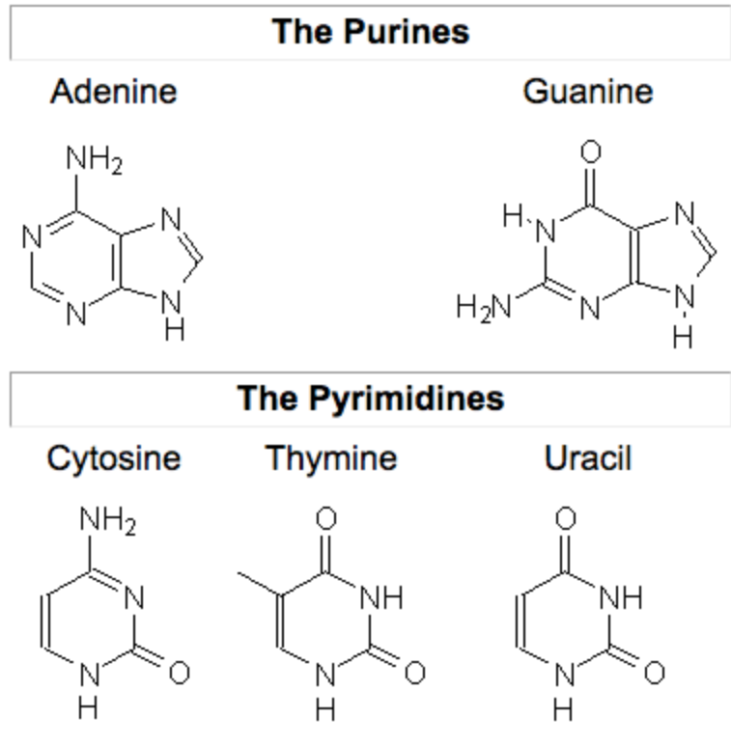 0d98fe06 flipgrid CCCA

Thursday 4.11.19- https://evansccca.weebly.com/

|  |  |
| --- | --- |
| **BIO Warm up:**  Turn OFF your cell phone and put in bin 😊   1. A strand of DNA has these bases:   AGC CAT GTA TAC What is the complementary RNA strand? | **CHEM warm up**  Turn OFF your cell phone and put in bin 😊  What is the percent composition of Ammonium Sulfide? |

Friday 4.12.19- https://evansccca.weebly.com/

|  |  |
| --- | --- |
| **BIO Warm up:**  Turn OFF your cell phone and put in bin 😊  A strand of DNA has these bases:  AGC CAT GTA TAC What is the complementary RNA strand? | **CHEM warm up**  Turn OFF your cell phone and put in bin 😊  1500 J of heat are given to a 0.25 Kg block of ice at -2°C.  What is the state of matter AND the temperature of the H2O at the end? |



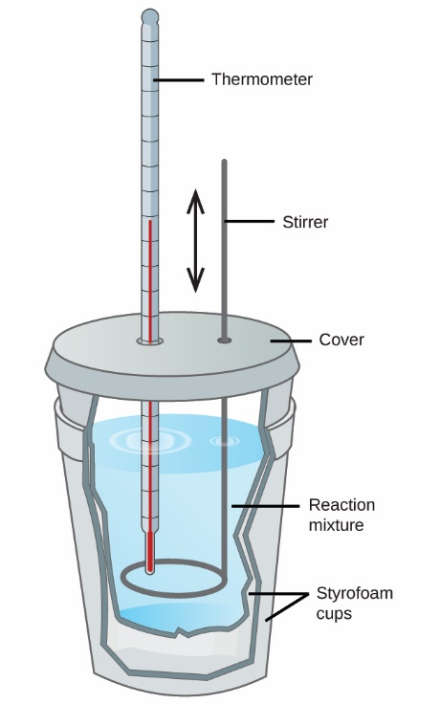

Finding the specific heat of an unknown metal:

Qlost by metal = Qgained by water