+

Weekly Planner: All science week of 4.29.19 

**Objectives for the week**:

|  |  |  |
| --- | --- | --- |
| Day | Honors Biology | Honors Chemistry |
| Mon 4.29 | HW check  Scientific Modeling Field test (Energy)  Go over #1-10  *HW=Finish #1-50 (ok to write on test to explain the answer) | HW  Go over EOC review #3 and 4  *HW=Stoichiomety review #1-6, study for quiz! |
| Tues  4.30  STUDY BUDDIES! | KAHOOT EOC REVIEW!!  https://kahoot.it/challenge/0983388 | KAHOOT EOC REVIEW!!  https://kahoot.it/challenge/0815115 |
| Wed 5.1  STUDY BUDDIES! | -1 team present?  -KAHOOT EOC REVIEW!!  <https://kahoot.it/challenge/016244>  Explained  -Round 2 review?  HW= TEST CORRECTIONS& 27,40,35,10,57,59,62,68,71,69 | KAHOOT EOC REVIEW!!  <https://kahoot.it/challenge/0473299>  Keq & Equilibrium notes  HW= finish pgs. 79-80  Test corrections!!  QUIZ tomorrow =)  CHALLENGE! L=2.2m  NH3 and HCl |
| Thurs  5.2 | KAHOOT EOC REVIEW!!  <https://kahoot.it/challenge/0184373>  WATER..explained  Study for test, watch each teams’ summary presentation! | KAHOOT EOC REVIEW!!  <https://kahoot.it/challenge/0703175>  LeChatelier’s principle  Study for the test, finish Lechat, anything make up due  5/3/19 |
| Friday 5.3 | KAHOOT EOC REVIEW!!  *HW= DUE mon! obj 3.1 # 1-40 EXPLAIN! FLipcode= ccca  Give mic drop and grade all teams! | KAHOOT EOC REVIEW!! |

NO warm up this week… all beginning of the class activities will involve Kahoot reviews!

BIO- Global Water crisis board summary:

<https://flipgrid.com/ccca>

Also, here is a direct link to this new Topic:

<https://flipgrid.com/de91d7f8>

Keq answers:

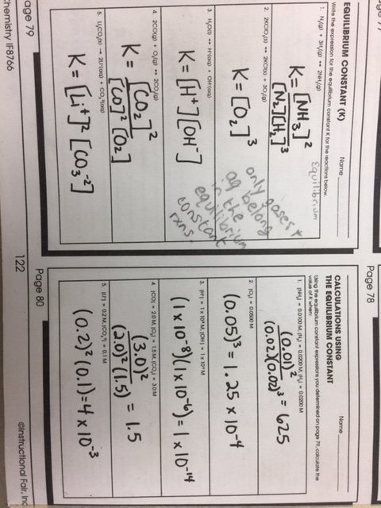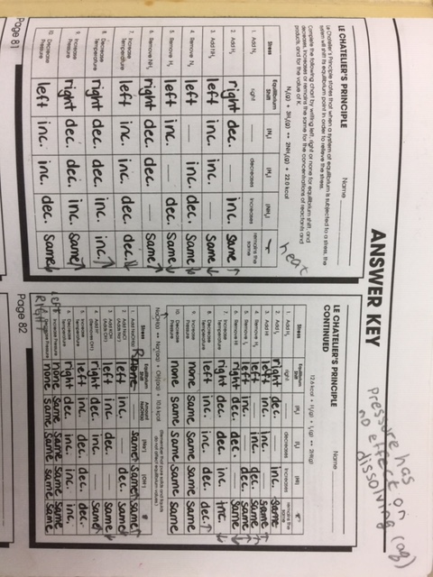

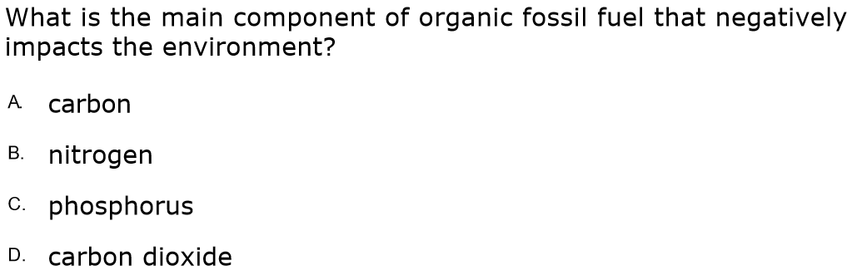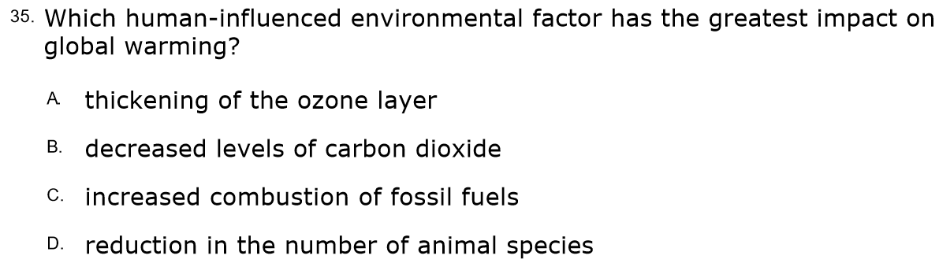

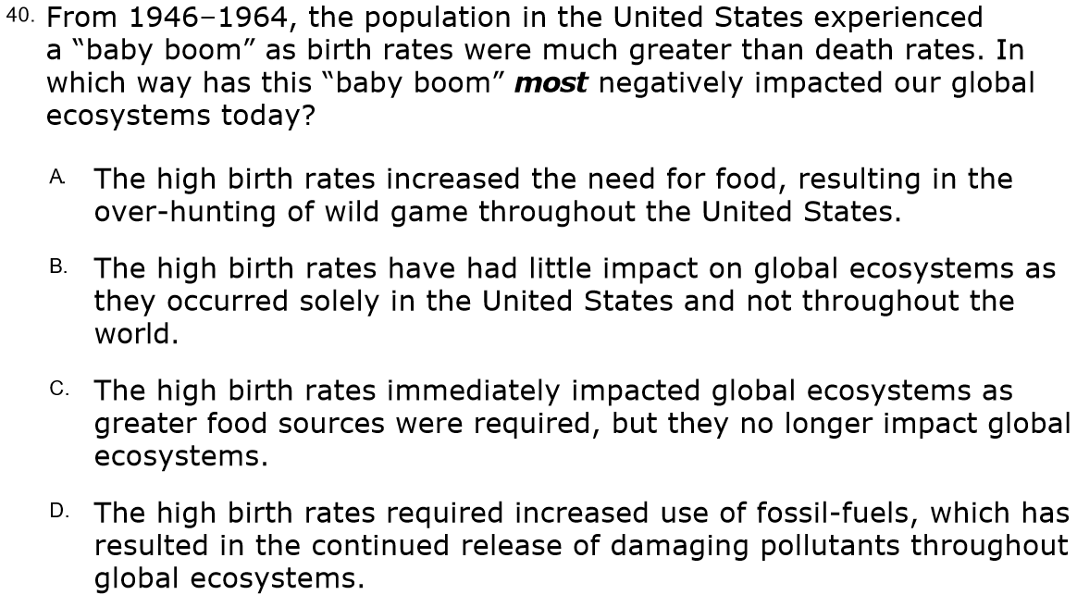

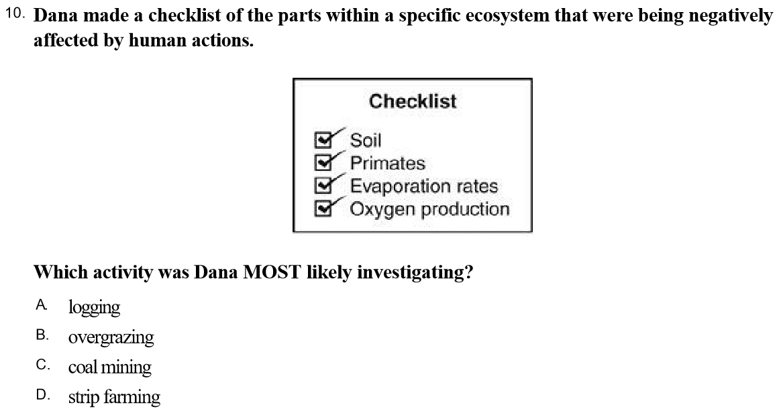

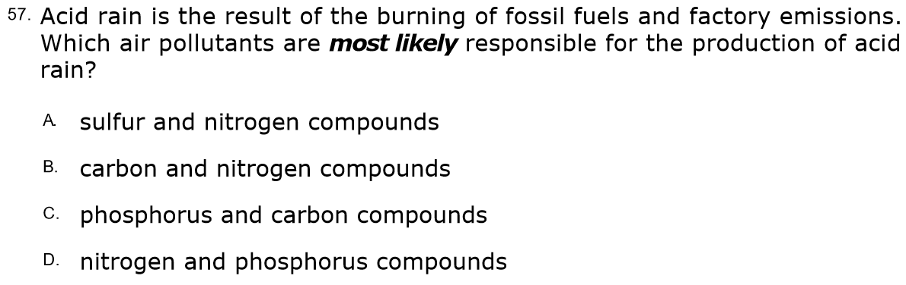

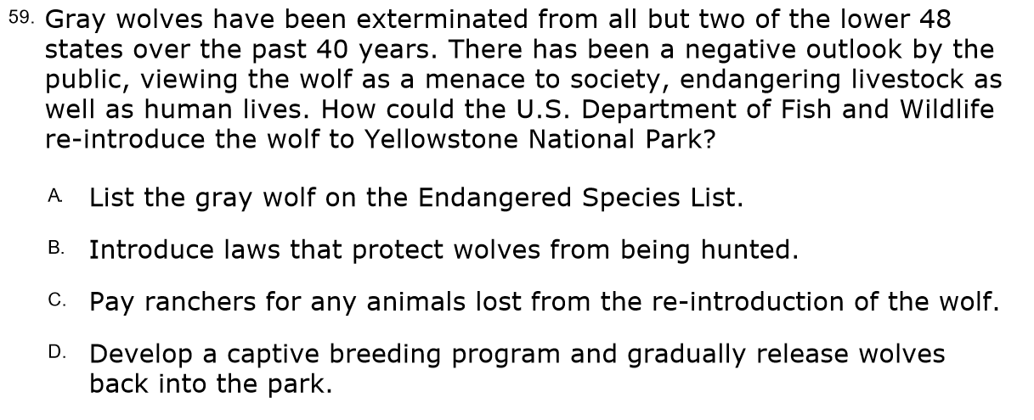

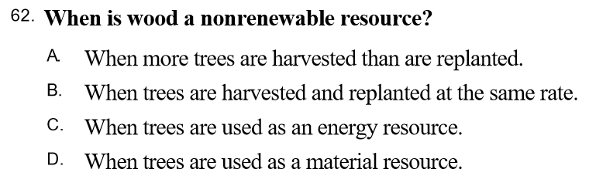**a**

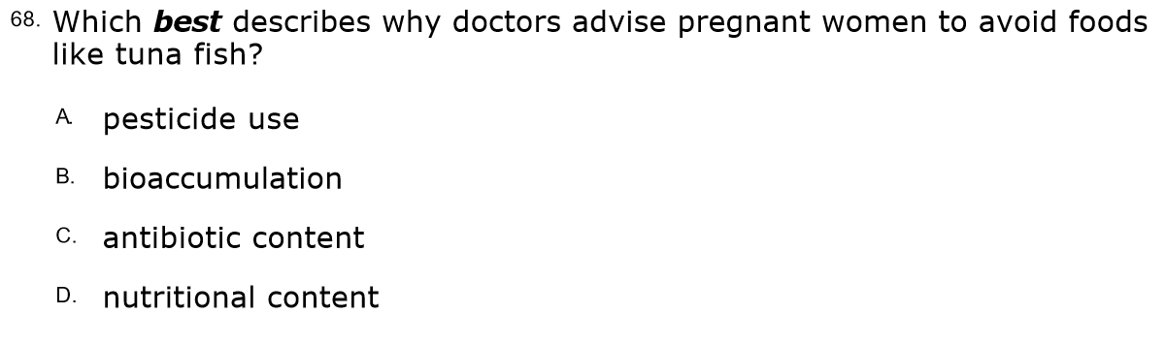**b**

