+

Weekly Planner: All science week of 4.22.19 

**Objectives for the week:** **EOC REVIEW!!**

**CHEM= Acids, bases and salts**

**\*\*Science gaming portal:** [**https://fold.it/portal/**](https://fold.it/portal/)

|  |  |  |
| --- | --- | --- |
| Day | Biology | Chemistry |
| Mon 4.22 | **BREAK** | **BREAK** |
| Tues  4.23  STUDY BUDDIES! | EOC review 1.1, go over #1-45  Present difficult ones  HW= look up #19  Fix #1-14  Finish up to #60 | EOC #1 and 2 Quiz (STRAIGHT form the review homework)  Acids and bases notes  Team practice  HW= all 4 worksheets |
| Wed 4.24  STUDY BUDDIES! | EOC 1.1 quiz  GO OVER 46-60 with TEAMS  Finish the rest of the packet!  HW= Finish #1-92 | GO over the 4 worksheets  Notes: pH and pOH calculations  Team practice |
| Thurs  4.25 | PANDEMIC LAB!!!  *HW=Finish/study #1-92!! | Paradigm LAB:  HW=pH and pOH lab  Study for test |
| Friday 4.26 | **TEST- objective 1.1**  [**https://learn.genetics.utah.edu/content/addiction/mouse/**](https://learn.genetics.utah.edu/content/addiction/mouse/)  **DUE Monday: mouse party and #1-10 (2.2)** | **TEST- ACIDS and bases**  **Infection lab!**  **Due Monday: EOC review #3 and 4, Koolaid lab, kahoot reviews.** |

Tuesday 4.23.19- https://evansccca.weebly.com/

EOC REVIEWS via Kahoot for this week!

BIO KAHOOT challenges:

<https://kahoot.it/challenge/0182305> 4.23 HJL, RAY

<https://kahoot.it/challenge/0557211> 4.24 RAD, RAY

<https://kahoot.it/challenge/0421839> 4.25 RAD

<https://kahoot.it/challenge/0408502> 4.26 KSE, CIB, RAY

CHEM KAHOOT challenges:

<https://kahoot.it/challenge/0299029> 4.23- KCH2, AM2

<https://kahoot.it/challenge/0749736> 4.24- AM2, BAKR3, SMB3

<https://kahoot.it/challenge/0733204> 4.25- BWH3

<https://kahoot.it/challenge/0808324> 4.26- RSG2, SMB3

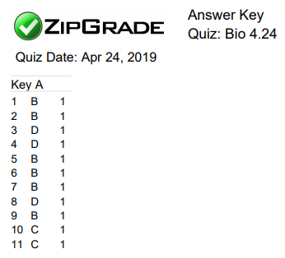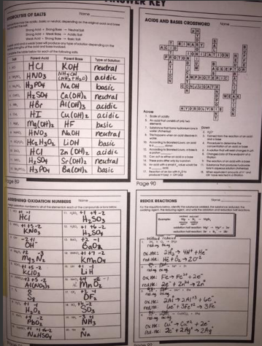

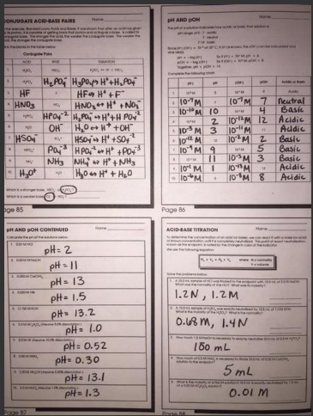

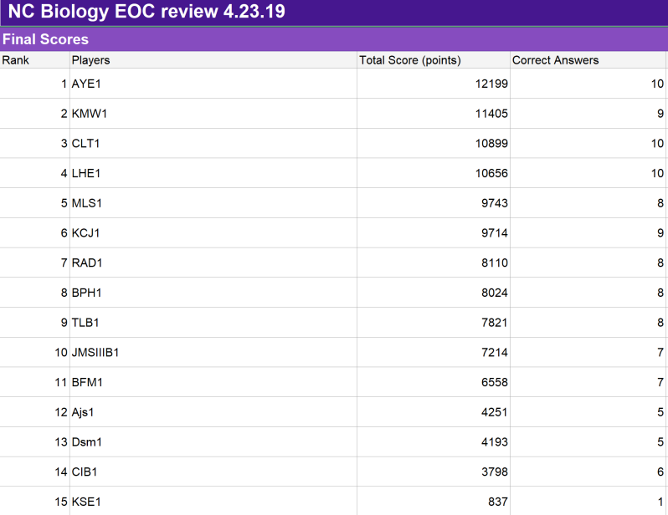 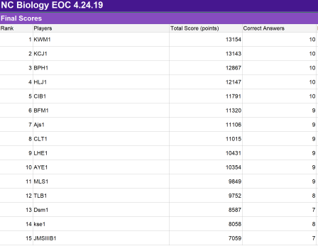

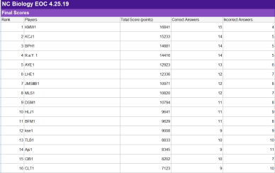 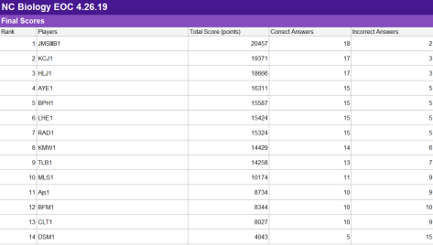

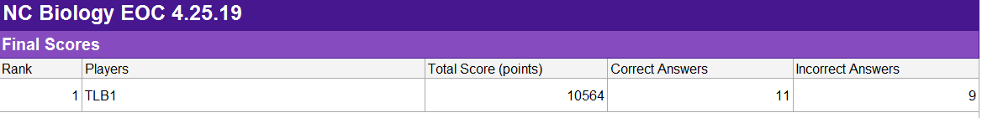

------------------------------

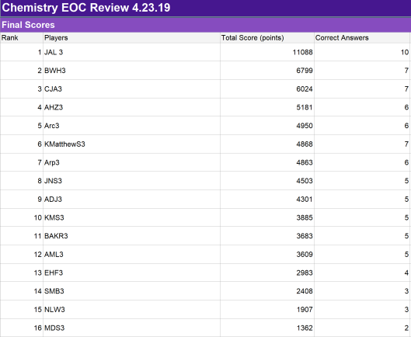 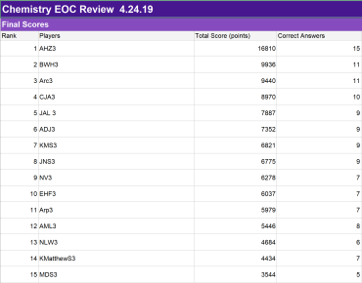

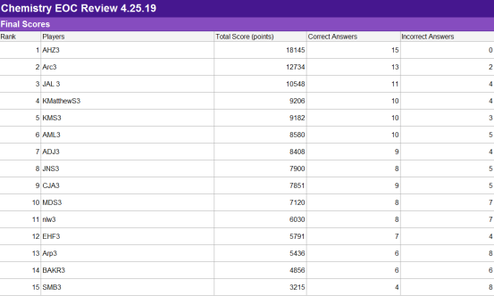 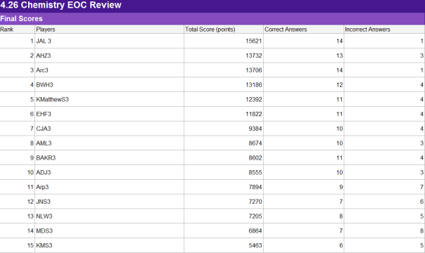

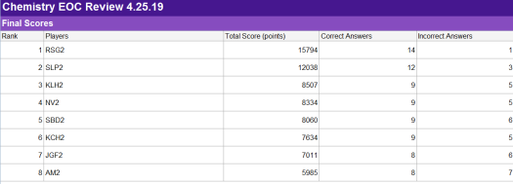 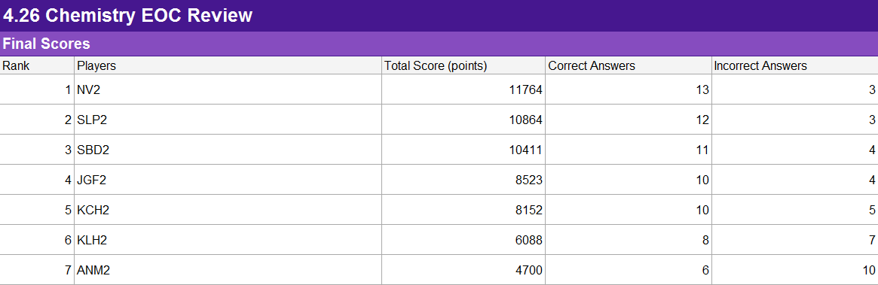

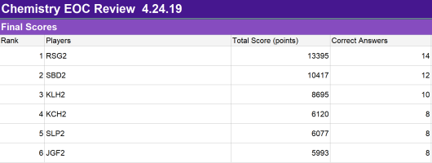

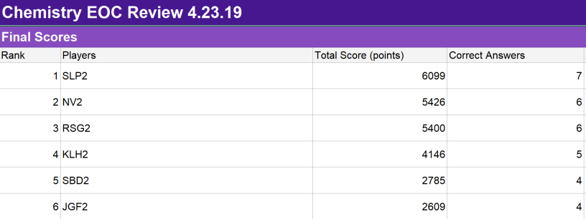

**Universal indicator lab!**

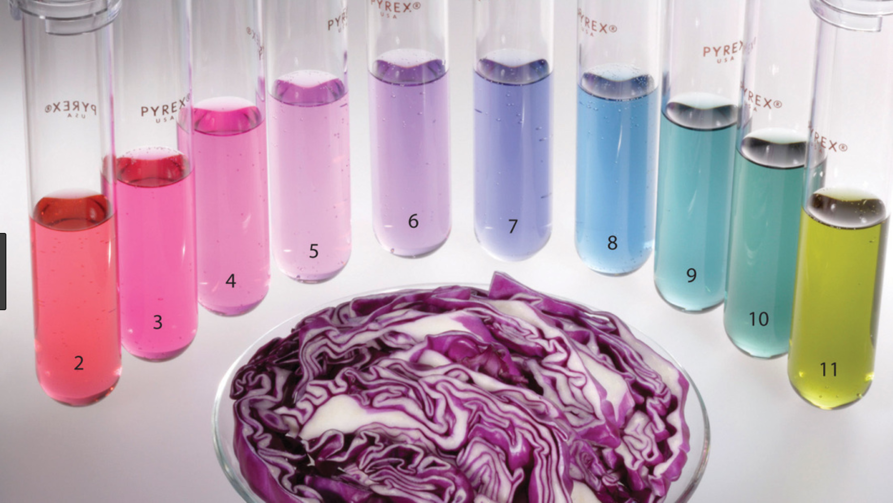

|  |  |  |  |  |  |
| --- | --- | --- | --- | --- | --- |
| **INTLS** | **4.23** | **4.24** | **4.25** | **4.26** | **Total** |
|  |  |  |  |  |  |
|  |  |  |  |  |  |
|  |  |  |  |  |  |
|  |  |  |  |  |  |
|  |  |  |  |  |  |
|  |  |  |  |  |  |
|  |  |  |  |  |  |
|  |  |  |  |  |  |
|  |  |  |  |  |  |
|  |  |  |  |  |  |
|  |  |  |  |  |  |
|  |  |  |  |  |  |
|  |  |  |  |  |  |
|  |  |  |  |  |  |
|  |  |  |  |  |  |
|  |  |  |  |  |  |
|  |  |  |  |  |  |
|  |  |  |  |  |  |
|  |  |  |  |  |  |
|  |  |  |  |  |  |
|  |  |  |  |  |  |
|  |  |  |  |  |  |
|  |  |  |  |  |  |
|  |  |  |  |  |  |
|  |  |  |  |  |  |
|  |  |  |  |  |  |
|  |  |  |  |  |  |
|  |  |  |  |  |  |
|  |  |  |  |  |  |

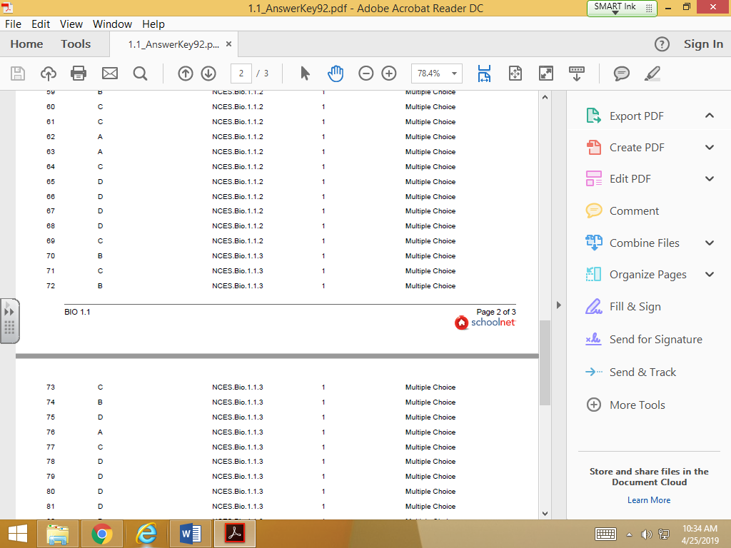

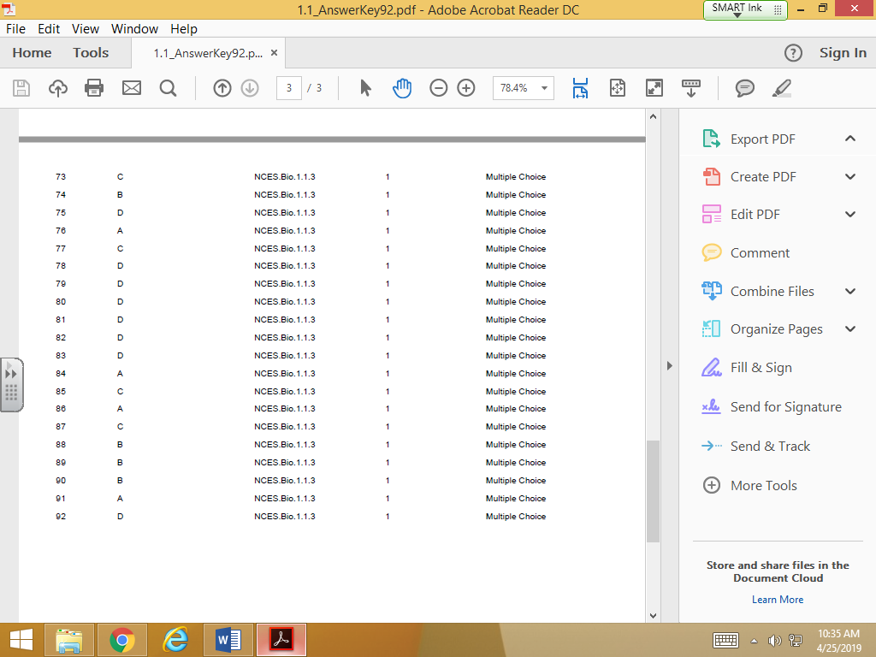

**CHEM LAB: ph, pOH, OH-, and H+ calculations! NAME: _______________**

**Rule: only 3 can actually *be whole numbers*, and you MUST do all calculations ON YOUR OWN!!**

|  |  |  |  |  |  |
| --- | --- | --- | --- | --- | --- |
| **Bin #** | **Est. pH** | **pOH** | **H+ molarity** | **OH- molarity** | **Possible identity (from chart)** |
| **1** |  |  |  |  |  |
| **2** |  |  |  |  |  |
| **3** |  |  |  |  |  |
| **4** |  |  |  |  |  |
| **5** |  |  |  |  |  |
| **6** |  |  |  |  |  |
| **7** |  |  |  |  |  |
| **8** |  |  |  |  |  |
| **9** |  |  |  |  |  |
| **10** |  |  |  |  |  |
| **11** |  |  |  |  |  |
| **12** |  |  |  |  |  |

**Conclusion questions (10 pts each):**

1. **Look up the how you can make limewater and provide a balanced equation on how it can be made.**
2. **Do research to find the most basic bottled water and report it’s pH. Then SHOW WORK to calculate its H+, pOH, and OH-.**
3. **Is acidic water considered to be healthier than basic? Why or why not?**
4. **List all the strong acids and strong bases on the back of this sheet. THEN DESCRIBE the main use of each.**

**BIOLOGY LAB Infectious Diseases**



**Objective: To Stay Healthy**

**Procedure:**

1. **Get a cup of water and a straw. DO NOT DRINK OR TOUCH!!**
2. **According to the roll, you will “exchange” a few drops of fluid from your cup with someone else’s.**
3. **Write the name of the person you exchanged with HERE:**

|  |
| --- |
|  |

1. **According to the roll, you will “exchange” a few drops of fluid from your cup with someone else’s.**
2. **Write the name of the person you exchanged with HERE:**

|  |
| --- |
|  |

1. **According to the roll, you will “exchange” a few drops of fluid from your cup with someone else’s.**
2. **Write the name of the person you exchanged with HERE:**

|  |
| --- |
|  |

1. **Sit with your EOC review team and reveal who is/is not infected. If infected, your name must ALWAYS be underlined for the rest of this game!**
2. **Now, your job is to sit with your team of 3 students and make a web chard of who exchanged with who. (TIMED: 5 minutes)**
3. **ONE person on your team will be given the “investigator” title and a badge by the teacher. Your investigator will move to another team and another investigator will come in with their data to help you solve the case… (TIMED: 5 minutes)**
4. **At the end of step 9, your original investigator returns to your table and you have 5 minutes to write down TWO names of individuals you suspect were the original infector.**
5. **Grades are as follows:**

**Get it right out of 4 guesses= 75% Get it right out of 3 guesses= 85%**

**Get it right out of 2 guesses= 95% Get it right out of 1 guess= 100%**

**\*\*DO NOT MAKE only one guess unless you are SO sure of it, you can’t even stand yourself!!**

