+

Weekly Planner: All science week of 4.1.19 

**Objectives for the week**: Bio.1.2.3 Explain how specific cell adaptations help cells survive in particular environments (focus on unicellular organisms). Chm.2.1.5 Explain the relationships between pressure, temperature, volume, and quantity of gas both qualitative and quantitative.

|  |  |  |
| --- | --- | --- |
| Day | Honors Biology | Honors Chemistry |
| Mon 4.1 | Finish ALL presentations and peer grading!  *HW= <https://www.youtube.com/watch?v=IxndOd3kmSs> Use 10 sentences to describe a Tardigrade. | COLLECT all work from last week!! pg 407 # 26-39, **Ch 13 #’s 44-63, EOC REVIEW #1-50**  Virtual discovery Lab- Gas behavior and properties  <http://www.glencoe.com/sites/common_assets/science/virtual_labs/PS08/PS08.html>  Model prep and presentation: <https://teachchemistry.org/periodical/issues/november-2015/gas-laws>  *HW= finish limiting reactant team lab, finish the two virtual labs. |
| Tues  4.2  STUDY BUDDIES! | NOTES_ Health and disease  <https://www.youtube.com/watch?v=VzPD009qTN4>  Virtual lab: Bacteria!  <https://www.hhmi.org/biointeractive/bacterial-identification-virtual-lab>  COMPLETE PARTS 1 and 2  *HW= Green book READ ch. 5 & write out your answers/reasoning for questions #1-6 | HAND IN VIRTUAL LABS!!!!  Quiz?  Gas law problems  *HW=Boyles law, Charle’s law and combined gas law due WED. Double check your 1-50 EOC review!  Finish TEST corrections!! |
| Wed 4.3  STUDY BUDDIES! | QUIZ! On lab and reading/HW  Lab: Bacteria  *HW= FINISH VIRTUAL LAB! | NOTES- Gas laws  *HW= finish Dalton’s law and Ideal gas law |
| Thurs  4.4 | Objective 1.1 Day  Be on task!  *HW= complete the rest up to #50. | Socraevic Questioning Day!  -Gas Laws  *HW= ’17 practice test |
| Friday 4.5  PROM | Finish all warm ups  **Socraevic Questioning Day!**  **-Test Postponed to Monday** | **Finish all warm ups**  **Go over practice test**  **BUTANE LAB!!!**  **-Test postponed to Monday** |

Warm up activities!

Monday 4.1.19- https://evansccca.weebly.com/

|  |  |
| --- | --- |
| **BIO Warm up:**  Turn OFF your cell phone and put in bin 😊  **Use words, diagrams and examples to differentiate a cladogram from a phylogenic tree.** | **CHEM warm up**  Turn OFF your cell phone and put in bin 😊     1. Find molar ratio out of 100g. 2. Find empirical formula 3. Find molecular formula |

Tuesday 4.2.19- https://evansccca.weebly.com/

|  |  |
| --- | --- |
| **BIO Warm up:**   1. Get out your phone and send your dichotomous key to my schoology email: [**adrienne.science15@gmail.com**](mailto:adrienne.science15@gmail.com) 2. Turn OFF your cell phone and put in bin 😊 3. Describe the biology of bacteria!   <https://www.youtube.com/watch?v=ORB866QSGv8> | **CHEM warm up**  Turn OFF your cell phone and put in bin 😊   1. 45.0 g of hydrochloric acid reacts with 20.0 g of strontium metal in a closed container.   SHOW WORK to determine what is left in this CLOSED container after the rxn. |

Wednesday 4.3.19- https://evansccca.weebly.com/

|  |  |
| --- | --- |
| **BIO Warm up:**  Turn OFF your cell phone and put in bin 😊  WHAT ARE YOU??  <https://www.youtube.com/watch?v=JQVmkDUkZT4> | **CHEM warm up**  Turn OFF your cell phone and put in bin 😊  -A glass jar is filled with 20g Nitrogen gas and 15 g Hydrogen gas. Draw a quantitative diagram for before and then after the reaction. |

Thursday 4.4.19- https://evansccca.weebly.com/

|  |  |
| --- | --- |
| **BIO Warm up:**  Turn OFF your cell phone and put in bin 😊  Describe a phospholipid bilayer and explain its purpose. | **CHEM warm up**  Turn OFF your cell phone and put in bin 😊  -A glass jar is filled with 20g Nitrogen gas and 15 g Hydrogen gas. Draw a quantitative diagram for before and then after the reaction. |

Friday 4.5.19- https://evansccca.weebly.com/

|  |  |
| --- | --- |
| **BIO Warm up:**  Turn OFF your cell phone and put in bin 😊  Draw a virus and explain why it is NOT living..  <https://www.youtube.com/watch?v=8FqlTslU22s> | **CHEM warm up**  Turn OFF your cell phone and put in bin 😊  Determine the molar mass of the gas in this experiment. What gas is it? |

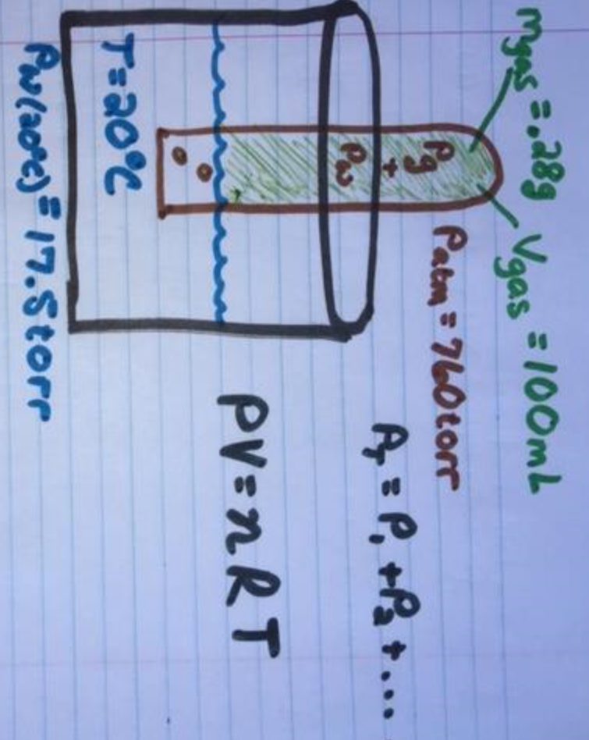

**CHEMISTRY Socraevic CHALLENGE-**

**-Explanation and reasoning**

**-qualitative analysis**

**-quantitative analysis**

**-proof/real life example/detailed picture that fits the problem**

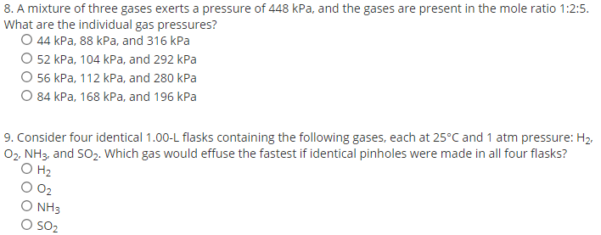

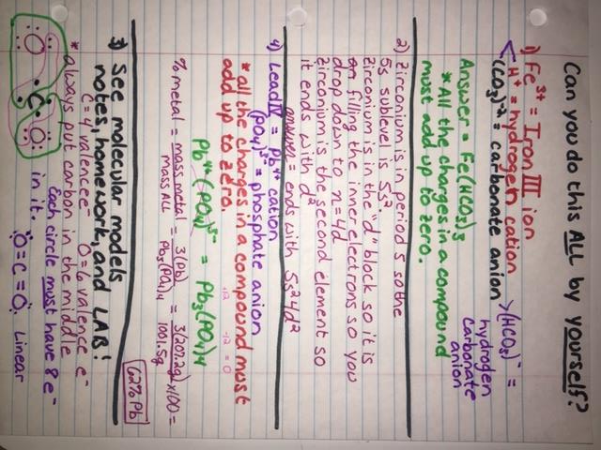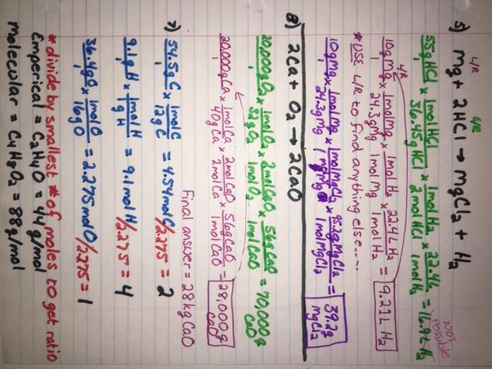

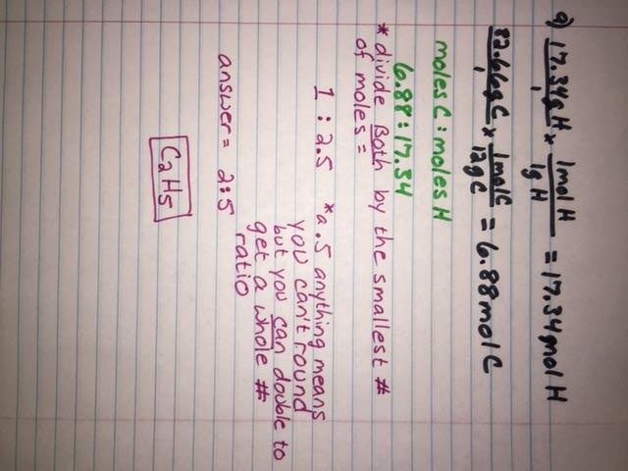

**4/3/19**

**1) Turn OFF cell phone and put in nearest bin.**

**2)-HAND IN whatever you have done for the lab and the 6 questions FOLDED together with your name on it.**