+

Weekly Planner: All science week of 3.25.19 

**Objectives for the week**: Bio.3.5.1 Explain the historical development and changing nature of classification systems. Bio.3.5.2 Analyze the classification of organisms according to their evolutionary relationships (including dichotomous keys and phylogenetic trees).Chm.2.2.4 Analyze the stoichiometric relationships inherent in a chemical reaction.

|  |  |  |
| --- | --- | --- |
| Day | Honors Biology | Honors Chemistry |
| Mon 3.25 | TEST (had been postponed on Friday)  HW= make your own cladogram about ANYTHING that has evolved. Be ready to present tomorrow! | TEST (had been postponed on Friday)  *HW= read ch 13 and do pg 410 # 77-86  Your team will present 2 of these tomorrow at random. |
| Tues  3.26  STUDY BUDDIES! | Notes- Classification  Presentations: classification!!!  HW= Notes from schoology pg #1-6 | Inquiry lab- Limiting reactant  Presentation- Law of conservation of mass model.  HW= Limiting reactant problems (finish all!) |
| Wed 3.27  STUDY BUDDIES! | NOTES- classification  LAB- dichotomous key!  8 pictures… key must work for ALL, creativity, on time!  HW= finish lab | Quiz?  Paradigm LAB- limiting reactant  *HW= pg 407 # 26-39, write out and show work/units! |
| Thurs  3.28 | Finish classification notes  Present Dichotomous keys  *HW= STUDY FOR TEST!! | Present HW (teams)  Paradigm lab  *HW= STUDY FOR TEST!!  **HW= Ch 13 #’s 44-63** |
| Friday 3.29 | **TEST- Classification**  **HW= EOC review #1-75** | **Test- limiting reactant**  **EOC REVIEW #1-50 -ok to answer right on that page.** |

Warm up activities!

Monday 3.25.19- https://evansccca.weebly.com/

|  |  |
| --- | --- |
| **BIO Warm up:**  Turn OFF your cell phone and put in bin 😊  A 100g of a radioactive isotope decays to 25g in 30 years. What is the half-life of this isotope? | **CHEM warm up**  Turn OFF your cell phone and put in bin 😊  A 100g of a radioactive isotope decays to 25g in 30 years. What is the half-life of this isotope? |

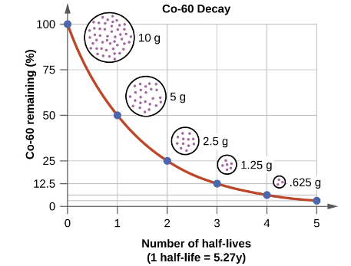

Tuesday 3.26.19- https://evansccca.weebly.com/

|  |  |
| --- | --- |
| **BIO Warm up:**  Turn OFF your cell phone and put in bin 😊  <https://www.youtube.com/watch?v=DVouQRAKxYo>  Write 3 things you learned about classification. | **CHEM warm up**  Turn OFF your cell phone and put in bin 😊  28 g of nitrogen gas reacts with excess hydrogen gas to make 30 g ammonia (NH3). What is the % yield? |

Wednesday 3.27.19- https://evansccca.weebly.com/

|  |  |
| --- | --- |
| **BIO Warm up:**  Turn OFF your cell phone and put in bin 😊  <https://www.youtube.com/watch?v=DVouQRAKxYo>  Why do scientists classify organisms? (opinion question) | **CHEM warm up**  Turn OFF your cell phone and put in bin 😊  Given: 21 slices of bread, 12 slices of cheese and 16 slices of bologna.  WRITE A BALANCED EQUATION |

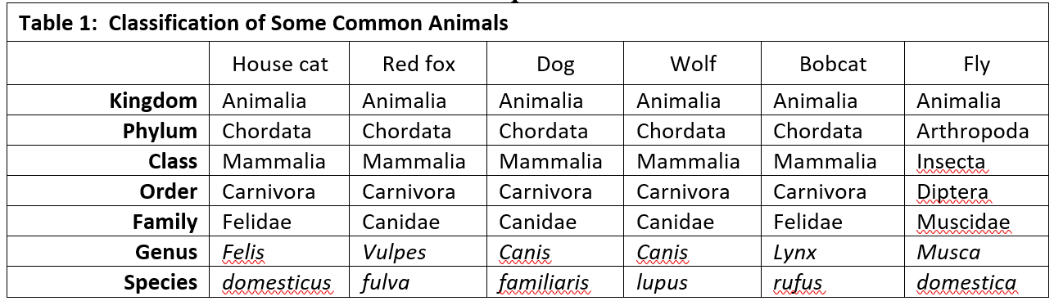

Thursday 3.28.19- https://evansccca.weebly.com/

FRIDAY-

Explain 2 things you learned from this presentation!!!

|  |  |
| --- | --- |
| **BIO Warm up:**  Turn OFF your cell phone and put in bin 😊  1) Which organism above is the LEAST like the others?  2) Why is it unfair to name your dog rufus?  3) If your friend says: “**Musca domestica**..flattened!!” What does she mean? | **CHEM warm up**  Turn OFF your cell phone and put in bin 😊  A compound consists of 27%Carbon and 73% Oxygen.   1. What is the empirical formula? 2. If it has a mass of 88 g/mol, what is the molecular formula? |



