+

Weekly Planner: All science week of 2.18.19 

**Objectives for the week:** Bio.1.2.2 Analyze how cells grow and reproduce in terms of interphase, mitosis and cytokinesis.Chm.1.2.2 Infer the type of bond and chemical formula formed between atoms. Chm.1.2.3 Compare inter- and intra- particle forces. Chm.1.2.4 Interpret the name and formula of compounds using IUPAC convention.

**\*\*Science gaming portal:** [**https://fold.it/portal/**](https://fold.it/portal/)

|  |  |  |
| --- | --- | --- |
| Day | Honors Biology | Honors Chemistry |
| Mon 2.18 | NOTES: The cell cycle and **mitosis**  -activity: flipbook  *HW= finish pg 3 cell cycle questions, finish title card and interphase card. | VSEPR theory notes  MOLECULAR MODELS LAB!  *HW= finish lab up to HCl only!! Finish test corrections. |
| Tues  2.19    (see info below) | SUPERMOON starting at 4pm today.  -Finish flipbook  -get all notes from powerpoint  *HW= all above due on Wed. 2/20/19 | WRITING AND NAMING chemical compounds  -student led instruction:  DO handout on Ch. 9. As always, prove understanding.  no electronics until tomorrow!!!!!  *HW= finish #1-19 (write out) |
| Wed 2.20  STUDY BUDDIES! | ACT  THE TEST CORRECTIONS BEFORE the test due tomorrow! | ACT  THE TEST CORRECTIONS BEFORE the test due tomorrow! |
| Thurs  2.21 | CATCH UP DAY  HW= study for quest, call each other for answers to presentations. | CATCH UP DAY  HW= study for quest, DO all the worksheet of mixed ionic/covalent (schoology me for answers). |
| Friday 2.22 | **QUEST** | **QUEST** |

BIOLOGY FLIPBOOK

At the top of EVERY card list the phase (see below):

* + Title Card – decorated and neat – be creative here
  + 1 notecard - Interphase
  + 3 notecards -Prophase
  + 1 notecard - Metaphase
  + 3 notecards -Anaphase
  + 3 notecards -Telophase
  + 1 notecard – Cytokinesis
  + 1 notecard- credits and personalization 😊

Monday 2.18.19- https://evansccca.weebly.com/

|  |  |
| --- | --- |
| **BIO Warm up:**  Turn OFF your cell phone and put in bin 😊  **Describe your current model of how all cells reproduce.** | **CHEM warm up**  Turn OFF your cell phone and put in bin 😊  Make a Lewis diagram of a molecule of ammonia  NH3 |

Tuesday 2.19.19- https://evansccca.weebly.com/

|  |  |
| --- | --- |
| **BIO Warm up:**  Turn OFF your cell phone and put in bin 😊  What does PMAT mean? | **CHEM warm up**  Turn OFF your cell phone and put in bin 😊  Give an example of each of the following shapes:  **-linear**  **-bent**  **-tetrahedral**  **-trigonal pyramidal**  **-trigonal planar** |

Wednesday 2.20.19- https://evansccca.weebly.com/

|  |  |
| --- | --- |
| **BIO Warm up:**  Turn OFF your cell phone and put in bin 😊 | **CHEM warm up**  Turn OFF your cell phone and put in bin 😊  Make a lewis dot and structural diagram of the 5 molecular shapes from 2.20 |

Thursday 2.21.19- https://evansccca.weebly.com/

|  |  |
| --- | --- |
| **BIO Warm up:**  Turn OFF your cell phone and put in bin 😊  What does polyploidy mean?  -how does it affect plant cells? Animal? | **CHEM warm up**  Turn OFF your cell phone and put in bin 😊  NAME the following compounds:Sn  LiCl2  Ca3(PO4)2  SnO2  CuSO4  Cu2O  PCl3  H2O |

Friday 2.22.19- https://evansccca.weebly.com/

|  |  |
| --- | --- |
| **BIO Warm up:**  Turn OFF your cell phone and put in bin 😊  Draw the stages of meiosis (ok to use our online book and/or draw on the back of the warm up).  **Turn in to Ms. Evans.** | **CHEM warm up**  Turn OFF your cell phone and put in bin 😊  -List the formula and names of 4 compounds that use roman numerals.  -List the formulas and names of 4 compounds with polyatomic ions  -List the formula and name of 4 binary molecules with multiple atoms. |

**DUE at 2:20**

**-ALL make up work**

**-This week’s warm up (COMPLETE!!)**

**-Ch 9 #1-19**

**DUE MONDAY🡪#1-34 practice test written out (like test corrections)**

**-Building molecules lab** [**https://phet.colorado.edu/en/simulation/build-a-molecule**](https://phet.colorado.edu/en/simulation/build-a-molecule)

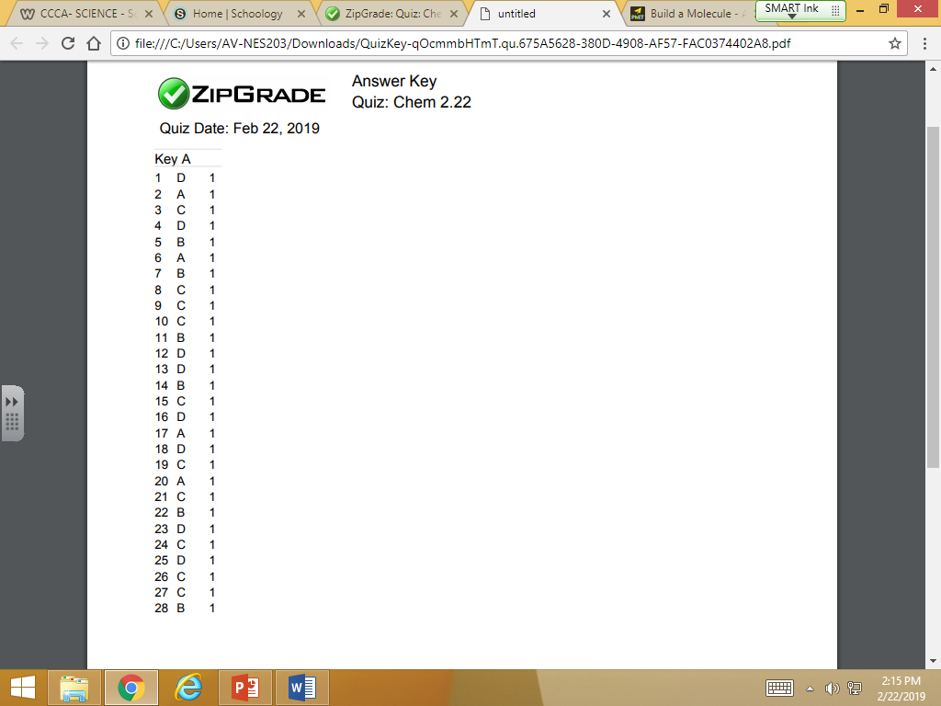

**Purple +5**

**Orange +5**

**Green +10**

**Blue +30**

**Red +50**

**Supermoon information:**

**Moonrise and moonset are the best time for viewing:**

[**https://www.timeanddate.com/moon/**](https://www.timeanddate.com/moon/)

[**https://www.space.com/34515-supermoon-guide.html**](https://www.space.com/34515-supermoon-guide.html)

***Do you like this kind of stuff? Let me know if you want to start an Astronomy club! -AE***

**Mixed Ionic and Covalent Naming – Answers**

*Name the following chemical compounds:*

1) LiC2H3O2 **lithium acetate**

2) P2O5 **diphosphorus pentoxide**

3) Ca(OH)2 **calcium hydroxide**

4) FeO **iron (II) oxide**

5) HNO2 **nitrous acid**

6) Br2 **bromine**

7) BF3 **boron trifluoride**

8) AlF3 **aluminum fluoride**

9) H2SO4 **sulfuric acid**

10) Co2(CO3)3 **cobalt (III) carbonate**

11) (NH4)2SO4 **ammonium sulfate**

12) PdSe2 **palladium (IV) selenide**

13) ZnO **zinc oxide**

14) SiO2 **silicon dioxide**

15) VO **vanadium (II) oxide**

*Write the formulas of the following compounds:*

16) cadmium nitrate **Cd(NO3)2**

17) carbonic acid **H2CO3**

18) lead (IV) phosphide **Pb3P4**

19) dinitrogen triselenide **N2Se3**

20) methane **CH4**

21) titanium (II) phosphate **Ti3(PO4)2**

22) hydrophosphoric acid **H3P**

23) silicon nitride **SiN**

24) magnesium arsenide **Mg3As2**

25) sulfur hexafluoride **SF6**

26) sodium nitride **Na3N**

27) copper **Cu**

28) phosphoric acid **H3PO4**

29) carbon disulfide **CS2**

30) mercury (I) cyanide **HgCN**

