+

Weekly Planner: All science week of 2.11.19 

**Objectives for the week:** **Bio.3.1 Explain how traits are determined by the structure and function of DNA. Bio.4.1 Understand how biological molecules are essential to the survival of living organisms.** Chm.1.2.1 Compare (qualitatively) the relative strengths of ionic, covalent, and metallic bonds. Chm.1.2.2 Infer the type of bond and chemical formula formed between atoms. Chm.1.2.3 Compare inter- and intra- particle forces. Chm.1.2.4 Interpret the name and formula of compounds using IUPAC convention. Chm.1.2.5 Compare the properties of ionic, covalent, metallic, and network compounds.

**\*\*Science gaming portal:** [**https://fold.it/portal/**](https://fold.it/portal/)

|  |  |  |
| --- | --- | --- |
| Day | Biology | Chemistry |
| Mon 2.11 | DNA discovery lab- timed  <https://learn.genetics.utah.edu/content/basics/builddna/>  <https://www.online-stopwatch.com/classroom-timers/>  NOTES: DNA structure and function  DNAi virtual #1  *HW= Finish DNAi #1 (pg 11&12)  <http://www.dnai.org/timeline/index.html> | Inquiry lab: salt vs. sugar  <https://phet.colorado.edu/en/simulation/sugar-and-salt-solutions>  NOTES: Ionic bonding vs. covalent bonding  TEAM PRACTICE: Ionic/covalent and electrons  *HW= phet build a molecule, pg 38-39. |
| Tues  2.12  STUDY BUDDIES! | NOTES: DNA replication  HW= pg 15 and 16 on back of notes. Ok to answer right on that paper. | Group presentations: Ionic and covalent structures  -Carbon monoxide  -Nitrogen trihydride  -Carbon tetrahydride  HW= 7: 52-57  8: 39-46 (as always, write out on a separate sheet of paper) |
| Wed 2.13  STUDY BUDDIES! | Notes- transcription/translation  -tutoring module: transcription  HW= fix quiz, redo amino acid chart, tutoring module | Quiz!  Ionic/covalent practice  *HW= fix quiz, do ch 7 finish up to #71 |
| Thurs    2.14 | DNA EXTRACTION LAB!  *HW= Translation tutoring ppt., finish virtual lab  <https://www.youtube.com/watch?v=gG7uCskUOrA> | GO over HW (group)  Ionic/covalent lab!  <https://teachchemistry.org/periodical/issues/september-2016/ionic-covalent-bonding>  *HW= finish virtual lab. |
| Friday 2.15 | **Test!**  **\*HW= READ ch 6**  [**https://cnx.org/contents/s8Hh0oOc@14.1:HXmkPxmm@6/Introduction**](https://cnx.org/contents/s8Hh0oOc@14.1:HXmkPxmm@6/Introduction) | **Test!**  **\*HW= READ Ch 4.6** |

Monday 2.11.19- https://evansccca.weebly.com/

|  |  |
| --- | --- |
| **BIO Warm up:**  Turn OFF your cell phone and put in bin 😊  **Describe your current model of DNA.** | **CHEM warm up**  Turn OFF your cell phone and put in bin 😊  Describe your current model of chemical bonding. |

*Note to Evans: make chart

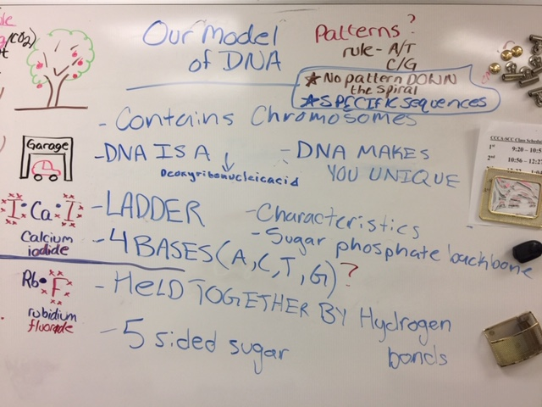

Tuesday 2.12.19- https://evansccca.weebly.com/

|  |  |
| --- | --- |
| **BIO Warm up:**  Turn OFF your cell phone and put in bin 😊  Describe the following in terms of their functions in DNA:  Covalent bonds:  Hydrogen bonds:  <https://www.hhmi.org/biointeractive/dna-replication-basic-detail> | **CHEM warm up**  Turn OFF your cell phone and put in bin 😊  How would you show an ionic bond between Iron and oxygen ?  How would you show a bond between Silicon dioxide? |

Wednesday 2.13.19- https://evansccca.weebly.com/

|  |  |
| --- | --- |
| **BIO Warm up:**  Turn OFF your cell phone and put in bin 😊  Compare/contrast purines and pyrimidines | **CHEM warm up**  Turn OFF your cell phone and put in bin 😊  Draw the following lewis structures:  CO, N2 , O2, CH2Cl2 |

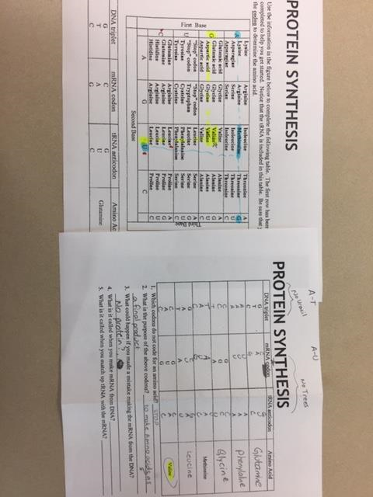

Thursday 2.14.19- https://evansccca.weebly.com/

|  |  |
| --- | --- |
| **BIO Warm up:**  Turn OFF your cell phone and put in bin 😊  What amino acids are made from the following mRNA codons?  UGG  AUG  AGU | **CHEM warm up**  Turn OFF your cell phone and put in bin 😊  1)How many neutrons are in an atom of Xenon?  2) What is the energy of ONE photon of green light?  (wavelength = 5.55 x 10-7 m)  3) Draw a lewis diagram of CH2F2 |

Friday 2.15.19- https://evansccca.weebly.com/

|  |  |
| --- | --- |
| **BIO Warm up:**  Turn OFF your cell phone and put in bin 😊  **DESCRIBE** 2 important things you learned this week. | **CHEM warm up**  Turn OFF your cell phone and put in bin 😊  **DESCRIBE** 2 important things you learned this week. |

**DNA building inquiry questions (after 15 min of play):**

1. **What blocks fit together and how did you know?**
2. **Was there a pattern of how the blocks fit together? What was it?**
3. **Did you finish the whole DNA molecule? Why or why not?**
4. **Describe a nucleotide in words.**
5. **What did the blocks represent and what were their specific names?**

**Salt vs. sugar inquiry questions (after 15 min of play)**

1. **Do either of these substances conduct electricity when dry?**
2. **Does just water conduct electricity?**
3. **Do the granules of salt and sugar look different on the screen for this simulation?**
4. **Once filled, how many milliliters of water does that bin always hold?**
5. **What are the concentration units and what does this mean?**
6. **Describe the minimum amount of salt required in a full bin to conduct electricity.**

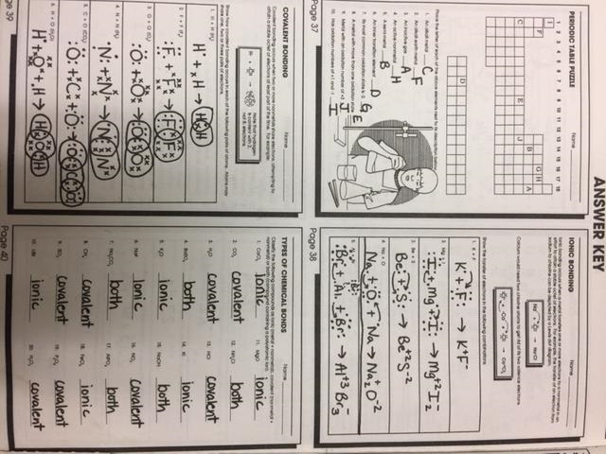

**\*Note: Final answers for ionic may look different**

|  |  |
| --- | --- |
| **TEACHER standards:**  Bio.3.1 Explain how traits are determined by the structure and function of DNA.  * Bio.3.1.1 Explain the double-stranded, complementary nature of DNA as related to its function in the cell.  * Bio.3.1.2 Explain how DNA and RNA code for proteins and determine traits.  * Bio.3.1.3 Explain how mutations in DNA that result from interactions with the environment (i.e. radiation and chemicals) or new combinations in existing genes lead to changes in function and phenotype.  Bio.4.1 Understand how biological molecules are essential to the survival of living organisms.  * Bio.4.1.2 Summarize the relationship among DNA, proteins and amino acids in carrying out the work of cells and how this is similar in all organisms. | **TEACHER standards:**  Chm.1.2.1 Compare (qualitatively) the relative strengths of ionic, covalent, and metallic bonds.  *Chm.1.2.2 Infer the type of bond and chemical formula formed between atoms.  *Chm.1.2.3 Compare inter- and intra- particle forces.  *Chm.1.2.4 Interpret the name and formula of compounds using IUPAC convention.  *Chm.1.2.5 Compare the properties of ionic, covalent, metallic, and network compounds. |

**NGSS:**

