Weekly Planner: All science week of 1.7.19 

**Objectives for the week**: What do we need to know to be successful in this class? Scientific method, Graphing, Nature of science.

|  |  |  |
| --- | --- | --- |
| Day | Honors Biology | Honors Chemistry |
| Mon 1.7.19 | Introduction to Biology  <https://www.youtube.com/watch?v=7L7x0BAqWis>  *HW= Parent signature packet,  read ch 1  <https://openstax.org/details/books/concepts-biology> | Introduction to Chemistry  <https://www.youtube.com/watch?v=izeuGr0lbN0>  *HW= Parent signature packet, Polyatomic ions Read/Do ch 1 questions (handout) |
| Tues  1.8  STUDY BUDDIES! | -Ch 1 Quiz  -graphing lab!  *HW= give mic drop up to classmates on flipgrid and Ch 1 questions #1-10, parent packet | -Ch 1 and polyatomic ion quiz  -graphing lab!  *HW= memorize the 13 polyatomics and do page 6 of syllabus packet. Video: <https://www.youtube.com/watch?v=l0jTMDtX4WY> |
| Wed 1.9  STUDY BUDDIES! | Video: scientific method  Notes: GRAPH  LAB! Graph analysis  *HW= Finish Ch 1 #1-20 BIOLOGY.. use google if you need it =D | Video- scientific method  Notes: Graph  LAB! Graph analysis  *HW= Finish ALL of graph questions! |
| Thurs  1.10 | Student presentations- #1-20  Go over graph lab.  LAB! Finding a mathematical relationship | Go over open questions  Dimensional analysis inquiry activity  Guided practice  Student-led problems  HW= # 1-12 show ALL work, units and cancel on a different sheet of paper. |
| Friday 1.11 | **TEST (on everything covered this week)**  **\*HW=READ 2.1 and 2.2**  **Graph of circle data!** | **TEST (on everything covered this week)**  **\*HW=do packet pages 2-7 ALL. SHOW ALL Work/units for page 7!** |

Warm up activities!

Monday 1.7.19- <https://evansccca.weebly.com/>Warm up= Bookmark website and do Flipgrid (Moved to TUES) introductions! <https://flipgrid.com/ccca>

Tuesday 1.8.19- https://evansccca.weebly.com/

|  |  |
| --- | --- |
| **BIO Warm up:**  Turn OFF your cell phone and put in bin 😊   1. From the dress code document **(FRONT AND BACK)**, circle the FIVE most commonly broken rules that are broken at this school. | **CHEM Warm up:**  Turn OFF your cell phone and put in bin 😊  1) From the dress code document **(FRONT AND BACK)**, circle the FIVE most commonly broken rules that are broken at this school. |

Wednesday 1.9.19- https://evansccca.weebly.com/

|  |  |
| --- | --- |
| **BIO Warm up:**  Turn OFF your cell phone and put in bin 😊   1. Describe how a graph should be set up. | **CHEM Warm up:**  Turn OFF your cell phone and put in bin 😊  1) Describe how a graph should be set up. |

Thursday 1.10.19- https://evansccca.weebly.com/

|  |  |
| --- | --- |
| **BIO Warm up:**  Turn OFF your cell phone and put in bin 😊  <https://www.youtube.com/watch?v=E91bGT9BjYk>  <https://www.youtube.com/watch?v=2RCy5hTxuYA> | **CHEM Warm up:**  Turn OFF your cell phone and put in bin 😊  <https://www.youtube.com/watch?v=E91bGT9BjYk>  https://www.youtube.com/watch?v=2RCy5hTxuYA |

Friday 1.11.2019

BIO- Turn to your table partner and explain to them HOW to properly set up a graph using the independent and dependent variables as well as how it should look!

CHEM- same as above   
☺

<https://www.ck12.org/book/CK-12-Biology/section/1.1/>

CH 1 questions: PLEASE do not write on this and answer in full sentences in your own words.

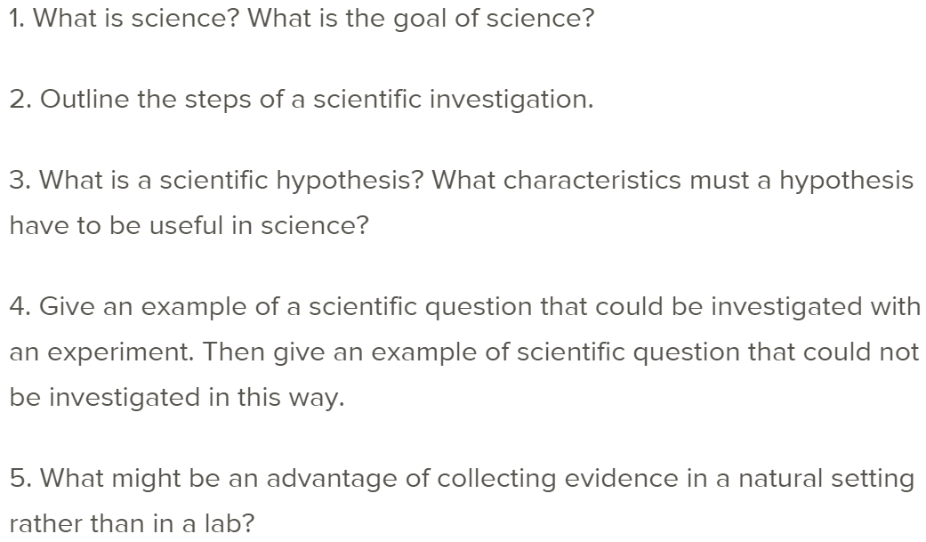

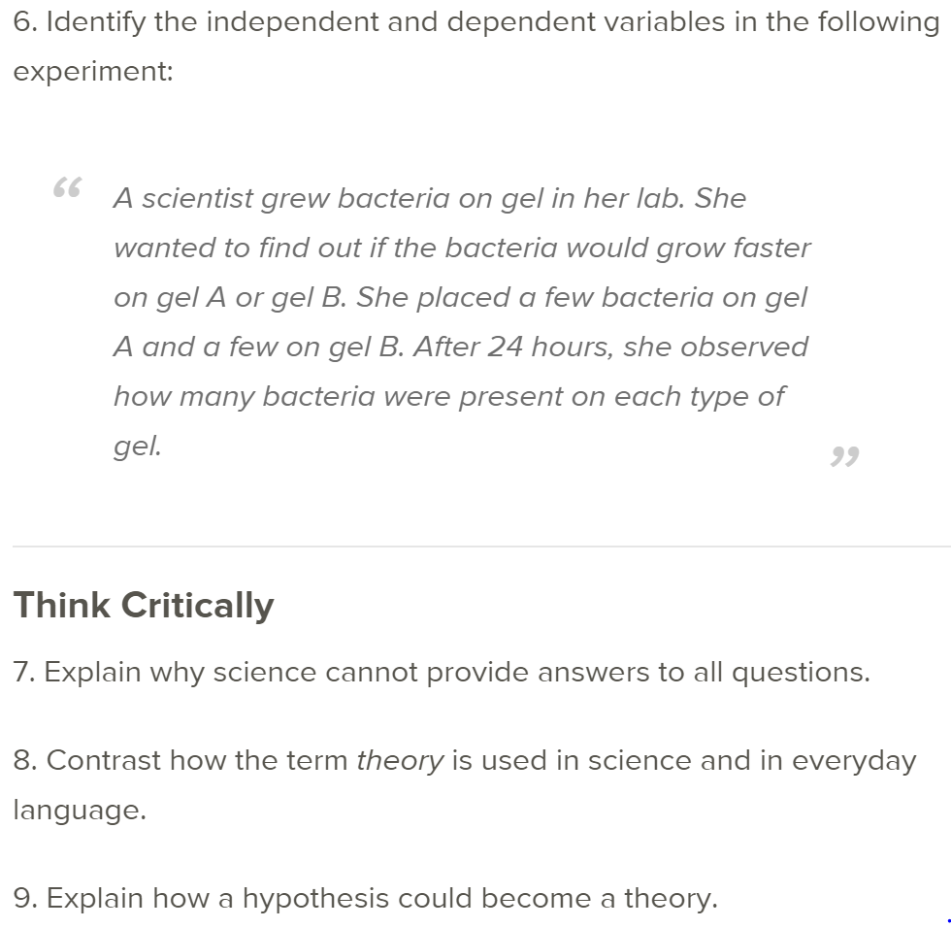

Circle data

9 circles minimum and label

Make sure it is in cm, not inches

NO CALCULATORS, just data

Full page graph

Line of best fit

Circ= Y AXIS

Diam= X axis