Weekly Planner: All science week of 1.22.19 

**Objectives for the week** BIO4.1.1 Compare the structures and functions of the major biological molecules (carbohydrates, proteins, lipids, and nucleic acids) as related to the survival of living organisms. Chem- Chm.1.1.1 Analyze the structure of atoms, isotopes, and ions. Analyze matter in terms of properties.

|  |  |  |
| --- | --- | --- |
| Day | Honors Biology | Honors Chemistry |
| Mon 1.21.19 | MLK DAY: <https://www.youtube.com/watch?v=t6lH7Z3_46A>  Believe in Yourself, Be Fearless, Fight for Yourself, Keep Moving, Moral Fortitude, Act NOW, Achieve Excellence, Stay True to your Principles, Stand for Something, HAVE A DREAM! -MLK | |
| Tues  1.22  STUDY BUDDIES! | <https://www.youtube.com/watch?v=YO244P1e9QM>  NOTES- biomolecules  <http://www.occc.edu/biologylabs/Documents/Organic%20Compounds/Organic%20Compounds.htm>  *HW= pg 5 concept map (notes).  -test corrections | Supplemental reading for definitions <https://misterguchctas.wordpress.com/2013/08/18/8/>  NOTES- Matter and properties, av. Isotopic mass.  -Properties of matter worksheets pgs 16-19  [www.youtube.com/watch?v=ooWfzpUIoNM&t=3s](http://www.youtube.com/watch?v=ooWfzpUIoNM&t=3s)  **Inquiry lab**- ATOMS and ions  *HW= Find phys/chem properties of heavy water! Study notes and do virtual lab for THURS. |
| Wed 1.23  STUDY BUDDIES! | **-HW check**  ***-QUIZ*** Biomolecules -notes  -GROUP PRESENTATIONS  *HW= review worksheet- fill in the blanks! | ***QUIZ*** matter and atoms notes  GROUP PRESENTATIONS  CORRECTIONS AND VIRTUAL LAB DUE TOMORROW!!! |
| Thurs  1.24 | <https://www.youtube.com/watch?v=qgVFkRn8f10> ENZYME LAB! (GROSS!)  <https://www.youtube.com/watch?v=ok9esggzN18>  *HW= Finish review worksheet, fill out schoology summary, finish lab. | Avg. isotopic mass notes  Isotopes LAB!!!!!  *HW= Finish isotope lab, do mcNuggium (pg 1-2, SW&units!) |
| Friday 1.25 | **TEST (on everything covered this week)**  **\*HW= read ch 3** | **TEST (on everything covered this week)**  **\*HW= read ch 3.1-3.4**  [**https://cnx.org/contents/RTmuIxzM@9.1:DIBYp8kR@3/Introduction**](https://cnx.org/contents/RTmuIxzM@9.1:DIBYp8kR@3/Introduction) |

Warm up activities!

Tuesday 1.22.19- https://evansccca.weebly.com/

|  |  |
| --- | --- |
| **BIO Warm up:**  Turn OFF your cell phone and put in bin 😊  Describe the 4 main biomolecules | **CHEM warm up**  Turn OFF your cell phone and put in bin 😊  Define matter. |

Wednesday 1.22.19- https://evansccca.weebly.com/

|  |  |
| --- | --- |
| **BIO Warm up:**  Turn OFF your cell phone and put in bin 😊  Make a Venn diagram for ADP vs ATP | **CHEM warm up**  Turn OFF your cell phone and put in bin 😊  **We learned 3 laws this week. Sketch the three shown below and label which law each belongs to**. |

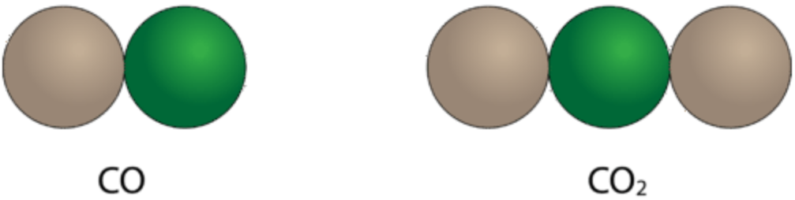 + 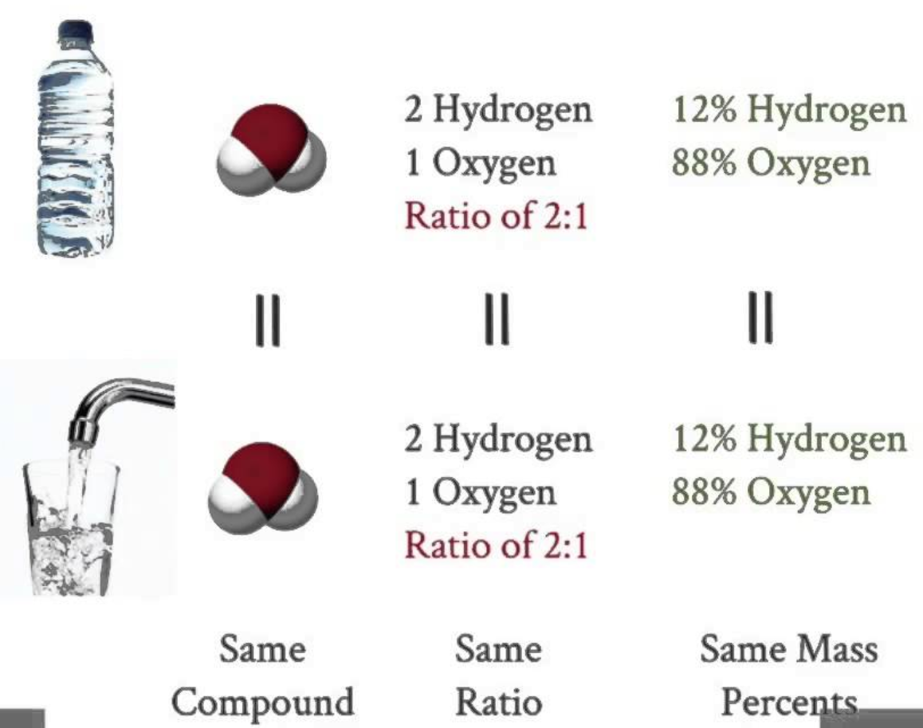 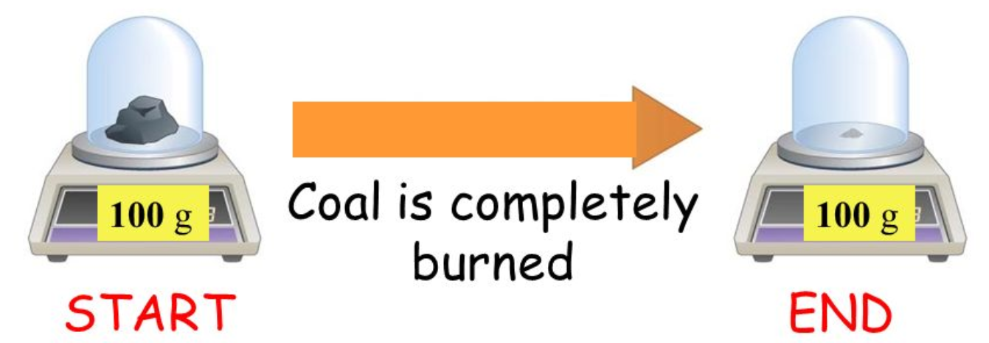

Thursday 1.24.19- https://evansccca.weebly.com/

|  |  |
| --- | --- |
| **BIO Warm up:**  Turn OFF your cell phone and put in bin 😊  Explain how a catalyst works using the sketch below: | **CHEM warm up**  Turn OFF your cell phone and put in bin 😊  Explain how a catalyst works using the sketch below: |

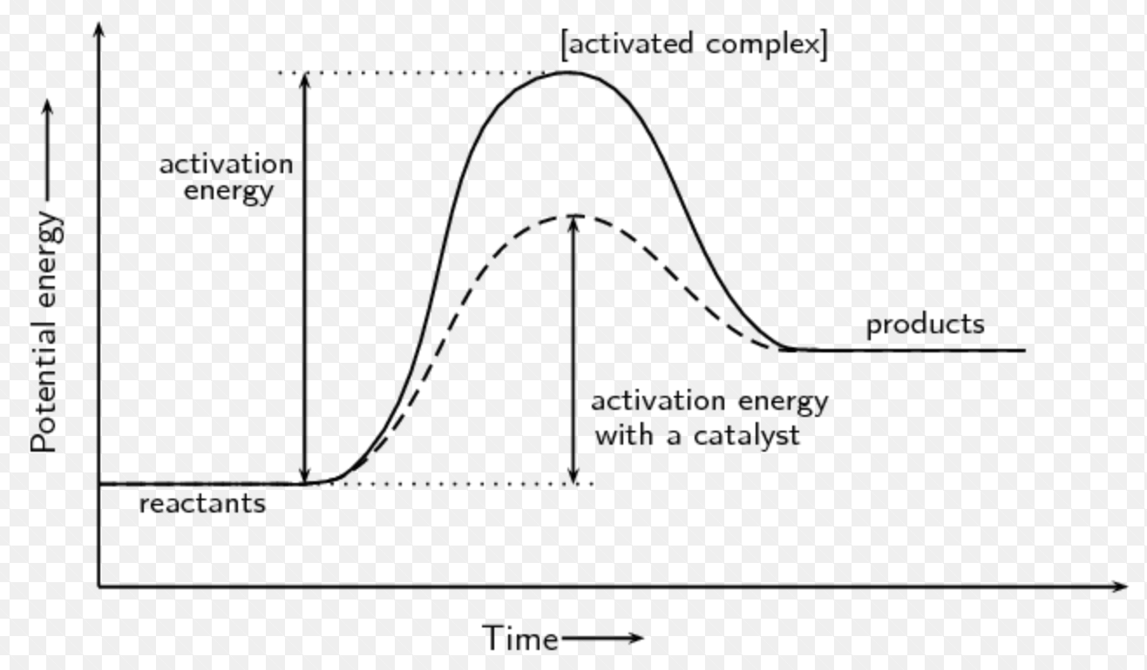

Friday 1.25.19- https://evansccca.weebly.com/

|  |  |
| --- | --- |
| **BIO Warm up:**  Turn OFF your cell phone and put in bin 😊  What is hydrolysis? What is dehydration synthesis? | **CHEM warm up**  Turn OFF your cell phone and put in bin 😊  Name and describe 3 isotopes of hydrogen. |

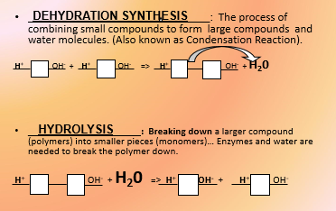

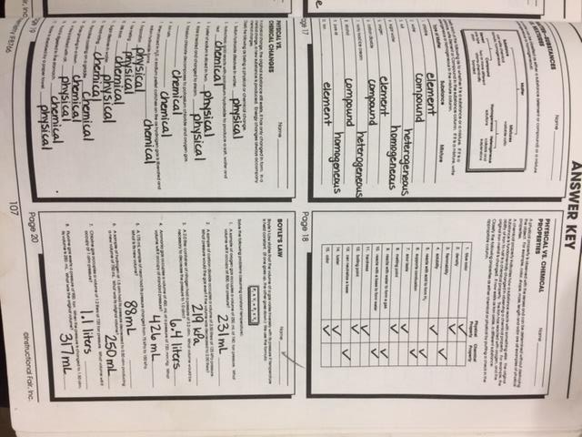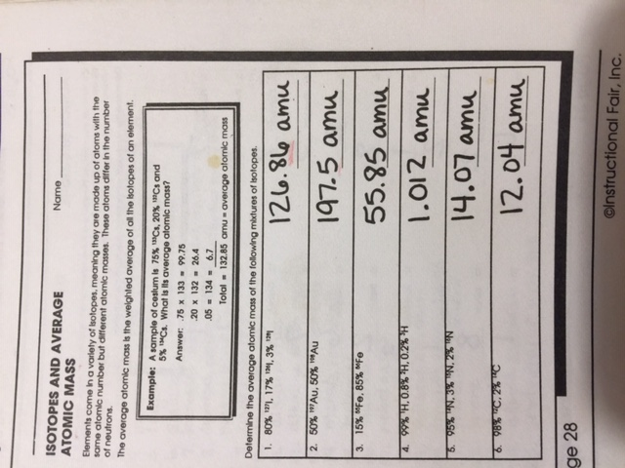

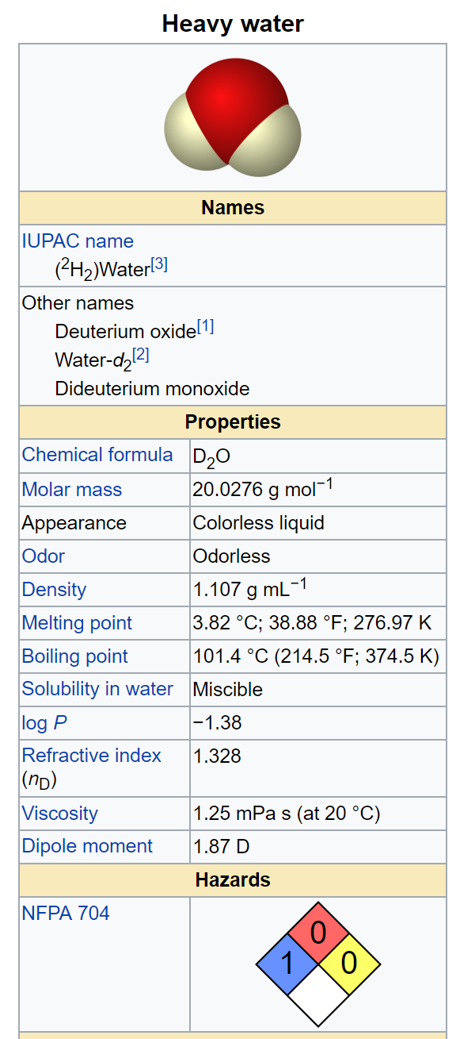

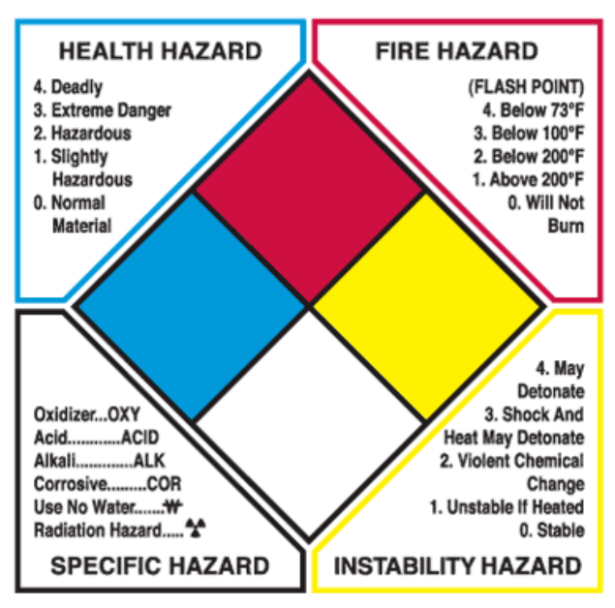

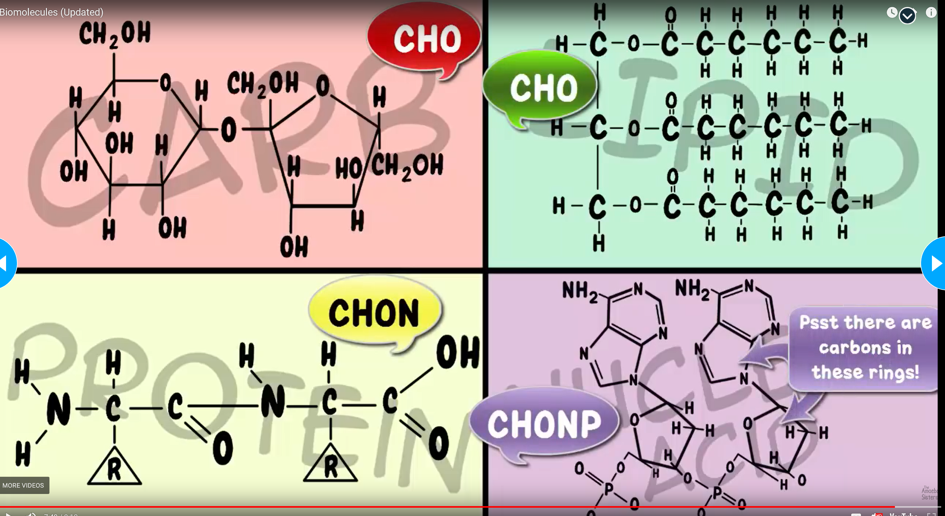

|  |  |  |
| --- | --- | --- |
| **Types of Organic Molecules** | **Monomers** | **Polymers** |
| Carbohydrates | Simple Carbohydrates or monocarbohydrates (glucose) | Complex Carbohydrate or polycarbohydrates (starch) |
| Lipids | Fatty acids | Saturated fats Polyunsaturated fats |
| Amino Acids | Amino Acids | Peptides & Proteins |
| Nucleic Acids | Nucleic Acids | DNA & RNA |

Chemical properties: Properties that describe whether something will undergo some particular chemical reaction. For example, burning stuff is a chemical reaction, so “flammability” is a chemical property. Keep in mind that these chemical  
properties are always described as being present or not present, depending on the item.

For example, a chemical property of a puppy is that it‟s flammable, while a chemical property of a tuba is that it‟s not flammable. Reacts with water.

· Physical properties: These are basically any other properties. Melting point is, for example, a physical property, because it‟s not describing a chemical change. Other physical properties include  
density, color, and mass.

--

Intensive properties: These don‟t depend on the amount of material present. For example, no matter how much ice you have, it will still melt at zero degrees Celsius. Other intensive properties include density, melting point, and solubility.  
Also, all chemical properties are intensive properties.

· Extensive properties: These depend on how much stuff you’ve got. These include height, length, width, and mass.

----

Solids are the hard state of matter. If you hit yourself on the head with something and it hurts, it‟s probably a solid. Solids are hard because the particles that make it up are all stuck in place.

· Liquids are the wet state of matter. If you put your hand in something and it gets all wet, it‟s probably a liquid. The particles in a liquid stick together a little bit, but not so much that  
you can‟t swirl your hand around in it.

· Gases are the state of matter that you can‟t really see but floats around all over the place. The particles in a gas don‟t really hang around each other much, so they fly all over the place. Examples  
of gases include oxygen and flatulence.

· Plasmas are gases that have lost their electrons. You can commonly see these in fluorescent lights or by staring directly into the sun.

----

Chemical changes are when you change one substance into another by making or breaking chemical bonds. You can usually tell this is happening because a solid is formed when you mix two solutions5 , because the material gives off heat (is  
exothermic), because the material absorbs heat (is endothermic), because the color changes, or because the material bubbles.6 Additionally, the chemical and physical properties of the material will change.

· Physical changes occur when you just change the form of something. For example, if you boil water, it‟s still H2O, making phase changes physical changes. Other physical changes include breaking,  
and dissolving, cutting.

-------------

law of conservation of mass, which says that the products of a chemical reaction will weigh the same as the reactants.

---------

Heterogeneous mixtures are mixtures where the stuff in it isn’t completely uniform. Usually, you can see a bunch of different things crammed together, as is the case with heterogeneous mixtures such as Chex Mix, granite,

· Homogeneous mixtures (also known as solutions) are mixtures in which things have mixed in a completely uniform fashion. Salt water, Kool Aid, of homogeneous mixtures.

-----------

Filtering: This is what happens when you make coffee.

· Distillation: This is when you boil a mixture and one of the components vaporizes before the other.

· Crystallization: This is when you get a solid to crystallize from a solution, using a variety of different means. I can‟t actually think of any good examples where this is done outside of a lab,  
so use your imagination.

-------------------

The law of definite composition, stating that no matter how you make a compound, it's got the same formula.

---

the law of multiple proportions basically says that if you’ve got a chemical formula, the number of atoms in the formula will be a whole number. As a result, chemical formulas look like H2O and not H2.1O.

