Weekly Planner: All science week of 1.14.19 

**Objectives for the week**: Bio- What is biochemistry and how are chemicals the building blocks of life? Chem- What is matter and why does it matter?

|  |  |  |
| --- | --- | --- |
| Day | Honors Biology | Honors Chemistry |
| Mon 1.14.19 | -HW check and progress reports  -class discussion: current event  -Homework presentations  -Notes: Biochemistry  *HW= CH 2#1-15 write out | -HW check and progress reports go home  -class discussion  -Homework presentations  -Notes: scientific notation  -Lab- the scale of the universe  *HW= finish lab, do page 8 ON that paper (only time EVER you not expected to write it out), PROGRESS REPORT SIGNED. |
| Tues  1.15  STUDY BUDDIES! | **Microscope lab!** [**https://www.youtube.com/watch?v=lo2aC_m2vyo**](https://www.youtube.com/watch?v=lo2aC_m2vyo)  -Finish Notes: Biochemistry  *HW= Ch 2 #1-25 write out  Lab= answer #3-4  Minilab @ home “water stream” | -Notes: significant figures and percent error  LAB! Measurement and conversion <https://www.youtube.com/watch?v=hQpQ0hxVNTg>  *HW= FINISH pg 8- 11(second time EVER you not expected to write it out)  *FINISH LAB!! |
| Wed 1.16  STUDY BUDDIES! | Go over HW/ Presentations  *HW= make 5, take 5 (names)  Phet🡪 molecule builder | -Notes: Atoms  <http://misterguch.brinkster.net/C2I.pdf>  Practice: Atoms  HW= finish notes sheet, online minilab: Phet🡪 molecule builder (build & name 10 large molecules) |
| Thurs  1.17 | Finish microscope lab  NOTES: Lewis dot diagrams and bonding, valence electrons  hydrophilic/hydrophobic  Stations lab!  *HW= finish lab, STUDY FOR TEST!!! | -Finish Notes: Atomic structure  *HW= finish 8 stations (SHOW WORK AND UNITS) Study for test! |
| Friday 1.18 | **TEST (on everything covered this week)**  **\*HW= read 1.2 and 1.3 on matter and its properties** | **TEST (on everything covered this week)**  **\*HW= CH. 2.3 biological molecules** |

Warm up activities!

Monday 1.14.19- https://evansccca.weebly.com/

|  |  |
| --- | --- |
| **BIO Warm up:**  Turn OFF your cell phone and put in bin 😊   1. Describe how a graph should be set up.   **Minilab: Finding pi 😊**  -current event: Organic food https://www.youtube.com/watch?v=8PmM6SUn7Es | **CHEM warm up**  Turn OFF your cell phone and put in bin 😊  1) Describe the largest thing you can imagine and the smallest thing you can imagine. |

Tuesday 1.15.19- https://evansccca.weebly.com/

|  |  |
| --- | --- |
| **BIO Warm up:**  Turn OFF your cell phone and put in bin 😊   1. Explain why you think ionic compounds form crystals and have a very high melting point. | **CHEM Warm up:**  Turn OFF your cell phone and put in bin 😊   1. Convert 1.2 g/cm3 to Kg/m3   (100cm)3 = (1 m)3  1 Kg = 1000 g |

Wednesday 1.16.19- https://evansccca.weebly.com/

|  |  |
| --- | --- |
| **BIO Warm up:**  Turn OFF your cell phone and put in bin 😊  Draw a picture of the experiment you did last night and show HOW the water molecules in the stream were aligned. (balloon was negative)  Current event: artificial sweeteners <https://www.youtube.com/watch?v=L6pJrxmDYEI> | **CHEM Warm up:**  Turn OFF your cell phone and put in bin 😊  If you do an experiment that finds the density of copper to be 9.52 g/cm3. What is your % error? |

Thursday 1.17.19- https://evansccca.weebly.com/

|  |  |
| --- | --- |
| **BIO Warm up:**  Turn OFF your cell phone and put in bin 😊  Explain what the following figures mean: | **CHEM Warm up:**  Turn OFF your cell phone and put in bin 😊  Explain what the following figures mean: |

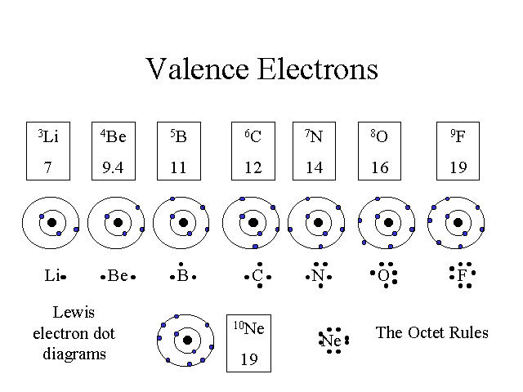

Friday 1.18.19- https://evansccca.weebly.com/

|  |  |
| --- | --- |
| **BIO Warm up:**  Turn OFF your cell phone and put in bin 😊  Name three things you learned this week. | **CHEM warm up**  Turn OFF your cell phone and put in bin 😊  Name three things you learned this week. |

CHEM STATION 7- Convert the following: SHOW WORK AND UNITS!!

1. 3,250 kg/m3 to g/cm3
2. 100 mi/hr to km/s

CHEM STATION 8-

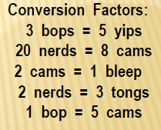 1) How many bops are in 22.5 yips?

2) How many tongs are equal to 4.8 nerds?

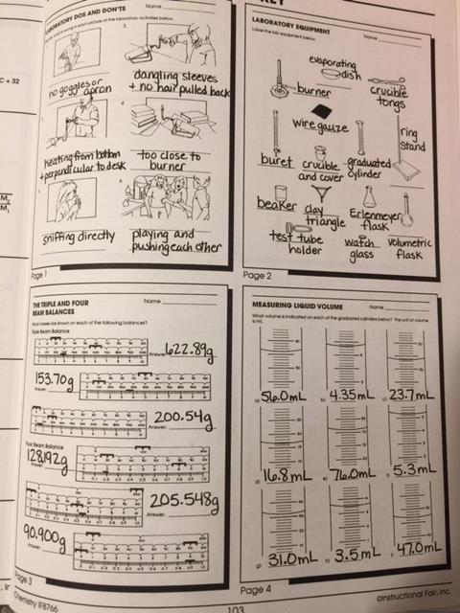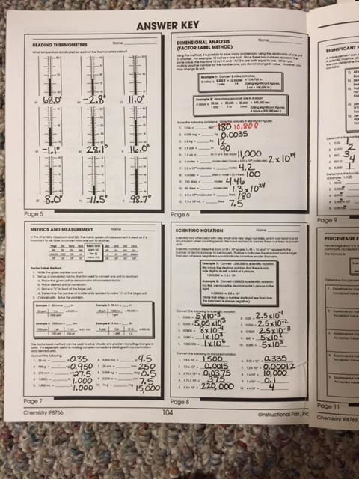

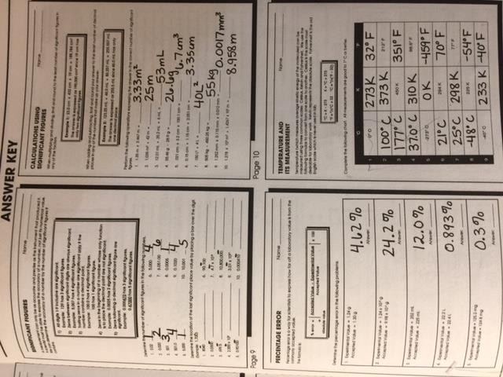

1. Property of inertia- resistance to change in motion

4. Atomic #= the # protons AND = # electrons IF it is not an ion.

10. Google🡪 Phet 🡪 build a molecule

11. valence = outer e-

13. stable atom has equal # of electrons and protons

BIOCHEM

1. Generally, how many valence electrons are needed for atoms to be most stable? a) 8 b) 6 c) 32 d) 18
2. Which type of bonding is characteristic of a substance that has a high melting point and electrical conductivity only in the liquid phase? a) ionic b) metallic c) nonpolar covalent d) polar covalent
3. Which compound is ionic? a) CaCl2 b) N2O c) HCl d) SO2
4. Which compound is covalent? A) Rb2Te b) CO2 c) BaCl2 d) NaCl
5. Which of the following explains why water is polar covalent
6. Hydrogen gives electrons to oxygen
7. Oxygen gives electrons to hydrogen
8. Electrons are unequally shared
9. Oxygen has 8 total electrons as an atom
10. When graphing, which variable belongs on the “x” axis?
11. Independent variable, the one that you measure as a result of the changes you made.
12. Independent variable, the one that you change during the experiment on purpose.
13. Dependent variable, the one that you measure as a result of the changes you made.
14. Dependent variable, the one that you change during the experiment on purpose.
15. The line of best fit always goes through every data point you collected. A) True B) False
16. 6) What type of bonds are present in a strip of magnesium ribbon? a) metallic b) covalent c) ionic d) London dispersion
17. 7) Which particles may be gained, lost, or shared by an atom when it forms a chemical bond? a) nucleons b) neutrons c) protons d) electrons
18. 9) Which type of bonds are formed when calcium atoms react with oxygen atoms? a) hydrogen b) coordinate covalent c) polar covalent d) ionic
19. 10) Which type of bond is formed by the transfer of electrons from one atom to another? a) an ionic bond c) a covalent bond b) a hydrogen bond d) a coordinate covalent bond
20. 11) Which atoms are most likely to form covalent bonds? a) nonmetal atoms that share electrons b) metal atoms that share protons c) nonmetal atoms that share protons d) metal atoms that share electrons
21. 14) The bond between hydrogen and oxygen in a water molecule is classified as a) covalent and nonpolar c) ionic and polar b) ionic and nonpolar d) covalent and polar
22. Which of the following is a characteristic property of ionic compounds?

|  |  |
| --- | --- |
| a. | They have low melting points. |
| b. | They have low boiling points. |
| c. | They form hard, brittle crystals with characteristic shapes. |
| d. | They contain no charged particles. |

1. In what form can an ionic compound conduct electricity?

|  |  |
| --- | --- |
| a. | as a solid |
| b. | when dissolved in water |
| c. | as a crystal |
| d. | when warmed slightly |

1. A chemical bond formed when two atoms share electrons is called a(n)

a. ionic bond b. covalent bond

c. polyatomic bond d. crystal bond

1. The atomic mass of an atom is the total number of ___ in the nucleus

a. protons and neutrons b. protons

c. protons and electrons d. neutrons

1. The zigzag line on the periodic table divides

a. alkali metals and transition metals c. semimetals and transition metals

b. metals and nonmetals d. inert gases and halogens

1. If you found a carbon-13 atom, you would know that

a. it has 13 protons b. it has 13 electrons

c. it has 13 neutrons d. it has 7 neutrons

1. Electrons involved in bonding between atoms are

a. valence electrons b. inside the nucleus

c. closest to the nucleus d. positively charged

