Biology Weekly Planner Week of 12/4/17 WEEK 18
*see detailed daily planner below this table….

Day | Objective | Essential question | Activities | Handouts/*Homework
Mon 12/4 | Review | Are we ready for the EOC? | ENCOMPASSING Reveiw pg 1-8 | Encompassing review  PG 1-8 DUE TUES!  https://www.youtube.com/watch?v=lo2aC_m2vyo
Tues  12/5 | Review | Are we ready for the EOC? | ENCOMPASSING Reveiw pg 9-16  -PRESENT pages 9-13 in class!! | Encompassing review  HW- complete up to page 22 on review!!
Wed | Review | Are we ready for the EOC? | ENCOMPASSING Reveiw pg 17-24  -MICROSCOPE LAB – meiosis/mitosis | Encompassing review
Thur | Review | Are we ready for the EOC? | ENCOMPASSING Reveiw pg 25-32  -MICROSCOPE LAB | Encompassing review  https://www.youtube.com/watch?v=6zyXCaqi1Mo
Fri  12/8 | Review | Are we ready for the EOC? | EOC EXAM Practice  -MICROSCOPE LAB bacteria and Insects | EOC EXAM Practice  36 PICTURES due 12/11

12/4
-Hand in population lab, turn OFF cell phones and hand in
-Warm up= back to teams!!
-HUGE review pgs 1-8

12/5
-Hand in population lab AT BEGIINING OF CLASS!! Anything after class starts counts for the NEXT DAY!!
-Hand in phones (turn off)
-Do pg 9-16
-Roll dice at the 45 min mark to present a page ( 9-13) to the class on whiteboards:
Table 1= page ____
Table 2= page ____
Table 3= page ____
Table 4= page ____
Table 5= page ____ -present, clean up and complete 17-22 for homework!

12/6
-Hand in population lab AT BEGIINING OF CLASS!! Anything after class starts counts for the NEXT DAY!!
-turn in phones
-Check pg 1-22
-Go over ppt ?????
EXIT pass:
- What is ADP?
- What does ADP do?
- What does ADP look like?
- What is ATP?
- What does ATP do?
- What does ATP look like?
- What is tonight’s homework?

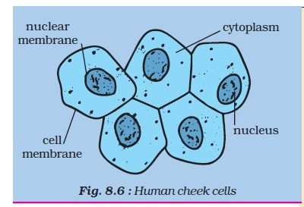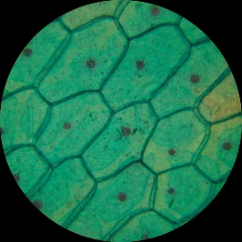

My nieces, ages 5 and 12…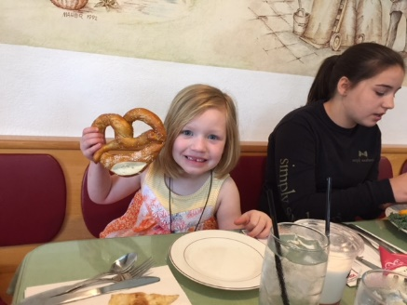

12/7
-Hand in phones (off), have ENTIRE review out on your desk.
- go over review
-LAB!!!
Be ready for EOC test tomorrow (60 q directly from the review).

MICROSCOPE SLIDES
-draw and LABEL all the stages of mitosis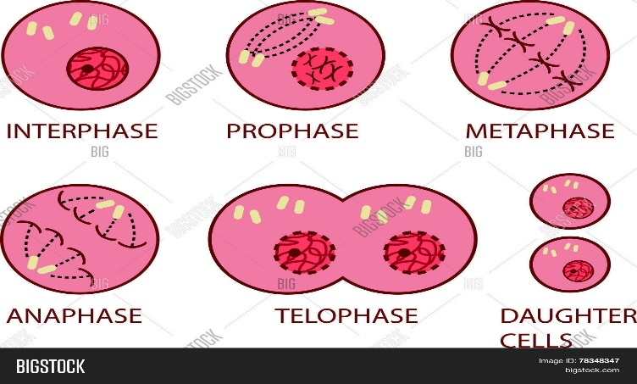
-other objects (listed on the board or already in the front of the room).

12/8
-Hand in phones (off), Get in test formation
-5 minutes to study
36 PICTUREs due 12/11

