Biology Weekly Planner Week of 10/23/17
Bio.3.1 Explain how traits are determined by the structure and function of DNA.
Day | Objective | Essential question | Activities | Handouts/*Homework
Mon 10/23 | Explain how traits are determined by the structure and function of DNA. | How are traits determined by the structure and function of DNA? | Get punnet square quiz back  Mid-term discussion | Work on project
Tues  10/24 | Explain how traits are determined by the structure and function of DNA. | How are traits determined by the structure and function of DNA? | Project recording day! | Work on Project  Email to schoology address:  adrienne.science15@gmail.com
Wed | Explain how traits are determined by the structure and function of DNA. | How are traits determined by the structure and function of DNA? | Notes: Mutations and advanced pedigree charts | Amoeba sisters mutations video  https://www.youtube.com/watch?v=GieZ3pk9YVo  Blood-type mystery DUE 10/26 (Thurs)  Research- Tay Sachs disease  -Turner’s syndrome  -Cystic fibrosis -Tay-Schs
Thur | Explain how traits are determined by the structure and function of DNA. | How are traits determined by the structure and function of DNA? | Finish advanced pedigree charts  Notes: Genetic engineering | This one BLEW my mind!!  https://www.youtube.com/watch?v=jAhjPd4uNFY  https://www.youtube.com/watch?v=aMDhUsxom0U GMOs
Fri  10/27 | Explain how traits are determined by the structure and function of DNA. | How are traits determined by the structure and function of DNA? | UNIT 5 TEST- Heredity | Cool quizlet: https://quizlet.com/1897832/gearig-biology-1-ch-5-multiple-choice-flash-cards/

10/23/17 Monday
Nesmith room 206 -
-Project work time
10/24/17 Tuesday
Nesmith room 206 -
-Project work time

10/25/17 Wednesday
Nesmith room 206 -
-Notes: Mutations and advances pedigree charts
-Practice pedigree charts
RESEARCH!!
Tay Sachs disease- Tay-Sachs disease is a rare, inherited disease. It is a type of lipid metabolism disorder. It causes too much of a fatty substance to build up in the brain. This buildup destroys nerve cells, causing mental and physical problems. .
Infants with Tay-Sachs disease appear to develop normally for the first few months of life. Then mental and physical abilities decline. The child becomes blind, deaf, and unable to swallow. Muscles begin to waste away and paralysis sets in. Even with the best of care, children with Tay-Sachs disease usually die by age 4. 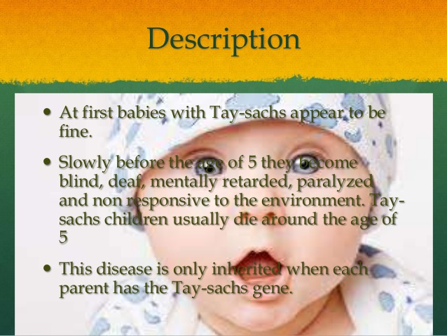

-Turner’s syndrome- Turner syndrome, a condition that affects only females, results when one of the X chromosomes (sex chromosomes) is missing or partially missing. Turner syndrome can cause a variety of medical and developmental problems, including short height, failure of the ovaries to develop and heart defects. 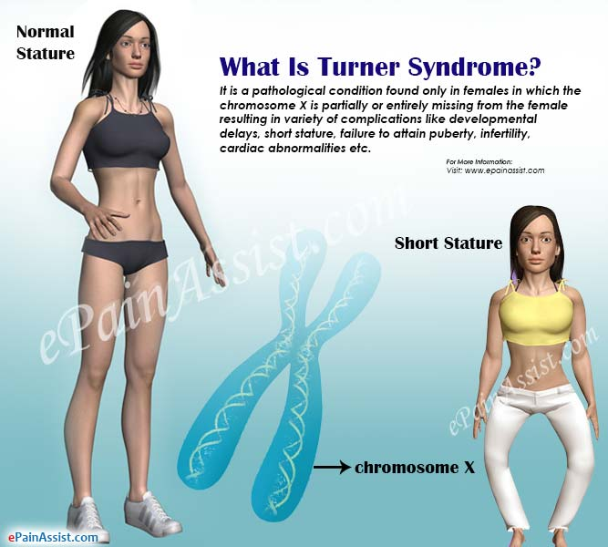
-Cystic fibrosis- Cystic fibrosis is a progressive, genetic disease that causes persistent lung infections and limits the ability to breathe over time.
In people with CF, a defective gene causes a thick, sticky buildup of mucus in the lungs, pancreas, and other organs. In the lungs, the mucus clogs the airways and traps bacteria leading to infections, extensive lung damage, and eventually, respiratory failure. In the pancreas, the mucus prevents the release of digestive enzymes that allow the body to break down food and absorb vital nutrients.
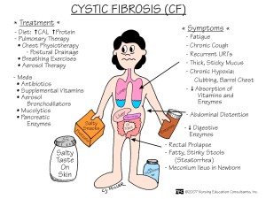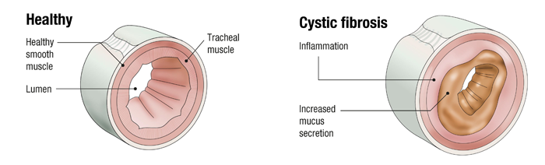

10/26/17 Thursday
Nesmith room 206 -
-Phones and hand in Blood type mystery
-make sure examples 1 and 2 of notes came out right
-Notes: Genetic engineering
-
10/27/17 Friday
Nesmith room 206 - PM Fire drill

