**Biology Weekly Planner** Week of 10/9/17

Bio.3.1 Explain how traits are determined by the structure and function of DNA.

|  |  |  |  |  |
| --- | --- | --- | --- | --- |
| Day | **Objective** | **Essential question** | **Activities** | **Handouts/*Homework** |
| Mon 10/9 | MID-TERM | Mid-TERM | MID-TERM | Meiosis project |
| Tues  10/10 | Explain how traits are determined by the structure and function of DNA. | How are traits determined by the structure and function of DNA? | -Heredity notes  -time to work on project | <https://www.youtube.com/watch?v=Mehz7tCxjSE> |
| Wed | PSAT | PSAT | -Heredity notes  -time to work on project | <https://www.youtube.com/watch?v=Y1PCwxUDTl8>  -ALL students should have the dihybrid crosses #1, #2, and #3 examples completed for tomorrow! See below for pictures to help you get started 😊 |
| Thur | Explain how traits are determined by the structure and function of DNA. | How are traits determined by the structure and function of DNA? | -Get back mid-term  -Heredity notes | HW= packet pgs 6-9  HW= GET permission slip signed!! |
| Fri  10/13 | Explain how traits are determined by the structure and function of DNA. | How are traits determined by the structure and function of DNA? | -Short quiz  -Go over the tough HW problems | Quiz check?  <https://www.youtube.com/watch?v=M1fZ74ieGRE>  DRAGONS!!  <https://www.lake.k12.fl.us/cms/lib05/FL01000799/Centricity/Domain/3480/dragon-genetics-packet.pdf>  <http://www.nclark.net/DragonGeneticsProtocol.pdf> |

[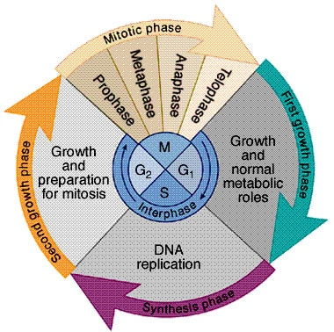](https://www.google.com/url?sa=i&rct=j&q=&esrc=s&source=images&cd=&cad=rja&uact=8&ved=0ahUKEwjt09_GydDWAhXKdSYKHc34Bx4QjRwIBw&url=https://schoolworkhelper.net/cell-cycles-interphase-mitosis-cytokinesis/&psig=AOvVaw3MkLDTcDjQzPeKRq95LOy4&ust=1506984979634563)WHY are cells small?

10/9/17 Monday



Nesmith room 206 - BACK TO exam formation - the faster you move, the more time you will have to look over your notes!!

* Mid term- essay= **In what ways do humans impact the environment and habitats of the World?**
* **31.transcription**
* Meiosis project

GENERAL outline due from your team on 10/10 (Tues)

10/10/17 Tuesday



Nesmith room 206 - BACK TO TEAMS! YAY! ☺

-NOTES: Heredity

-Team project time!

Kids who need to make up mid-term or quiz= Andrea, Jasmine, Aliyah

10/11/17 Wednesday





Nesmith room 206

* 9:10 am SIGN IN THE BUS DRIVERS!!!!!!
* PSAT and accu-placer students,send off
* Heredity- dihybrid crosses! 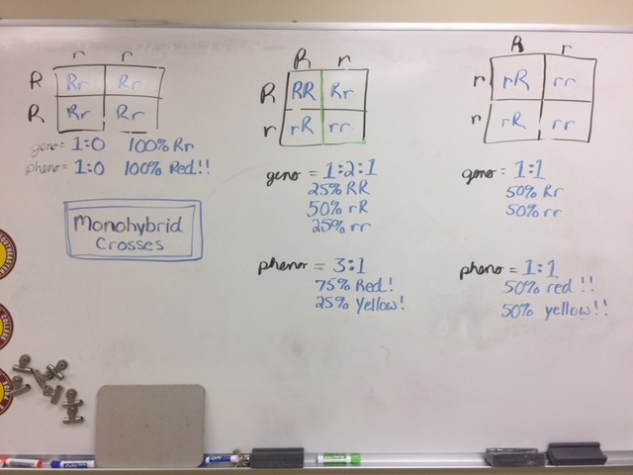
* Dihybrid cross #1

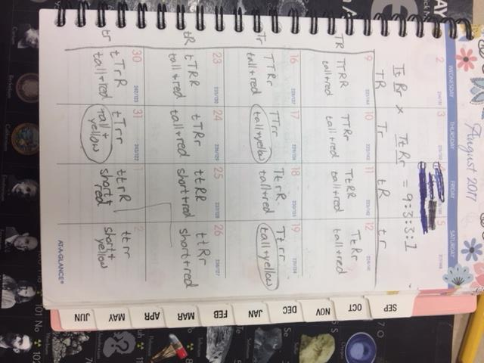

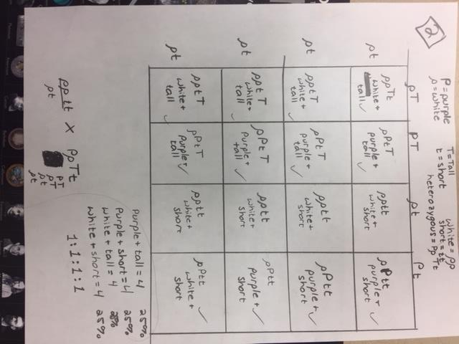

#3= do on your own!!! YOU CAN **DO** IT!!

10/12/17 Thursday





Nesmith room 206

-Turn off cell phone and trade it in for a permission slip (due tomorrow)

-Get a colored pencil for activity

-Dihybrid crosses

-practice!

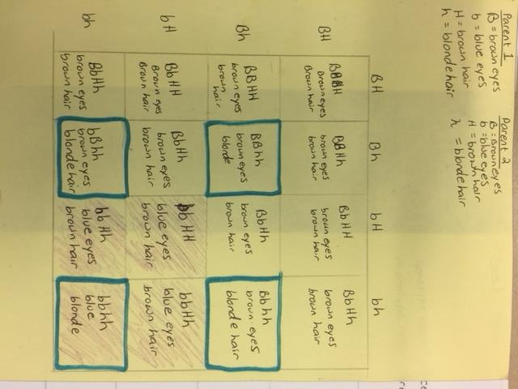

10/13/17 Friday





Nesmith room 206

-Turn off cell phone and turn in for a permission slip.

- Have pages 1-9 open on your desk

Notes- weird genetics