Cell phones: DO NOT bring your cell phones to class and expect to use them during instructional time. They may be left at home, in the main office, or will be collected before class begins. Parents may call the school at 642-7141 x422 to reach their child in an emergency.
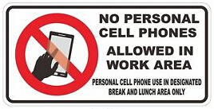
Course information: Physics is a branch of science that describes how matter, energy, motion, and force interact with one another. Topics covered in class will include forces, motion, gravity, work, energy, momentum, waves, electricity, and magnetism.

Please bring the following to class daily:
-Pencils -1" Three-ringed binder -Last night’s homework -Lined paper
*Be seated with all four of these things out when the class begins
Attendance Policy: Academic performance is directly affected by attendance. More than 10 absences will result in an automatic failing grade. Upon return to school, a parent note is required within TWO DAYS of returning to school. If you do NOT bring in a note within these two days, the absence will be unexcused and will not be changed at a later date. If you have questions on this, please see administration.
Any absences of three or more days mean you will need to provide documentation from a doctor or a court authority.
Students are responsible to obtain all missed work and submit it to the instructor in a timely manner. Every day missed on the block schedule is worth THREE hours missed on the traditional schedule so please plan your time accordingly and get work turned in to avoid your grade dropping. The class policy is two days to hand in missing work so you do not fall behind. County policy of 5 days will be adhered to but know that catching up must be your main priority.
Assignments and Homework: Homework will be assigned every single day. If the student completed everything during class time, then they are to use the 30 minutes to look over new concepts and notes taken in class.
***ALWAYS have homework out on your desk at the beginning of class. If you do not have it out when I check it, you will receive a zero and I will not accept it even 5 minutes later. You have been warned.
Always check our website (above) and schoology if you are absent.
Office Hours: If you have problems or concerns regarding anything with the class, it is your responsibility to come by and discuss it with me or make an appointment. I will help you in any way I can, but you need to put forth a genuine effort to improve.
Progress reports: Reports will be sent home every three weeks.
Other Required materials:
-Colored pencils -A small USB drive for projects
Class wish list: (things we will need in the classroom throughout the year for ALL the kids)
-tissues -dry-erase markers -kool-aide -plain crackers
-glass cleaner -plastic cups -hand sanitizer
-ZipLoc freezer bags (quart size) -liquid food coloring

Scientific Calculator:

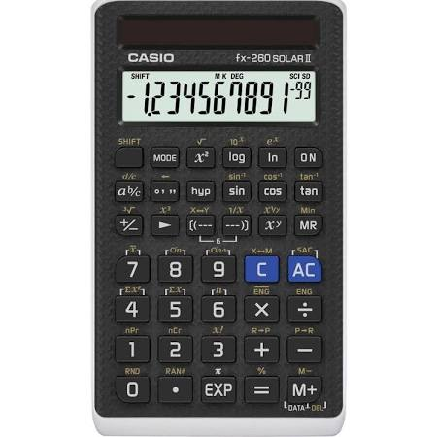Logarithm and Exponent keys

*Required for chemistry, physics, and other upper level sciences in college.
**I have found these for $8 or less.. please message me if you need help finding the current deals.

