SOUND lab phys. SPR 2020
In this homework, we will be using the Sound Simulation that we used in class is available online from the class homepage: http://www.colorado.edu/physics/phys1010
Begin by visiting the Sound Applet and exploring the various controls you have:
o you can change amplitude and frequency of the sound wave
o you can move the listener toward or away from the speaker
o you can turn the audio on or off, and you can listen to either the sound at the speaker or the sound heard by the listener
o you can switch between the Listen Screen and the Measure Screen
o in the Measure Screen you have a ruler and timer which you can use to make measurements; you also have blue lines which you can move around to help you measure.
o you can stop, run, or clear the sound waves
o you can add another tone, and octave above the primary frequency, and observe the change in the wave form and the sound out of your speaker.
1) In class, we discussed how our ears detect sound.
a) The Listen Screen of the sound simulation lets you adjust the frequency and amplitude sliders and move the listener. The solid gray of the background represents the pressure of the air when no sound wave is present. Use the adjustments available to closely examine the relationship between the movement of the speaker cone and the sound waves produced and traveling away from the cone.

True False When the speaker is producing sound waves, the motion of the speaker produces a slight decrease in the pressure in front of the speaker during the forward motion of the speaker head and a slight increase in pressure during the backward motion of the speaker head.
True False In this simulation, a darker shade of gray indicates an increase in pressure compared to the undisturbed air pressure.
True False To increase the volume of a tone at 400 Hz heard by the listener, the speaker must oscillate back and forth more times each second than it does to produce the tone with lower volume.
True False If the speaker produces larger fluctuations in pressure, the volume of the tone heard by the listener increases.
True False To produce a lower pitch tone, the speaker must oscillate back and forth fewer times each second.

b) In the following graph we have plotted the pressure measured at the listener’s ear as a function of time for a 200 Hz tone generated by the speaker.
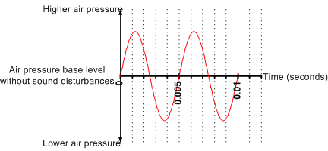
In the graphs of pressure versus time below, the dashed red line indicates the original 200 Hz tone.
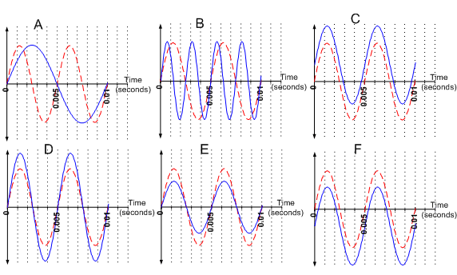
Which of the blue solid curves represents the variation in the pressure at the eardrum versus time when:

The speaker is producing a lower pitch tone:
The volume of the speaker is turned up:

The speaker sound is unchanged, but the listener has moved to be further from the speaker:
The speaker is oscillating back and forth, completing this cycle 400 times per second:
c) You hear a Concert A tone from the speaker. Describe the motion of the speaker and how this motion leads to our ears detecting Concert A tone, that is include the chain of cause-and-effect logic that results in your hearing Concert A tone from the speaker.

2) Now that we have a sense of how frequency, wavelength, and amplitude relate to what we hear, let’s examine how frequency and wavelength are related to each other.
a) Switch to the Measure Screen on the applet. Here you will find a ruler and a timer. Note that the time starts and stops when you hit run/stop. Use the ruler and the relationship between speed, distance, and time to measure the speed of sound at two different frequencies (200 Hz and 400 Hz). Describe the process you used to find the speed and then compare your answer to the speed of sound in air at sea level at 0 degrees C (331 m/s). Does the speed of sound depend on the frequency of the sound?
[When doing measurements with the ruler, you want to be sure that the ruler oriented parallel to the direction the wave is moving. Since we can’t tilt this ruler, you will need to do your measurements with the ruler placed so that it lines up with the centerline of the speaker].
b) We can use this tool to help us understand better the relationship between wavelength, frequency, period, and speed of sound.
i) If the speaker is producing a 250 Hz tone, what is the wavelength of the sound wave generated by the speaker?
ii) For this 250 Hz tone, how many times per second does the pressure in your ear oscillate through a complete cycle?
iii) How much time elapses between when your ear experiences one pressure maximum until the next pressure maximum?

c) I am climbing Longs peak and see bolt of lightning in the distance. I count 7 seconds before I hear the roar of the thunder. How far away was the lightening in miles?

Student answer sheet on next page:

*Directions: submit a picture of this page for credit.

1a) I. ________ II._________ III. ___________ IV.___________ V.____________

1b) For this portion, provide an answer and a REASON for your answer.
I. The speaker is producing a lower pitch tone:

II. The volume of the speaker is turned up:

III. The speaker sound is unchanged, but the listener has moved to be further from the speaker:

IV. The speaker is oscillating back and forth, completing this cycle 400 times per second:

2a) Description of process used:

2b) I. If the speaker is producing a 250 Hz tone, what is the wavelength of the sound wave generated by the speaker?

II. For this 250 Hz tone, how many times per second does the pressure in your ear oscillate through a complete cycle?

III. How much time elapses between when your ear experiences one pressure maximum until the next pressure maximum?

2c) Make a model of this problem and use the speed of sound to calculate. The speed of light is so fast that it doesn't even count in this calculation. SHOW WORK And all units to solve!

