MEASUREMENT AND MATTER NOTES HONORS CHEMISTRY
Directions: This packet will serve as your notes for this unit . Follow along with the PowerPoint presentation and fill in the missing in formation. Important terms / ideas are in all capitals and bolded!
• CHEMISTRY:

**ALL __________ AND ______________ THINGS ARE MADE OF __________… CHEMISTRY AFFECTS ____________________!!!
• Branches of Chemistry
-ORGANIC:

-INORGANIC:

-ANALYTICAL:

-BIOCHEMISTRY:

-PHYSICAL:

• Types of Chemistry
-PURE CHEMISTRY:

-APPLIED CHEMISTRY:

• Observations

-QUALITATIVE:

-QUANTITATIVE:
• Scientific Notation

-Short cut for writing _____ or ________ numbers
-Always contains a number greater than ___ and less than ____ followed by X 10N (N = a __________)

-Move the ___________ (left or right) until the number is between 1 and 10 AND the number of __________ moved will = ____
-If no ___________ is present, assume it is at the _______!
Move ________: N is _____________
Move _________: N is _______________
*Example:

-Need to move decimal until number is between ___ and ____
-Which way is it moving?:
-Count the number of _________ moved (___) to give X 10N
-More Examples:
a) 0.00002789 b) 1,230 c) 99,800,000,000 d) 0.0071
-Express ______________ in STANDARD NOTATION:
Move decimal _______________ as before!
- b) c) d)
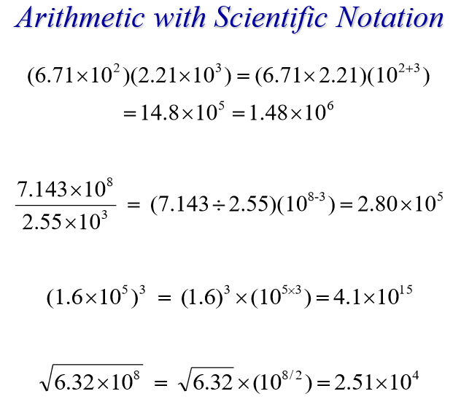
• Accuracy vs. Precision

-ACCURACY:

-PRECISION:
*Tools with ______ numbers after the decimal = ______ precise
**WHEN MAKING __________________, IT’S GOOD TO HAVE ________________.
-Dartboards: (draw the darts for each AND label the type):
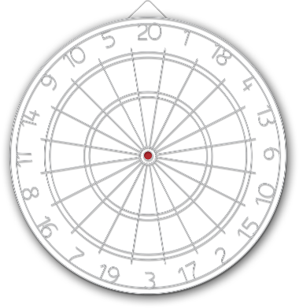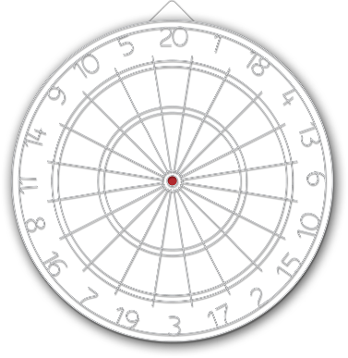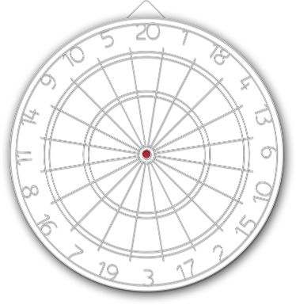

• Precise vs. Imprecise

-Example:

Mass of silver = ___________ g Mass of silver = ______ g

-________ precise measurement will have _________________ after the decimal, this means the _________ is more ______________! -Which is the _________________ measurement?

4.609 Liters 4.6 Liters 5 Liters

• PERCENT ERROR:

-Equation:

-Example: Sally found the mass of a _______ sample to be ________. What is the % error in her measurements?

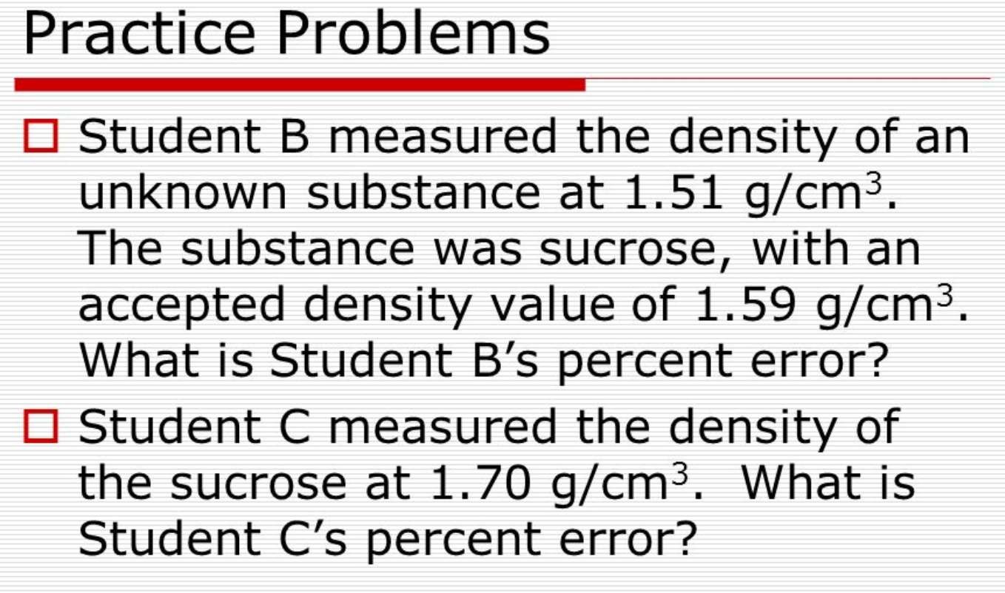
Work:

For the remainder of the period, use the time wisely to memorize the information needed by Friday

