PARADIGM LAB- Limiting reactant Initials of all team members:
Team members absentee agreement regarding absences and/or lack of team production.
Signatures of all team members and today’s date:

OBJECTIVE- To conduct and experiment then calculate the EXACT contents of the jar left after the experiment.
Part 1 Data:
Mass of candle before experiment ________g (measured)
Amount of time the candle burned _______s (measured during experiment).
OTHER OBSERVATIONS:
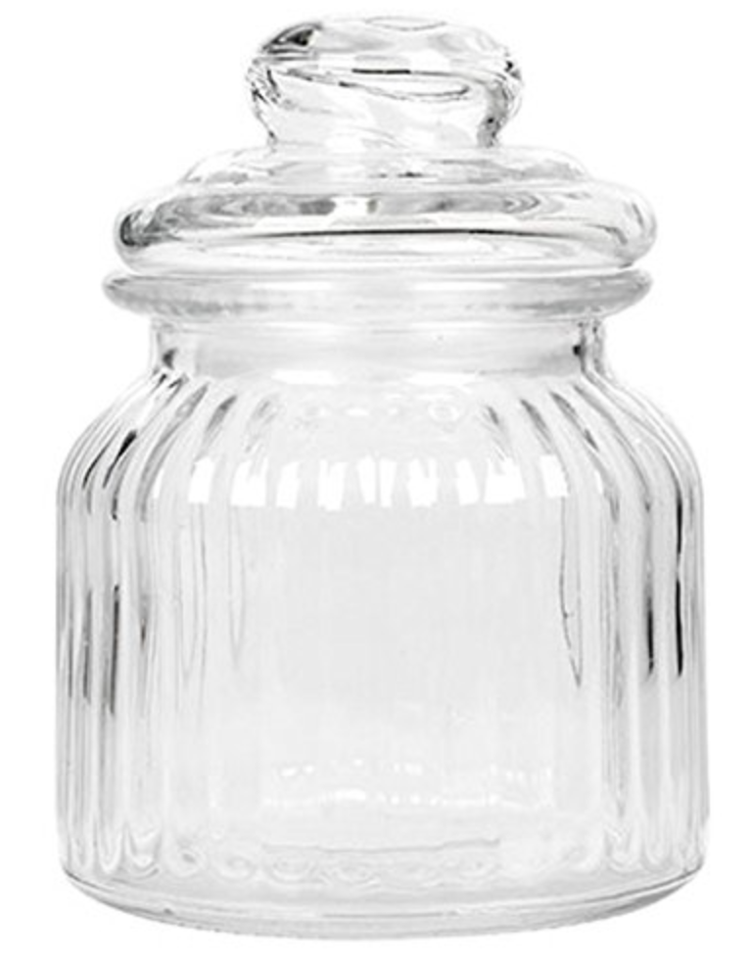
Part 2 data:  Volume of container: Describe/explain how you find it.  *hint- does the candle itself take up volume too? | Describe/explain how you find the volume of just oxygen in this container.
TEAM MEMBER NAME _________________________________________
Data analysis:
- What do you have to do to get the number of moles of O₂ that is used up?

- The candle wax we are using is C₇H₁₆. Describe/explain how you would write a balanced equation for this reaction?

- Describe/explain how you would find the number of GRAMS of candle wax used up in the reaction.

- Describe/explain how you would find the number of molecules of CO₂ produced.

- Describe/explain how you would find the number of grams of water produced.

- In the space below, make a before and after diagram to quantitatively describe your experiment!
Before After

