• Measurements
-Quantities that have both a ___________ and a _______
-Fundamental to ________________ so it is important to _______ measurements and determine if a measurement is ______________
WITHOUT _______ MEASUREMENTS, THE _______ OBTAINED IN THE LAB WILL BE _____________!!
• Making Measurements
-In making a measurement, write down all of the _________ (exact) digits that the _____________ gives and also one _____________ digit that you ____________
-Why would any digits be uncertain?
1) Instruments are _________ free of _______
2) Measuring __________ involves some ______________

• Estimating Digits
-Digital Displays: _________________ on the display is the _______________ digit
-Scales: With __________ the bottom of the __________ surface (______________) is where the reading is taken… estimate the _______ digit
*MUST READ THE ________________ AT ________________ FOR AN ______________ READING IN LAB!!
• SIGNIFICANT FIGURES ("SIG FIGS"):
-Rules:
1) All _____________ digits are significant
2) Zeros ____________ other sig figs ________ Ex:
3) Zeros at the ____ before an implied ______________ don’t count (if it’s there then they do) Ex:
4) When a number is __________ than one, zeros before the _______ S.F. don’t count Ex:
5) Zeros after a ____________ do count (once you have a S.F.) Ex:
• Rounding with Sig Figs
-If digit to the right is LESS than 5… ______________________!! (Ex: 56.43 with 3 Sig Figs would be ______)
-If digit to the right is GREATER than 5… __________________!! (Ex: 67.39 with 3 Sig Figs would be ______)
-If digit to the right EQUALS 5… ____________________________!! (Ex: 94.65 with 3 Sig Figs would be ______, while 94.75 with 3 Sig Figs would be ______)
• Math with Sig Figs
-Multiplication and Division: Count SIG FIGS in each and use the _________ amount in the answer!
Ex: 3.052 X 2.10 X 0.75 = CORRECT SIG FIGS =
-Addition and Subtraction: Count DECIMAL PLACES in each and use the _________ amount in the answer!
Ex: 3.45645 mL – 2.43 mL = CORRECT SIG FIGS =
• Sig Fig Practice
-How many ___________ are in these numbers? 1) 91,600 2) 0.003005
-Calculate and ________ using the appropriate rule: 3) 0.04216 + 0.0004134 = 4) (5.610) X (34.908) X (2.30) =
• SI Units
-English system is not used in __________, instead we will use the International System of Units (________________)
-Decimal based system (__________________ conversions)… makes sharing ______ easier
-Seven Base Units are used (only look at five for now)
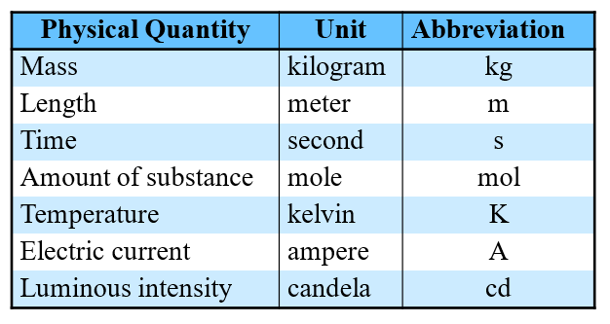•
Non SI Units
-Two units used in _____________ that are ______ SI units
Volume=_____________ Temperature= ______________
-To these base units (grams, liters, seconds, meters) ___________ are attached to make the new unit ____________ or __________ than the base unit…
PRACTICE: 9 sentences…

• Prefixes
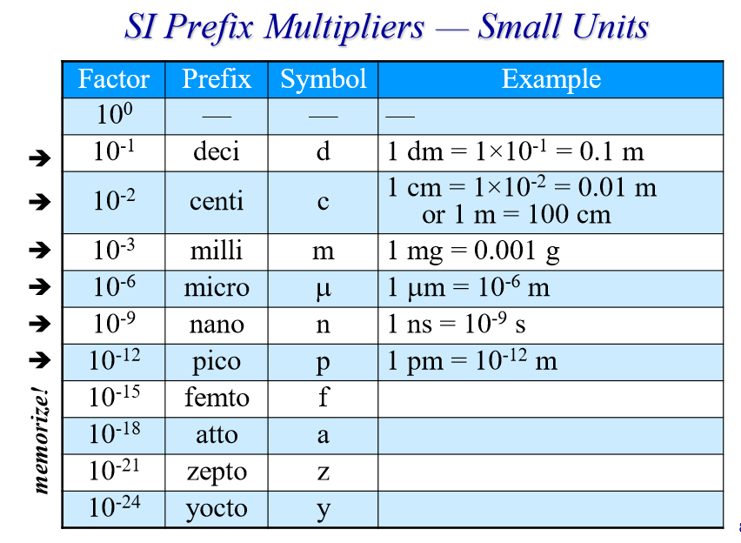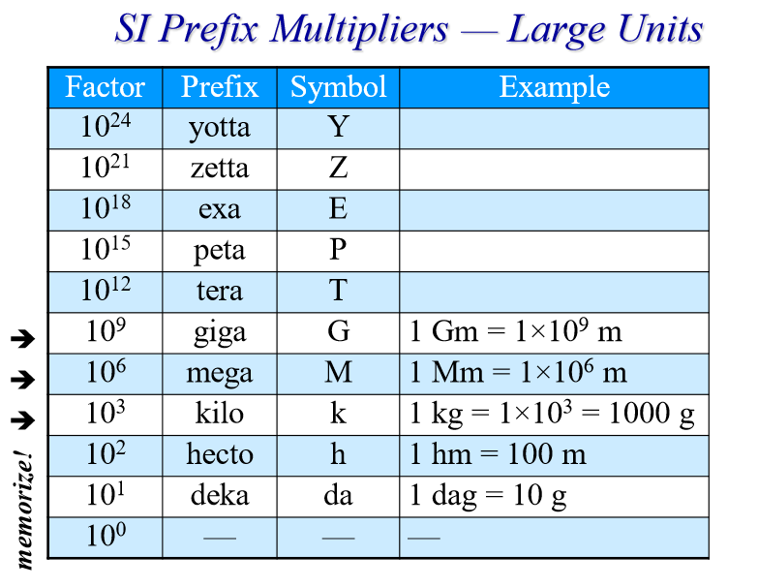M (mega) = ____ k (kilo) = 10³ D (deka) = 10¹ d(deci) = ____
c (centi) = 10⁻² m m(milli) = ____ µ (micro) = 10⁻⁶ n (nano) = ___
Positive exponents are ___________ than the base unit, while negative are ___________
-Ex: 1 km = __________ m (KILO is __________)
-Ex: _________ mm = 1 m (MILLI is __________)
• DERIVED UNITS:
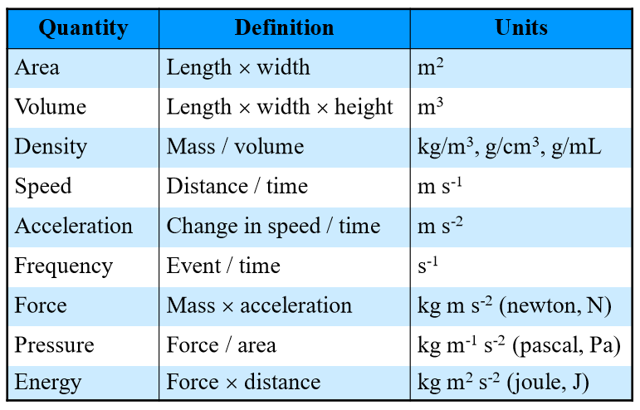
• Which Unit Should Be Used?
a) Length of a marathon (mm or km)
b) Amount of water contained in a soda can (mL or kL)
c) Mass of piece of paper (dg or mg)
d)Time it takes to blink your eye once (ks or ms)
e) Number of waves that pass by per second (m/s, Hz)
f) The force of the atmosphere on the top of your head (J, Pa, N)
g) The amount of energy in a bag of popcorn (J, N, Pa)
• TEMPERATURE:
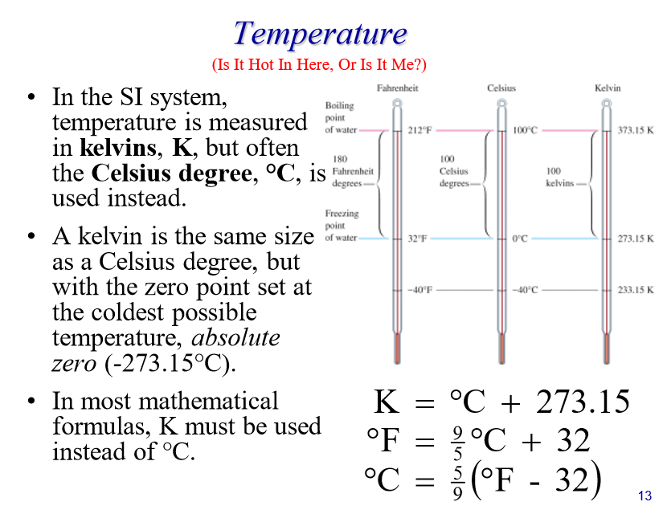-Water FREEZES at _______ and BOILS at ________
-Zero point on the __________ scale is ABSOLUTE ZERO (__________)
-Room Temperature= _______°C or ____K
-Human Body Temperature= 98.6°F or _____°C or _____K
• Temperature Conversions Practice:
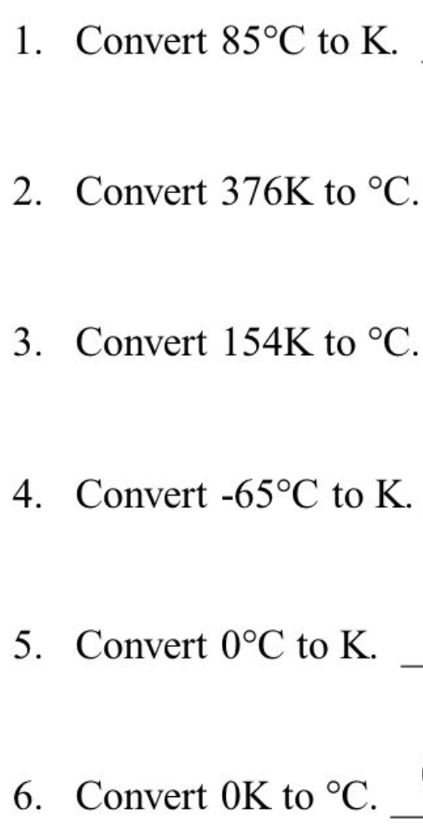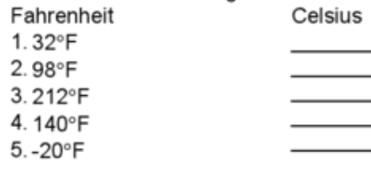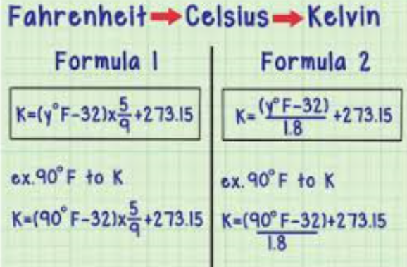
• Conversion Factors
-Amounts can be expressed in different _________ ways
-Some Common Conversions:
1 in = 2.54 cm 1 ft = 12 in 1 yd = _____ 1 mi = 5280 ft 1 m = 10 dm 1 m = _______
1 m = 1000 mm ________ = 1 km 1 g = _______ 1 g = 100 cg 1 g = 1000 mg 1000 g = _______
1 mL = 1 cm3 1000 mL = _____ 1 min = 60 s 1 hr = _______ 1 day = 24 hr 365 days = _____

• Dimensional Analysis: Way to analyze and solve problems using the units of the measurements (conversion factors)
-Steps:
1) Start with what is ________
2) Determine what ______ you must end up in
3) Multiply what is given by a _________________ that will ________ out the starting unit
4) Continue ______________ by conversion factors until the desired unit is reached
5) Do the ________… multiply across the top, then divide
In these problems, the UNITS ARE YOUR ____________… LET THEM ________ THE WAY!!!
-Example: What is 258 cm expressed in meters?
**In order to cancel a unit, one must be on the “_____” and the other must be on the “_________” (immediately write the top unit on the __________ for the conversion factor)!!
-Examples: (SHOW ALL WORK!)
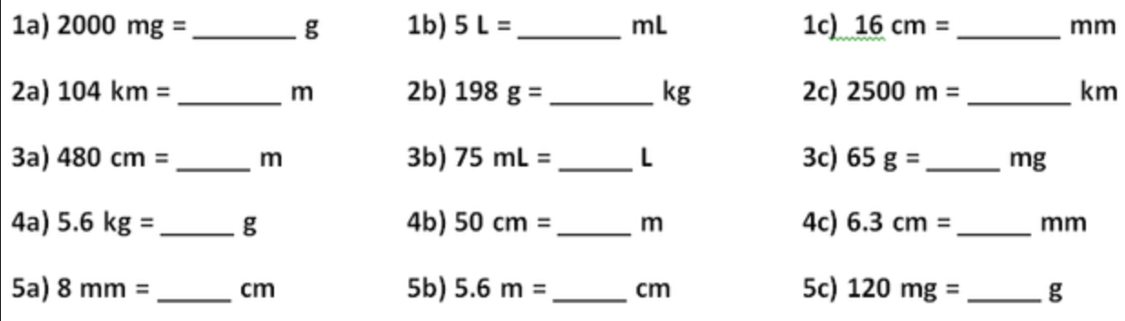
WORK SPACE:

Tougher conversion problems:
Convert 164 inches to meters

Convert 102,780,000 seconds to days

Conver 144 oz to liters

Convert 100 Km/hr to m/s

• DENSITY:
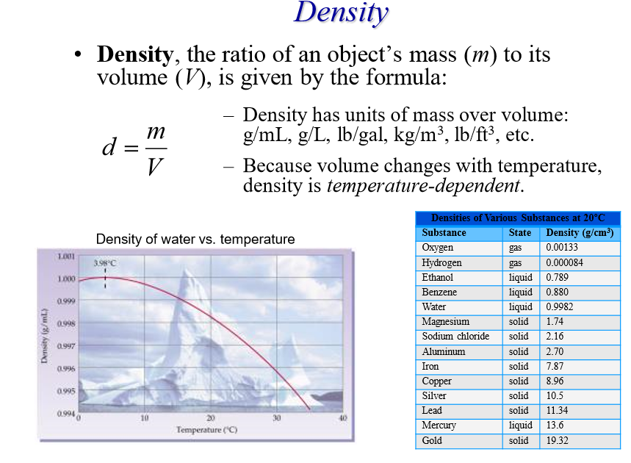
-INTENSIVE PROPERTY:

-If ___________ is given, mass or volume could be determined…
a) A piece of wood has a mass of ______ and a volume of 23 mL. What is the density?

b) Mercury metal is poured into a graduated cylinder that holds ________. The mercury used to fill the cylinder weighs 0.3060 kg. Calculate the density (in g/cm³) of mercury.

c) A piece of wood has a density of 0.82 g/mL and a volume of 10 mL (= 10 cm³). What is the mass of the wood in mg?
d) Aluminum has a density of ______ g/cm³. What is the mass (in kg) of a cube with a side of 6.78 cm?

• Density of Water
-Liquid water at room temperature will have a density of _____________
-When water becomes ice it’s density actually _____________ (0.92 g/cm³)… due to the shape the crystals form that trap __________________ inside (about _______ of ice is below water and the rest is above)
• How Does Something Float?
-Lower density items _________ on higher density items… ice is _______________ than water!
-Most ALL _________ solids less dense than water---
-Helium is less dense than ______
-A _________ is less dense than water
• Density and Temperature - cause __________________ and _________________ currents.
• Lava Lamp Density *Wind and wind patterns
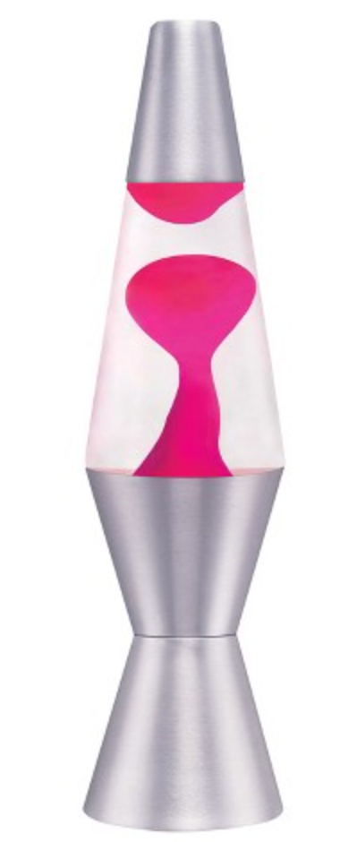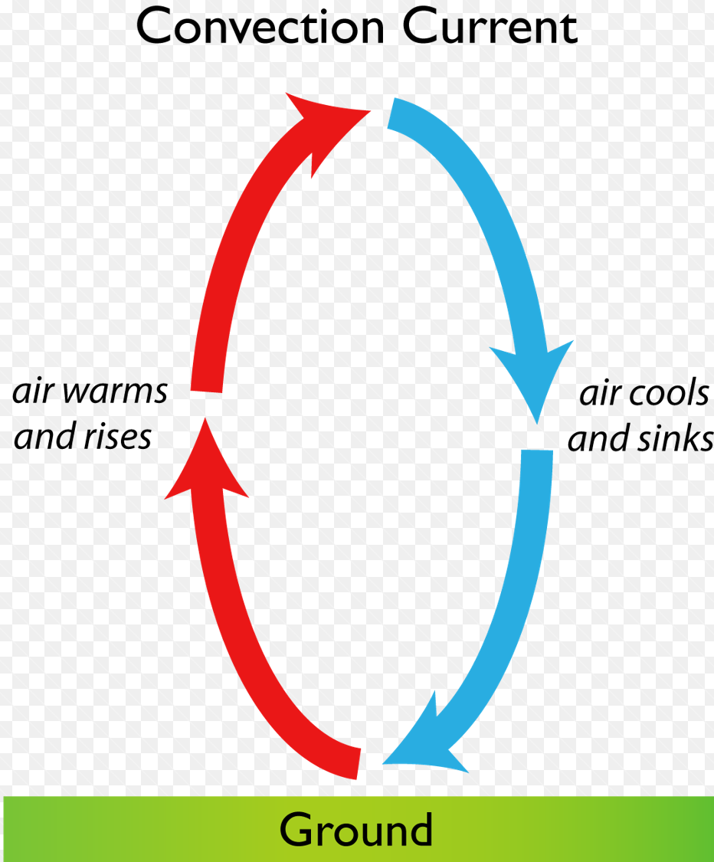

Without a large ΔT, or large difference in temperature, the convection process will slow down and eventually stop.

• MATTER:

-MASS:

-WEIGHT:

*MASS _______ WEIGHT!

-Three States of Matter

o SOLID: definite _________, definite _________, high ________, not easily _________________, ________ moving particles

o LIQUID: ______________ shape, ________ but has a definite volume, not easily compressed

o GAS: ______________ shape, _____________ volume (takes the shape of the container), _______ density, easily compressed, _______ moving particles (VAPOR = _____________ state that is liquid or solid)

-KINETIC MOLECULAR THEORY:

• Phase Changes

*Substances can change phase by __________ or __________________ energy!!!

-MELTING:

-FREEZING:

-EVAPORATION:

-CONDENSATION:

-SUBLIMATION:

11

• Describing Matter

-INTENSIVE PROPERTY:

Ex:

-EXTENSIVE PROPERTY:

Ex:

• Types of Properties

-PHYSICAL PROPERTY:

Ex:

-CHEMICAL PROPERTY:

Ex:

• Types of Changes

-PHYSICAL CHANGE:

Ex:

-CHEMICAL CHANGE:

Ex:

• MIXTURE:

-Two Types

o HOMOGENEOUS:
Ex:

o HETEROGENEOUS:
Ex:

• SOLUTION:

-SOLUTE:

-SOLVENT:

12

Solution Solute Solvent Lemonade Soda pop Ocean water

-INSOLUBLE:

-SOLUBLE:

• What Affects Solubility Rate?

1) _________________: increasing the _______ will _____________ the dissolving rate

2) ________________: _____________ will increase dissolving rate

3) __________________: the greater amount of ________ that is added, the _______ soluble it will become

4) _______________: more surface area a solute has, the _________ its dissolving rate will be

• Separating Mixtures

-Differences in ________________ properties can be used to separate mixtures 1) DECANT: ___________ one layer leaving behind another layer of a mixture (____________)

2) FILTRATION: separates a ________ from the ________

3) MAGNET: removes substances that are _______________ (ex: ______ filings)

4) CHROMATOGRAPHY: separates ____________

5) DISTILLATION: uses a difference in _______________ of two substances to separate them

• PURE SUBSTANCE:

-Two Types

o ELEMENT:

Ex:

o COMPOUND:

Ex:

13

• Chemical Symbols

-Each element has a _____ or ______ letter symbol

-First letter is always ________________ and the second letter (if present) is ____________

-Ex:

-Sometimes the symbols come from the _________ name (ex:___________________)

• CHEMICAL REACTION:

*Basically, a __________________________ has taken place…

-REACTANTS:

-PRODUCTS:

-Examples:

• Chemical Reaction Indicators

1) Energy Transfer è Ex:

2) Color Change è

Ex:

3) Production of Gas è Ex:

4) PRECIPITATE è Ex:

*ONLY CAN BE _____________THAT A _______________ TOOK PLACE, IF THE SUBSTANCE _______________!!

• Reaction Laws

-LAW OF CONSERVATION OF ENERGY: Energy can neither be __________ nor ___________… only changed from one _______ to another!

Ex:
14

-LAW OF CONSERVATION OF MASS: Mass can neither be __________ nor ____________… Total mass in the universe is ____________!

Ex:

-LAW OF CONSERVATION OF MASS / ENERGY: Total ____________ of mass and energy in the universe is a ____________!

Ex:

• ENERGY:

-_____________ is the SI unit for energy -Another common unit is _______________

-1 calorie = __________ Joules

-1 Cal (kilocalorie) = _______ calories

• THERMODYNAMICS:

-Energy is _________________ in a chemical reaction (_______________ to ___________)

-HEAT (_______________________) is also usually produced or absorbed o SYSTEM:
o SURROUNDINGS:

• Heat Transfer

-EXOTHERMIC:

Ex:

-ENDOTHERMIC:

Ex:

• HEAT CAPACITY:

-_______________ Property… depends on how much! (Ex: _____________ vs. ____________)

-SPECIFIC HEAT CAPACITY (C or Cp): -Water has a ________ Cp (4.184 J/g°C)… need ________ heat to raise the temperature -Metals have a ______ Cp… ________ heat needed to raise the temperature
15

• Specific Heat Problems

-Units are usually __________ or __________

-Equation:

q = _________ (Joules) m = ________ (grams) c = _________________ DT = ___________ Temp – ____________ Temp (°C)

-Example: When _______ of heat is added to ______ of olive oil at 21°C, the temperature increases to 85°C. What is the specific heat of the olive oil?

-Example: How many calories does _______ of water absorb when it is heated from 25.0°C to 80.0°C?

• CALORIMETRY:

-CALORIMETER: ________ used to measure _______ (ex: _____________… good insulators)

-ENTHALPY (H): measure of _________________ as heat

____________ = ____________

*Heat gained by system will be _________ as heat lost by surroundings (and vice versa)!

-Example: An unknown metal with a mass of ______ grams is heated to a temperature of 80.0°C. It is then placed in ______ grams of water that is at a temperature of _______. The temperature of the water and metal then rise to a temperature of 23.5°C. What is the specific heat of the metal?

