Course Description: AP Computer Science Principles (CSP) curriculum is a full year, rigorous, entry level course that introduces high school students to the foundations of modern computing. The course covers a broad range of foundational topics such as programming, algorithms, the Internet, big data, digital privacy and security, and the societal impacts of computing.
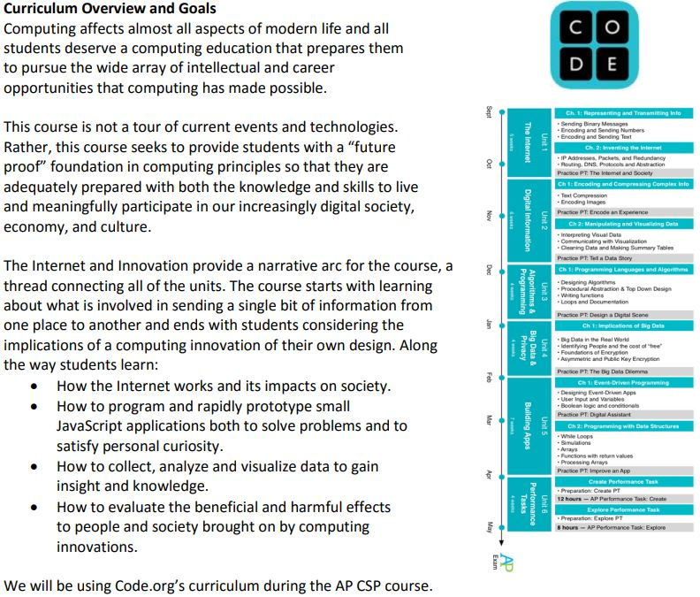

CLASS Grading Scale Assessment : •50% TESTS/Projects •15% Quizzes
•15% Homework •10% Daily/Participation •10%Notebook

Classroom Policies: DO NOT BRING FOOD OR DRINK BY THE COMPUTERS! You are expected to be in class on time and follow all of the school rules and established board policies including the dress code. Cell phones are to be turned OFF and locked in the cell phone jail.

Academic Honesty Policy: I recognize that working with other classmates can help in understanding the material and problem solving. However, there is a fine line between asking for help and having someone else do the work for you.
This is acceptable: • Discussing course material and assignments with other students • Helping a classmate identify a problem by looking at it yourself and giving verbal suggestions that help the student figure out the correct answer. • Turning to the web or elsewhere for instruction beyond the course’s own, for references, and for solutions to technical difficulties. • Working with a tutor to help you with the course, provided the tutor does not do your work for you.
This is not acceptable: • Copying work from another student or online sources and presenting as your own. • Giving another student your own work. • Looking at another individual’s work during an exam/quiz. • Using resources during a quiz beyond those explicitly allowed in the exam/quiz’s instructions. • Failing to cite materials (media, program code, text, etc.) that are not your own If a situation occurs in which you are not sure if your actions are reasonable, please check with your instructor first.

Supplies/requirements: Students are responsible for providing their own supplies (paper, pencil/pen, notebook), which are to be brought to class daily.
To meet the AP certification performance task requirements, students MUST be in attendance for the Tues-Thurs SMART lunch sessions.
https://mrexley.weebly.com/ap-computer-science-principles.html

