Chemistry March 16 and 17, 2020
Essential Question and Objective: What is stoichiometry and how do we use it for chemical conversions? Students will understand the nature and complexities of stoichiometry.
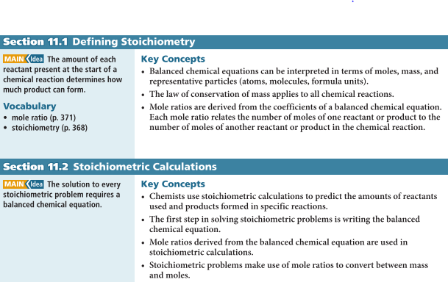
Activity | Link | Student responsibility
Video 1: | stoichiometry introduction | Take notes in your notebook
Video 2: | stoich. guided practice | For each of the 3 problems below in black, make a MODEL (balanced equation) for each and solve while using correct UNITS throughout.
Student Practice | on Schoology | On your OWN paper, write the balanced equation then show all work and UNITS to solve.
Lab (Wed) | Smores' Stoichiometry  I'm really bummed we can't do this as a class, but I will do it tomorrow to share the data with you. | Look over the lab and be able to explain what is going on and why.

#2------------------>

Chemistry March 18-20, 2020
I am sending you the worksheets for March 18-20 via Schoology. Please do them in your notebook. March 23-27 will be our spring break and we will resume online classes on March 30, 2020.

