A close up of a sign

Description generated with very high confidence

**Biology Weekly Planner** Week of 8/14/17

Bio.1.1 Understand the relationship between the structures and functions of cells and their organelles.

|  |  |  |  |  |
| --- | --- | --- | --- | --- |
| Day | **Objective** | **Essential question** | **Activities** | **Handouts/*Homework** |
| Mon | Students will understand what living things are made of. | What are the molecules that make up living things? | -notes: macromolecules  -Circle lab  <https://www.youtube.com/watch?v=YO244P1e9QM>  -convert grams to milligrams | Powerpoint- Macromolecules  *Graph analysis of data(3rd only)  *profile pic |
| Tues | Students will understand what living things are made of. | What are the molecules that make up living things? | -notes: macromolecules  -Circle lab- part 2 | Powerpoint- Macromolecules  *Graph analysis of data  *macromolecules self quiz |
| Wed | Students will understand technology and the engineering cycle. | What is technology and the engineering cycle? | -notes: Technology and the engineering cycle  -Tower lab part 1 | Powerpoint- technology, science, and engineering  *research for engineering cycle of the tower lab |
| Thurs | Students will understand technology and the engineering cycle. | What is technology and the engineering cycle? | -notes: Technology and the engineering cycle  -Tower lab part 1 | Powerpoint- technology, science, and engineering  *research for engineering cycle of the tower lab  *review for test |
| Fri | Students will test on all the information from unit 1 | Do we know all we need to know for the test? | -Test  -Biochemistry notes preview | Test  *Read handout on next unit. |

8/14/17 Welcome to….



Nesmith room 206 Ms. Evans

* Short video
* Notes: Macromolecules
* LAB- investigating circles
* Graphing review

8/15/17 Welcome to….



Nesmith room 206 Ms. Evans

* Short video
* Finish Notes: Macromolecules
* LAB- investigating circles
* Graphing review

<https://web.microsoftstream.com/video/9f3fcb4a-37bb-4bfe-804c-16901392446a>

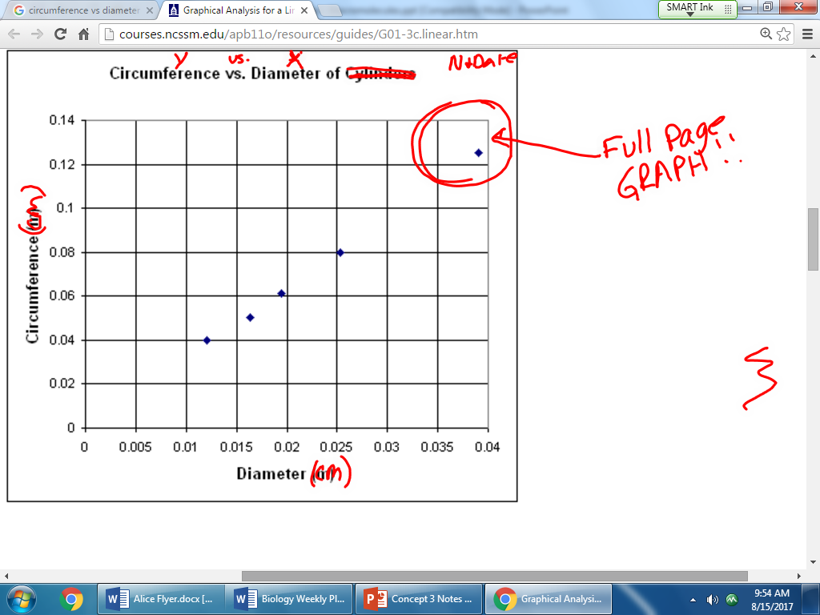

**ABSENT STUDENT**- Assigned 8/15…

Student info packet- fill out ALL and get signed/returned.

Syllabus (get initialed)

2013 concept inventory- WRITE out question and answers on sep. Sheet of paper.

Research how to do an outline… (steps, etc)

Outline chapter 1.1

Outline chapter 1.2

Outline chapter 1.3

Outline chapter 1.4

---- Give to me ASAP, then I can give you the other 2/3 of remaining work that you missed.

8/16/17 Welcome to….





Nesmith room 206 Ms. Evans

* How to avoid garbage duty-



* HW check
* Short quiz
* Graphing analysis and conclusion



* <https://www.youtube.com/watch?v=_4F8jeyLie4> <https://www.youtube.com/watch?v=fA9Z_l7R_SQ>
* Technology/engineering notes
* LAB- the tower project

Analysis: on back of graph is ok

* Draw line of best fit as you learned in math.
* SHOW WORK to find the equation of that straight line

Conclusion questions:

1. What UNITS did you put in for the circumference?
2. What UNITS did you put in for the diameter?
3. What were the UNITS for the slope and why?
4. Define diameter.
5. Rewrite YOUR equation to have radius in it rather than diameter.

8/17/17 THURSDAY Welcome to….





Nesmith room 206 Ms. Evans

--Hand in lab

-Check your area! turn in phones.

-Notes: Technology/Engineering/Science

*NEXT GENERATION SCIENCE STANDARDS

- Competition lab

Tower lab evaluation due FRIDAY!!!

TEST FRIDAY