Biology Weekly Planner Week of 11/13/17
Bio.3.5 Analyze how classification systems are developed upon speciation.
Bio.3.5.1 Explain the historical development and changing nature of classification systems.
Bio.3.5.2 Analyze the classification of organisms according to their evolutionary relationships (including dichotomous keys and phylogenetic trees).
Bio.3.5.1 Generalize the changing nature of classification based on new knowledge generated by research on evolutionary relationships and the history of classification system.
Bio.3.5.2 Classify organisms using a dichotomous key.
Bio 3.5.2 Compare organisms on a phylogenetic tree in terms of relatedness and time of appearance in geologic history.

Day | Objective | Essential question | Activities | Handouts/*Homework
Mon 10/9 | Students will explain how classification systems are developed upon speciation. | What is the classification system and how does it work? | -notes: classification  -MiniLAB: evolution | Https://www.youtube.com/watch?v=DVouQRAKxYo (watch AGAIN)  -Finish Lab
Tues  10/10 | Students will explain how classification systems are developed upon speciation. | What is the classification system and how does it work? | -more classification notes Cladograms and dichotomous keys | https://www.youtube.com/watch?v=GK_vRtHJZu4 biodiversity
Wed | Students will explain how classification systems are developed upon speciation. | What is the classification system and how does it work? | -short quiz | #47-70 due FRIDAY!!!  Addiction video we watched:  https://www.youtube.com/watch?v=ao8L-0nSYzg  NEWSPAPER INTERVIEW THURS  -See below for what we think they may ask students:
Thur | Students will explain how classification systems are developed upon speciation. | What is the classification system and how does it work? | Lab: fingerprinting | Finish #1-70
Fri  10/13 | Students will explain how classification systems are developed upon speciation. | What is the classification system and how does it work? | UNIT TEST- classification | Finish #1-85

WHY are cells small? 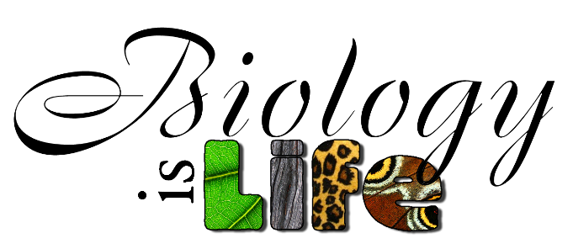
11/13/17 Monday
-Turn in cell phones and work you missed if absent
-Announcements: Late Work meetings today, plan for rest of the semester, EOC reviews, special sessions,
-# 48-62
-MiniLab!! Evolution of bird beaks
-Analysis/conclusion due tues!

11/14/17 Tuesday
-Turn off/in cell phones and LAB!!
-Notes: Cladograms and dichotomous keys
-Team review # 47- 62 -Question and answer with reason –Sketch?

11/15/17 Wednesday
-Turn in cell phones and work you missed if absent
Notes: Cladograms and dichotomous keys
-Team review # 47- 70 -Question and answer with reason –Sketch? THIS IS DUE Friday 11/17!
QUESTIONS TO BE READY TO HANDLE FOR TOMORROW:
- Why are official so concerned about the opioid addiction problem in Columbus county?
- What is a disease and why is addiction considered one?
- What solutions do you propose for the community?
- What can you, as a student, do to help the problem?

10/16/17 Thursday
-Turn in cell phones and work you missed if absent

10/17/17 Friday
-Turn in cell phones and work you missed if absent
-UNIT TEST
Finish #1-85 for Monday!!!

