**Biology Weekly Planner** Week of 11/27/17 WEEK 17!!!

Bio.2.1 Analyze the interdependence of living organisms within their environments. Bio.2.1.1 Analyze the flow of energy and cycling of matter (such as water, carbon, nitrogen and oxygen) through ecosystems relating the significance of each to maintaining the health and sustainability of an ecosystem. Bio.2.1.2 Analyze the survival and reproductive success of organisms in terms of behavioral, structural, and reproductive adaptations. Bio 2.1.3 Explain various ways organisms interact with each other (including predation, competition, parasitism, mutualism) and with their environments resulting in stability within ecosystems. Bio.2.1.4 Explain why ecosystems can be relatively stable over hundreds or thousands of years, even though populations may fluctuate (emphasizing availability of food, availability of shelter, number of predators and disease).

|  |  |  |  |  |
| --- | --- | --- | --- | --- |
| Day | **Objective** | **Essential question** | **Activities** | **Handouts/*Homework** |
| Mon 11/27 | Bio.2.1.2 Analyze the survival and reproductive success of organisms in terms of behavioral, structural, and reproductive adaptations. | How do animals adapt in terms of behavioral, structural, and reproductive measures? | -Animal behavior intro video  Notes: Ecology | <https://www.youtube.com/watch?v=EyyDq19Mi3A> |
| Tues  11/28 | Bio 2.1.3 Explain various ways organisms interact with each other (including predation, competition, parasitism, mutualism) and with their environments resulting in stability within ecosystems. | How do populations interact with each other? | Finish Ecology notes  Finish Dragons! | Climate change  -tell me all about it on WED! 😊 |
| Wed | Bio.2.1.4 Explain why ecosystems can be relatively stable over hundreds or thousands of years, even though populations may fluctuate (emphasizing availability of food, availability of shelter, number of predators and disease). | What graphs can we use to show population change? | POPULATION NOTES  -Lizard and Cane toad  LAB! Population of bacteria | * DUE THURS #1-16 full sentences! |
| Thur | Bio.2.1 Analyze the interdependence of living organisms within their environments. | How delicate are species on our planet? | -5 human impacts on the environment  -Finish population lab  -review for test | <https://www.youtube.com/watch?v=5eTCZ9L834s> (5 human impacts)  SCIshow version: <https://www.youtube.com/watch?v=OZIXPQt4DoI>  REVIEW 2.1 and 2.2  -Put a STAR by the 30 you have no clue or are not sure  -get answers from website  -WRITE OUT 15 of them! |
| Fri  12/1 | Bio.2.1 Analyze the interdependence of living organisms within their environments. | How are ALL living things “webbed“ together? | TEST- ecology | TEST- ecology  POPULATION LAB and graph DUE Mon 12/4! |

-expect a quiz on HOW to do this lab!!! (Meaning, I will know if you just copied answers).

WHY are cells small? [](https://www.google.com/url?sa=i&rct=j&q=&esrc=s&source=images&cd=&cad=rja&uact=8&ved=0ahUKEwieqczivLrXAhXm5YMKHUmoAL4QjRwIBw&url=https://sites.google.com/site/dehartofbiology/&psig=AOvVaw3Ijb4oXQ93-FGd3QW_Dn1U&ust=1510625420581485)

11/27/17 Monday -Dance room announcements

-Turn in transcription/translation- turn off and turn in phone, progress reports!

-Notes: Ecology

-Animal behavior video

[](https://www.google.com/url?sa=i&rct=j&q=&esrc=s&source=images&cd=&cad=rja&uact=8&ved=0ahUKEwieqczivLrXAhXm5YMKHUmoAL4QjRwIBw&url=https://sites.google.com/site/dehartofbiology/&psig=AOvVaw3Ijb4oXQ93-FGd3QW_Dn1U&ust=1510625420581485)



11/28/17 TUESDAY

* Hand in Cell phones and any missed work
* Warm up= What is an invasive species?
* [](https://www.google.com/url?sa=i&rct=j&q=&esrc=s&source=images&cd=&cad=rja&uact=8&ved=0ahUKEwieqczivLrXAhXm5YMKHUmoAL4QjRwIBw&url=https://sites.google.com/site/dehartofbiology/&psig=AOvVaw3Ijb4oXQ93-FGd3QW_Dn1U&ust=1510625420581485)
* 11/29/17 WEDNESDAY
* Hand in cell phone and any info on climate change you obtained last night WITH YOUR NAME ON IT!
* Warm up= What is an invasive species?
* Lizard video
* Population notes
* Virtual lab: populations!
* DUE THURS #1-16 full sentences!

[](https://www.google.com/url?sa=i&rct=j&q=&esrc=s&source=images&cd=&cad=rja&uact=8&ved=0ahUKEwieqczivLrXAhXm5YMKHUmoAL4QjRwIBw&url=https://sites.google.com/site/dehartofbiology/&psig=AOvVaw3Ijb4oXQ93-FGd3QW_Dn1U&ust=1510625420581485)

11/30/17 THURSDAY

-Hand in cell phone and #1-16

-WARM UP= Secret student survey!!!

-5 human impacts (10 min)

-Finish populations lab! Turn in.

-May work on test review when finished.

[](https://www.google.com/url?sa=i&rct=j&q=&esrc=s&source=images&cd=&cad=rja&uact=8&ved=0ahUKEwieqczivLrXAhXm5YMKHUmoAL4QjRwIBw&url=https://sites.google.com/site/dehartofbiology/&psig=AOvVaw3Ijb4oXQ93-FGd3QW_Dn1U&ust=1510625420581485)

12/1/17 Friday

-Hand in cell phone and #1-15 (coincide with #’s from packet).

-WARM UP= TEST FORMATION

-Finish Population lab OR Dragon’s world 😊

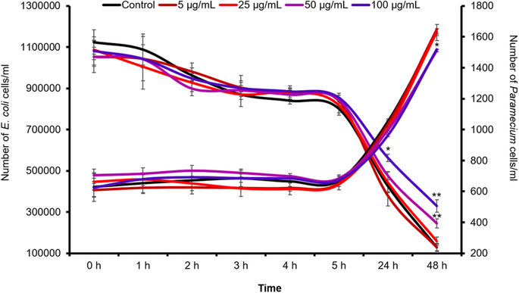

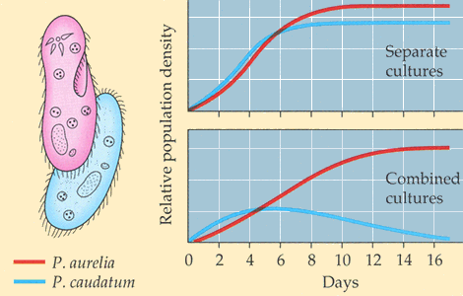

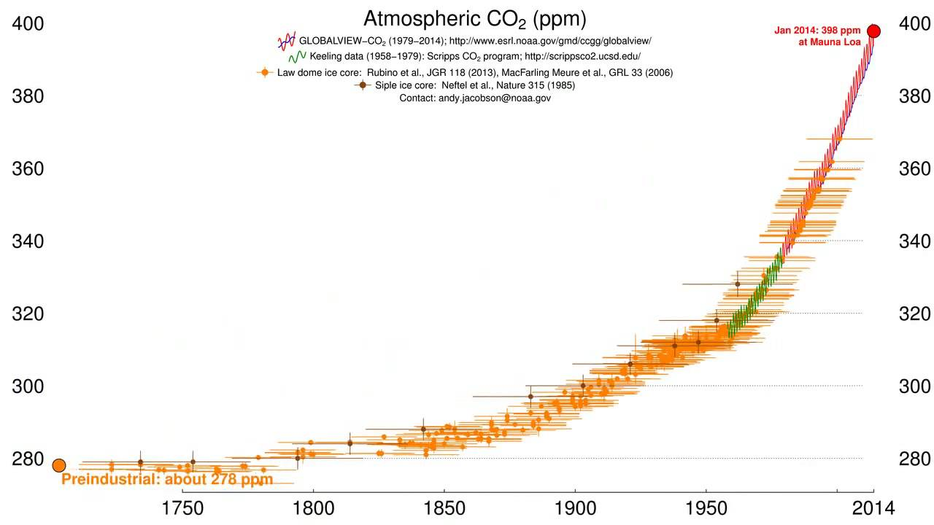0

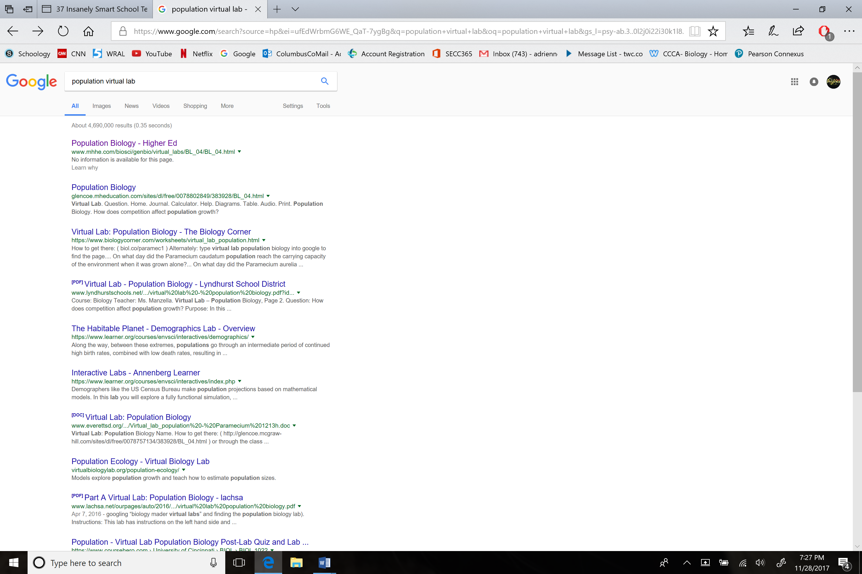

RUBRIC  - Transcription and translation

-DNA can be divided into segments called genes

-Proteins  (the final product) are made of amino acids

-RNA polymerase= enzyme to split the double helix

-Transcription= DNA code is copied to mRNA

-EXITS nucleus

-Translation= use mRNA to build proteins

-tRNA picks up the proper amino acid and delivers to ribosome

-START/STOP codons

-Amino acids are floating free in the cytoplasm to be picked up

-The finished protein is exported by the GOGLI

Bio.2.1.1 • Deconstruct the carbon cycle as it relates to photosynthesis, cellular respiration, decomposition and climate change. • Summarize the nitrogen cycle (including the role of nitrogen fixing bacteria) and its importance to synthesis of proteins and DNA. • Identify factors that influence climate such as: ▪ greenhouse effect (relate to carbon cycle and human impact on atmospheric CO2) ▪ natural environmental processes (relate to volcanic eruption and other geological processes) • Explain the recycling of matter within ecosystems and the tendency toward a more disorganized state. • Analyze energy pyramids for direction and efficiency of energy transfer. ▪ Living systems require a continuous input of energy to maintain organization. The input of radiant energy which is converted to chemical energy allows organisms to carry out life processes. ▪ Within ecosystems energy flows from the radiant energy of the sun through producers and consumers as chemical energy that is ultimately transformed into heat energy. Continual refueling of radiant energy is required by ecosystems.

6

Biology ● Unpacked Content Current as of August 17, 2012

Bio 2.1.2 Note: The focus has moved away from an exhaustive study of classes of living things through comparative anatomy to emphasizing connections between organisms’ adaptations (behavioral, structural, and reproductive) and survival in their particular environment. ▪ Analyze how various organisms accomplish life functions through adaptations within particular environments (example: water or land) to ensure survival and reproductive success. ▪ Relate prior understanding of survival and reproductive success to evidence of variations observed in species in three areas: ▪ behavioral adaptations – suckling, taxes/taxis, migration, estivation, hibernation, habituation, imprinting, classical conditional, and trial and error learning ▪ structural adaptations–nutrition, respiration, transport and excretion mechanisms, camouflage, movement ▪ reproductive adaptations– sexual versus asexual, eggs, seeds, spores, placental, types of fertilization.

Bio 2.1.3 • Identify and describe symbiotic relationships such as mutualism and parasitism. (middle school review) • Exemplify various forms of communication and territorial defense including communication within social structure using pheromones (Examples: bees, ants, termites), courtship dances, territorial defense (Example: fighting fish). • Explain patterns in predator /prey and competition relationships and how these patterns help maintain stability within an ecosystem with a focus on population dynamics. Note: There is much debate about whether commensalistic relationships are just early mutualism. We may just not understand the benefits to each organism.

Bio.2.1.4 • Generalizing that although some populations have the capacity for exponential growth, there are limited resources that create specific carrying capacities and population sizes are in a dynamic equilibrium with these factors. (e.g. food availability, climate, water, territory). • Interpret various types of population graphs – human population growth graphs indicating historical and potential changes, factors influencing birth rates and death rates, and effects of population size, density and resource use on the environment. • Explain how disease can disrupt ecosystem balance. (Examples: AIDS, influenza, tuberculosis, Dutch Elm Disease, Pfiesteria, etc.)

Bio.2.2 Understand the impact of human activities on the environment (one generation affects the next). Bio.2.2.1 Infer how human activities (including population growth, pollution, global warming, burning of fossil fuels, habitat destruction and introduction of nonnative species) may impact the environment. Bio.2.2.2 Explain how the use, protection and conservation of natural resources by humans impact the environment from one generation to the next.

Bio.2.2.1 • Summarize how humans modify ecosystems through population growth, technology, consumption of resources and production of waste. • Interpret data regarding the historical and predicted impact on ecosystems and global climate. • Explain factors that impact North Carolina ecosystems. (Examples: acid rain effects in mountains, beach erosion, urban development in the Piedmont leading to habitat destruction and water runoff, waste lagoons on hog farms, Kudzu as an invasive plant, etc.).

Bio.2.2.2 • Explain the impact of humans on natural resources (e.g. resource depletion, deforestation, pesticide use and bioaccumulation ) • Exemplify conservation methods and stewardship.