**Biology Weekly Planner** Week of 8/28/17

Bio.1.1 Understand the relationship between the structures and functions of cells and their organelles.

|  |  |  |  |  |
| --- | --- | --- | --- | --- |
| Day | **Objective** | **Essential question** | **Activities** | **Handouts/*Homework** |
| Mon 8/21 | ECLIPSE! | ECLIPSE! | ECLIPSE! | ECLIPSE! |
| Tues  8/22 | Students will understand cells: structure, and function. | What is cell theory? | Pre-Lab- Prokaryotic cells!  Virtual lab- Biomacromolecules | -Lab plan: prokaryotic cells  -start virtual lab: Biomacromolecules |
| Wed | Students will understand cells: structure, and function. | What are the parts of cells and what do they do? | -Notes: Cells  Finish lab- Prokaryotic cells | Notes: Cell structure and function.  -Lab: prokaryotic cells |
| Thur | Students will understand cells: structure, and function. | What are the parts of cells and what do they do? | -Finish notes-Cell theory  -Day 1 peek at results  -Virtual lab | -Lab: prokaryotic cells  -Virtual lab- BioMacromolecules |
| Fri  8/25 | Students will understand cells: structure, and function. | What are the parts of cells and what do they do? | -Quest  -virtual lab  -Day 2 peek at results | Double down quest- 8/7-8/25  BioMacromolecules virtual lab |

8/22/17 Tuesday Welcome to….

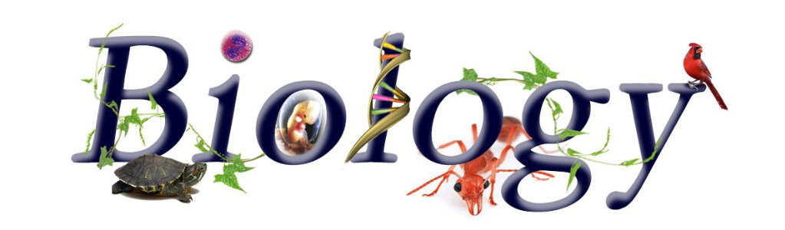



Nesmith room 206 Ms. Evans

-Back to classroom teams configuration!

-Turn in coloring page (Hamburger fold with your name on it)- TURN OFF cell phone to hand in

-Lab planning: simple protists

-Activity: Biomacromolecules!!!

8/23/17 Wednesday Welcome to….





Nesmith room 206 Ms. Evans

Notes: Cell theory

-LAB!! Bacteria…. (YICK… WASH your hands THREE times after)

-Begin lab write up

8/24/17 Thursday Welcome to….





Nesmith room 206 Ms. Evans

-Phones- Area check- Uniforms- sign in/out –Café - parking

-Finish notes: Cell theory <https://www.youtube.com/watch?v=4OpBylwH9DU>

<https://www.youtube.com/watch?v=zuNMVzTeCtw>

-Finish virtual lab *REMIND ME TO GIVE all papers back at end of class please!!

8/25/17 Friday Welcome to….





Nesmith room 206 Ms. Evans

-QUEST 8/7-8/25

-Complete virtual lab! & Lab safety (DUE Monday 8/28)

-Crash course Lab safety <https://www.youtube.com/watch?v=VRWRmIEHr3A>

VERSION A&B- #24 answer choices: a. Nitrogenous base b.Polypeptides c. Phospholipids d.Nucleic Acids