Weekly Planner: All science week of 9.4.18 



**Objectives for the week**: Bio.1.1.1 Summarize the structure and function of organelles in eukaryotic cells (including the nucleus, plasma membrane, cell wall, mitochondria, vacuoles, chloroplasts, and ribosomes) and ways that these organelles interact with each other to perform the function of the cell. Bio.1.1.2 Compare prokaryotic and eukaryotic cells in terms of their general structures (plasma membrane and genetic material) and degree of complexity. Bio.1.1.3 Explain how instructions in DNA lead to cell differentiation and result in cells specialized to perform specific functions in multicellular organisms.

Chm.1.2.2 Infer the type of bond and chemical formula formed between atoms. Chm.2.2.4 Analyze the stoichiometric relationships inherent in a chemical reaction. Chm.2.2.5 Analyze quantitatively the composition of a substance (empirical formula, molecular formula, percent composition, and hydrates).

S.L.C’s are next week!!! 9/11 and 9/13

|  |  |  |
| --- | --- | --- |
| Day | Honors Biology | Honors Chemistry |
| Mon 9.3 | Holiday | Holiday |
| Tues  9.4  STUDY BUDDIES! | Finish presentations!  Notes- Cells (finish)  Group work  HW= finish osmosis and #1-28 in packet! | Make up work for absentees  Go over HW  Group work #11-17  Show all work and units  Finish for HW  Block 3= do test corrections! |
| Wed 9.5  STUDY BUDDIES! | Last presentation(s)!  New teams!  Warm up and hand in test corrections.  Finish ALL of note packet  ENZYME LAB set up! | Go over HW  Group work  #18-23  FLIPGRID INTRO!! |
| Thurs  9.6 | Catalyst LAB DAY!!! | Practice test (SEE BELOW!) |
| Friday 9.7 | TEST/quiz  HW= read ch 4 (Cell energy) | TEST/quiz  HW= get paper towel tubes |

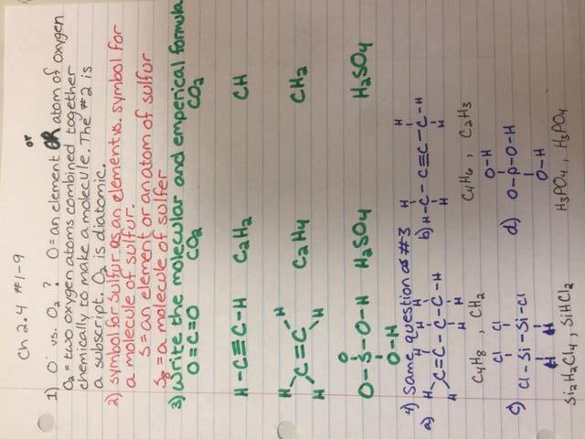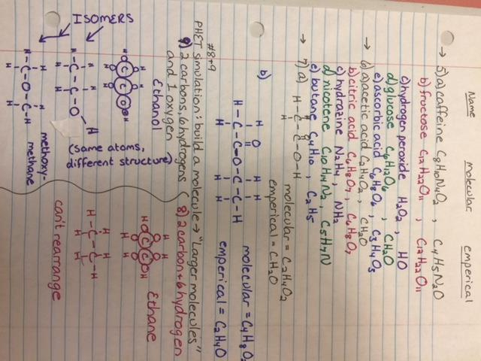

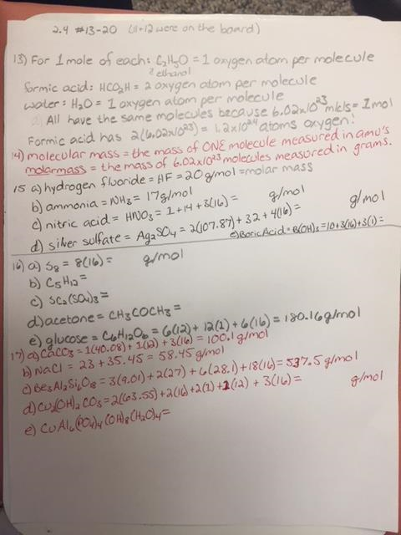

Tuesday 9.4.18- https://evansccca.weebly.com/

|  |  |
| --- | --- |
| Turn OFF cell phones and put in basket with any make up work :)  <https://www.youtube.com/watch?v=7iRRDcYKL-M>  (#17=B)  1) make a venn diagram for plant vs. animal cells | Turn OFF cell phones and put in basket with any make up work :)  1) Name the diatomic elements and give their chemical symbol. |

**NEW BIOLOGY TEAMS!!!!!\*\*\*\*\*\***

|  |  |  |  |  |
| --- | --- | --- | --- | --- |
| **Table 1** | **Natasha V.** | **Jessica B.** | **Chris L.** | **Ariana L.** |
| **Table 2** | **John Lane** | **Marcus S.** | **Sarah D.** | **Alexis P.** |
| **Table 3** | **Katelynn S.** | **Faith M.** | **Jacob H.** | **Shade P.** |
| **Table 4** | **Carah A.** | **Lydia P.** | **Aaron C.** | **Star L.** |
| **Table 5** | **Hope F.** | **Laney S.** | **Adam Z.** | **Noell S.** |
| **Table 6** | **Kamy S.** | **Katie B.** | **Bella C.** | **Samantha L.** |

Describe Hobbies? Life experiences? Morning routine? Describe your favorite movie?

Describe pets? Describe siblings?

Wednesday 9.5.18- https://evansccca.weebly.com/

|  |  |
| --- | --- |
| Turn OFF cell phones and put in basket with any corrections/make up work :)   1. Explain endosymbiosis in terms of mitochondria and chloroplasts.   <https://www.youtube.com/watch?v=9i7kAt97XYU> | Turn OFF cell phones and put in basket with any make up work :)   1. Find the molar mass of Ca3(PO4)2 =310g/mole   Al2(SO4)3= |

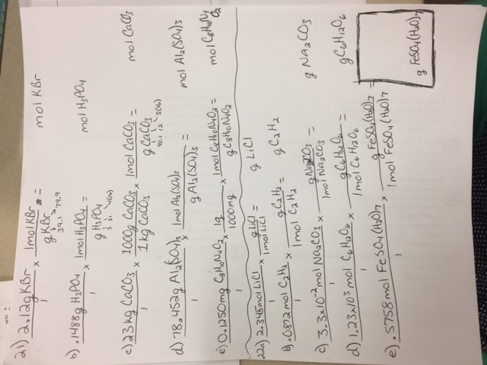

**NEW BLOCK 2 teams!**

|  |  |  |  |  |
| --- | --- | --- | --- | --- |
| **Table 1** | **Erin O.** | **Hannah N.** | **Julenna C.** | **Jalen O.** |
| **Table 2** |  |  |  |  |
| **Table 3** | **Tobey M.** | **Riley D.** | **Rossy B.** | **Garrison S.** |
| **Table 4** |  |  |  |  |
| **Table 5** | **Anna P.** | **Ryan T.** | **Nathan R.** | **Noah T.** |
| **Table 6** | **Robert L.** | **Gracie F.** | **Alexis L.** |  |

**NEW BLOCK 3 teams!**

|  |  |  |  |  |
| --- | --- | --- | --- | --- |
| **Table 1** | **Erin O.** | **Lexie B.** | **Tasia G.** | **Hannah T.** |
| **Table 2** | **Chandler W.** | **Khari S.** |  |  |
| **Table 3** | **Chris W.** | **Aliyah C.** | **Maraysia R.** | **David H.** |
| **Table 4** |  |  |  |  |
| **Table 5** | **Hannah C.** | **Autumn D.** | **Kayley B.** | **Adam J.** |
| **Table 6** | **Mae G.** | **Austin M.** | **Destiny B.** | **Jasmine M.** |

Thursday 9.6.18- https://evansccca.weebly.com/

|  |  |
| --- | --- |
| Turn OFF cell phones and put in basket with any make up work :)   1. Make a Venn diagram for a virus vs. a bacteria   <https://www.youtube.com/watch?v=wUgEhfo_qxU> | Turn OFF cell phones and put in basket with any make up work :)  **1.What is the molar mass of CuSO4 • 5H2O ?**  [**https://www.youtube.com/watch?v=2IWoSR2jYgY**](https://www.youtube.com/watch?v=2IWoSR2jYgY) |

Friday 9.7.18- https://evansccca.weebly.com/

|  |  |
| --- | --- |
| Turn OFF cell phones and put in basket with any make up work :)  1) respiration equation!! | Turn OFF cell phones and put in basket with any make up work :)  1) SHOW WORK to convert 3.7 x 10-3 moles of Ba(OH)2 to grams. |

What mass of Ba(NO3)2 is equal to 8.4 x 10 -2 moles of Ba(NO3)2 ?

DUE MONDAY!!! READ and take notes on the last half of Ch 2.4

GET: Paper towel rolls!! Wrapping paper rolls!! Tubes greater than 4.5 cm diameter!

Cool videos:

**paperslides!** https://www.youtube.com/watch?v=E5RXynA_D3I

https://www.youtube.com/watch?v=Qf6L1PTG3p4

**endosymbiosis!** https://www.youtube.com/watch?v=9i7kAt97XYU

**The puppy nose!** https://www.youtube.com/watch?v=p7fXa2Occ_U

**Virus**: https://www.youtube.com/watch?v=wUgEhfo_qxU

CHEM QUEST!!! 9/7! NAME___________________________ BLOCK________________

Polyatomic ions:

|  |  |  |  |
| --- | --- | --- | --- |
| Ion and charge | name | Ion and charge | name |
| NH4+ | ammonium | OH- | hydroxide |
| CO32- | carbonate | NO3-‑ | nitrate |
| SO42- | sulfate | NO2- | nitrite |
| PO43-‑ | phosphate | HCO3- | Hydrogen carbonate |
| MnO4- | permangenate | HSO4- | Hydrogen sulfate |

Find the molar mass of the Following:

1) CO2

2) O3

3) Li2CO3

4) NaCl

5) Cu(NO3)2 **·** 3 H2O

SOLVE:

1. How many moles are equal to 920 g of Na2SO4?

2) What mass of water is equal to 2 moles?

3) How many moles of CO2 is equal to 12 g of CO2?

4) Convert 1.2 x 102 grams of AgCl to moles.

5) What mass of CaCO3 is equal to 0.50 moles of CaCO3?

6) Convert 2.2 x 10 -2 ­moles of NaNO3 to grams.

7) **How many grams are equal to 0.01 moles of CuSO4 · 5 H2O?**

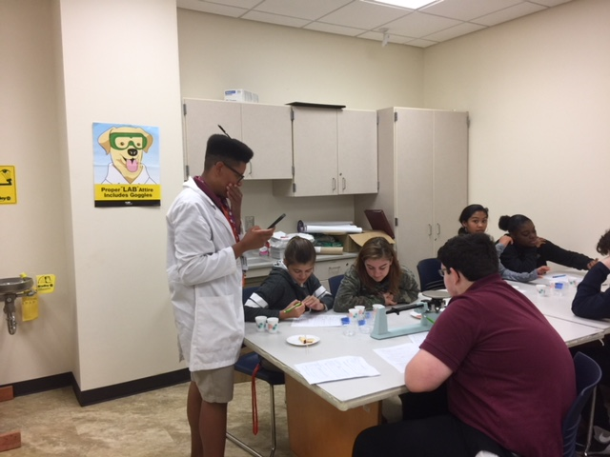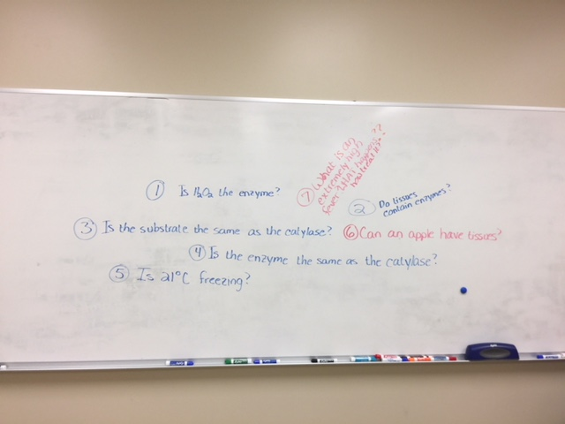

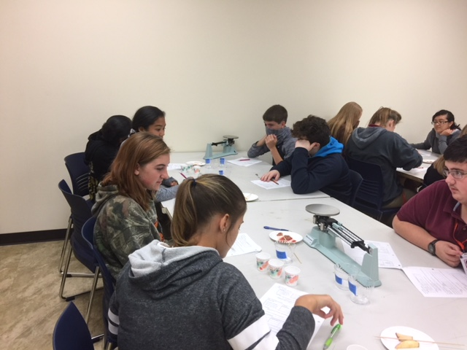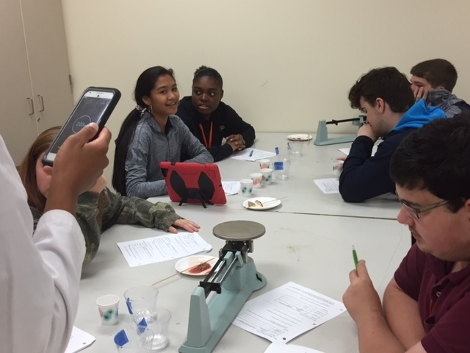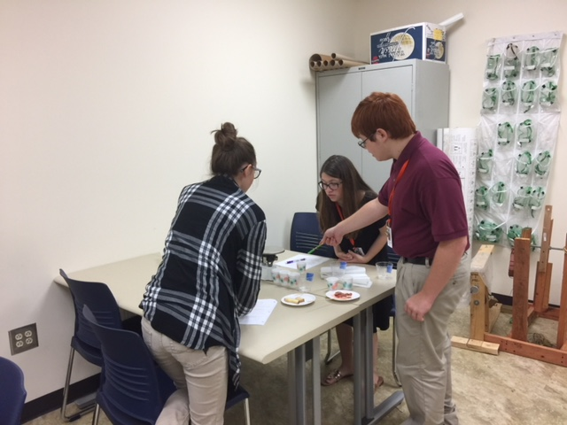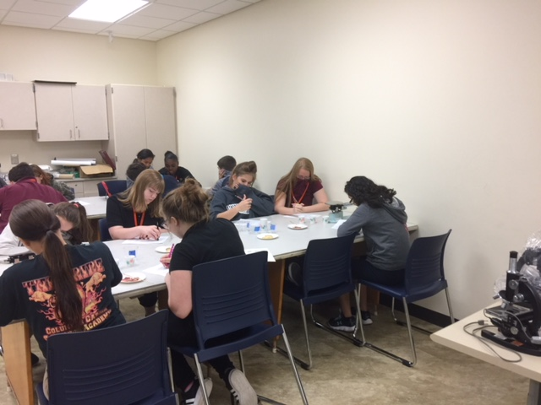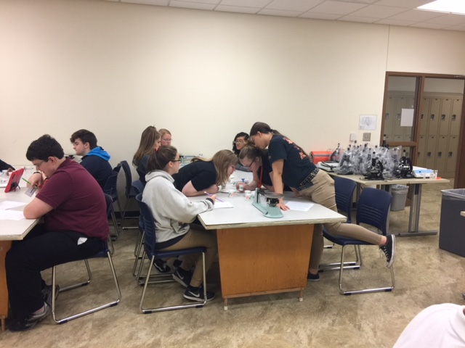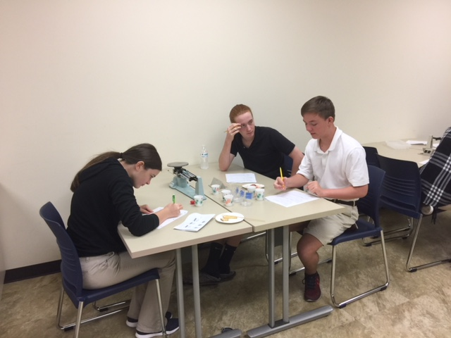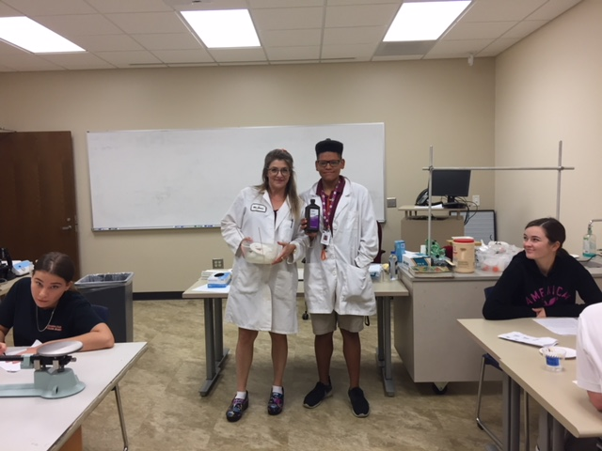

<http://assessment.aaas.org/test/zzaulw>      =BIO_50   pw=cccascience

<http://assessment.aaas.org/test/zzaulx>    =CHEM50