Weekly Planner: All science week of 9.10.18 



**Objectives for the week**: **Bio.4.2 Analyze the relationships between biochemical processes and energy use in the cell.** Bio.4.2.1 Analyze photosynthesis and cellular respiration in terms of how energy is stored, released, and transferred within and between these systems. Bio 4.2.2 Explain ways that organisms use released energy for maintaining homeostasis (active transport). **Bio.1.1 Understand the relationship between the structures and functions of cells and their organelles.**

Chm.2.2.4 Analyze the stoichiometric relationships inherent in a chemical reaction. Chm.2.2.5 Analyze quantitatively the composition of a substance (empirical formula, molecular formula, percent composition, and hydrates).

S.L.C’s are postopned

|  |  |  |
| --- | --- | --- |
| Day | Biology | Chemistry |
| Mon 9.10 | Notes- Ch 4  Virtual lab: cell respiration  Read Ch 7- and do pg 129 # 3-23 full sentences!!  HW= look over notes only. | Make up test/quiz  **LAB!!!! Moles :)**  #23-33 |
| Tues  9.11  STUDY BUDDIES! | Read Ch 7- and do pg 129 # 3-23 full sentences!! | Ch 4.2  #24-33 show all work  -number, units, and units of WHAT |
| Wed 9.12  STUDY BUDDIES! | **BE SAFE!! I am thinking of all of you!!**  **\*ONLY if you have time on your hands!! I have posted pictures of Tuesday’s classwork below, that should at least get you STARTED on it so you can finish it 😊** | |
| Thurs  9.13 |
| Friday 9.14 |

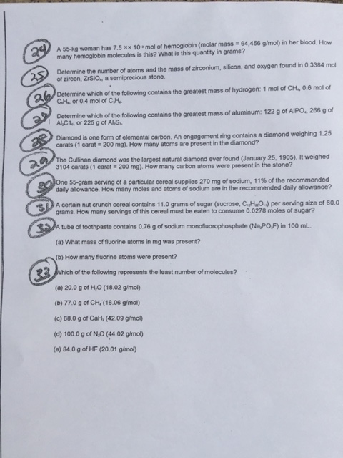

**DO NOT Copy!! Please just refer to this as your guide in case you get stuck or want to check your thought process.**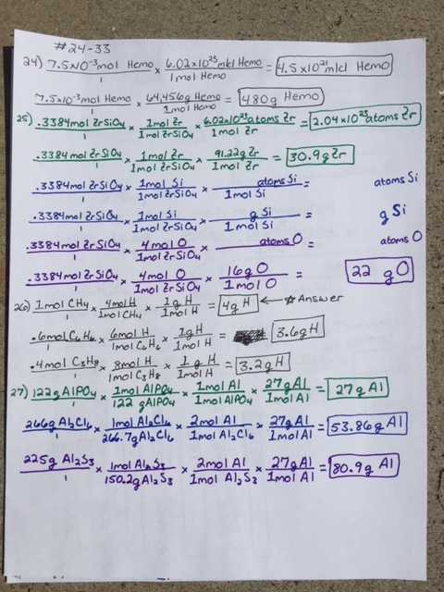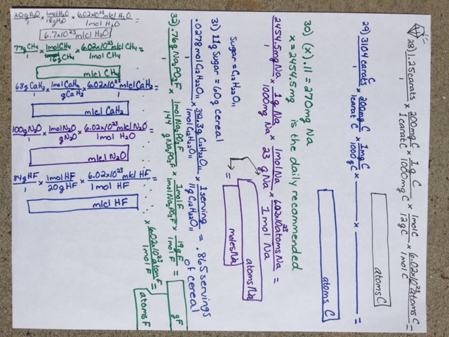

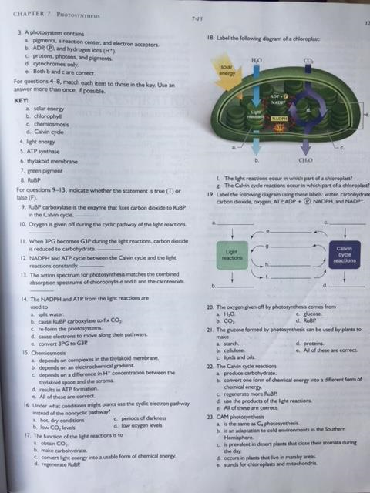

BIO HELP #3-23 Photosynthesis- ch 7

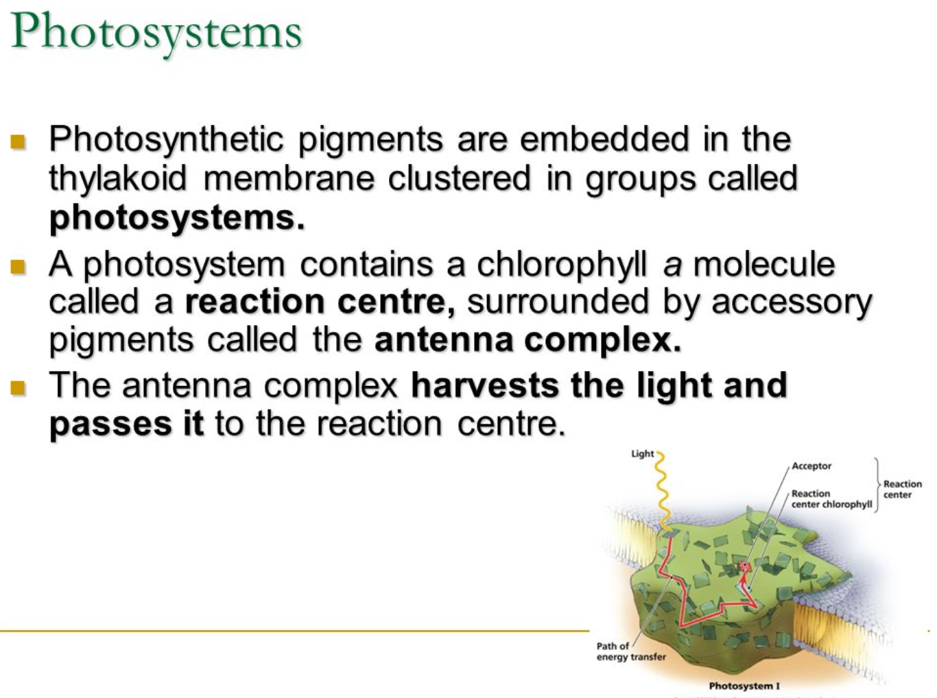 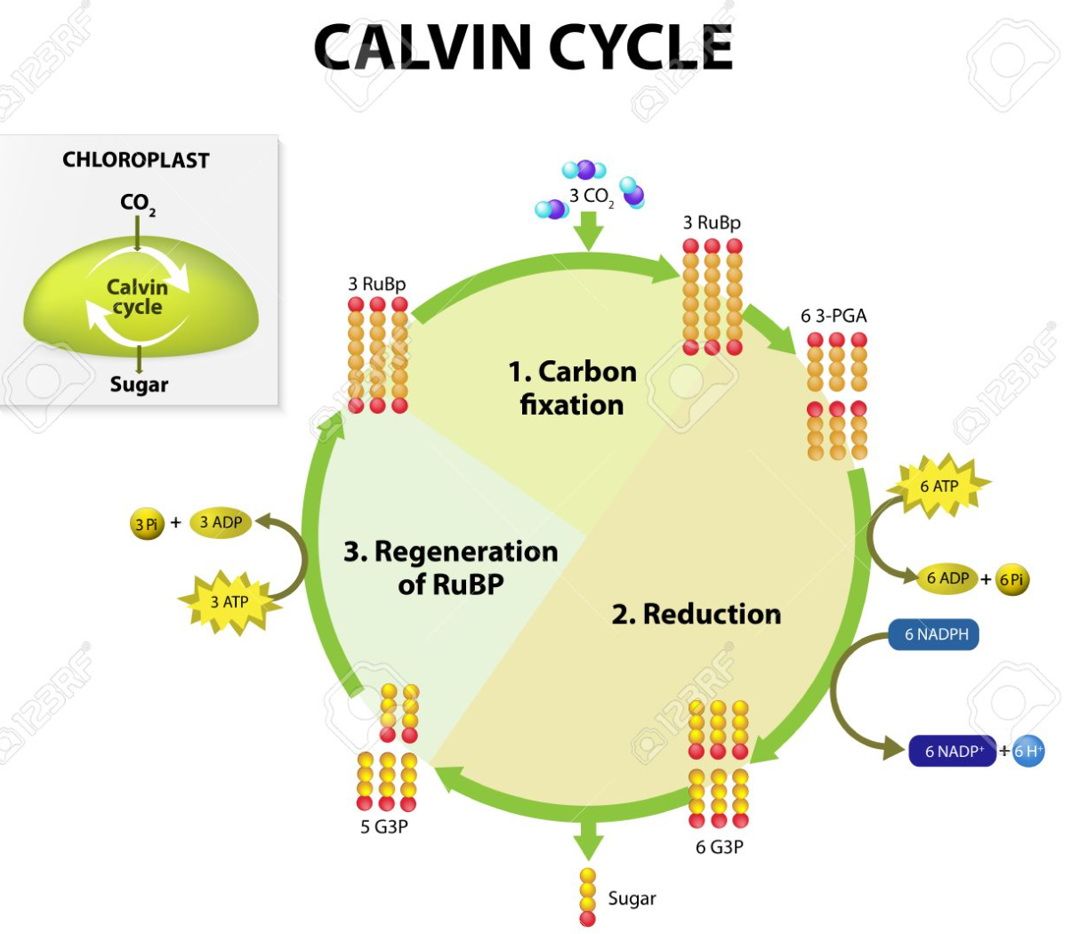

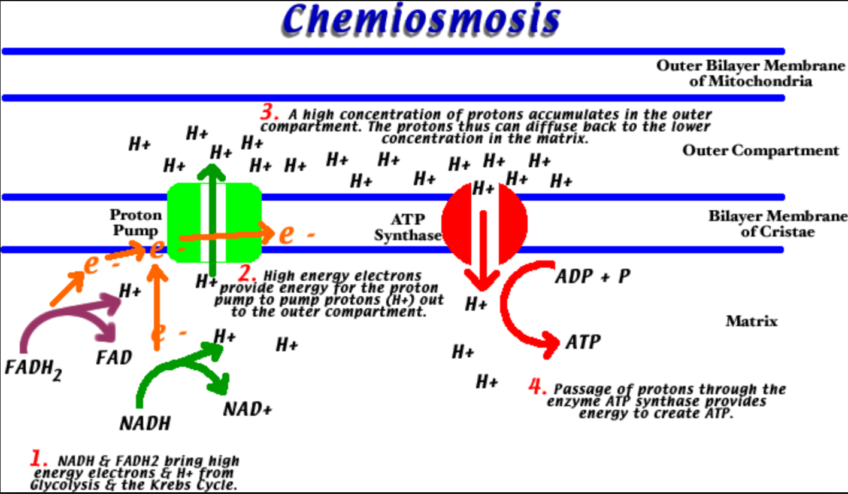

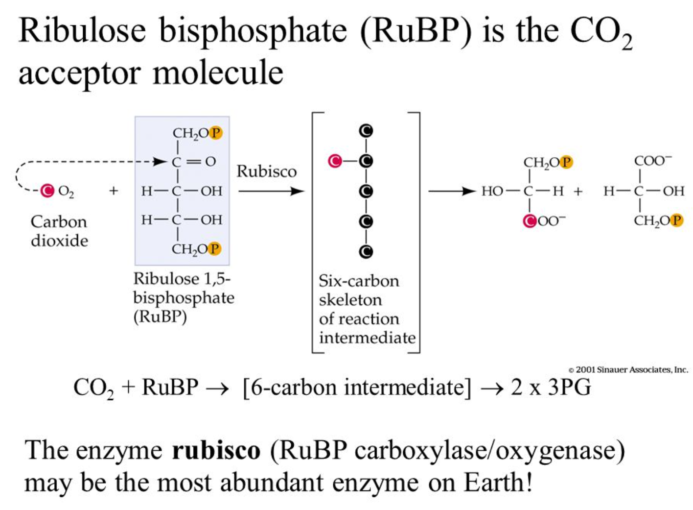 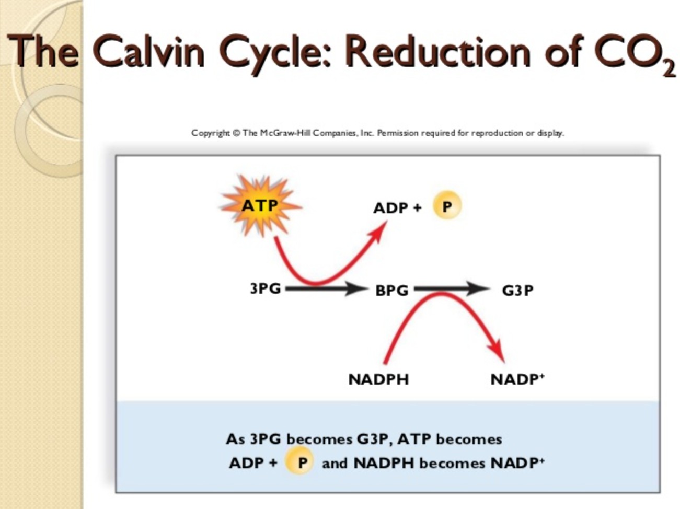

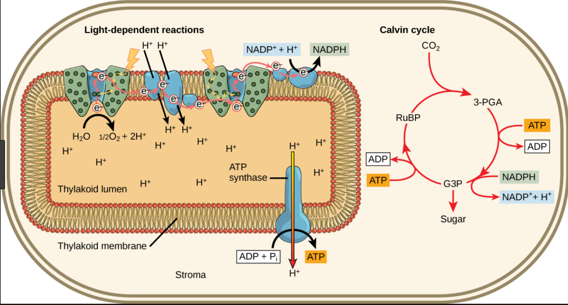

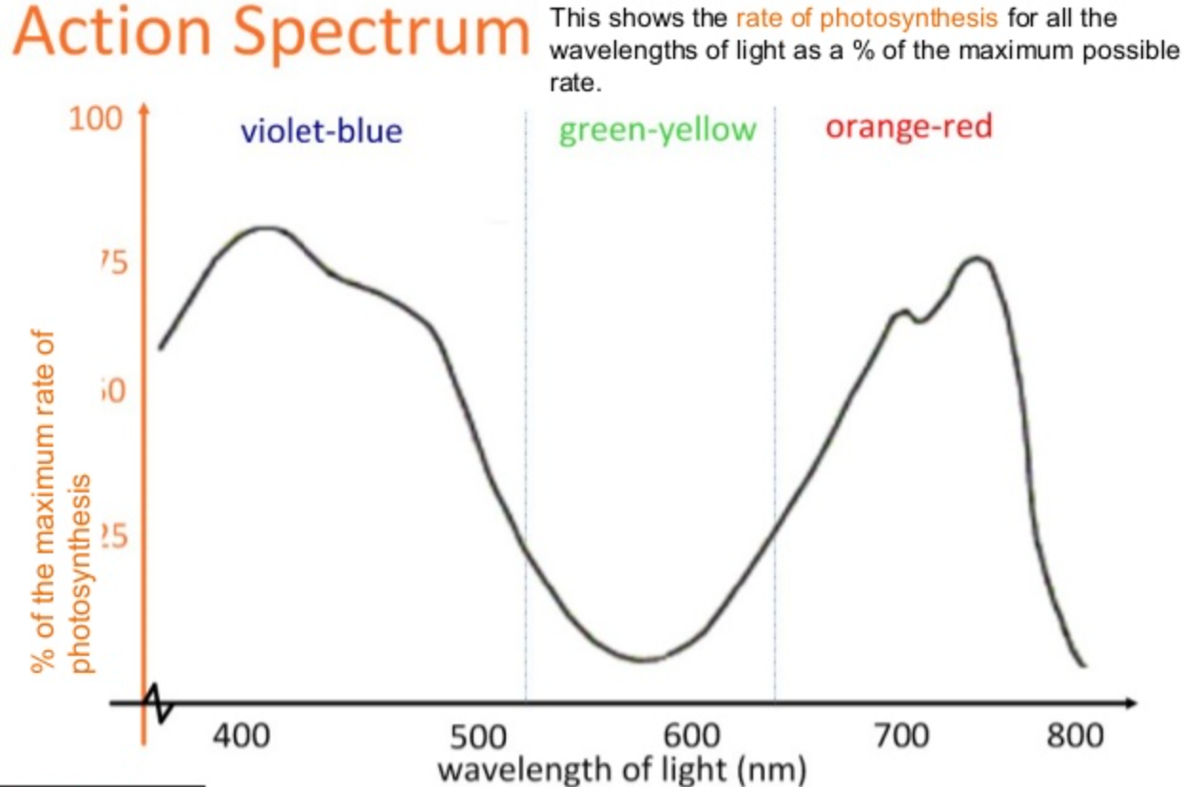

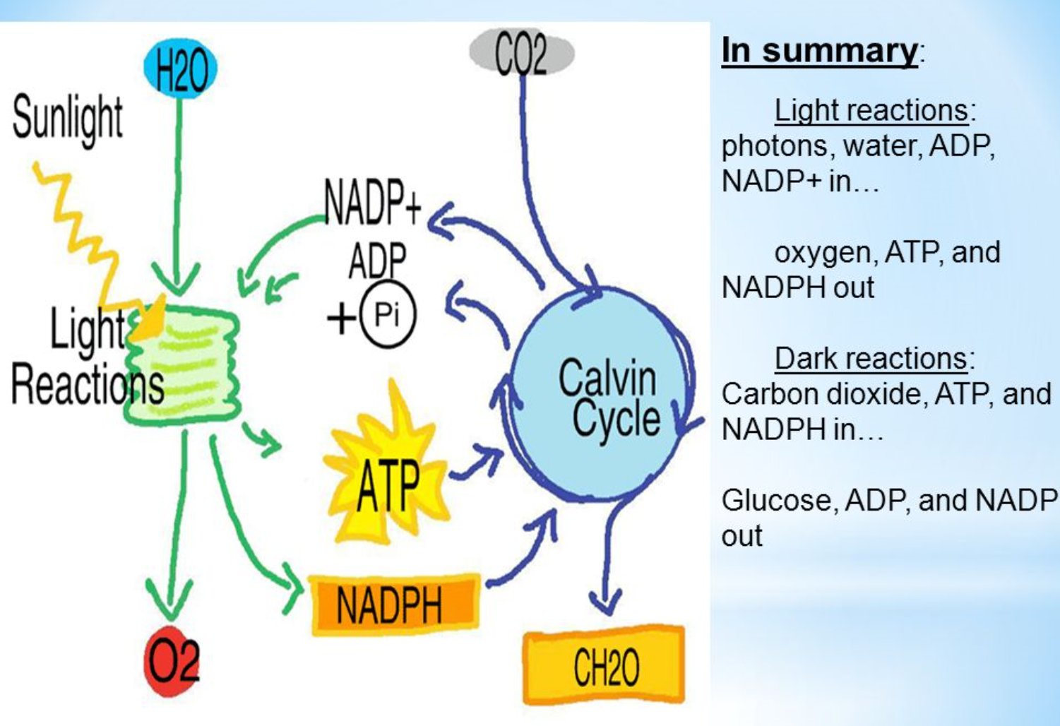

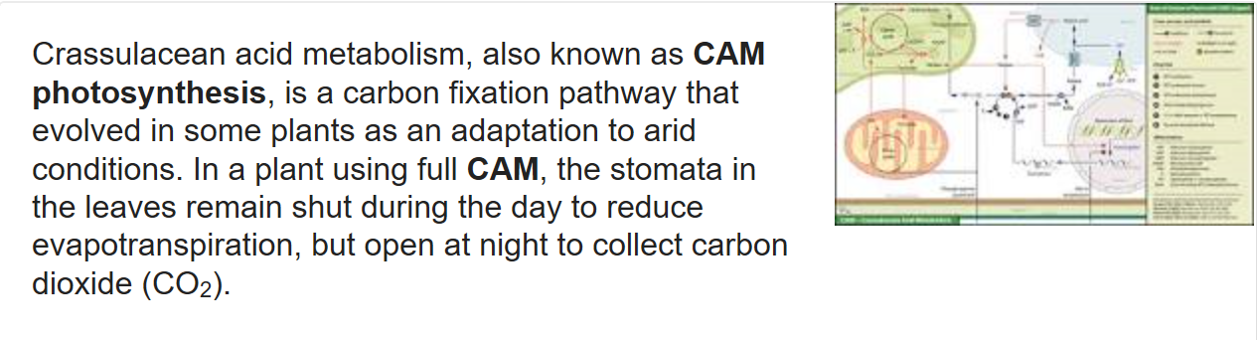

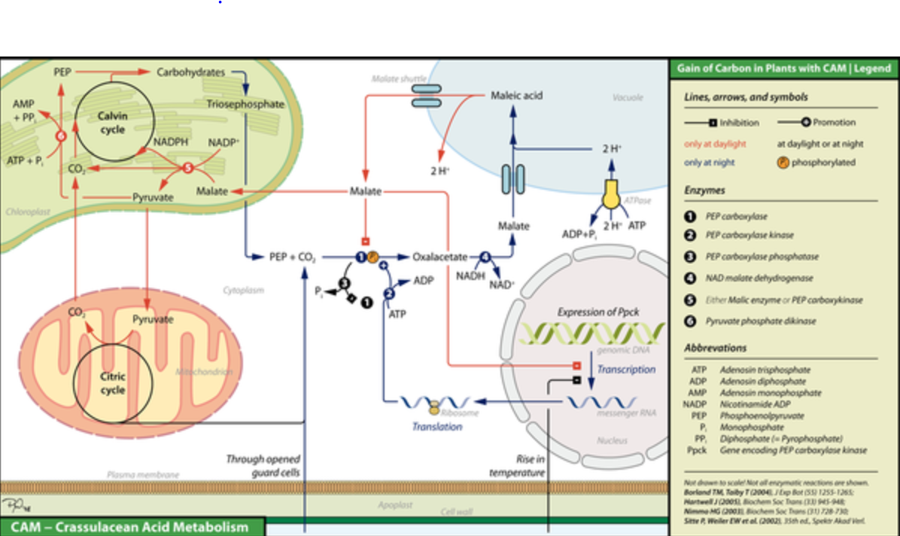

Monday 9.10.18- https://evansccca.weebly.com/

|  |  |
| --- | --- |
| Turn OFF cell phones and put in basket with any make up work :)  What do we, as humans, have to keep in homeostasis for our body?  Describe 7 ways the human body maintains homeostasis.  <https://www.youtube.com/watch?v=Iz0Q9nTZCw4> | Turn OFF cell phones and put in basket with any make up work :)   1. If you have 36 g of water, how many moles of water do you have? How many molecules? |

LAB QUESTIONS

1. Why blanked out?
2. Explain why gases have a specific volume for the same temperature and same number of molecules.
3. Describe the process (in detail) of how you produced CO2.
4. EXPLAIN how you knew how much CO2was made.

Cool videos:

**paperslides!** https://www.youtube.com/watch?v=E5RXynA_D3I

https://www.youtube.com/watch?v=Qf6L1PTG3p4

**endosymbiosis!** https://www.youtube.com/watch?v=9i7kAt97XYU

**The puppy nose!** https://www.youtube.com/watch?v=p7fXa2Occ_U

**Virus**: https://www.youtube.com/watch?v=wUgEhfo_qxU

<http://assessment.aaas.org/test/zzaulw>      =BIO_50   pw=cccascience

<http://assessment.aaas.org/test/zzaulx>    =CHEM50