Weekly Planner: All science week of 8.6.18



**Objectives for the week**: Scientific method, measurement, scientific notation, metric measurement, and conversion. NGSS 1.1 NCSCOS 0.5

|  |  |  |
| --- | --- | --- |
| Day | Honors Chemistry | Honors Biology |
| Mon 8.6 | Science intro, scientific notation, % error    -Intro ppt I  -Team practice (pg 1-4 notes)  Homework: get stuff signed, finish team practice, memorize polyatomics and elements 1-54. | Scientific method,  Measurement and conversion, safety    -Intro ppt I  -Unit 1.1 team work  Homework: get stuff signed, finish 1.1 pgs 1-2 |
| Tues  8.7 | Scientific method,  Measurement and conversion  - Go over HW  -significant figures pages 5-6..concepts only..  -team practice (worksheet pg 9-12)  Homework: wkst pg 9-12 | Scientific method,  Measurement and conversion  -Finish 1.1 notes  -TEAM practice Ch 1.1  Homework: Ch 1.1 #1-20 |
| Wed 8.8 | Measurement  -Team HW presentations  -Dimensional analysis  Homework: SHOW WORK for pg 7-8 worksheet | Scientific method, Intro to bio  -Team HW presentations  -ch 1.2  Homework: Finish Ch 1.2 #1-10 |
| Thurs  8.9 | Measurement  Welcome to Chemistry: <https://www.youtube.com/watch?v=izeuGr0lbN0&t=2s>  -Finish packet (entire)  -team practice  -Measurement and density lab    Homework: Study for test | ORGANISMS  - Go over 1.1 and 1.2  -measurement lab?  Welcome to Biology: <https://www.youtube.com/watch?v=7L7x0BAqWis&t=15s>  -team practice  Homework: Study for test |
| Friday 8.10 | Test: Unit 0.5  CLASS DISCUSSION:  -dress code  -tardies and lunch  -absences  -fire/weather/lockdown info  Homework: Read Ch 2 | Test: Unit 0.5  CLASS DISCUSSION:  -dress code  -tardies and lunch  -absences  -fire/weather/lockdown info  Homework: Read Ch 2 |

The daily warm up for each class will be projected below and color coded by class each morning. All classes are different each semester so changes will occur except for Fridays test/quiz.

https://www.nextgenscience.org/search-standards 

Monday 8.6.18- https://evansccca.weebly.com/

|  |  |
| --- | --- |
| **Warm up:**  Fill out the student info sheet and return it AND YOUR turned OFF cell phone to the bin 😊 | **Warm up:**  Fill out the student info sheet and return it AND YOUR turned OFF cell phone to the bin 😊 |

CHEM BOOK: openstax.org 🡪subjects🡪 Chemistry (atoms first)

BIO BOOK: openstax.org 🡪subjects🡪 Concepts of Biology

Tuesday 8.7.18- https://evansccca.weebly.com/

[https://www.randomlists.com/random-country?qty=17#](https://www.randomlists.com/random-country?qty=17)

BIO: CHEM:

|  |  |
| --- | --- |
| **Warm up:**  Turn off cell phone and put in bin 😊  -3 QT= Three questions/thoughts | **Warm up:**  Turn off cell phone and put in bin 😊  -3 QT= Three questions/thoughts  -Name your favorite elements |

CHEM BOOK: openstax.org 🡪subjects🡪 Chemistry (atoms first)

BIO BOOK: openstax.org 🡪subjects🡪 Concepts of Biology

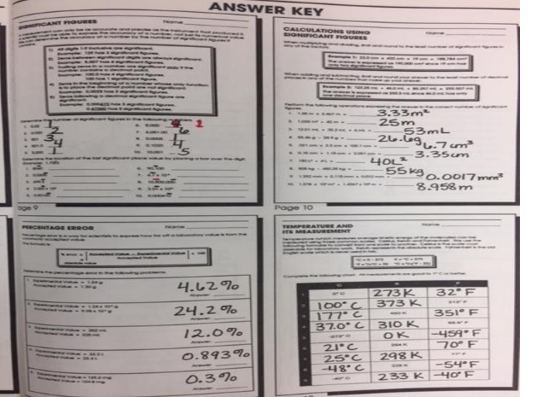

Wednesday 8.8.18-

BIO: CHEM: 1 in= 2.54 cm 1m = 100 cm

|  |  |
| --- | --- |
| **Warm up:**  Turn off cell phone and put in bin 😊   * Describe a eukaryote.   Put signed papers and warm up in bin. | **Warm up:**  Turn off cell phone and put in bin 😊   * How tall are you in inches? * In cm? * In meters? |

CHEM BOOK: openstax.org 🡪subjects🡪 Chemistry (atoms first)

BIO BOOK: openstax.org 🡪subjects🡪 Concepts of Biology

A prokaryote -uses binary fission to reproduce itself.

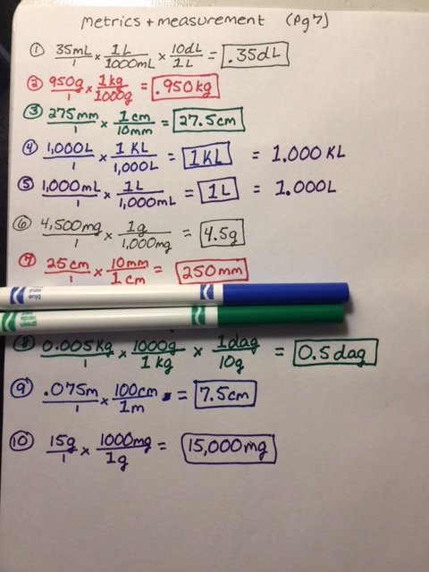

Thursday 8.8.18-

BIO: CHEM: 1 in= 2.54 cm 1m = 100 cm

|  |  |
| --- | --- |
| **Warm up:**  Turn off cell phone and put in bin 😊  -Describe the main points of this video: <https://www.youtube.com/watch?v=VXW5mLE5Y2g>  Put any late work in bin | **Warm up:**  Turn off cell phone and put in bin 😊  Describe the IPK  (what does it stand for? What is it made of? )  <https://www.youtube.com/watch?v=hQpQ0hxVNTg>  Put any late work in bin |

CHEM answers to pg 2-8 will be posted here🡪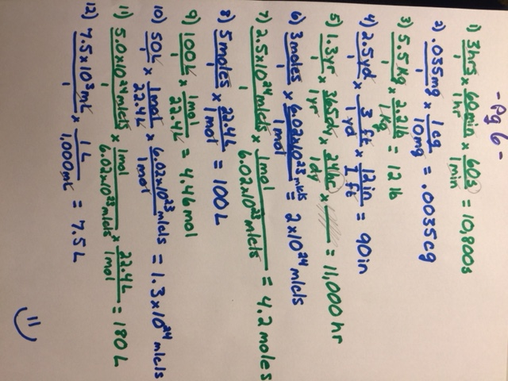

Welcome to Biology: <https://www.youtube.com/watch?v=7L7x0BAqWis&t=15s>

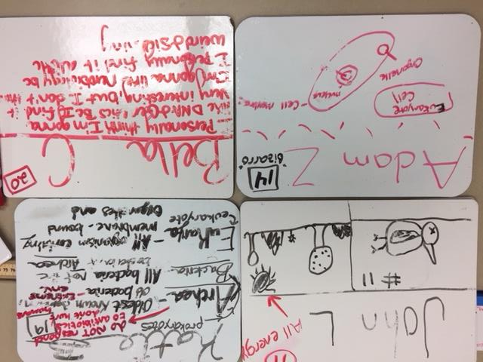

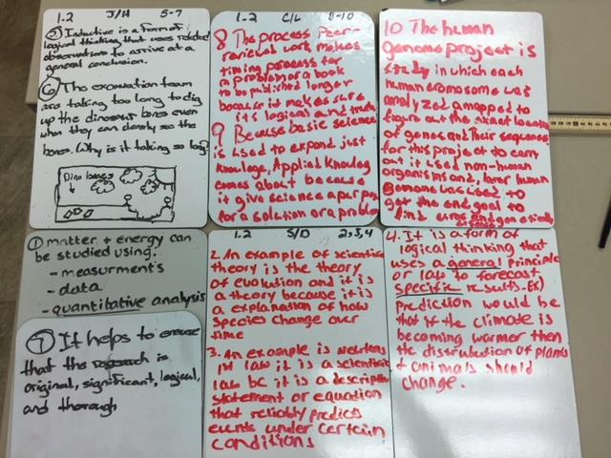

Welcome to Chemistry: <https://www.youtube.com/watch?v=izeuGr0lbN0&t=2s>

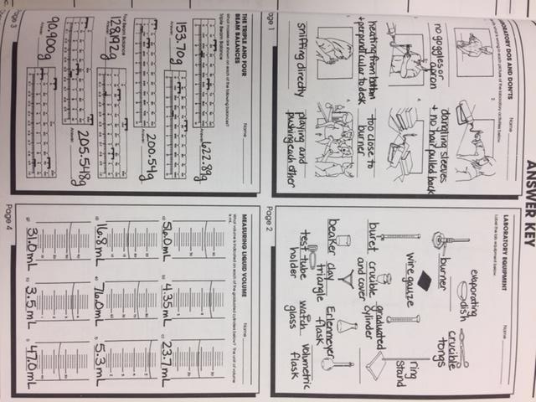

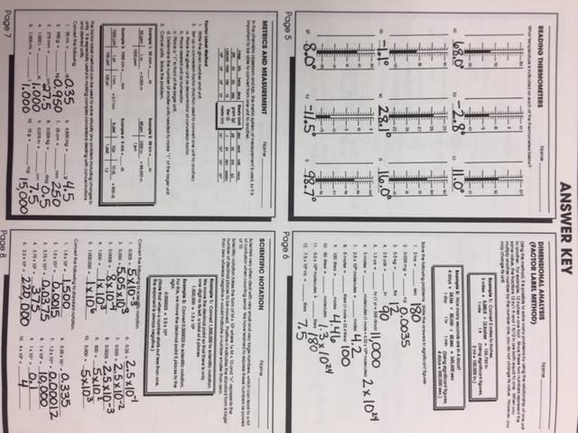

Friday 8.10.18-

BIO: CHEM: 1 in= 2.54 cm 1m = 100 cm

|  |  |
| --- | --- |
| **Warm up:**  Turn off cell phone and put in bin 😊  **Describe a macromolecule.**  **Turn in warm up and clean area.** | **Warm up:**  Turn off cell phone and put in bin 😊  Tasha does the 100m in 5.5 sec. What is her speed in mi/hr?  **Turn in warm up and clean area.** |

