Weekly Planner: All science week of 8.27.18 



**Objectives for the week**: Bio.1.2.1 Explain how homeostasis is maintained in the cell and within an organism in various environments (including temperature and pH). Bio.1.1.1 Summarize the structure and function of organelles in eukaryotic cells (including the nucleus, plasma membrane, cell wall, mitochondria, vacuoles, chloroplasts, and ribosomes)

Chm.1.1.1 Analyze the structure of atoms, isotopes, and ions. Chm.2.2.3 Analyze the law of conservation of matter and how it applies to various types of chemical equations Chm.1.1.3 Explain the emission of electromagnetic radiation in spectral form in terms of the Bohr model.

|  |  |  |
| --- | --- | --- |
| Day | Honors Biology | Honors Chemistry |
| Mon 8.27 | -Presentations  -Warm up  -NOTES: cells  -PROGRESS REPORTS GO OUT!!  HW= P/R signed, chapter 3.1-3.6 end of section questions. | -Warm up and hand in all labs  -Intro to current events/chem  % composition lab!  -Notes: Isotopic mass  McNuggium  HW= signed P/R, GUM LAB, worksheets # 27 &28 |
| Tues  8.28  STUDY BUDDIES! | -Warm up and HW check  -notes: cell functions  **POLAR/nonpolar LAB!**  **HW=plasma membrane coloring, finish gummy lab prep.** | -Warm up and HW check  -Notes:  **Isotope lab!**  **HW= finish isotope lab, do crossword (skip # 13,16,17,19)** |
| Wed 8.29  STUDY BUDDIES! | **-Warm up and health brief by Marcus S.**  **-presentations**  **-notes: osmosis**  **-Team practice**  **OSMOSIS LAB!**  **-Study and complete lab write up!!!** | Warm up  -NOTES finish ALL of CH 2  TEAM practice  HW= online book Ch 2.2 and 2.3 questions in full sentences! |
| Thurs  8.30 | **GO OVER HW**  **TEAM 3.1-3.6 presentations**  **STUDY** | GO OVER HW  TEAM 2.1-2.3 presentations  *anyone may report to room 203 after school or before school for a copy of an old test. |
| Friday 8.31 | **Test**  **----**  **HW= complete cell diagrams with functions and do test corrections.** | **Test**  **---**  **HW= CH 2.4 #1-9 full sentences and show ALL work!**  **SEE Erin’s 1-3 below…. (BE READY to present it!)** |

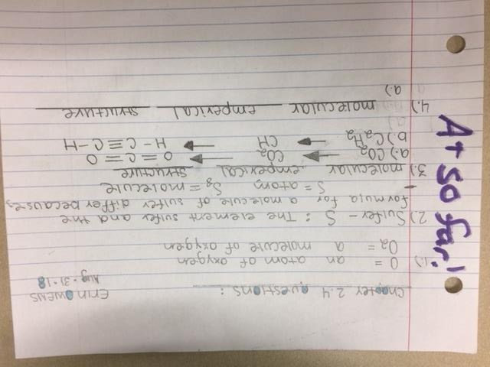

Monday 8.27.18- https://evansccca.weebly.com/

|  |  |
| --- | --- |
| **BIO Warm up:**   1. Draw a reaction diagram for energy vs. time and use the following words:   - reactants, products, activation energy, catalyzed reaction  Turn OFF your cell phone and put in bin 😊 | **CHEM Warm up:**   1. Put your NAME on every sheet and turn in the rest of your lab. 2. Draw a reaction diagram for energy vs. time and use the following words:   - reactants, products, activation energy, catalyzed reaction  Turn OFF your cell phone and put in bin 😊 |

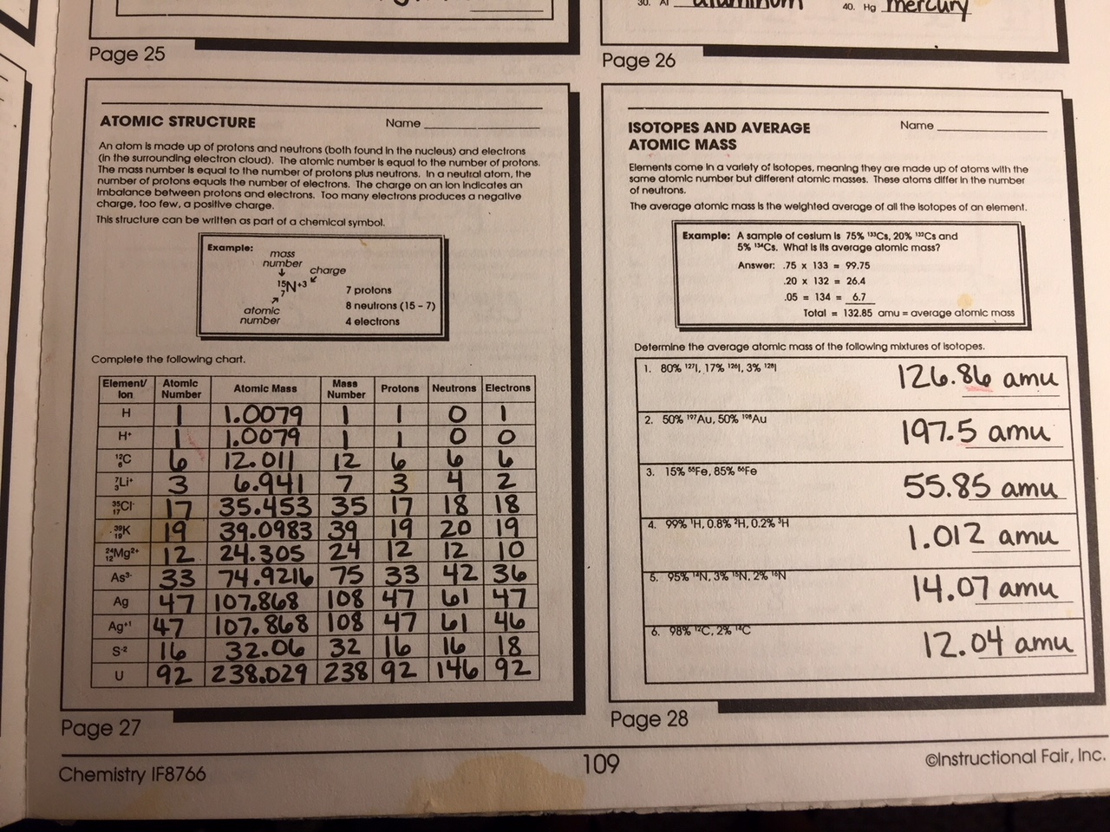

[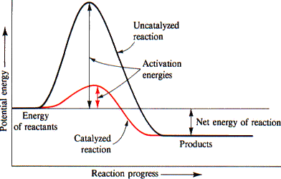](https://www.google.com/url?sa=i&rct=j&q=&esrc=s&source=images&cd=&cad=rja&uact=8&ved=2ahUKEwjN18Ty_4vdAhXKhOAKHbZiCNcQjRx6BAgBEAU&url=http://www.chem.uiuc.edu/rogers/text13/tx133/tx133fr.html&psig=AOvVaw2-yfLaBqSSImZrC-pFHhJF&ust=1535416902267925)

Tuesday 8.28.18- https://evansccca.weebly.com/

|  |  |
| --- | --- |
| **BIO Warm up:**  Turn OFF your cell phone and put in bin 😊  Describe and draw your minilab | **CHEM Warm up:**  Turn OFF your cell phone and put in bin 😊   1. Show work to convert 1250 of gas to dm3   (*hint= 1L of volume = 1 dm3) |

Wednesday 8.29.18- https://evansccca.weebly.com/

|  |  |
| --- | --- |
| **BIO Warm up:**  Turn OFF your cell phone and put in bin 😊  Describe and draw your minilab results.   1. Why does your look different? 2. In terms of polarity and density, what happened? | **CHEM Warm up:**  Turn OFF your cell phone and put in bin 😊  Element “X” has two isotopes. One with a mass of 35 and it makes up 75% of the sample. The other has a mass of 37 and it makes up 25% of the sample.  What is the average isotopic mass? |

Explain what you learn from this short video on cell membranes:

<https://www.youtube.com/watch?v=qBCVVszQQNs>

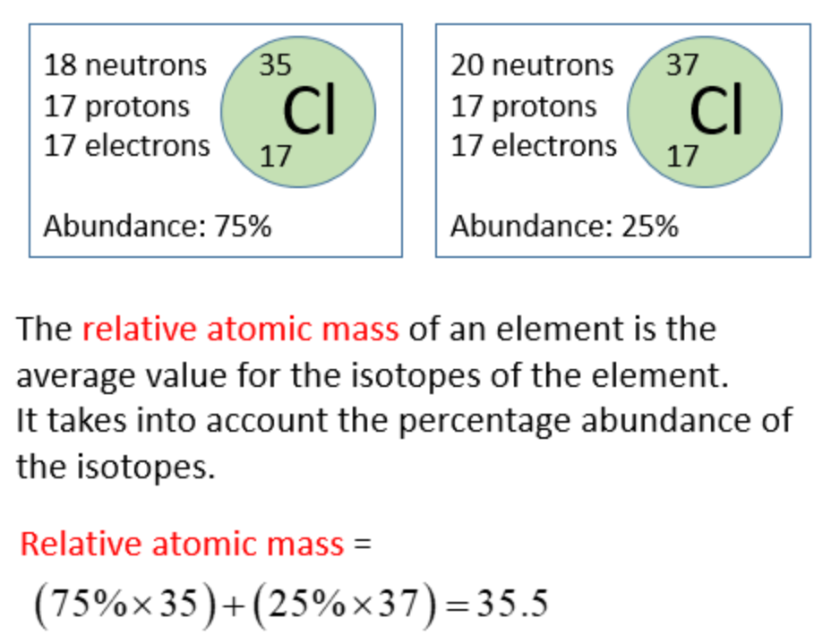

Thursday 8.30.18- https://evansccca.weebly.com/

|  |  |
| --- | --- |
| **BIO Warm up:**  Turn OFF your cell phone and put in bin 😊  Describe the difference between an analysis and a conclusion | **CHEM Warm up:**  Turn OFF your cell phone and put in bin 😊   1. THREE isotopes of hydrogen |

Friday 8.31.18- https://evansccca.weebly.com/

|  |  |
| --- | --- |
| **BIO Warm up:**  Turn OFF your cell phone and put in bin 😊   1. In your own words, explain what a computer model does for science.   <https://www.youtube.com/watch?v=Z7OGGBgM9Kg> | **CHEM Warm up:**  Turn OFF your cell phone and put in bin   1. **SHOW WORK to calculate the mass ratio of Na2O** |

2,3,4,5,9,11,16,

17, 18, 23,24,27,28,30,

33,34,35,36,40,41,42,

45,47,48,49,51,52,53,

54,55, 57,59,60 (33 total)