Weekly Planner: All science week of 8.20.18 



**Objectives for the week**: Bio.4.1.1 Compare the structures and functions of the major biological molecules (carbohydrates, proteins, lipids, and nucleic acids) as related to the survival of living organisms. Bio.4.1.2 Summarize the relationship among DNA, proteins and amino acids in carrying out the work of cells and how this is similar in all organisms. Bio.4.1.3 Explain how enzymes act as catalysts for biological reactions.

Chm.1.1.1 Analyze the structure of atoms, isotopes, and ions. Chm.1.1.2 Analyze an atom in terms of the location of electrons. Chm.1.1.3 Explain the emission of electromagnetic radiation in spectral form in terms of the Bohr model.

|  |  |  |
| --- | --- | --- |
| Day | Honors Biology | Honors Chemistry |
| Mon 8.20 | -Collect microscope lab  -go over HW & classwork  -lab safety video and quiz  -review for test  HW= study! | Polyatomics quiz #1  -Collect 3 worksheets  -collect practice test  -Go over 1.2 questions and Friday’s classwork  HW= study! |
| Tues  8.21  STUDY BUDDIES! | Assessment  LAB SAFETY  Lab safety: <https://www.youtube.com/watch?v=VRWRmIEHr3A>  Presentations?  HW= CH 2.2 (read and answer the questions, finish 36 lab problems | Assessment  LAB safety  Lab safety: <https://www.youtube.com/watch?v=VRWRmIEHr3A>  HW= Read Ch 2 again (take notes?), finish 36 lab safety problems |
| Wed 8.22  STUDY BUDDIES! | GO OVER LAB SAFETY  -STATION LAB! Chapter 2  Presentations- Culture 21??  HW= HAVE 3 stations finished!! | **GO OVER LAB SAFETY**  **-STATION LAB! Chapter 2**  **CH 2 notes/ppt**  **HW=** HAVE two stations finished & do test corrections. |
| Thurs  8.23 | LAB DAY!! | LAB DAY!! |
| Friday 8.24 | **TEST**  **HW= READ CH 3!!!** | **QUIZ**  **HW= READ CH 2.2-2.4 and take notes!** |

Monday 8.20.18- https://evansccca.weebly.com/

|  |  |
| --- | --- |
| **BIO Warm up:**  Turn OFF your cell phone and put in bin 😊   1. Name each of the four main biomolecules and name a monomer of each.   *psssst…. TOMORROW is the 21st. | **CHEM Warm up:**  Turn OFF your cell phone and put in bin 😊  ) Describe a colloid and a suspension using a venn diagram. <https://www.youtube.com/watch?v=b3HS_woWaJQ> |

Lab safety: <https://www.youtube.com/watch?v=VRWRmIEHr3A>

Tuesday 8.21.18- https://evansccca.weebly.com/

|  |  |
| --- | --- |
| **BIO Warm up:**  Turn OFF your cell phone and put in bin 😊   1. Draw a Bohr diagram of a Fluorine atom. | **CHEM Warm up:**  Turn OFF your cell phone and put in bin 😊   1. Draw a diagram of a chlorine atom |

Wednesday 8.22.18- https://evansccca.weebly.com/

|  |  |
| --- | --- |
| **BIO Warm up:**  Turn OFF your cell phone and put in bin 😊   1. Hand in your 5 questions and answers *NAME!!!. 2. Explain the four forces of the universe. | **CHEM Warm up:**  Turn OFF your cell phone and put in bin 😊     1. Explain what an atom would look like if blown up to the size of a football stadium. What does this mean about atoms? |
| **Thursday 8/23:**  **Na+**  **I - 131** | **Thursday 8/23:**  **Na+**  **I isotope with a mass of 132**  **O-2** |
|  |  |

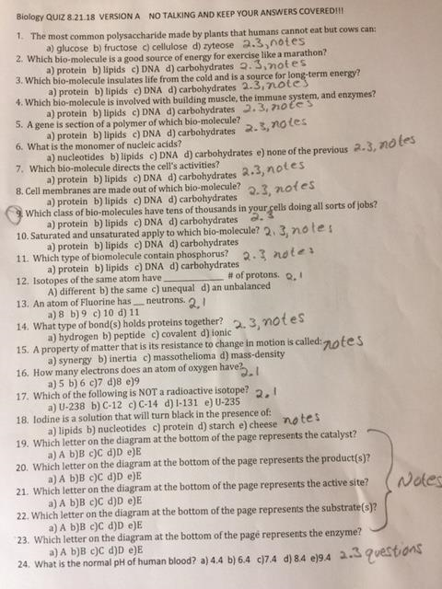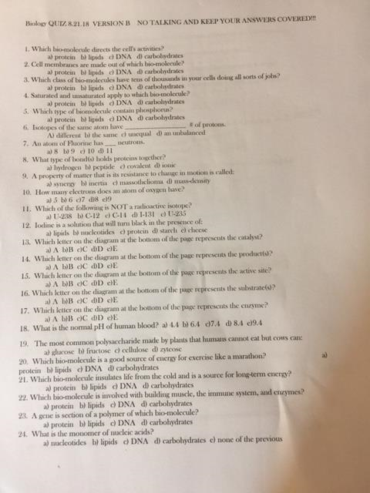

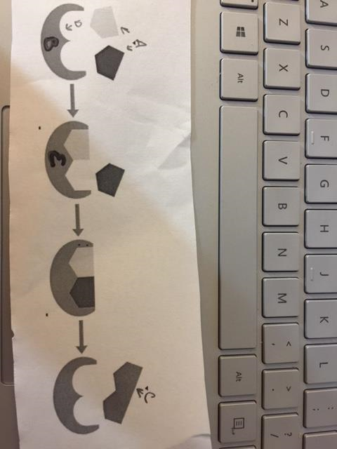

Thursday 8.23.18- https://evansccca.weebly.com/

|  |  |
| --- | --- |
| **BIO Warm up:**  Turn OFF your cell phone and put in bin 😊  **Na+**  **I - 131** | **CHEM Warm up:**  Turn OFF your cell phone and put in bin 😊 |

Friday 8.24.18- https://evansccca.weebly.com/

|  |  |
| --- | --- |
| **BIO Warm up:**  Turn OFF your cell phone and put in bin 😊   1. What is Benedicts solution, what color is it normally, and what color does it turn?   https://www.youtube.com/watch?v=Lt7RCIfudYQ | **CHEM Warm up:**  Turn OFF your cell phone and put in bin 😊   1. What are the 5 postulates of Dalton’s atomic theory?   https://www.youtube.com/watch?v=IdSUqsq1yY8 |