Weekly Planner: All science week of 8.13.18



**Objectives for the week**: Scientific method, measurement, scientific notation, metric measurement, and conversion. NGSS 1.1  NCSCOS 0.5

|  |  |  |
| --- | --- | --- |
| Day | Honors Chemistry | Honors Biology |
| Mon 8.13 | -Test corrections explanation  -Measurement lab!  <https://www.youtube.com/watch?v=BAf6HoVK6JI>  <https://www.youtube.com/watch?v=-ZDt4ax8U-A&t=1s>  <https://www.youtube.com/watch?v=TRURCvaypjA>  HW= complete test corrections and read ch2 | -Test corrections explanation  -Measurement lab!  <https://www.youtube.com/watch?v=BAf6HoVK6JI>  <https://www.youtube.com/watch?v=-ZDt4ax8U-A&t=1s>  <https://www.youtube.com/watch?v=TRURCvaypjA>  HW= complete test corrections and read ch 2 |
| Tues  8.14  STUDY BUDDIES! | Finish LAB  -Notes: Classification of matter  **HW= Finish lab & SHOW WORK, Read Ch. 1.2 and do q. 1-5 at the end of 1.2** ☺ | Finish LAB  -Notes: Biomolecules  HW= Do your Culture 21, test corrections, finish lab calculations, go over current notes. |
| Wed 8.15  STUDY BUDDIES! | NOTES! Ch 1.2  HW1= colloid, suspension  HW= Ch 1.2 ALL end of section questions in full sentences. | FINISH NOTES!!!  HW= ALL end of section 2.3 (biological molecules) questions in full sentences. |
| Thurs  8.16 | Go over HW # 1-16  Physical/chemical change notes (see ppt)  HW= Finish ALL three worksheets! (physical/chemical) | Pictures  HW= study for test, finish microscope lab  Google🡪 virtual microscope lab |
| Friday 8.17 | TEST | TEST |

Monday 8.13.18- https://evansccca.weebly.com/

|  |  |
| --- | --- |
| **Warm up:**  Turn off your cell phone and put in bin 😊  1)Name 4 things you remember from the weekend reading. | **Warm up:**  Turn OFF your cell phone and put in bin 😊  1)Name 4 things you remember from the weekend reading. |

Tueday 8.14.18- https://evansccca.weebly.com/

|  |  |
| --- | --- |
| **Warm up:**  Turn off your cell phone and put in bin 😊  -measure the length and volume below. Report your answers in cm and cm3. | **Warm up:**  Turn OFF your cell phone and put in bin 😊  -measure the length and volume below. Report your answers in cm and cm3. |

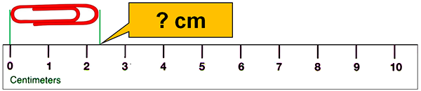

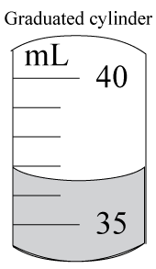

Wednesday 8.15.18- https://evansccca.weebly.com/

|  |  |
| --- | --- |
| **Warm up:**  Turn off your cell phone and put in bin 😊  -Describe a homogeneous mixture and a heterogeneous mixture. | **Warm up:**  Turn OFF your cell phone and put in bin 😊   * Name the country for your Culture 21 and list one organism you have researched thus far. |

Thursday 8.16.18- https://evansccca.weebly.com/

|  |  |
| --- | --- |
| **Warm up:**  Turn off your cell phone and put in bin 😊  -Describe your observations every 10 seconds… | **Warm up:**  Turn OFF your cell phone and put in bin 😊  -Describe your observations every 10 seconds… |

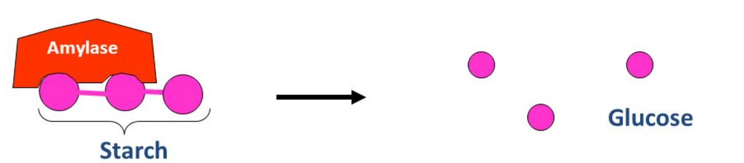

Friday 8.17.18- https://evansccca.weebly.com/

[](https://www.google.com/url?sa=i&rct=j&q=&esrc=s&source=images&cd=&cad=rja&uact=8&ved=2ahUKEwj57pSHjvDcAhXuTN8KHT1XCzIQjRx6BAgBEAU&url=http://www.classofoods.com/page1_7.html&psig=AOvVaw3s79Lg4fSr9GFQ-PdPn1e_&ust=1534458098341482) <http://www.classofoods.com/page1_7.html>

From our minilab, describe what happened using the following words:

Chapter 1 Key and Explanations BIOLOGY AND CHEM (see below)

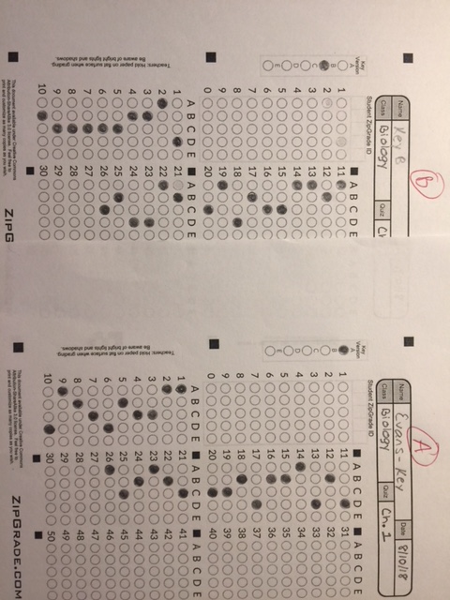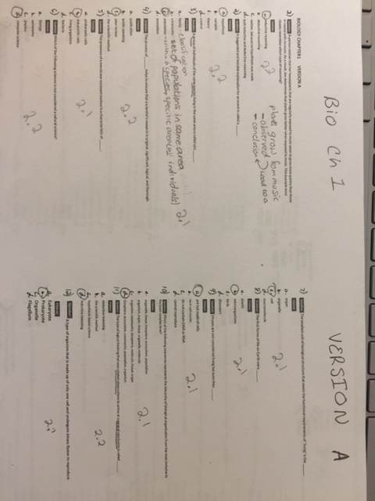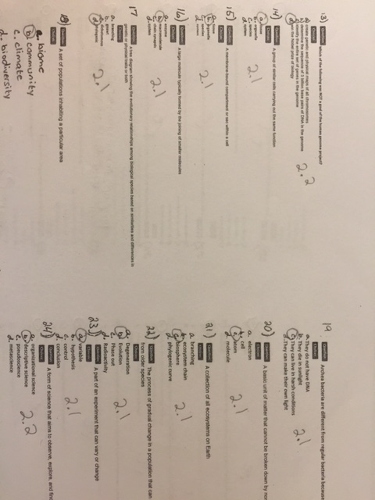

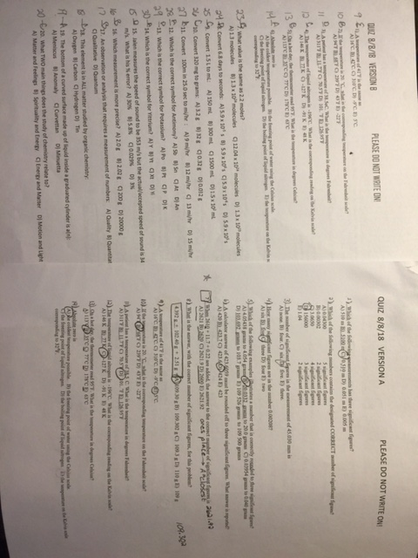

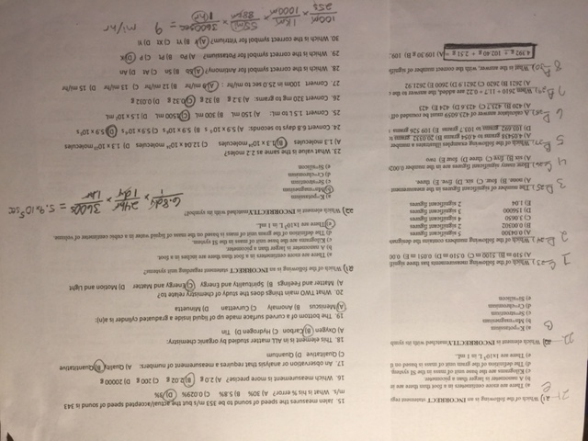

Lab safety: https://www.youtube.com/watch?v=VRWRmIEHr3A