Weekly Planner: All science week of 11.5.18
Objectives for the week: Bio.3.4.1 Explain how fossil, biochemical, and anatomical evidence support the theory of evolution. Bio.3.4.2 Explain how natural selection influences the changes in species over time. Bio.3.4.3 Explain how various disease agents (bacteria, viruses, chemicals) can influence natural selection. Chm.1.2.1 Compare (qualitatively) the relative strengths of ionic, covalent, and metallic bonds.
Day | Honors Biology-  EQ= What is evolution and how do we prove it? | Honors Chemistry-  EQ= What are the types of bonds and what do they look like?
Mon 11.5 | https://www.youtube.com/watch?v=GhHOjC4oxh8  Notes: Evolution  HW= finish evolutionary proof packet | Hurricane review session: Chemical bonds  HW= finish chemical bonds practice test, do test corrections
Tues  11.6  STUDY BUDDIES! | Finish notes: Evolution concepts  VIRTUAL LAB! Evolution  https://www.pbs.org/wgbh/nova/labs/lab/evolution/research#/evo/buildatree/1  HW= everyone finish module 1 under your own log in!, and test corrections. GET a 6/6!!! | LAB! Molecular models kit!  HW= test corrections (10/26 and 11/2)
Wed 11.7  STUDY BUDDIES! | Notes: speciation  Modules 2 and 3  HW= test corrections due THURS!! | Finish molecular models  Notes: Calorimetry
Thurs  11.8 | NOTES: CLADOGRAMS!  https://www.youtube.com/watch?v=ouZ9zEkxGWg  https://www.youtube.com/watch?v=9_QAyTk7WrA  Modules 4-6 | Notes: States of matter and calorimetry.  HW= finish ice to steam problem  Do #1-7 on worksheet on a separate sheet of paper.
Friday 11.9 | TEST- Evolution  HW=Modules 1-6 due Tuesday | QUEST- Bonds and molecular structure  HW= read ch 9 a couple more times and REALLY try to answer # 1-18.

TEACHER instructions for evolution lab: Teachers can use NOVA Labs: Evolution to help middle and high school students understand how scientists use evidence to determine evolutionary relationships. While short video clips briefly discuss ideas of natural selection, the activities focus on creating phylogenies based on anatomical, fossil, and DNA evidence. It's best if students already have a good understanding of the mechanism of natural selection prior to using this tool.
Within the module, each short game gives students another piece of the evolution puzzle, first using anatomical, then fossil, then DNA evidence. Students drag and drop organisms into phylogenic trees based on similar traits to figure out evolutionary relatedness. Organism descriptor cards give kids most of the information they'll need, but they may need to do some digging with terms like tail fluke. Let kids design and redesign phylogenies until they find one that works. Kids will be surprised when their trees show them that a banana is more closely related to an onion than a lemon. In the Fossils: Rocking the Earth section, students sort fossils into trees to learn about whether or not present-day birds have anything in common with dinosaurs. After kids have mastered phylogeny basics, they can conduct their own investigations in the Deep Tree section, looking for evolutionary relationships in more than 70,000 different species.
Standouts:
- Fossils: Rocking the Earth -- Sort fossils to help place extinct organisms into phylogenic trees.
- DNA Spells Evolution -- Use actual DNA sequences to determine evolutionary relationships.
- Tree of Life and Death -- See how phylogenic trees are used to treat diseases.

Monday 11.5.18- https://evansccca.weebly.com/
Reminder to turn OFF cell phones and put in basket  The picture below is a platypus, where do you think it evolved from and why? | Reminder to turn OFF cell phones and put in basket  Describe the three types of bonds and explain the properties of each.
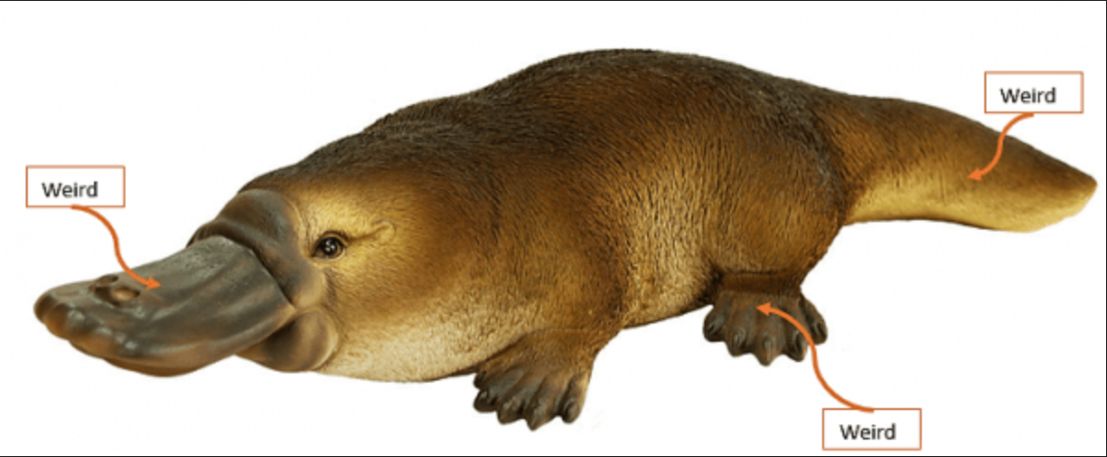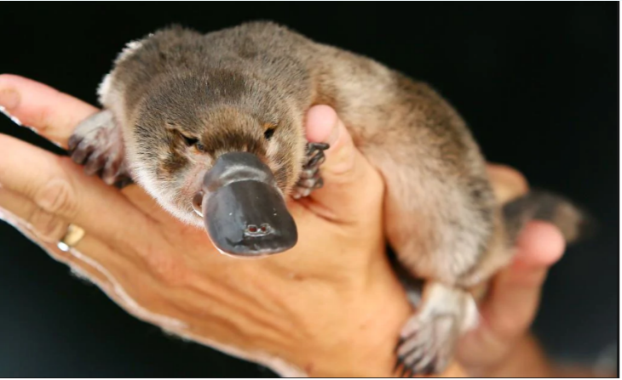

Tuesday 11.6.18- https://evansccca.weebly.com/
Reminder to turn OFF cell phones and put in basket https://www.youtube.com/watch?v=lIEoO5KdPvg  Name 5 evidences of evolution: | Reminder to turn OFF cell phones and put in basket  Give FIVE examples of hydrocarbons and explain how they react in air.

Wednesday 11.7.18- https://evansccca.weebly.com/
Reminder to turn OFF cell phones and put in basket Describe speciation and give two examples of it.  https://www.youtube.com/watch?v=2oKlKmrbLoU&t=.5s | Reminder to turn OFF cell phones and put in basket  Write a balance equation for the following reactions:  -Ethene burns  -Magnesium is placed in aqueous hydrochloric acid  - When lead II nitrate reacts with potassium iodide, a precipitate is formed.

Thursday 11.6.18- https://evansccca.weebly.com/
Reminder to turn OFF cell phones and put in basket  What is a tail fluke?  https://www.youtube.com/watch?v=U0lk7jFQKgs | Reminder to turn OFF cell phones and put in basket  Draw the STRUCTURAL diagram of the following shapes:  Pyramidal, tetrahedral and trigonal planar.

Friday 11.9.18- https://evansccca.weebly.com/
Reminder to turn OFF cell phones and put in basket What is a tail fluke?  Draw a diagram of one | Reminder to turn OFF cell phones and put in basket 14 g H₂ react with excess oxygen. How many Liters of water vapor are produced?
CHEM ANSWERS to bonding test:
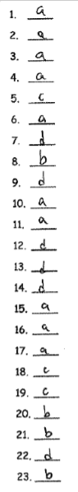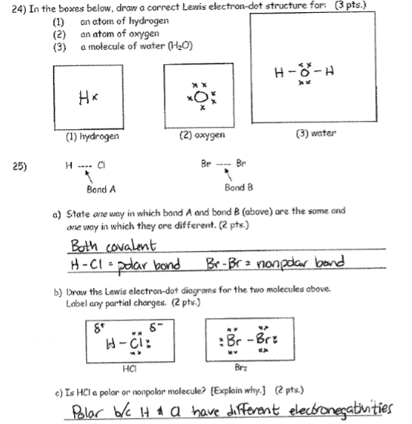
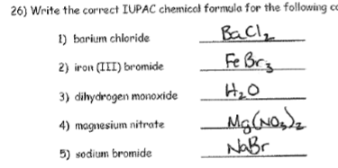
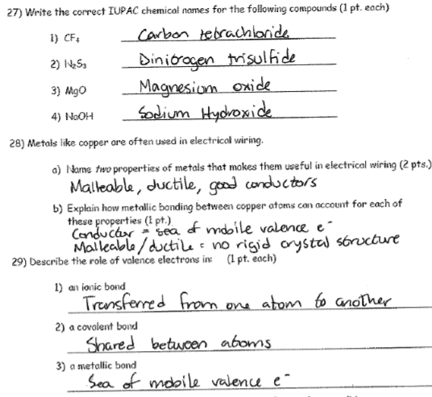
30= covalent
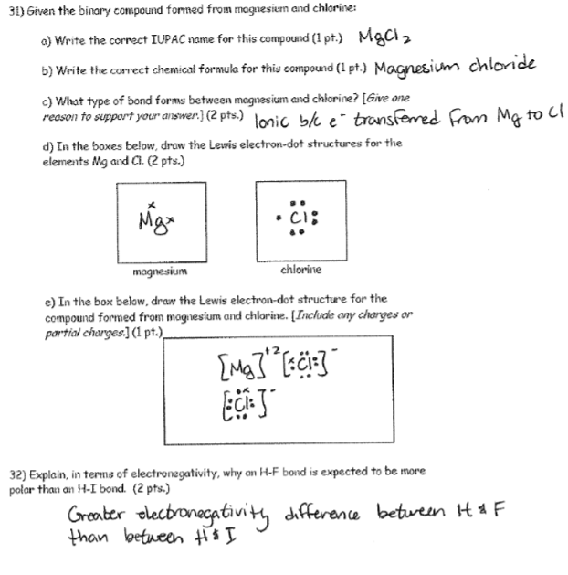
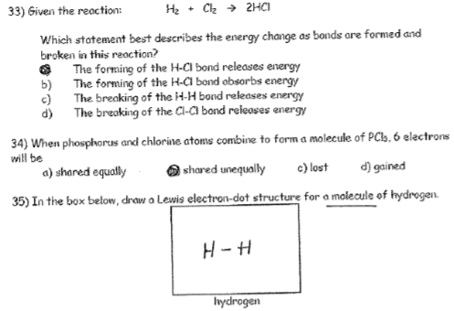
MOLECULAR SHAPES:
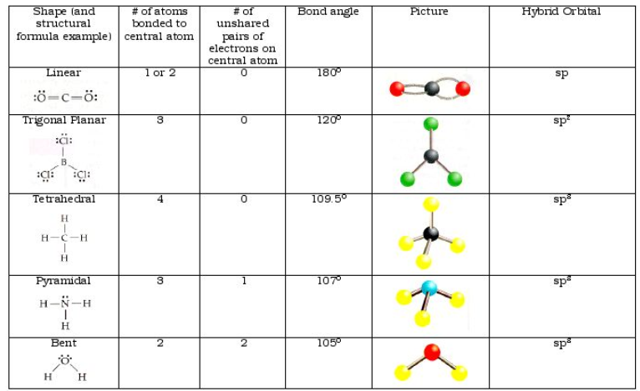

Black-
White-
Blue-
Green-
Red-
Gray-
Yellow-
Purple-
Short, single bonds-
Longer, double/triple bonds-

