Weekly Planner: All science week of 11.26.18
Objectives for the week: Bio.2.2.1 Infer how human activities (including population growth, pollution, global warming, burning of fossil fuels, habitat destruction and introduction of nonnative species) may impact the environment. Bio.2.2.2 Explain how the use, protection and conservation of natural resources by humans impact the environment from one generation to the next. Chm.3.1.1 Explain the factors that affect the rate of a reaction (temperature, concentration, particle size and presence of a catalyst). Chm.3.1.2 Explain the conditions of a system at equilibrium. Chm.3.1.3 Infer the shift in equilibrium when a stress is applied to a chemical system (Le Chatelier’s Principle).

Day | Honors Biology-  EQ= What is ecology and why is it so important? | Honors Chemistry-  EQ= What are reversible reactions and how do they work?
Mon 11.26 | Notes: Ecology  -practice  HW= make sure you have correct answers to #1-60 | Notes- reversible reactions  -practice  HW=  K_{eq} pg 79 and 80 and LeChat worksheet #1-6.
Tues  11.27  STUDY BUDDIES! | Finish Ecology Notes  Lorax | Go over LeChat worksheet  Get review back  Finish LeChat and  * HW= pg 84 and 85!
Wed 11.28  STUDY BUDDIES! | QUEST- Ecology | QUEST- Reversible reactions
Thurs  11.29 | EOC REVIEW | EOC REVIEW
Friday 11.30 | EOC REVIEW | EOC REVIEW

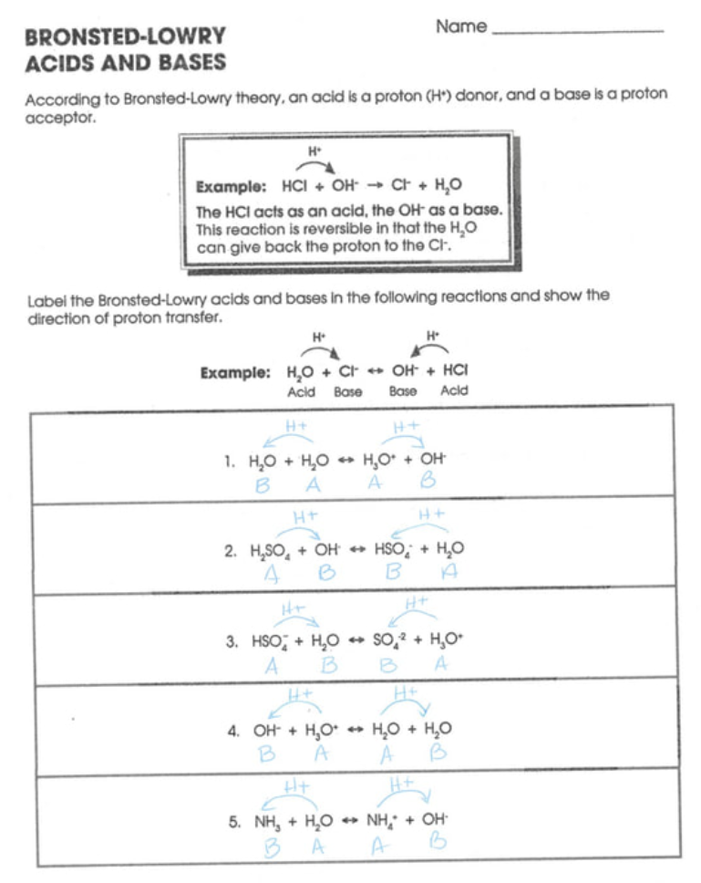
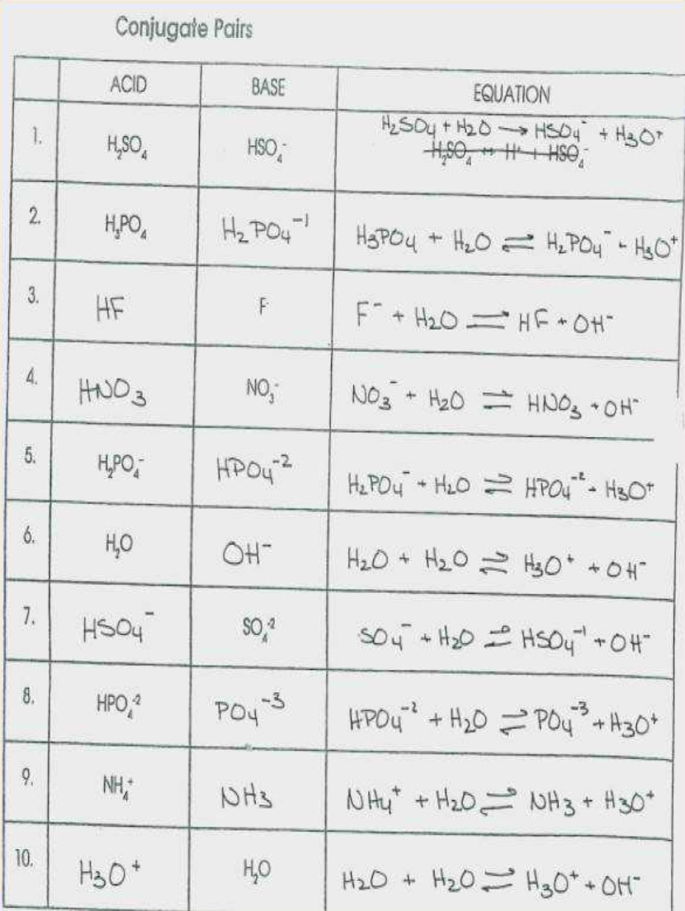
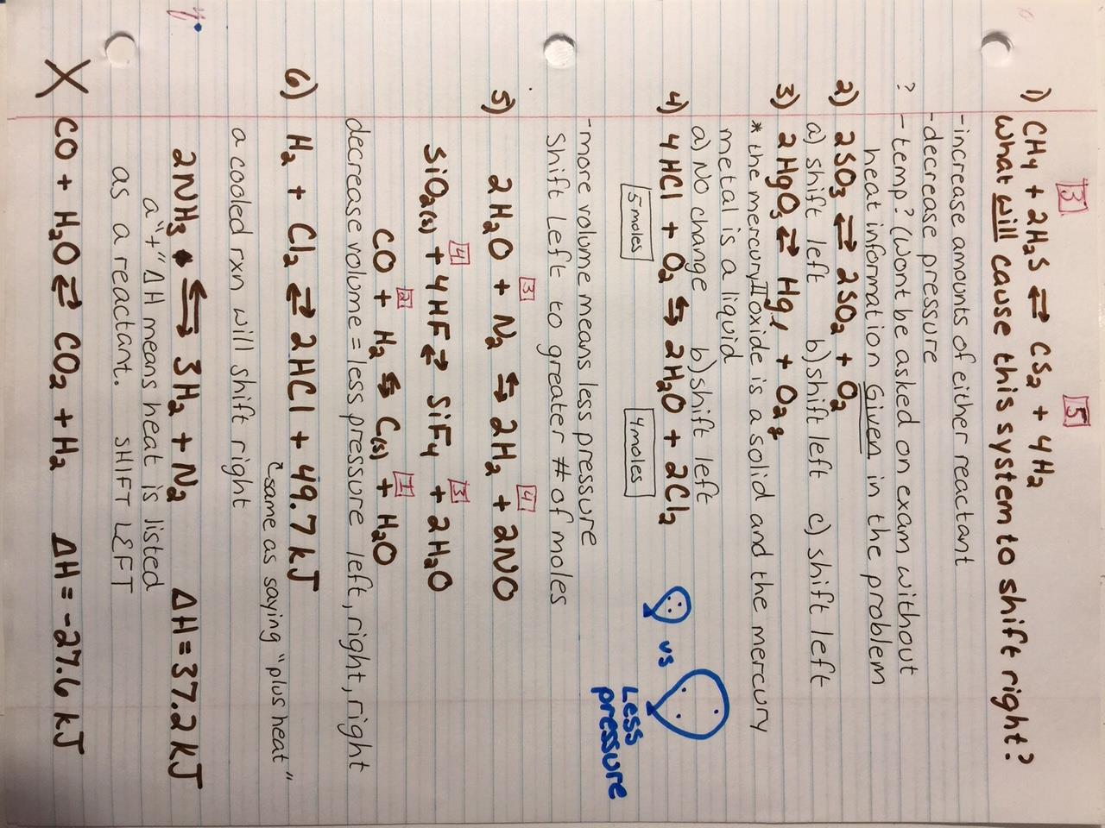
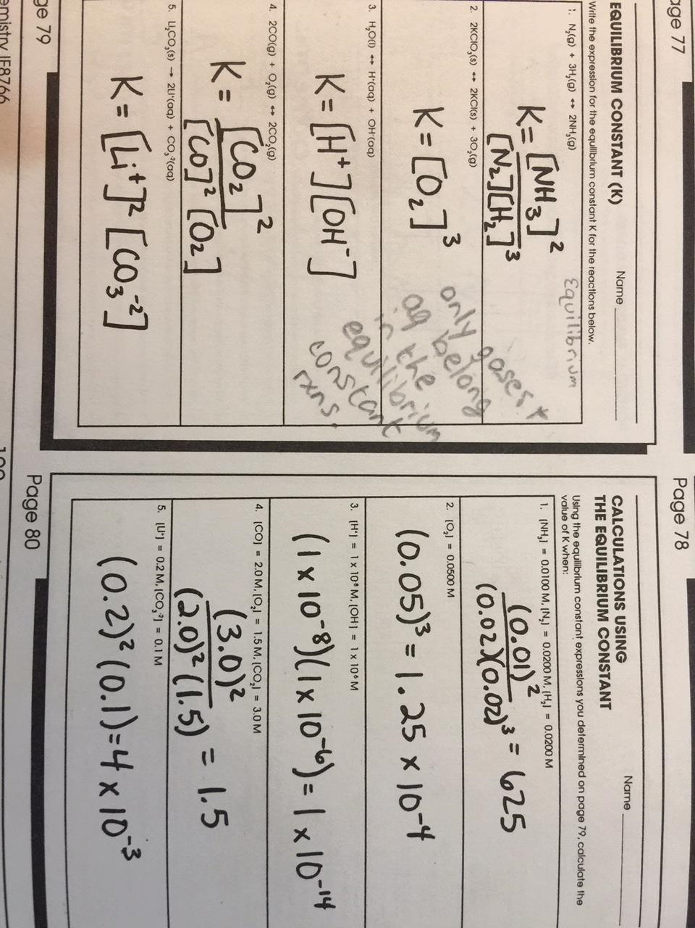
Warm ups this week are on your own paper and you keep them in your notes.
Reminder to turn OFF cell phones and put in bin  - Describe interdependence and give an example of it.  https://www.youtube.com/watch?v=GlnFylwdYH4&t=1s | Reminder to turn OFF cell phones and put in bin  -List ALL the ways you can speed up a reaction.  https://www.youtube.com/watch?v=OttRV5ykP7A  https://phet.colorado.edu/en/simulation/legacy/reversible-reactions

CHEM answers 1-43
Chemistry Final Exam Sample Items
- Which idea of John Dalton is no longer considered part of the modern view of atoms?
  - Atoms are extremely small.
  - Atoms of the same element have identical masses.
  - Atoms combine in simple whole number ratios to form compounds.
  - Atoms of different elements can combine in different ratios to form different compounds.

- Which best describes the current atomic theory?
  - Atoms consist of electrons circling in definite orbits around a positive nucleus.
  - Atoms are composed of electrons in a cloud around a positive nucleus.
  - Atoms can easily be split, at which time they become radioactive.
  - An atom’s mass is determined by the mass of its neutrons.

- What is the nuclear composition of uranium-235?
  - 92 electrons and 143 protons
  - 92 protons and 143 electrons
  - 143 protons and 92 neutrons
  - 92 protons and 143 neutrons
Notice it said nuclear composition and in the nucleus are protons and neutrons
Atomic number of uranium = 92 so 92 protons
Neutrons = 235-92 = 143

- Which best describes the relationship between subatomic particles in any neutral atom?
  - The number of protons equals the number of electrons.
  - The number of protons equals the number of neutrons.
  - The number of neutrons equals the number of electrons.
  - The number of neutrons is greater than the number of protons.
In order to be neutral, positives and negatives must equal so protons (+) = electrons (-)

- What is the name of the compound PbO₂?
  - Lead oxide
  - Lead (II) oxide
  - Lead oxide (II)
  - Lead (IV) oxide
Pb⁺⁴O⁻² cross cross to give Pb₂O₄ which can be reduced to PbO₂

- What is the name of HCl (aq)?
  - Chloric acid
  - Hydrochloric acid
  - Hydrogen chloride
  - Perchloric acid
Starts with H so is an acid, no oxygen so use prefix hydro and change ending to –ic

- What is the chemical formula for calcium nitrate?
  - CaNO₃
  - Ca(NO₂)₂
  - Ca(NO₃)₂
  - Ca₃N₂
Ca⁺²NO₃⁻¹ cross cross to give choice C

- What is the correct formula for dinitrogen pentoxide?
  - N₄O
  - NO₂
  - N₂O₅
  - NO₄
Di means 2 and penta means 5

- If the volume of an 18.5 g piece of metal is 2.35 cm³, what is the identity of the metal?
  - Iron
  - Lead
  - Nickel
  - Zinc
Calculate density by doing mass divided by mass then look up the density on the reference table which shows it must be iron. Remember density is unique for everything.

- Which substance listed in the table is a liquid at 27°C?
Melting Boiling
Point Point
I | 28°C | 140°C
II | -10°C | 25°C
III | 20°C | 140°C
IV | -90°C | 14°C
  - I
  - II
  - III
  - IV
For I, 27°C is below melting point so it would still be a solid.
For II and III, 27°C is above boiling point so would be a gas.

- Which will increase the solubility of most solid solutes?
  - Decreasing the temperature
  - Decreasing the amount of solvent at constant temperature
  - Increasing the amount of solute at constant temperature
  - Increasing the temperature
Increasing temperature causes particles to move faster so dissolves quicker.
- What happens to the pressure of a constant mass of a gas at constant temperature when the volume is doubled?
  - The pressure is doubled
  - The pressure remains the same
  - The pressure is reduced by ½
  - The pressure is reduced by ¼
Constant temperature is Boyle’s law which is inverse.

- What is the pressure, in atmospheres, exerted by a 0.100 mol sample of oxygen in a 2.00 L container at 273°C?
  - 4.48 x 10⁻¹ atm
  - 2.24 x 10⁰ atm
  - 1.12 x 10³ atm
  - 2.24 x 10³ atm
Use the equation PV=nRT. Use the R value with atm in the unit and remember that temperature must be in Kelvin.

- Which pair of elements would most likely bond to form a covalently bonded compound?
  - Sodium and fluorine
  - Barium and chlorine
  - Phosphorus and oxygen
  - Magnesium and sulfur
Covalent bonds are between two nonmetals.

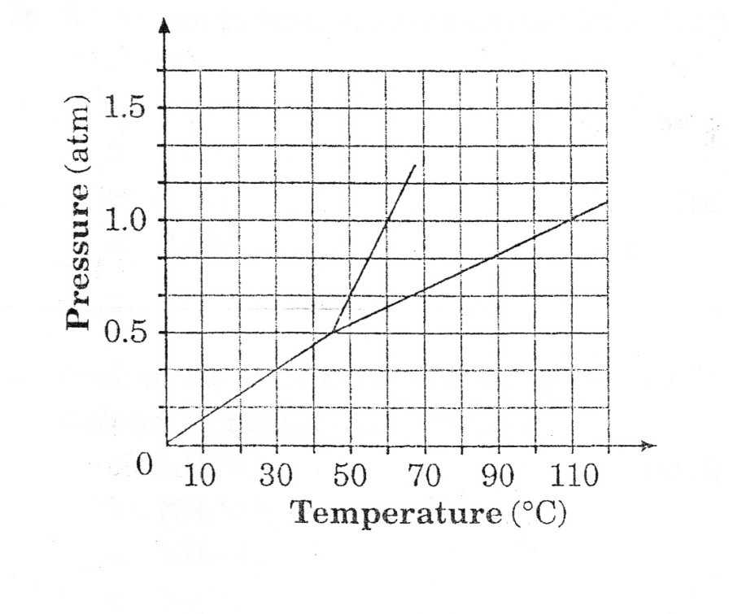
- Consider this phase diagram.

At what temperature does the normal boiling point occur?
  - 45°C
  - 60°C
  - 100°C
  - 110°C
Normal boiling point occurs at 1 atm. So find 1 atm then go over to the line that separates liquid and gas.

- The compound formed between element X and oxygen has the chemical formula X₂O. Which element would X most likely represent?
  - Fe
  - Zn
  - Ag
  - Sn
Criss cross backwards so oxygen has a -2 charge. The oxygen has no subscript so the X must have a +1 charge. Fe can be +2 or +3, Zn is +2 and Sn can be +2 or +4. Silver is the only one that can have a +1 charge.

- Which electron configuration represents a transition element?
  - 1s²2s²2p³
  - 1s²2s²2p⁶3s²
  - 1s²2s²2p⁶3s²3p⁶4s²3d⁷
  - 1s²2s²2p⁶3s²3p⁶4s²3d¹⁰4p⁴
Transition elements are in groups 3-12. Add up exponents which equal 27 which is cobalt. A is nitrogen, B is magnesium, D is selenium.

- Given the electron configuration of 1s²2s²2p⁴, how many electrons does this element have in its outer level?
  - 2
  - 4
  - 6
  - 8
Outer level is number of valence electrons. This element is oxygen which has 6 valence electrons.

- Which correctly lists four atoms from smallest to largest radii?
  - I, Br, Cl, F
  - F, I, Br, Cl
  - Si, P, S, Cl
  - Cl, S, P, Si
Atoms get larger as you go down and to the left on the periodic table.

- Which have the lowest electronegativities?
  - Alkali metals
  - Halogens
  - Rare earth elements
  - Transition metals
Electronegativity increases as you go up and to the right on the periodic table so the farther left you go the lower it is. Alkali metals are the first group so farthest left and therefore lowest electronegativity.

- How many moles are in 59.6 grams of BaSO₄?
  - 0.256 mole
  - 3.91 moles
  - 13.9moles
  - 59.6 moles
Grams to moles is a one step problem. Need to calculate formula mass of barium sulfate.
59.6 g x (1 mol/233.33g)

- What is the volume of two moles of hydrogen gas at STP?
  - 44.8 L
  - 22.4 L
  - 11.2 L
  - 2.00 L
The volume of a gas at STP is 22.4 L/mol so double that.

- How many molecules are contained in 55.0 g of H₂SO₄?
  - 0.561 molecule
  - 3.93 molecules
  - 3.38 x 10²³ molecules
  - 2.37 x 10²⁴ molecules
Have to convert grams to moles using formula mass and then moles to molecules using Avogadro’s number.
55g x (1 mol/98g) x (6.022x10²³/1mol)

- If a sample of magnesium has a mass of 60 g, how many moles of magnesium does the sample contain?
  - 1.1 moles
  - 1.2 moles
  - 2.0 moles
  - 2.5 moles
Convert grams to moles, just one step.
60g x (1mol/24.3g)

- How many grams of KCl are necessary to prepare 1.5 L of a 0.500 M solution of KCl?
  - 224 g
  - 74.6 g
  - 56.0 g
  - 24.9 g
M = molarity which is mol/L.
Need to determine moles first. 0.5M = mol/1.5L mol=0.5 x 1.5=0.75 mol
Convert moles to grams 0.75 mol x 74.45 g/1 mol

- What is the molarity of a solution containing 20.0 g of sodium hydroxide dissolved in 1.0 L of solution?
  - 0.5 M
  - 0.4 M
  - 0.3M
  - 0.2 M
M = molarity which is mol/L.
Convert grams to moles 20g x (1mol/40g) = 0.5mol
M = 0.5 mol/1L

- Analysis shows a compound to be, by mass, 43.8% N, 6.2% H and 50.0% O. Which is a possible molecular formula for the substance?
  - NH₄NO₂
  - NH₄NO₃
  - NH₃OH
  - N₂OH
Need to determine empirical formula first.
Change percents to grams, grams to moles, divide by smallest number of moles, whole numbers become subscripts.
N 43.8g x 1mol/14g = 3.1/3.1 = 1
H 6.2g x 1 mol/1g = 6.2/3.1 = 2
O 50g x 1mol/16 g = 3.1/3.1 = 1
Empirical formula = NH₂O
A, which can be written N₂H₄O₂ is the only one that can be reduced down to NH₂O.

- A compound has an empirical formula of CH₂O and a molecular mass of 180 g. What is the compound’s molecular formula?
  - C₃H₆O₃
  - C₆H₁₂O₆
  - C₆H₁₁O₇
  - C₁₂H₂₂O₁₁
If the empirical formula is not given then you have to determine it like in the previous question. Once you have it, like in this problem, you then have to determine formula mass of the empirical formula then divide the molecular mass by the mass of the empirical formula. This will be a whole number so you then multiply subscripts by this number.
Mass of CH₂O = 12 + 2 + 16 = 30
180/30 = 6, so multiply subscripts by 6

- What is the percent by mass of iron in the compound Fe₂O₃?
  - 70%
  - 56%
  - 48%
  - 30%
Percent is always part/whole x 100.
The whole is the formula mass and the part is the mass of that element.
111.6/159.6 x 100 = 70%

- Metallic sodium reacts violently with water to form hydrogen and sodium hydroxide according to the balanced equation:

2Na + 2H₂O → 2NaOH + H₂
How many moles of hydrogen gas are generated when 4.0 moles of sodium react with excess
water?
  - 1.0 mole
  - 2.0 moles
  - 3.0 moles
  - 4.0 moles
Mole to moles problems are one step just using coefficients.
4 mol Na x (1 mol H₂/2 mol Na)
- Consider this reaction:

3Ca (s) + 2H₃PO₄ (aq) → Ca₃(PO₄)₂ (s) + 3H₂ (g)
How many moles of calcium are required to produce 60 g of calcium phosphate?
  - 0.145 mole
  - 0.194 mole
  - 0.387 mole
  - 0.581 mole
60g Ca₃(PO₄)₂ x (1 mol Ca₃(PO₄)₂/310 g Ca₃(PO₄)₂) x (3 mol Ca/1mol Ca₃(PO₄)₂)

- According to the equation 2H₂O (l) → 2H₂ (g) + O₂ (g), what mass of water is required to yield 22.4 L of oxygen gas at STP?
  - 12 g
  - 18 g
  - 24 g
  - 36 g
22.4 L O₂ x (1 mol O₂/22.4 L O₂) x (2 mol H₂O/1 mol O₂) x (18 g H₂O/ 1 mol H₂O)
- Consider this reaction:

3Mg (s) + 2H₃PO₄ (aq) → Mg₃(PO₄)₂ (s) + 3H₂ (g)
How many grams of magnesium phosphate should be produced if 5.40 g of magnesium react?
  - 1.8 g
  - 19. 5 g
  - 58.4 g
  - 175 g
5.4 g Mg x (1 mol Mg/24.3 g Mg) x (1 mol Mg₃(PO₄)₂/3 mol Mg) x (262.9g Mg₃(PO₄)₂/1 mol Mg₃(PO₄)₂

- Methane (CH₄) is burned in oxygen according to this balanced chemical equation:
CH₄ (g) + 2O₂ (g) → CO₂ (g) + 2H₂O (g)
What volume of carbon dioxide is formed when 9.36 L of methane are burned at STP?
  - 9.36 L
  - 15.0 L
  - 18.7 L
  - 22.4 L
Mole to mole, volume to volume, molecule to molecule can all be done in one step using coefficients.
9.36 L CH₄ x (1 L CO₂/1 L CH₄)
OR
9.36 L CH₄ x (1 mol CH₄/22.4 L CH₄) x (1 mol CO₂/1 mol CH₄) x (22.4 L CO₂/1mol CO₂)

- Consider the spectrum for the hydrogen atom. In which situation will light be produced?
  - Electrons absorb energy as they move to an excited state.
  - Electrons release energy as they move to an excited state.
  - Electrons absorb energy as they return to the ground state.
  - Electrons release energy as they return to the ground state.
Remember that light/energy is absorbed causing an electron to jump up but then released as it falls back down.
- Which statement regarding red and green visible light is correct?
  - The speed of green light is greater than that of red light.
  - The wavelength of green light is longer than that of red light.
  - The energy of green light is lower than that of red light.
  - The frequency of green light is higher than that of red light.
Use the last page of the reference table to notice that green light has a shorter wavelength than red light. Wavelength and frequency are inverse. So, shorter wavelength means higher frequency.

- Which color of light would a hydrogen atom emit when an electron changes from the n=5 level to the n=2 level?
  - Red
  - Yellow
  - Green
  - Blue
Use the last page of the reference table and determine what wavelength is released when an electron falls from n=5 to n=2 then look at the visible spectrum to find which color corresponds to that wavelength.
- What energy level transition is indicated when the light emitted by a hydrogen atom has a wavelength of 103 nm?
  - n=2 to n=1
  - n=3 to n=1
  - n=4 to n=2
  - n=5 to n=2
Again, use the last page of the reference table.
- A piece of metal is heated then placed in a beaker of cool water. Which statement best describes the effect of the temperature changes on the kinetic energy of the particles?
  - Kinetic energy of metal atoms decreases when it was heated.
  - Kinetic energy of water molecules increases when the hot metal is placed in it.
  - Kinetic energy of water molecules decreases when the hot metal is placed in it.
  - Kinetic energy of metal atoms increases when placed in the cool water.
Heat always moves from hot to cold so the metal would heat the water. When temperature increase, kinetic energy increase because temperature is a measure of kinetic energy.
- The gases helium, neon, and argon are in separate containers at 55°C. Which is true about the kinetic energy of the gases?
  - Helium has the lowest mass and therefore greatest kinetic energy.
  - They each have a different kinetic energy.
  - Argon has the greatest mass and therefore the greatest kinetic energy.
  - They all have the same average kinetic energy.
Again, temperature is a measure of average kinetic energy, so if they are at the same temperature they must have the same kinetic energy.
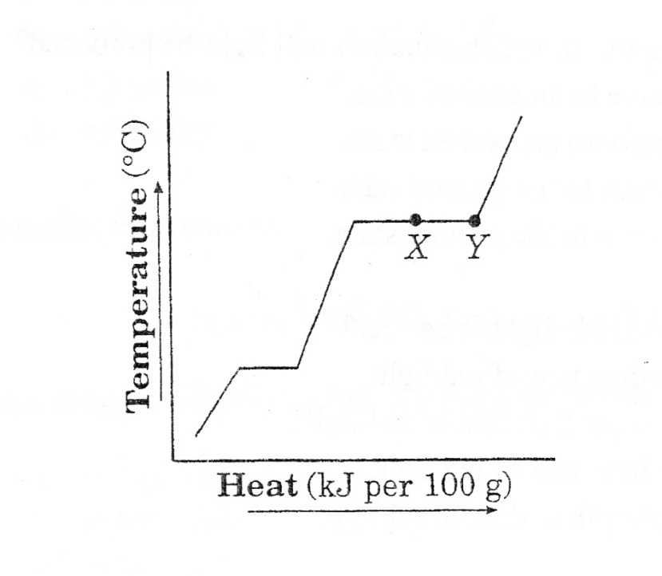
- This is a heating curve for a substance.

Between points X and Y, which would be observed?
  - Solid and liquid will be present.
  - Only vapor will be present.
  - Liquid and vapor will be present.
  - Only liquid will be present.
On this diagram, the diagonals are the states of matter and the horizontal lines are the phase changes. Vaporization and condensation occur at X and Y so both liquid and gas will be present.
- An open container of water is brought to a boil and heated until all of the water is converted to water vapor. Which describes the changes in the water molecules?
  - The molecules speed up and move farther apart.
  - The molecules speed up and move closer together.
  - The molecules slow down and move farther apart.
  - The molecules slow down and move closer together.
As temperature increases, so does kinetic energy as well as distance between molecules. Boiling turns it into a gas and gases have the fastest molecules that are the farthest apart.
- Six grams of gold was heated from 20°C to 22°C. How much heat was applied to the gold?
  - 1.55 J
  - 15.5 J
  - 17.0 J
  - 32.5 J
Use the equation Q = m c ΔT and solve for Q. You have to look up the specific heat of gold using the reference table.
Q=6 x 0.129 x 2

OUTBREAK!!!
MY NAME:
 | People’s germs in my cup before round 1
ROUND 1 | People in my cup before round 2
Round 2 | People in my cup before round 3
Round 3 | People in my cup before round 4
Round 4 | ALL People’s germs in my cup !!!

http://i2sea.stanford.edu/AcidOcean/AcidOcean.htm
Ocean Acidification Virtual Lab Questionnaire

1. What does CO₂ + H₂O produce?

2. When CO₂ combines with water does the pH increase, decrease or remain the same?

3. What are several sources of CO₂? What is CO₂ sink?

4. What is the current level of CO₂ (ppm)

5. What is the pH of an orange?

6. Which organism was studied in your virtual lab?

7. Name a calcifying organism.

8. What is the average pH of seawater?

9. Which larvae were longer; the ones raised in a pH 7.7 or 8.1?

10. How could a smaller larvae impact a kelp forest food web?

Volume of our mixing cup=
Mass of K.A. for solution #1=
Mass of K.A. for solution #2=
Mass of K.A. for solution #3=
Mass of K.A. for solution #4=
https://www.cdc.gov/mobile/applications/sto/web-app.html SOLVE THE OUTBREAK!
