Weekly Planner: All science week of 11.13.18 SEE BOTTOM FOR TEST HINT!
Objectives for the week: Bio.3.4.1 Explain how fossil, biochemical, and anatomical evidence support the theory of evolution. Bio.3.4.2 Explain how natural selection influences the changes in species over time. Bio.3.4.3 Explain how various disease agents (bacteria, viruses, chemicals) can influence natural selection. Chm.1.2.1 Compare (qualitatively) the relative strengths of ionic, covalent, and metallic bonds.
Day | Honors Biology-  EQ= How do scientists classify organisms and why? | Honors Chemistry-  EQ= What are the gas laws and how do we use them?
Mon 11.12 | Holiday | Holiday
Tues  11.13  STUDY BUDDIES! | Notes: Classification  *HW= test corrections! https://www.youtube.com/watch?v=yyX7HH0omIU  HW= finish warm up, do test corrections! | Go over warm up  Set up Lab activity  Pre-lab questions  LAB??  https://www.youtube.com/watch?v=eR49g3ubTBg  *HW= finish lab, finish 1-18,  BOYLES LAW WORKSHEET!
Wed 11.14  STUDY BUDDIES! | Finish dichotomous keys notes!!  Darwin’s Story  *HW= common vs. scientific names (20) | NOTES: Charles’ Law, Combined gas law, ideal gas law,  *HW= test correction, 3 worksheets on notes today!!! (pg 21, 22,and 24)
Thurs  11.15 | Finish all notes  Darwin  Dichotomous key assignment! | GO OVER/ present all homework  https://www.youtube.com/watch?v=RqffPYOoxd8  Partial pressure, test review.  TALK ABOUT CultureCHEM!!
Friday 11.16 | TEST- classification and diversity  **HW= finish dichotomous key presentation!! | Test- Gas laws and thermochemistry  **HW= pgs 67, 68 and 69. (answers given… show work and units to solve!!)

CHEMISTRY AND CULTURE OF THE WORLD: 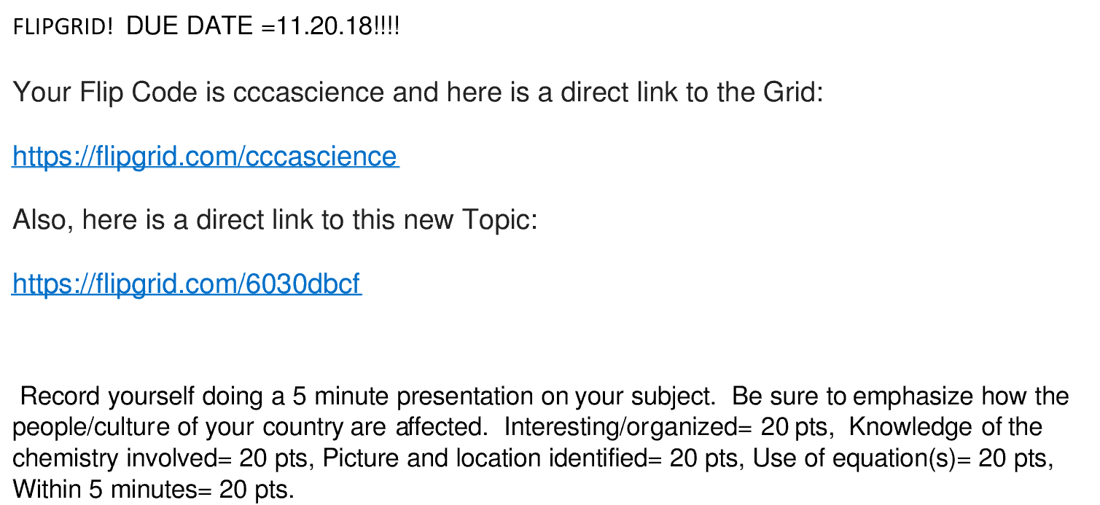

WARM-up 11/13 Tuesday www.evansccca.weebly.com
Reminder to turn off cell phone and put in basket  Make a venn diagram of the following: plant vs fungi cell | Reminder to turn off cell phone and put in basket  You have a cup of 425 g coffee at 98° C that you wish to cool down. What mass of tap water at 18°C would you need to pour in to make it a comfortable 50°C?  Q _{lost by hot water} = Q _{gained by tap water}

WARM-up 11/14 Wed www.evansccca.weebly.com
Reminder to turn off cell phone and put in basket  Name an organism from each of the 6 kingdoms:  -archeabacteria  -Eubacteria  -Protista  -Fungi  -Plantae  -Animalia | Reminder to turn off cell phone and put in basket  A weather balloon is blown up to a volume of 1.2L at sea level. What is the new volume of the balloon at 45kPa (Kilopascals)?

FLIPGRID! DUE DATE =11.20.18!!!!
Your Flip Code is cccascience and here is a direct link to the Grid:
https://flipgrid.com/cccascience
Also, here is a direct link to this new Topic:
https://flipgrid.com/6030dbcf

Record yourself doing a 5 minute presentation on your subject. Be sure to emphasize how the people/culture of your country are affected. Interesting/organized= 20 pts, Knowledge of the chemistry involved= 20 pts, Picture and location identified= 20 pts, Use of equation(s)= 20 pts, Within 5 minutes= 20 pts.
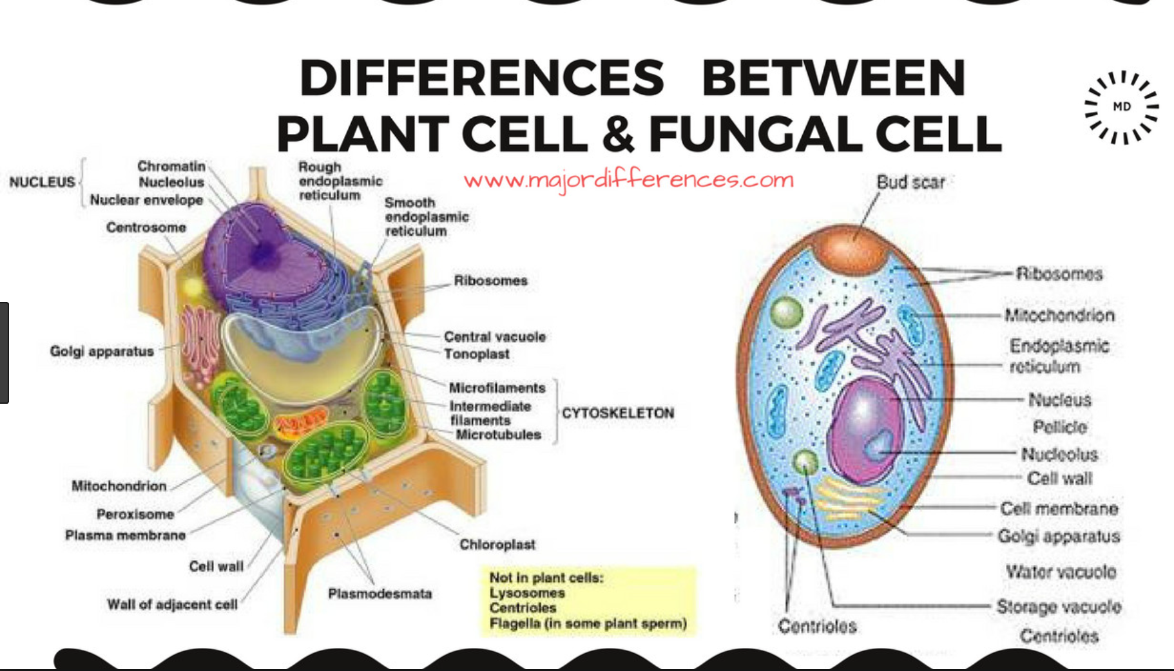
https://www.majordifferences.com/2017/09/6-differences-between-plant-cell-and.html#.W-rirPl961s
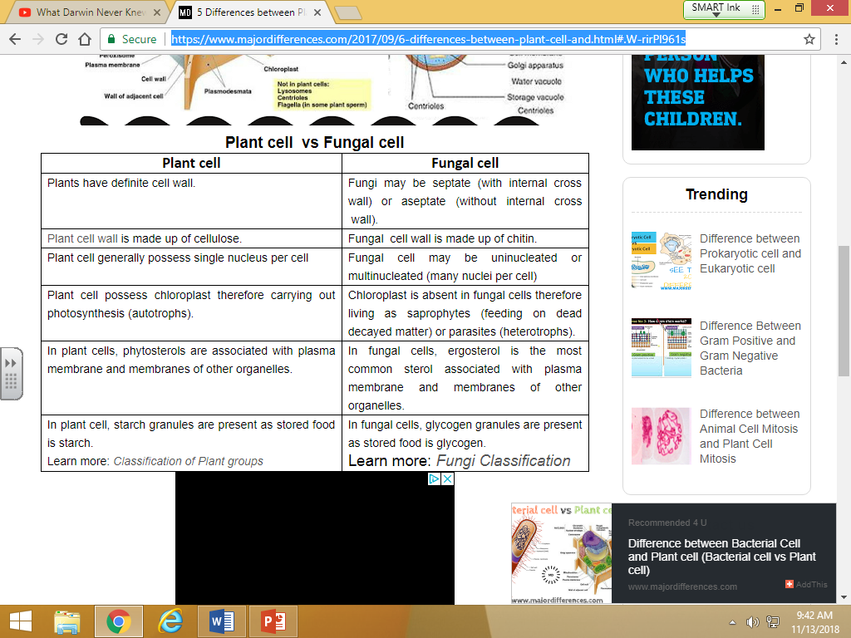

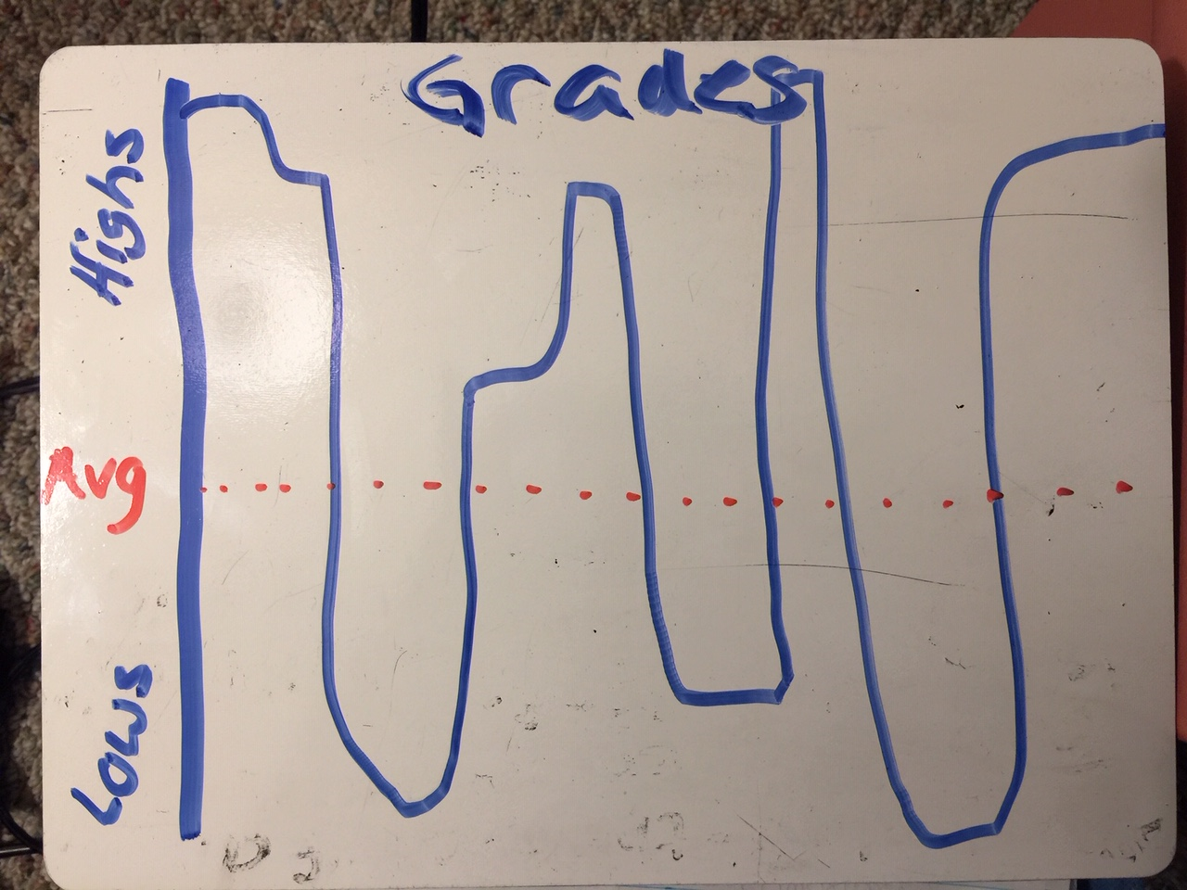
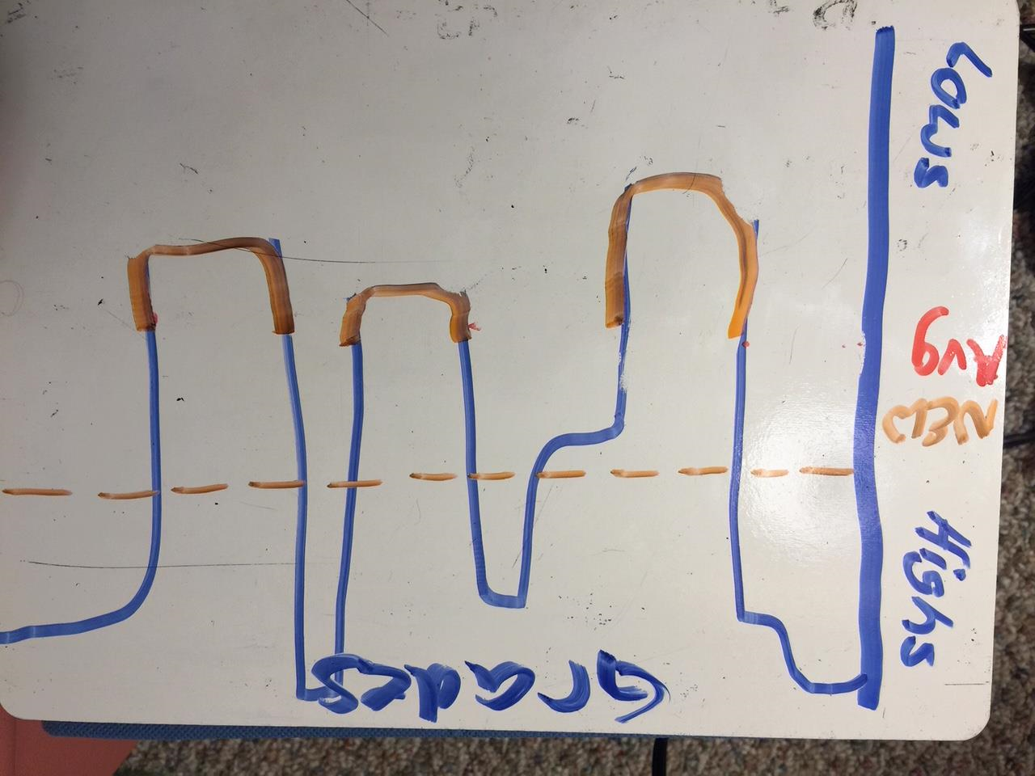

WARM-up 11/15 Thursday www.evansccca.weebly.com
Reminder to turn off cell phone and put in basket  Aristotle classified organisms based on macrotraits. How did the microscope change that? | Reminder to turn off cell phone and put in basket  V_{balloons}= 22.4 dm³  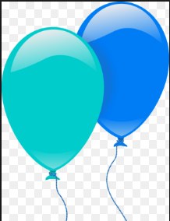 The balloon on the left contains 1 mole of Helium gas. The balloon on the right contains 1 mole Hydrogen gas. Assume STP.  - How many particles are in each?  - What is the density of each? g/mL  - _{Which will float? Why?}

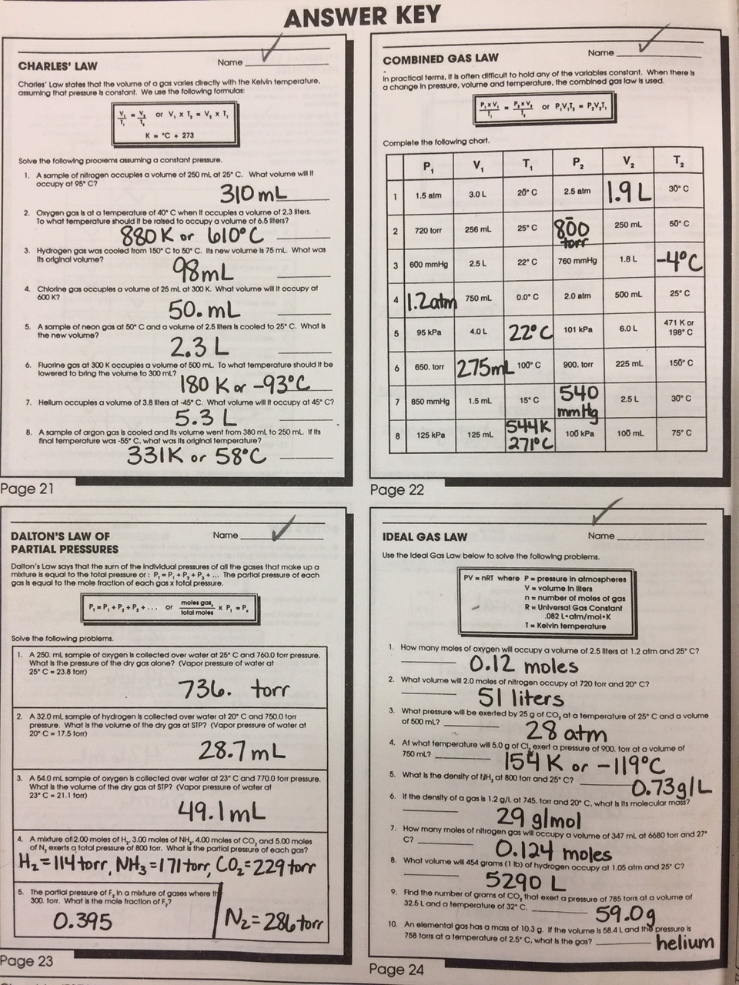

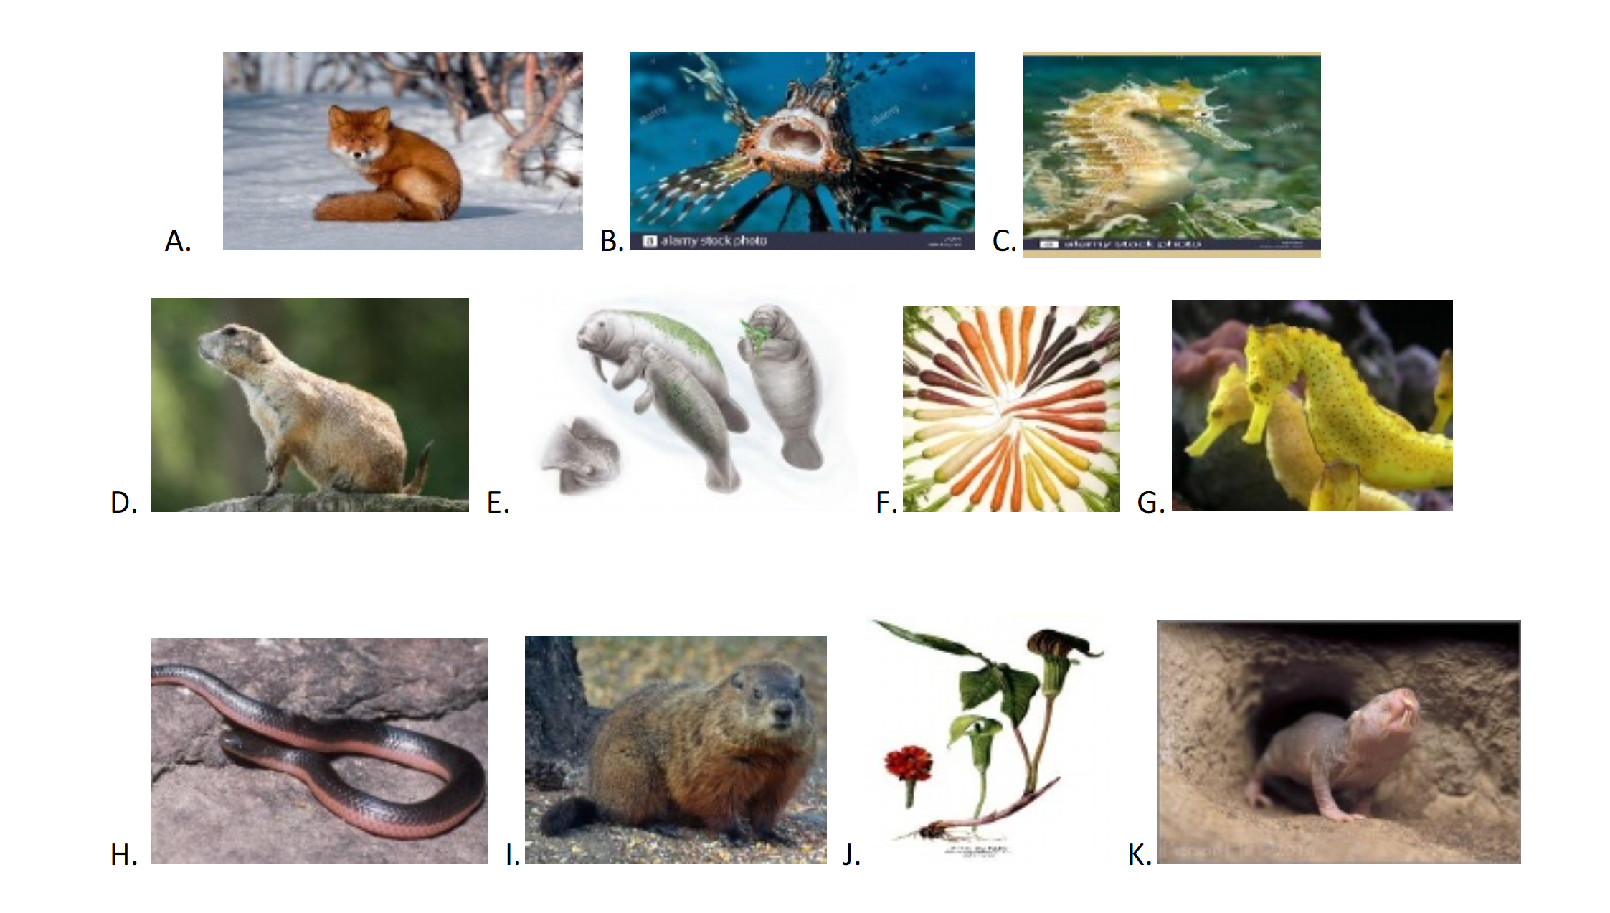
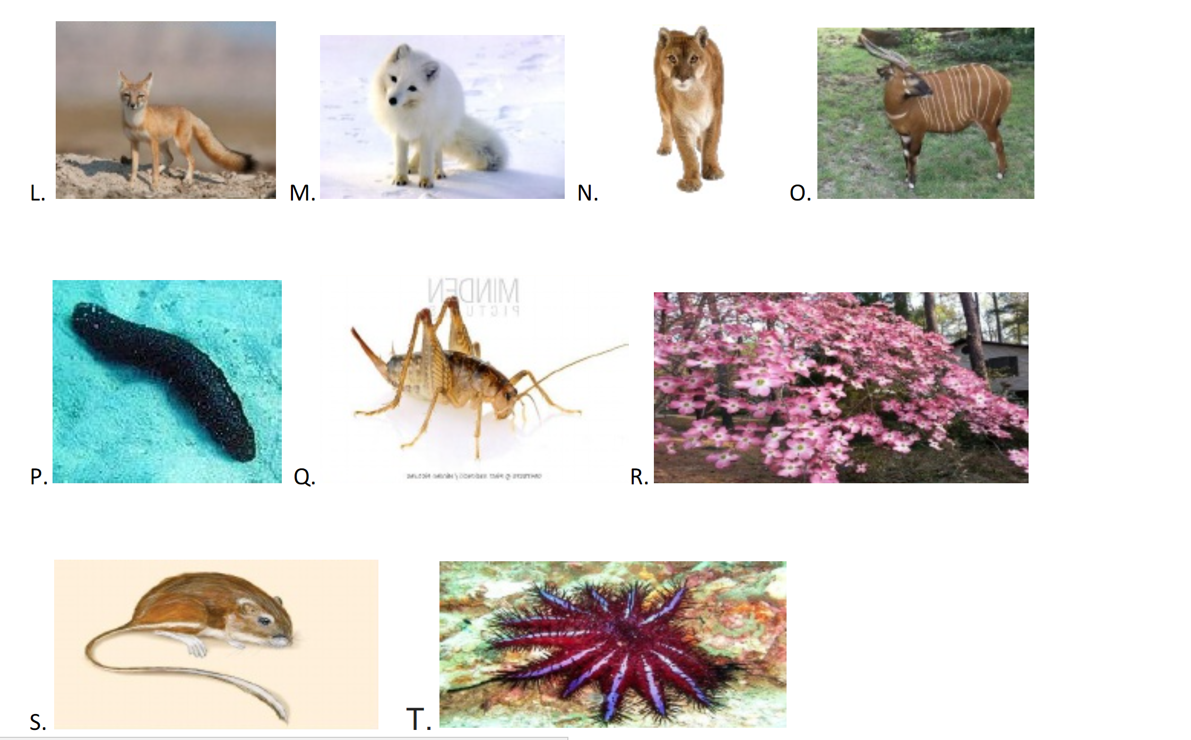

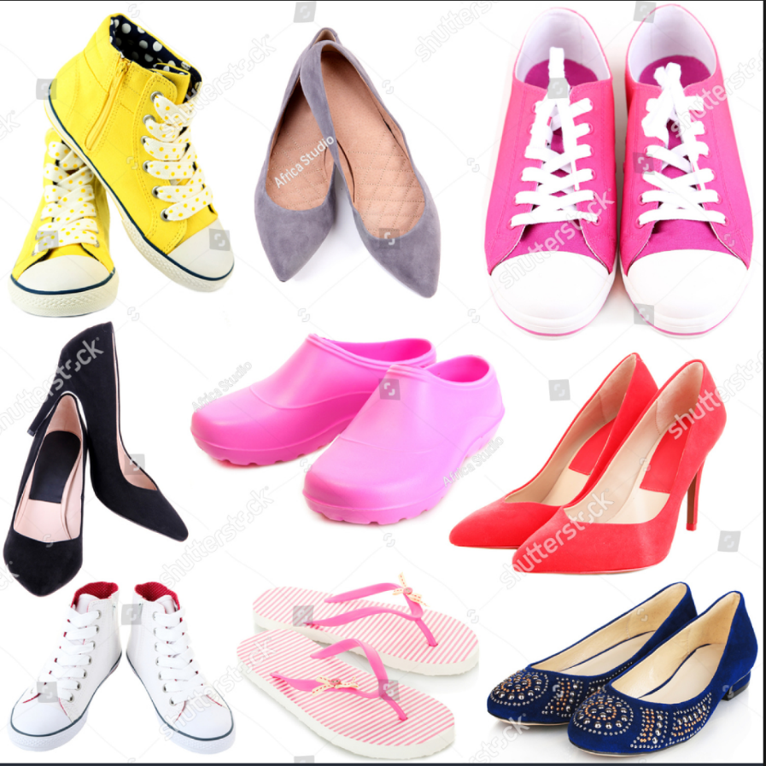

- Are they dress shoes? YES= go to #2, NO = go to #6
- Are they Gray? YES= SHOE B , NO= go to #3
- Are they black? YES= SHOE D, NO= go to #4
- Are they red? YES= SHOE F, NO = go to # 5
- Are they blue? YES= SHOE I
- Are they flip flops? YES= Shoe H, No= go to
- Do they have yellow dotted shoestrings? YES= SHOE A, NO= go to #8
- Are they High tops? YES= SHOE G , No= go to #9
- Are they pink with laces? YES= SHOE C, No= go to #10
- Are they pink and used in the rain? YES= Shoe E, No= go to #1

BIOLOGY!! Your Flip Code is cccascience and here is a direct link to the Grid:
https://flipgrid.com/cccascience
Also, here is a direct link to this new Topic:
https://flipgrid.com/7b8a2547 DUE DATE 11/20/18!!! You will make a collage of 10 items then create a working dichotomous key for them.
Your presentation will show both the collage and the dichotomous key. You will also present HOW to use your key for the most complicated item to find on that key. Your classmates will be voting on how well you made your key as well as how well you present it!
Good luck and HAVE FUN!!

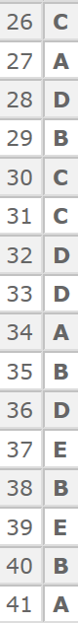 IIIIII IIIII

WARM-up 11/16 Friday www.evansccca.weebly.com
Reminder to turn off cell phone and put in basket  What was your favorite scientific name this week and WHY? | Reminder to turn off cell phone and put in basket  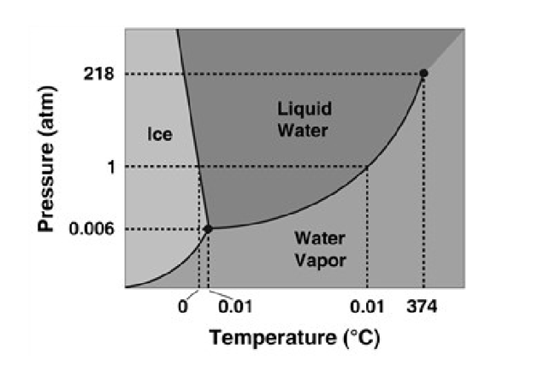  - At what temperature and pressure is the triple point?  - What happens at the triple point?

CHEM VERSION A= Answers to 11, 14 and 17 are E!!
CHEM VERSION B= Answers to 3, 15 and 18 are E!!
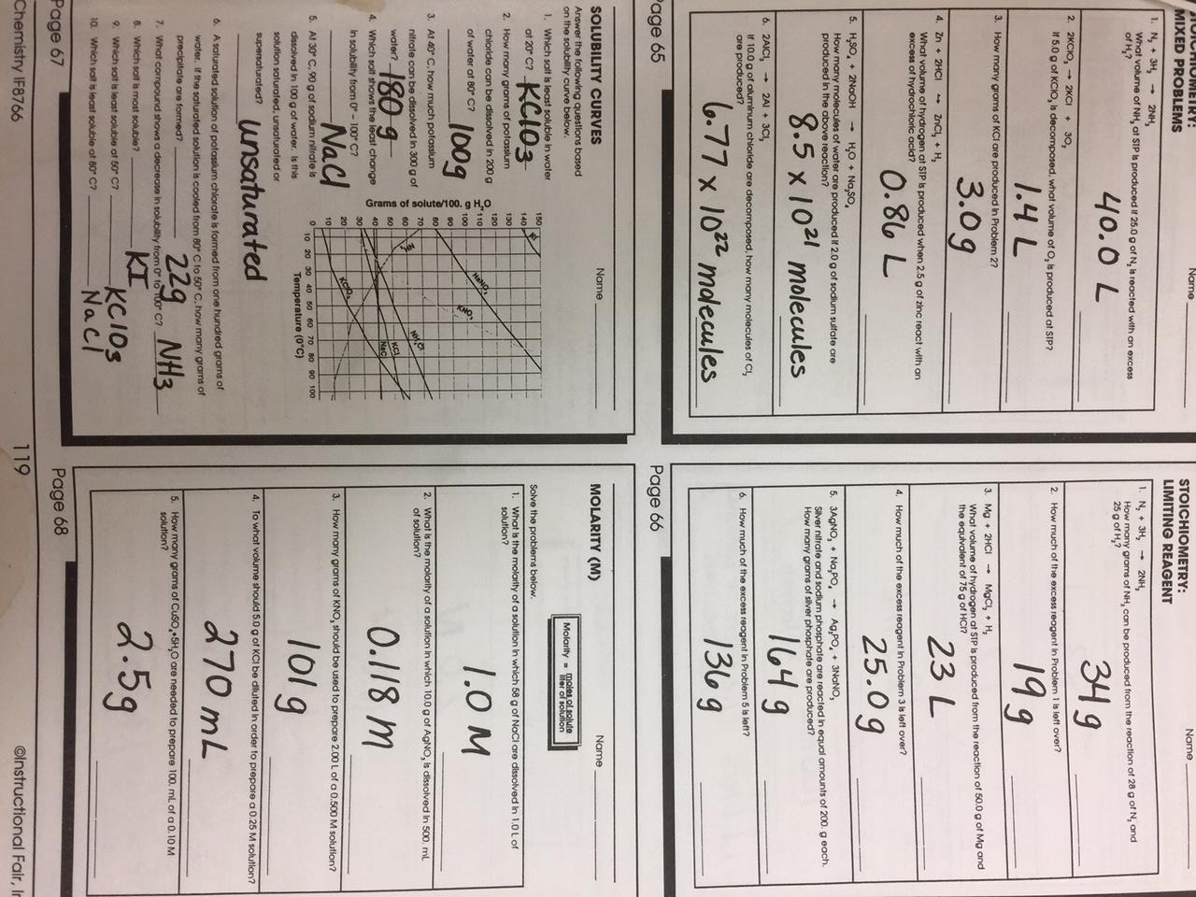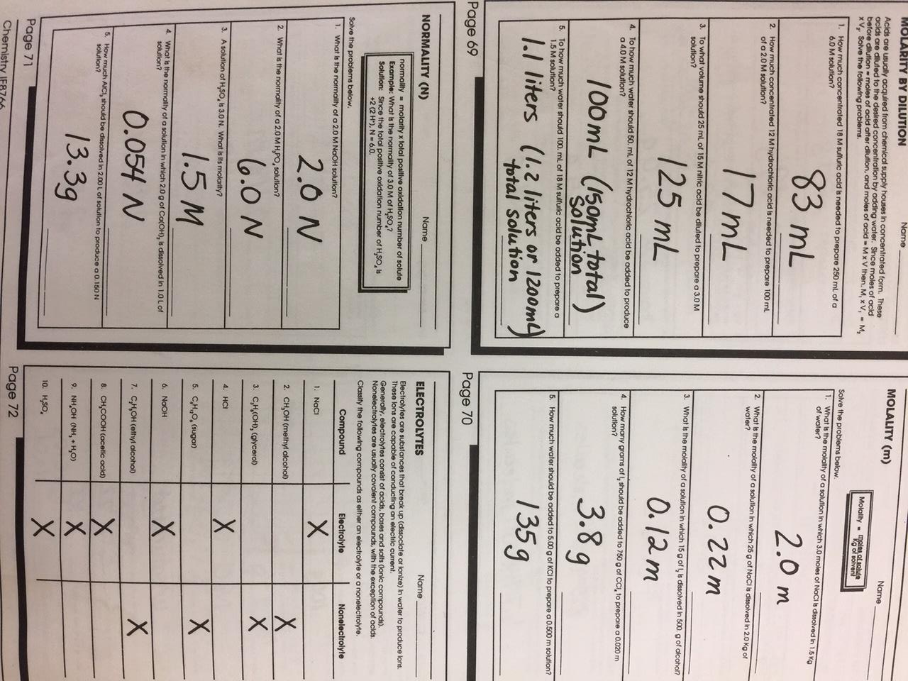

BIO TEST essay- Describe how Aristotle classified organisms vs. Linnaus
CHEM test= Explain why a change of state means there is no change in temperature.

