Weekly Planner: All science week of 10.8.18 



**Objectives for the week**: Bio.3.1.1 Explain the double-stranded, complementary nature of DNA as related to its function in the cell.

Chm.1.3.1 Classify the components of a periodic table (period, group, metal, metalloid, nonmetal, transition). Chm.1.3.2 Infer the physical properties (atomic radius, metallic and nonmetallic characteristics) of an element based on its position on the Periodic Table. Chm.1.3.3 Infer the atomic size, reactivity, electronegativity, and ionization energy

|  |  |  |
| --- | --- | --- |
| Day | **Honors Biology** – How do cells reproduce? | **Honors Chemistry** -How does the periodic table work? |
| Mon 10/8 | -Warm up and HW check  -Notes: mitosis (15 slides)  -Virtual lab: mitosis  -fix project  *HW= virtual LAB #1- mitosis | -Warm up and HW check  -video presentations of moletown  -Periodic table info  *HW= REVIEW your video! And 20 q periodic properties. |
| Tues 10/9  STUDY BUDDIES! | **-Warm up and HW check**  **-finish mitosis/meiosis notes**  **-get tests back**  *HW= test corrections | -Warm up and HW check  -go over HW  -video presentations of moletown?  -Periodic table info  **\*HW= test corrections** |
| STUDY 10/10 BUDDIES!  Ms. E- check PLC | **-Warm up and HW check**  **-Mid term review!**  **-Karyotype lab**  **https://create.kahoot.it/kahoots/my-kahoots**  **\*HW= Karyotype lab, #1-72, kahoot?** | **-Warm up and HW check**  **-Mid term review!**  **-Ionic/covalent bonds**  **https://create.kahoot.it/kahoots/my-kahoots** |
| Thurs 10/11 | **-Warm up and HW check**  **-Mid term review!**  **https://create.kahoot.it/kahoots/my-kahoots** | **-Warm up and HW check**  **-Mid term review!**  **-electronegativity and electron affinity**  **https://create.kahoot.it/kahoots/my-kahoots** |
| Friday 10/12 | **BIO- mid term** | **CHEM- mid term** |

Monday 10.8.18- https://evansccca.weebly.com/

|  |  |
| --- | --- |
| **BIO Warm up:**  Turn OFF your cell phone and put in bin 😊   1. Explain how it is possible that we share 40% similar DNA with Yeast cells.   https://www.youtube.com/watch?v=ks7DMu-p0J8 | **CHEM Warm up:**  Turn OFF your cell phone and put in bin 😊   1. Describe the brilliance of Mendeleev’s periodic table.   Periodic table: https://www.youtube.com/watch?v=uPkEGAHo78o  Mendeleev: https://www.youtube.com/watch?v=fPnwBITSmgU |

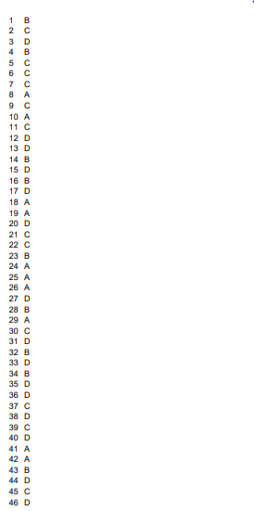

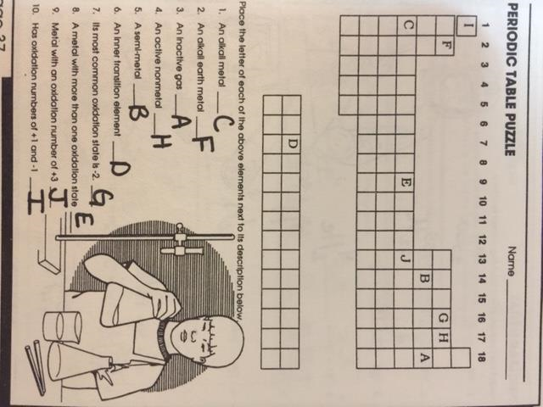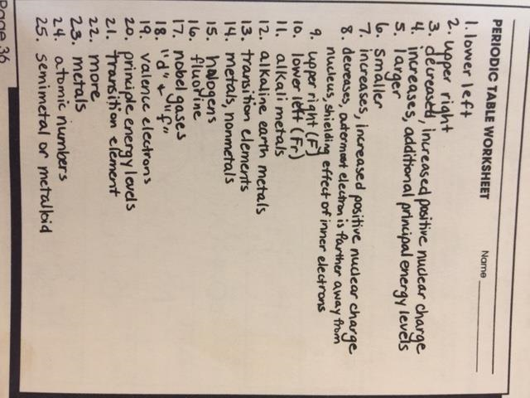

Tuesday 10.9.18- https://evansccca.weebly.com/

|  |  |
| --- | --- |
| **BIO Warm up:**  Turn OFF your cell phone and put in bin 😊  Describe the purpose of meiosis and explain why it is called a “reduction division”.  <https://www.youtube.com/watch?v=VzDMG7ke69g> | **CHEM Warm up:**  Turn OFF your cell phone and put in bin 😊  Write the electron configuration and the Lewis dot diagram for the following:  Li , Li+ Ca, Ca2+ Al, Al 3+ |
| **Human egg cells have 23 chromosomes.** |  |

Wednesday 10.10.18- https://evansccca.weebly.com/

|  |  |
| --- | --- |
| **BIO Warm up:**  Turn OFF your cell phone and put in bin 😊  Make a Venn diagram for Meiosis vs Mitosis | **CHEM Warm up:**  Turn OFF your cell phone and put in bin 😊  Draw a Bohr diagram of an atom that has an electron absorbing a photon to jump to an excited state.  <https://www.youtube.com/watch?v=h3E9jNDnrDo>  COOL!!!! <https://www.youtube.com/watch?v=FzKwxqV0QJ8>  Note… the wavelength ( ) of microwaves are ..  **wavelength of microwave oven** radiation is about 12 cm and the quantum energy of a **microwave** photon is about 1 x 10-5 eV. |

Thursday 10.11.18- https://evansccca.weebly.com/

|  |  |
| --- | --- |
| **BIO Warm up:**  Turn OFF your cell phone and put in bin 😊  What is ATP? | **CHEM Warm up:**  Turn OFF your cell phone and put in bin 😊  Draw Lewis dot diagrams for Mg, Cl, Na, Ca, and O |

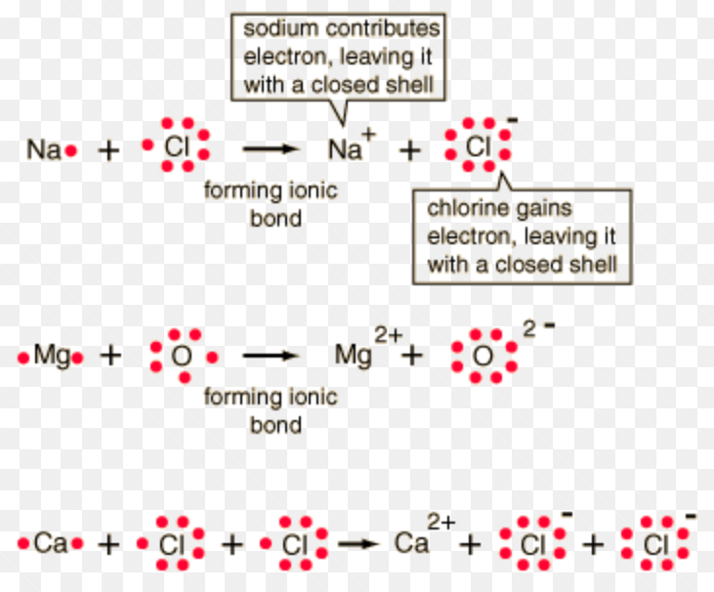

Friday 10.12.18- https://evansccca.weebly.com/

|  |  |
| --- | --- |
| **BIO Warm up:**  Turn OFF your cell phone and put in bin 😊  What is ADP?  [https://play.kahoot.it/#/k/4668db13-b9e3-4624-98a7-188bacd3b8a6](https://play.kahoot.it/%23/k/4668db13-b9e3-4624-98a7-188bacd3b8a6) | **CHEM Warm up:**  Turn OFF your cell phone and put in bin 😊  Write the formulas for the compounds above! |
|  | |
|  | **Ca2+ + Cl- 🡪 CaCl2**  **Mg+2 + O2- 🡪 MgO**  **Na+ + Cl - 🡪 NaCl**  **Ca2+ + (OH)- 🡪 Ca(OH)2** |

