Weekly Planner: All science week of 10.29.18 



**Objectives for the week**: Bio.3.3.1 Interpret how DNA is used for comparison and identification of organisms. Bio.3.3.2 Summarize how transgenic organisms are engineered to benefit society. Bio.3.3.3 Evaluate some of the ethical issues surrounding the use of DNA technology (including cloning, genetically modified organisms, stem cell research, and Human Genome Project).

Chm.2.2.5 Analyze quantitatively the composition of a substance (empirical formula, molecular formula, percent composition, and hydrates).

|  |  |  |
| --- | --- | --- |
| Day | **Honors Biology** – How can biotechnology change the world? | **Honors Chemistry** -What are the stoichiometric exchanges in chemistry and how do we use them? |
| Mon 10/29 | Notes: Biotechnology  <https://www.youtube.com/watch?v=BK12dQq4sJw> HOW it’s done  <https://www.youtube.com/watch?v=AhsIF-cmoQQ> HUMAN GENOME  **HW= virtual lab #1-12!!** | Go Over %yield and hydrates  Notes: Limiting reactant  <https://phet.colorado.edu/en/simulation/legacy/reactants-products-and-leftovers>  HW= #1-4, pictures, units, units of what, FULL page each problem! |
| Tues 10/30  STUDY BUDDIES! | [**https://www.youtube.com/watch?v=jAhjPd4uNFY&t=1s**](https://www.youtube.com/watch?v=jAhjPd4uNFY&t=1s) **CRISPR**  **DNA Fingerprinting notes**  **HW= Finish virtual lab and Test corrections!** | **Presentations! #1-4**  **HW= Limiting reagent worksheet # 1-3 problems.** pictures, units, units of what, FULL page each problem! |
| STUDY 10/31 BUDDIES! | <https://www.youtube.com/watch?v=bfGcm54ppNQ> EXTREME GENES of rarity  LAB!!! DNA extraction!  HW= finish test corrections and study! | HW Verification  Short quiz?  LAB!!! Limiting reactant  HW= finish lab, do warm up. |
| Thurs 11/1 | **TEST CORRECTIONS DUE**  **-Finish notes: biotech**  [**https://www.youtube.com/watch?v=3d88uMH8KIA**](https://www.youtube.com/watch?v=3d88uMH8KIA) **Extreme genes!**  **HW= fix quiz (use your notes), study for test!** | Finish unit notes  HW= do practice test  FIX your quiz! |
| Friday 11/2 | **TEST** | **TEST**  **HW= read Ch 11**  [**https://cnx.org/contents/s8Hh0oOc@13.11:Pj8cW7X1@8/Introduction**](https://cnx.org/contents/s8Hh0oOc@13.11:Pj8cW7X1@8/Introduction)  **& DO TEST CORRECTIONS** |

Monday 10.29.18- https://evansccca.weebly.com/

|  |  |
| --- | --- |
| Remember to turn off cell phone and put in basket 😊  What are stem cells and how do they become “anything the body needs”? | Remember to turn off cell phone and put in basket 😊  What is percent yield, and give an example of how % yield affects industrial production.  i.e. Ammonia production |

TODAY AND TOMORROW= VOTE FOR ROSSEY!

This week: SPIRIT WEEK

Here are the days:

**Monday: Crazy Hair VS. Tacky Clothes**

**Tuesday: Past VS. Future**

**Wednesday: Reality VS. Fantasy**

**Thursday: City VS. Country**

**Friday: Sleepwear VS. Business-wear**

<https://www.hhmi.org/biointeractive/bacterial-identification-virtual-lab>

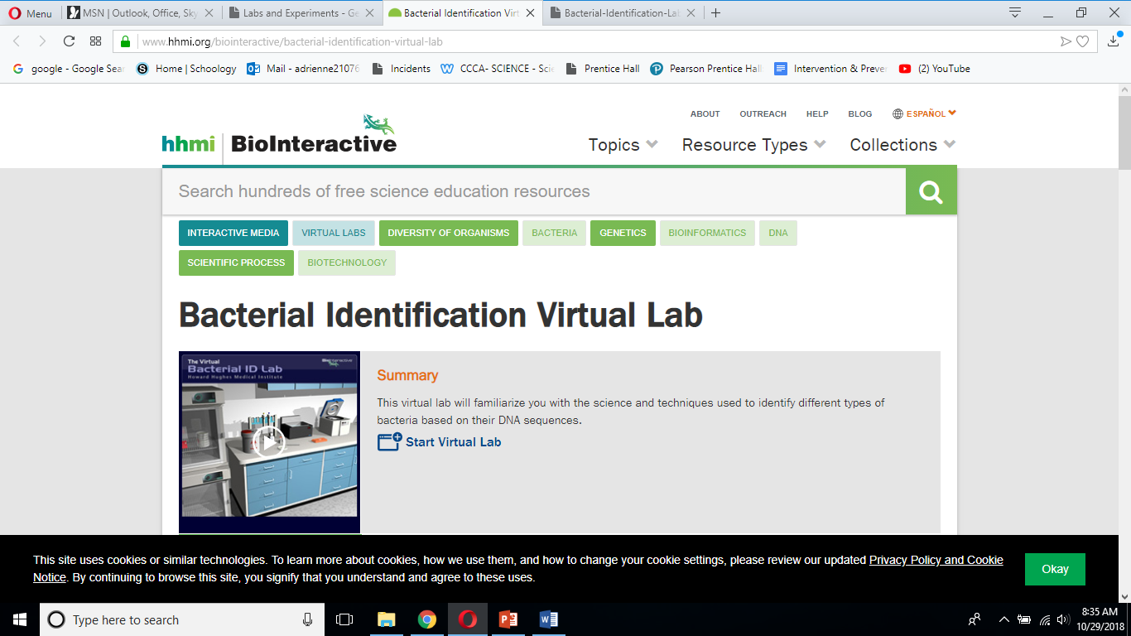

Tuesday 10.22.18- https://evansccca.weebly.com/

|  |  |
| --- | --- |
| Remember to turn off cell phone and put in basket 😊  What was the human genome project and why was it so important? | Remember to turn off cell phone and put in basket 😊  Describe a limiting reactant, an excess reactant, and explain HOW to figure out the amount of excess reactant left over. |

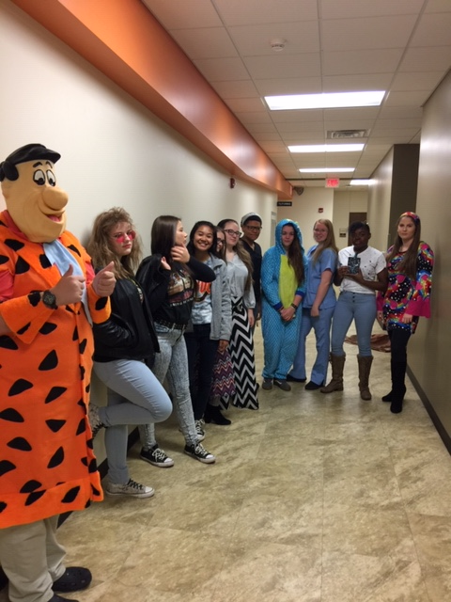

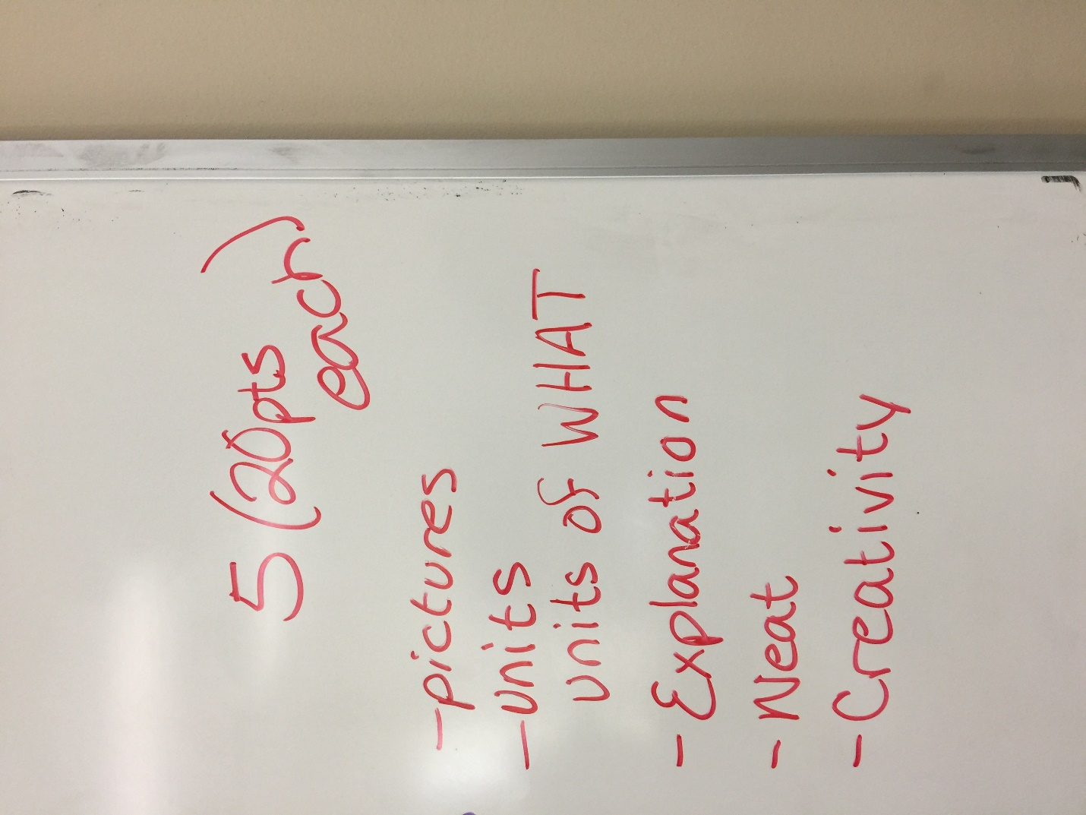

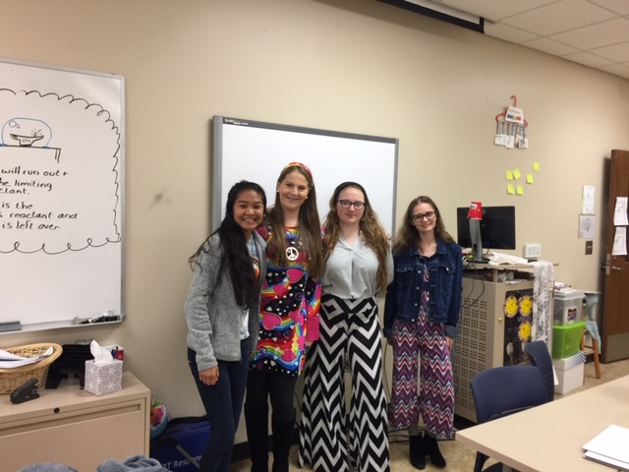

Wednesday 10.31.18-https://evansccca.weebly.com/

|  |  |
| --- | --- |
| Remember to turn off cell phone and put in basket 😊  What is CRISPR and how does it work? | Remember to turn off cell phone and put in basket 😊  NAME the following compounds and identify them as either ionic or covalent:  CaCl2  S2O3  CCl4  N2O  NH4Cl  FeSO4 |

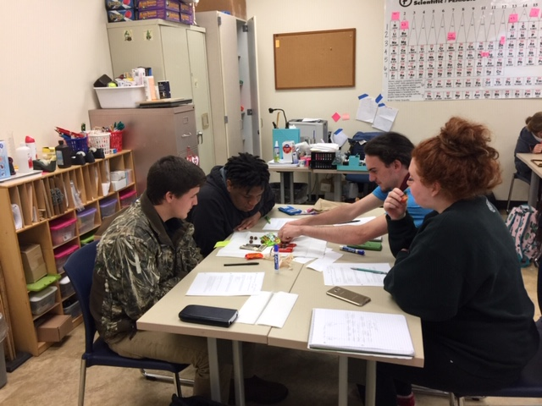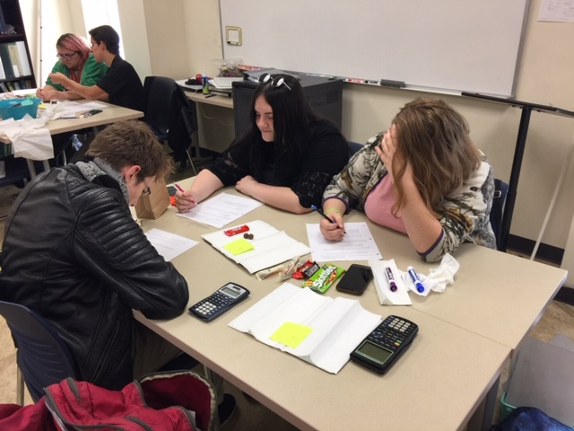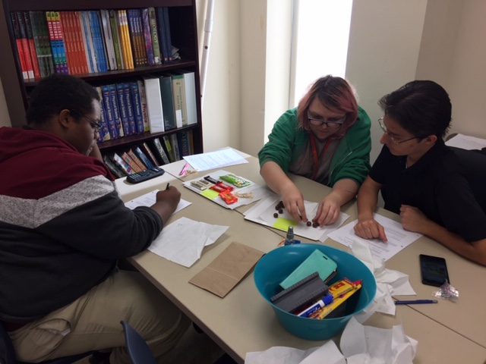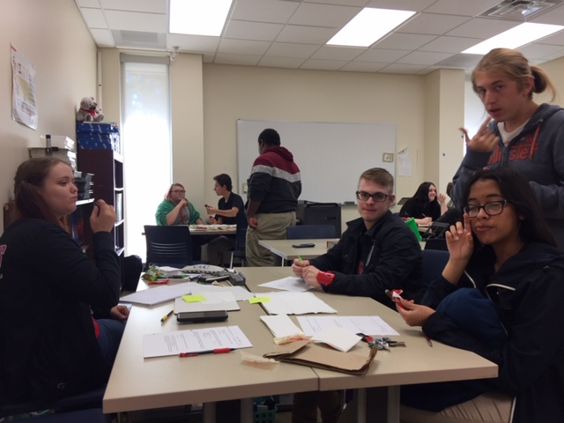

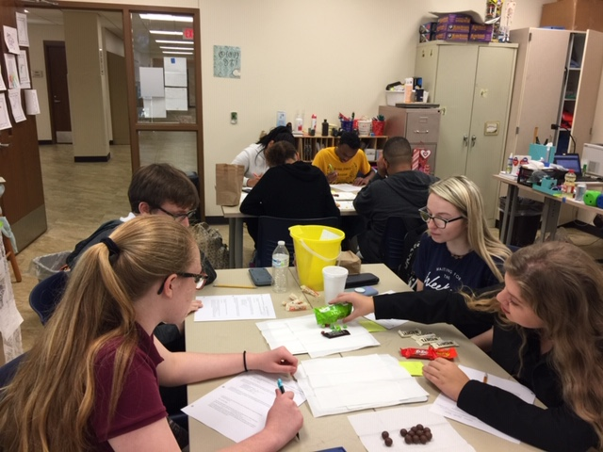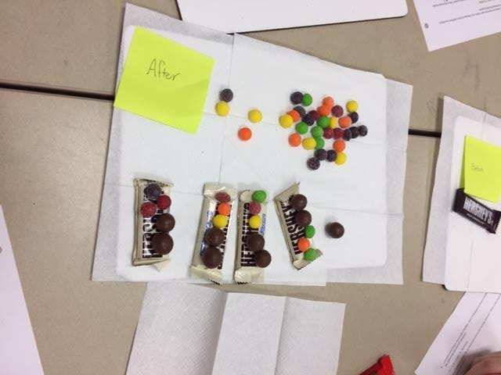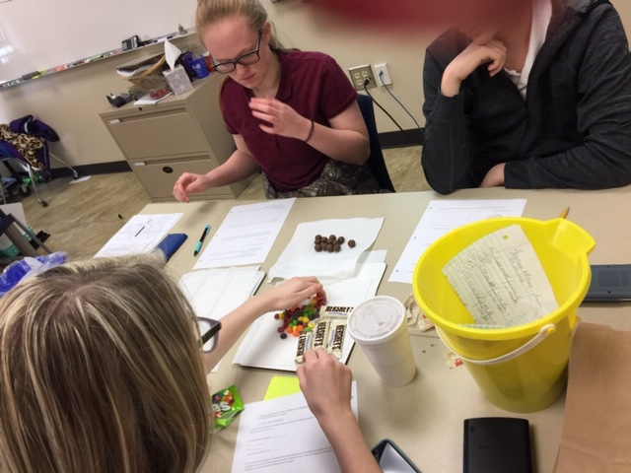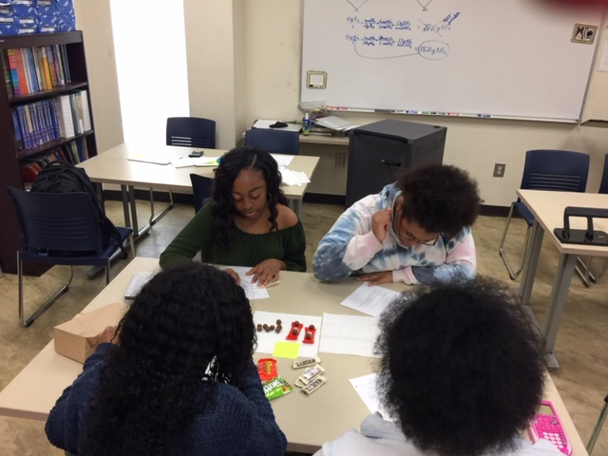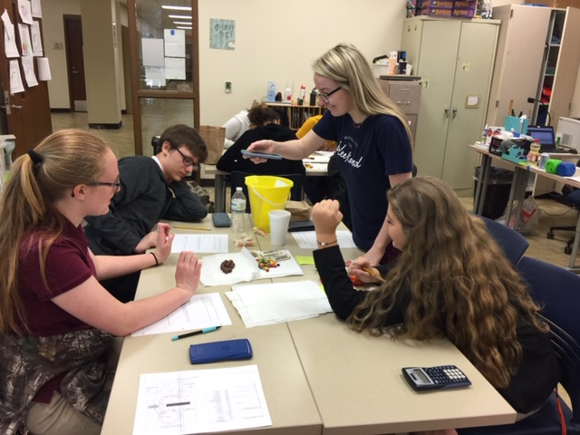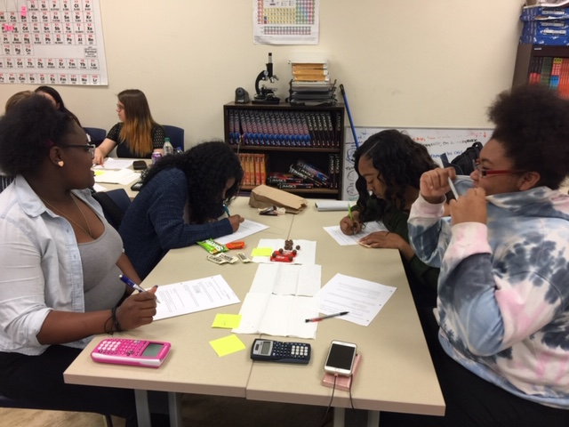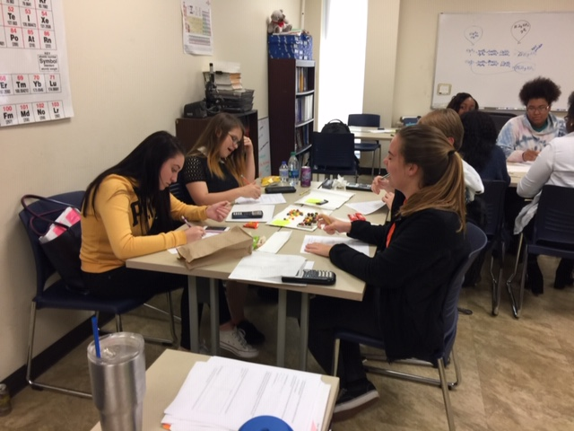

What is a DNA microarray?

Thursday 11/1/18-https://evansccca.weebly.com/

|  |  |
| --- | --- |
| Remember to turn off cell phone and put in basket 😊  What is a DNA microarray?  <https://www.youtube.com/watch?v=6ZzFihESjp0> | Remember to turn off cell phone and put in basket ☺  LABEL THE FOLLOWING AS IONIC OR COVALENT THEN WRITE OUT THE NAMES OR EACH:  NiCl, N2F, CoBr2, Li3PO4, S2O5 |

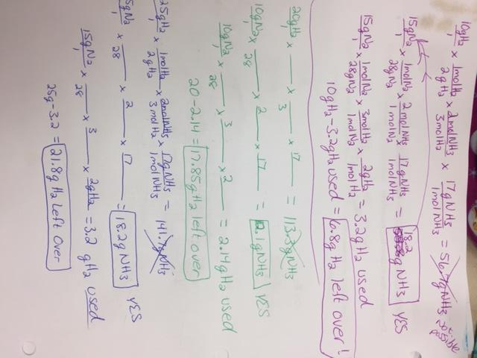

Friday 11/2/18- https://evansccca.weebly.com/

|  |  |
| --- | --- |
| Remember to turn off cell phone and put in basket 😊  **Are you FOR or AGAINST biotechnology? WHY?** | Remember to turn off cell phone and put in basket ☺  What is the volume of 1 gram of hydrogen gas at STP? |

