Weekly Planner: All science week of 10.22.18 



**Objectives for the week**: Bio.3.2.2 Predict offspring ratios based on a variety of inheritance patterns (including dominance, co-dominance, incomplete dominance, multiple alleles, and sex-linked traits). Bio.3.2.3 Explain how the environment can influence the expression of genetic traits.

Chm.1.3.1 Classify the components of a periodic table (period, group, metal, metalloid, nonmetal, transition).

|  |  |  |
| --- | --- | --- |
| Day | **Honors Biology** – How does genetic make up determine traits? | **Honors Chemistry** -What is the language of chemistry and how do we use it? |
| Mon 10/22 | -Dragon wrap-up  [www.youtube.com/watch?v=8FIDeOOL52Q&t=1s](http://www.youtube.com/watch?v=8FIDeOOL52Q&t=1s)  -Notes: pedigree charts, blood types, and genetic disorders.  HW= Ch 8.3 all end of chapter questions | -Packet wrap up  -Notes: types of reactions  -Pg 58-61: writing and balancing equations  HW= pg 58-61 |
| Tues 10/23  STUDY BUDDIES! | -Notes: pedigree charts, blood types, and genetic disorders.  **HW= finish whole packet**  **-will be graded for completion** | **Classwork (Garrison and Hannah lead)**  **15q at 6 pts each**  **-underline givens**  **-circle wanted**  **-show all work and units**  **-show all units of WHAT**  **-prove how units cancel out**  **-box in final answer**  **Will be graded for completion.** |
| STUDY 10/24 BUDDIES! | **-notes: biotechnology**  **-Genetic disorders vLab**  **HW= 3 family pedigrees with whatever trait/genetic disease you like.** | **-Notes: Acid/base reactions**  **-Ionic and net ionic equations**  **HW= 10 problems, 3 equations each** |
| Thurs 10/25 | **10th graders to F/B..you are STILL responsible for HW!!**  **-CW/HW=3 pedigree charts and the 4 quiz questions below.** | STATIONS!  Actual test questions at each.  HW= stations are posted below |
| Friday 10/26 | ***TEST***  ***HW= read ch 10***  [***https://cnx.org/contents/s8Hh0oOc@13.7:Pdu1uR8Y@6/Introduction***](https://cnx.org/contents/s8Hh0oOc@13.7:Pdu1uR8Y@6/Introduction) | **TEST**  **HW= research: % yield, limiting reactant and hydrates** |

Monday 10.22.18- https://evansccca.weebly.com/

|  |  |
| --- | --- |
| Remember to turn off cell phone and put in basket 😊  How is a Zygote different from a haploid cell? How are they similar? | Remember to turn off cell phone and put in basket 😊  2 g Magnesium burns in air, what mass of magnesium oxide is produced?  <https://www.youtube.com/watch?v=fErqU1mwRX0> |

Pedigree analysis: <http://virtuallabs.stanford.edu/life/pedigree.swf>

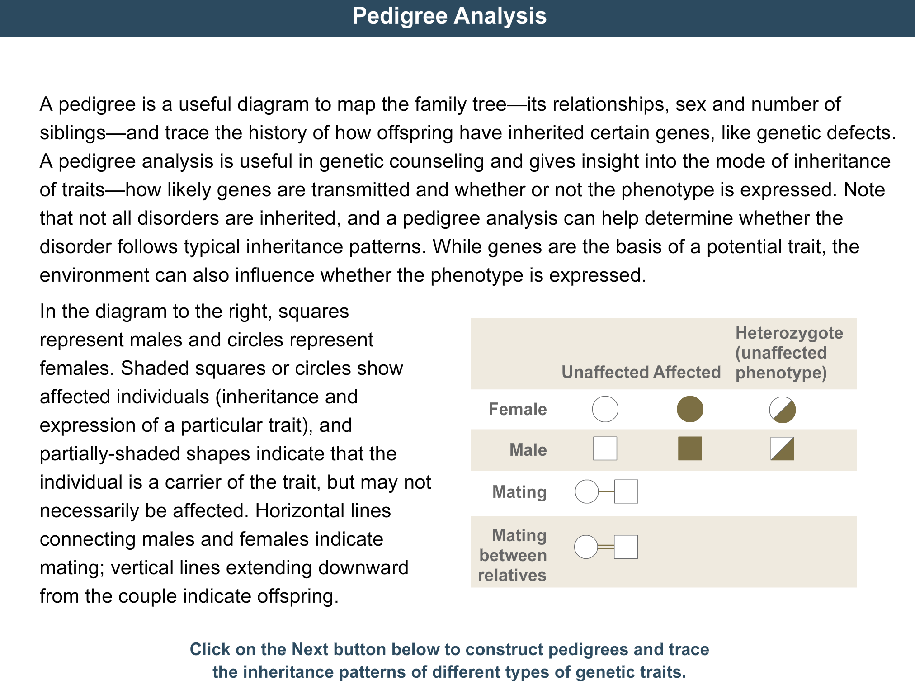

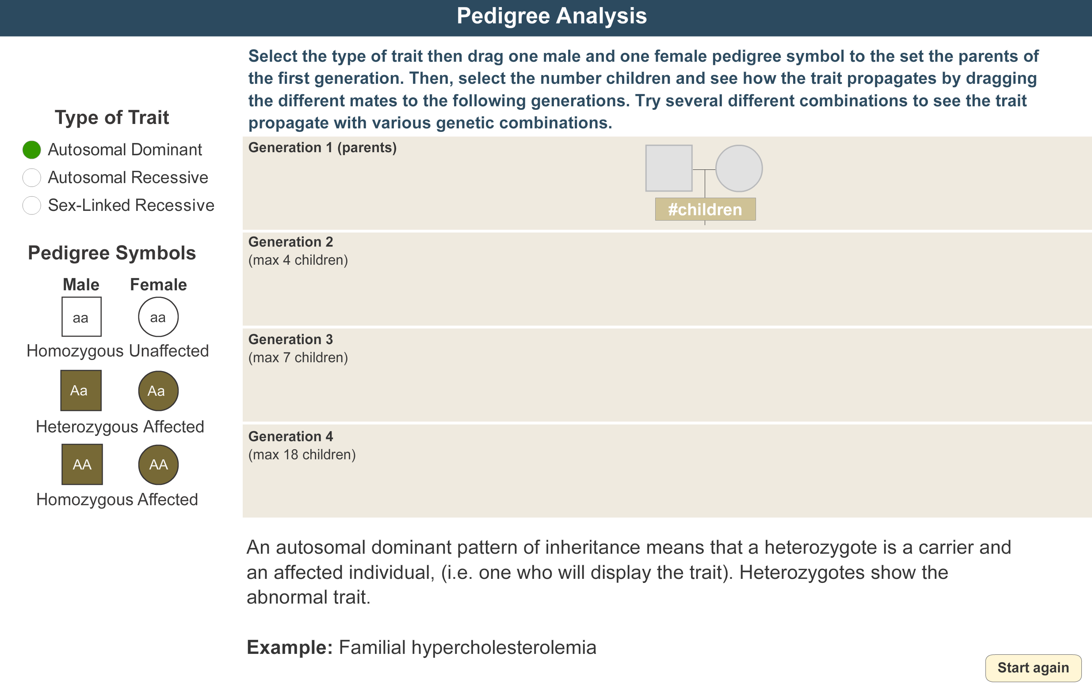

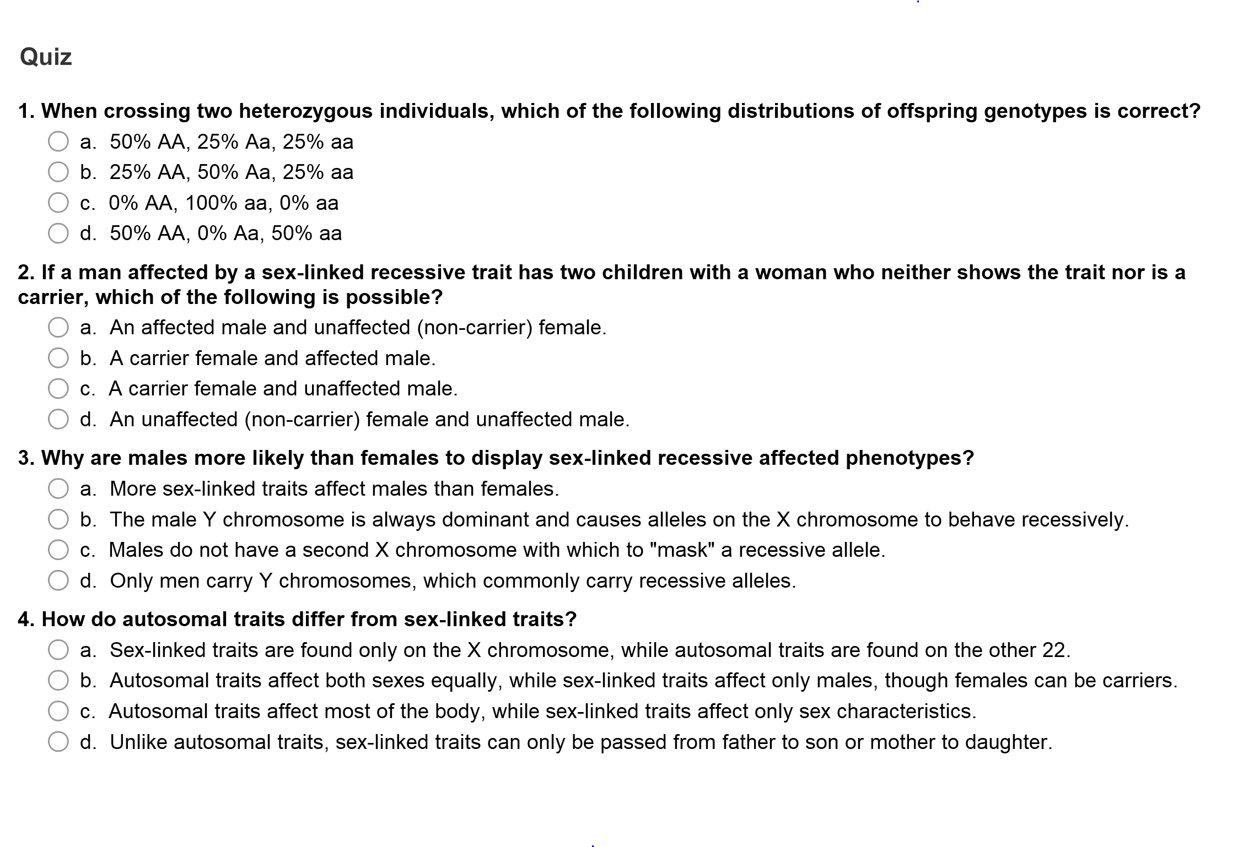

Tuesday 10.23.18- https://evansccca.weebly.com/

|  |  |
| --- | --- |
| Remember to turn off cell phone and put in basket 😊  What is an antigen?  What is an antibody?  <https://www.youtube.com/watch?v=ttjn1jVACk8> Blood type | Remember to turn off cell phone and put in basket 😊  10.0 grams of Zinc reacts with excess HCl. What mass of Zinc chloride is produced?  What volume of hydrogen gas is produced? |

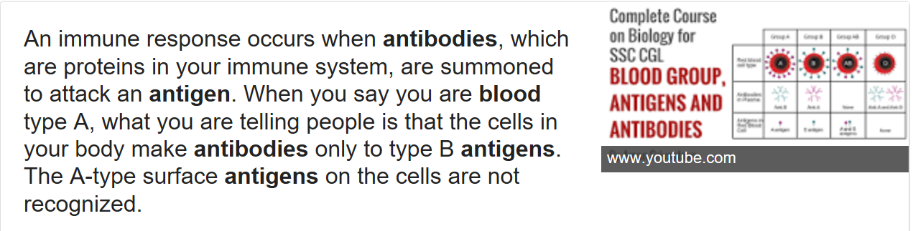

Wednesday 10.24.18- https://evansccca.weebly.com/

|  |  |
| --- | --- |
| Remember to turn off cell phone and put in basket 😊  What are pedigree charts and how do you use them?  <https://www.youtube.com/watch?v=Gd09V2AkZv4> | Remember to turn off cell phone and put in basket 😊  From Tuesday’s problem,  What volume of hydrogen gas is produced? |

Thursday10.25.18- https://evansccca.weebly.com/

|  |  |
| --- | --- |
| Remember to turn off cell phone and put in basket 😊  What causes sickle cell anemia? | Remember to turn off cell phone and put in basket 😊  Write a net ionic equation for an acid and a base reacting. |

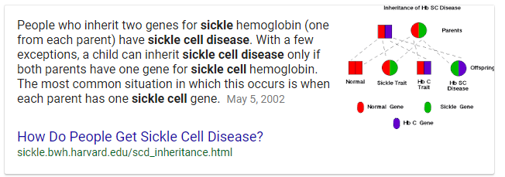

Friday 10.26.18- https://evansccca.weebly.com/

|  |  |
| --- | --- |
| Remember to turn off cell phone and put in basket 😊  What is disjunction? Non-disjunction? | Remember to turn off cell phone and put in basket 😊  A compound contains 2.4 g of Carbon and 0.8 g of hydrogen. What is the mole ratio of elements?  What is the empirical formula? |

[ib.bioninja.com.au](https://www.google.com/imgres?imgurl=http://ib.bioninja.com.au/_Media/nondisjunction-2_med.jpeg&imgrefurl=http://ib.bioninja.com.au/standard-level/topic-3-genetics/33-meiosis/non-disjunction.html&h=550&w=930&tbnid=EdjUKFvexGBbTM:&q=disjunction+and+nondisjunction&tbnh=126&tbnw=214&usg=AI4_-kT46EP-gXBXOij4ZbGA_f2YMtlSAg&vet=1&docid=PUX5aAm6zRwBiM&sa=X&ved=2ahUKEwjErqvlkqTeAhWDhOAKHa1nCrYQ9QEwAHoECAwQBg)

**Disjunction** takes place twice meiosis, when the sister chromatids separate and move to the opposite poles. To compare this with non-**disjunction** is when this process of separation of chromatids (mitosis) and homologous chromosomes (meiosis) fails to occur.

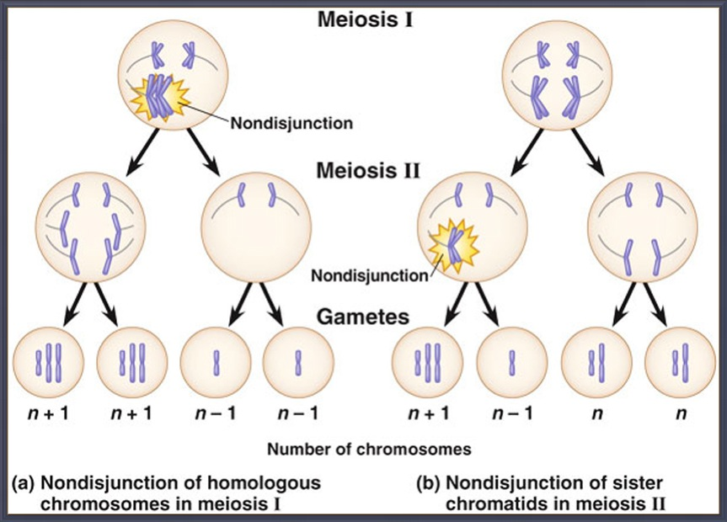

BIOLOGY STUDY GUIDE!!

1. Explain mutations can occur in DNA sequencing? (i.e. deletion, insertion…)
2. Sickle cell anemia is a genetic condition that occurs because of a single point mutation in the DNA gene for hemoglobin. How is this mutation expressed in humans?
3. What prevents thymine from pairing with guanine in DNA?
4. What prevents adenine from pairing with cytosine in DNA?
5. What happens during transcription?
6. How does meiosis explain the variety of genotypes in potential offspring?
7. How are each of these inherited? A. diabetes B. cystic fibrosis C. hemophilia D. albinism (dominant/recessive/sex-linked/??)
8. Wat characteristic is present in offspring produced by sexual reproduction, but is missing in offspring produced by asexual reproduction?
9. How can drugs and chemical pollutants affect the expression of traits?
10. Why is Duchenne muscular dystrophy more common in males?
11. What is the probability a child will have type B blood if the mother is type AB and the father is type A?
12. What is the role of meiosis in reproduction?
13. If two parents both have AB blood type, what is the chance they will have a child with only O blood type?
14. DNA mutations caused by ultraviolet radiation are responsible for which conditions?
15. A tall pea plant (TT) is crossed with a short pea plant (tt). What is the probability that the offspring will be short?
16. What is incomplete dominance?
17. What is a roan cow?
18. What is disjunction?
19. What is nondisjunction?
20. What is heterozygous?

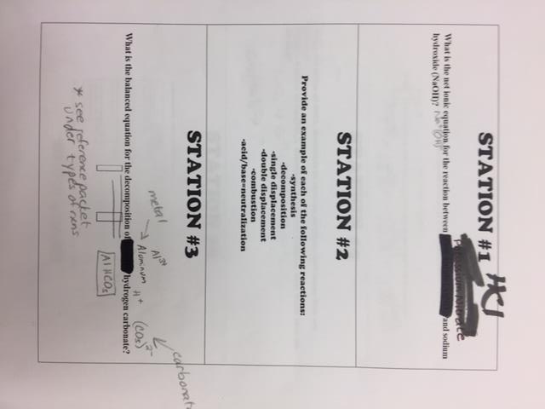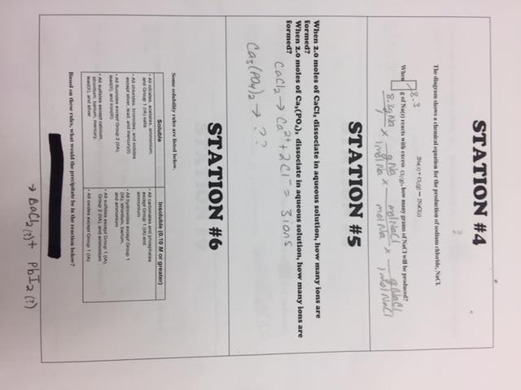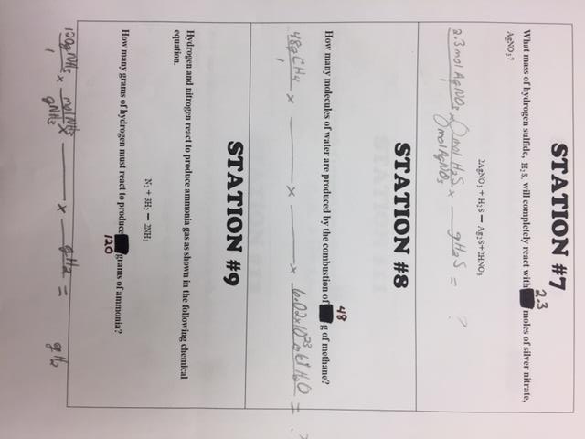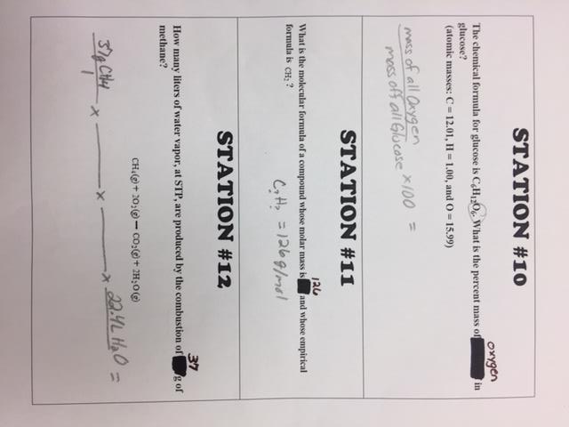

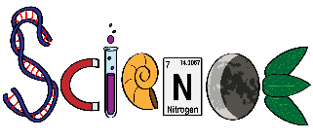WARM up Week of 10/22/18 NAME_________________

__________________

|  |
| --- |
| MON-10/22 |
| TUES-10/23 |
| WED-10/24 |
| THURS-10/25 |
| FRI-10/26 |