Weekly Planner: All science week of 10.15.18 



**Objectives for the week**: Bio.3.2.2 Predict offspring ratios based on a variety of inheritance patterns (including dominance, co-dominance, incomplete dominance, multiple alleles, and sex-linked traits). Bio.3.2.3 Explain how the environment can influence the expression of genetic traits.

Chm.1.3.1 Classify the components of a periodic table (period, group, metal, metalloid, nonmetal, transition). Chm.1.3.2 Infer the physical properties (atomic radius, metallic and nonmetallic characteristics) of an element based on its position on the Periodic Table. Chm.1.3.3 Infer the atomic size, reactivity, electronegativity, and ionization energy

|  |  |  |
| --- | --- | --- |
| Day | **Honors Biology** – How well can we do on the benchmark? | **Honors Chemistry** -How can we prepare for the benchmark? |
| Mon 10/15 | -Warm up  -benchmark exam  HW= read Ch 8  <https://cnx.org/contents/s8Hh0oOc@13.6:KSwZ73fG@5/Introduction> | -Warm up  OBJECTIVE3 1-3 (ALL)  HW= write formulas and NAMES of front worksheet then answer the gram formula mass on the back of it. |
| Tues 10/16  STUDY BUDDIES! | **NOTES: Genetics**  **HW= 20 questions** | -Warm up  OBJECTIVE 1-3(ALL)  **HW= study!! Kahoot info below…** |
| STUDY 10/17 BUDDIES! | **Finish genetics notes**  **Dihybrid crosses!**  [**https://concord.org/teaching-genetics/dragons/**](https://concord.org/teaching-genetics/dragons/)  HW 10 punnett questions! | BENCHMARK EXAM  HW= read ch 7  <https://cnx.org/contents/RTmuIxzM@9.3:QPpKLT1A@7/Introduction> |
| Thurs 10/18 | **-Go over 10 punnets**  **-Notes (co-dominance and other patterns) dihybrid crosses!**  **HW=Finish dihybrid cross from board, AND make your own dihybrid cross that includes incomplete dominance!!!** | Notes: Reactions  Practice: Balancing and types  HW=pg 58 (#9 product should be CO2), finish other rxns too if you didn’t already. |
| Friday 10/19 | **QUEST- Genetics**  **MAKE A BABY DRAGON!!!!**  **Wow!** [**https://learn.concord.org/**](https://learn.concord.org/)  ***DUE MONDAY! = Picture and 10 q.*** | **QUEST**  **Room 210 Lab: Types of reactions**  ***DUE MONDAY!- take notes from ppt!.***  ***Per 3= pg 59*** |

Monday 10.15.18- https://evansccca.weebly.com/

|  |  |
| --- | --- |
| Remember to turn off cell phone and put in basket 😊  Any missing work can be put in basket too.  -From memory, what do you know about ADP and ATP? | Remember to turn off cell phone and put in basket 😊  Any missing work can be put in basket too.  -compare ionic, covalent, and metallic bonds |

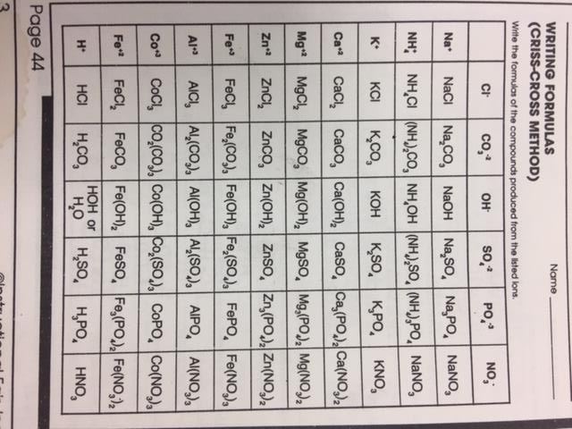

STUDENTS! You must write the correct name of the formula too.

Alleles and genes

<https://www.youtube.com/watch?v=pv3Kj0UjiLE&t=1s>

Tuesday 10.16.18- https://evansccca.weebly.com/

|  |  |
| --- | --- |
| Remember to turn off cell phone and put in basket 😊   * - Explain how 2 brown mice could have a baby that has white fur ? | Remember to turn off cell phone and put in basket 😊  Balance the following equation:    C2H6 + O2 🡪 CO2 + H2O |

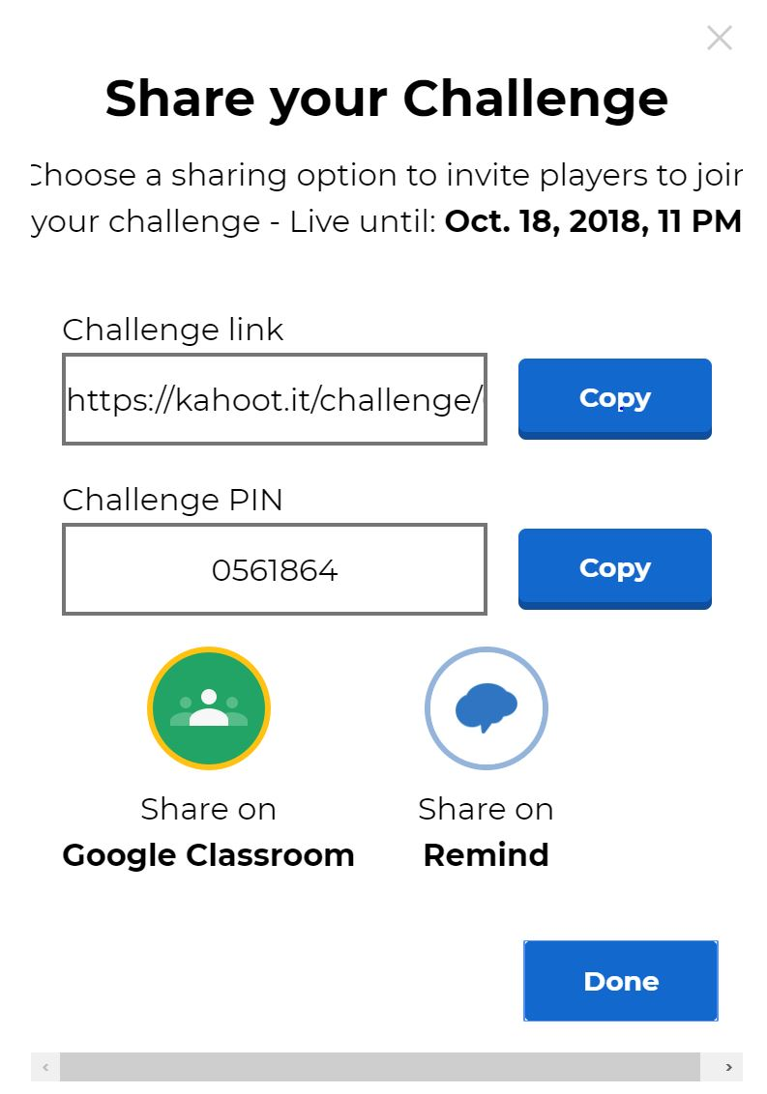

A BRIEF quiz on chapter 8 VERSION: A NAME:_______________________________

KEEP YOUR ANSWERS COVERED!!!!

|  |  |
| --- | --- |
| **QUESTION** | **YOUR answer** |
| __________________ set the framework for genetics long before chromosomes or genes had been identified, at a time when meiosis was not well understood. |  |
| This word also means “daughter or son” |  |
| This type of plant has flowers at the end of its stem. |  |
| This type of plant has flowers out the sides of its stem. |  |
| A trait whose expression is masked by another trait when the alleles for both traits are present in an individual |  |
| A variation in an inherited characteristic |  |
| The first generation in a cross |  |
| A __________________ is useful for determining probabilities because it is drawn to predict all possible outcomes of all possible random fertilization events and their expected frequencies. |  |
| When genes oppose each other, with one gene suppressing the expression of another. |  |
| The observable traits expressed by an organism are described as its ________. |  |
| The underlying genetic makeup, consisting of both physically visible and non-expressed alleles, of an organism |  |
| AFTER chromosomes cross-over, they are then called ___________ chromosomes. |  |
| Paired unit factors (i.e., genes) segregate equally into gametes such that offspring have an equal likelihood of inheriting any combination of factors |  |
| The two seed shapes of Pea plants |  |
| The two flower colors of Pea plants |  |

IDEA BANK Below: (words may or may not be used, some answers above may not be on this list)

|  |  |  |  |  |
| --- | --- | --- | --- | --- |
|  |  |  |  |  |
| Filial | D | Macromolecule | Recombinant | White |
| Mendel | DNA | Nitrogen Base | Round | Pink |
| P | Epistasis | Oval | Segregation | Round |
| Punnett | F1 | Phenotype | Terminal | Wrinkled |
| Allele | Gene | Phosphate | Test cross | Green |
| Axial | Genotype | Purple | Trait | Tubular |
| Crick and Watson | Green | Recessive | Tubular | Yellow |

**A BRIEF quiz on chapter 8 VERSION: B NAME:_______________________________**

**KEEP YOUR ANSWERS COVERED!!!!**

|  |  |
| --- | --- |
| **QUESTION** | **YOUR answer** |
| A trait whose expression is masked by another trait when the alleles for both traits are present in an individual |  |
| A variation in an inherited characteristic |  |
| The first generation in a cross |  |
| A __________________ is useful for determining probabilities because it is drawn to predict all possible outcomes of all possible random fertilization events and their expected frequencies. |  |
| When genes oppose each other, with one gene suppressing the expression of another. |  |
| The observable traits expressed by an organism are called…… |  |
| The underlying genetic makeup, consisting of both physically visible and non-expressed alleles, of an organism |  |
| AFTER chromosomes cross-over, they are then called ___________ chromosomes. |  |
| Paired unit factors (i.e., genes) segregate equally into gametes such that offspring have an equal likelihood of inheriting any combination of factors |  |
| The two seed shapes of Pea plants |  |
| The two flower colors of Pea plants |  |
| __________________ set the framework for genetics long before chromosomes or genes had been identified, at a time when meiosis was not well understood. |  |
| This word also means “daughter or son” |  |
| This type of plant has flowers at the end of its stem. |  |
| This type of plant has flowers out the sides of its stem. |  |

IDEA BANK Below: (words may or may not be used, some answers above may not be on this list)

|  |  |  |  |  |
| --- | --- | --- | --- | --- |
|  |  |  |  |  |
| Filial | D | Macromolecule | Recombinant | White |
| Mendel | DNA | Nitrogen Base | Round | Pink |
| P | Epistasis | Oval | Segregation | Round |
| Punnett | F1 | Phenotype | Terminal | Wrinkled |
| Allele | Gene | Phosphate | Test cross | Green |
| Axial | Genotype | Purple | Trait | Tubular |
| Crick and Watson | Green | Recessive | Tubular | Yellow |

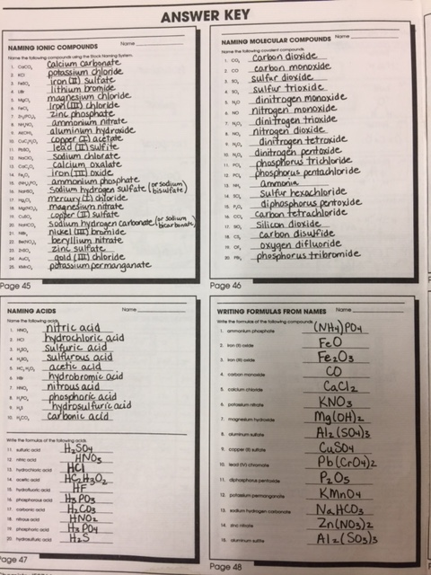

Wednesday 10.17.18 https://evansccca.weebly.com/

|  |  |
| --- | --- |
| Remember to turn off cell phone and put in basket 😊   * Compare/contrast alleles and genes * https://www.youtube.com/watch?v=pv3Kj0UjiLE | Remember to turn off cell phone and put in basket 😊  Aluminum plus oxygen yields aluminum oxide |

Thursday 10.18.18- https://evansccca.weebly.com/

|  |  |
| --- | --- |
| Remember to turn off cell phone and put in basket 😊   * Name two new things you learned about chickens.   https://www.youtube.com/watch?v=KsuesiVJgtI | Remember to turn off cell phone and put in basket 😊  Write a balanced equation for photosynthesis. |

**Mendel’s peas!** [**http://www2.edc.org/weblabs/mendel/MendelMenu.html**](http://www2.edc.org/weblabs/mendel/MendelMenu.html)

[**http://www.glencoe.com/sites/common_assets/science/virtual_labs/E09/E09.html**](http://www.glencoe.com/sites/common_assets/science/virtual_labs/E09/E09.html)

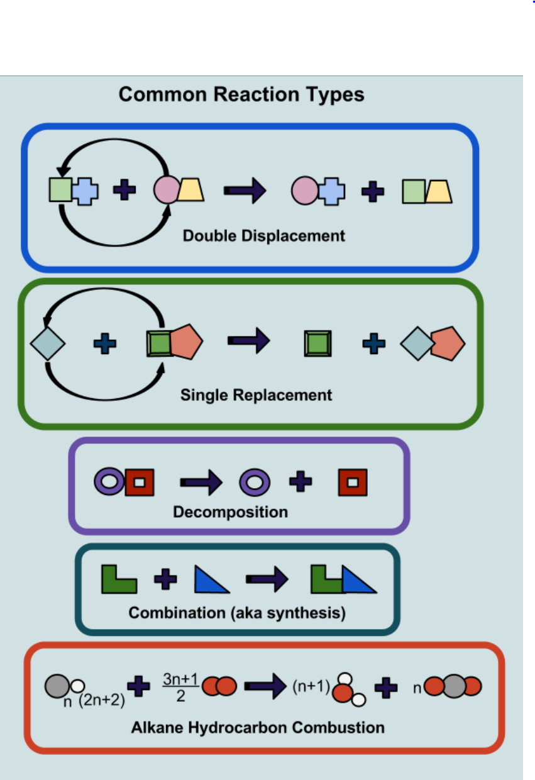

Friday 10.19.18- https://evansccca.weebly.com/

|  |  |
| --- | --- |
| Remember to turn off cell phone and put in basket 😊  -If you had a pet dragon, what kind of traits would you like it to have? | Remember to turn off cell phone and put in basket 😊  -What MAJOR law of chemistry is upheld by balancing an equation? |

QUIZ- on EXACTLY what we did yesterday NAME______________________

|  |  |  |
| --- | --- | --- |
| **Compound** | **Correct name** | **Molar mass (g/mole)** |
|  | Sodium Chloride |  |
| BaSO4 |  |  |
| Ca(NO3)2 |  |  |
|  | Sodium Phosphate |  |
| LiBr |  |  |
|  | Barium Nitrate |  |
| K2S |  |  |

QUIZ- on EXACTLY what we did yesterday NAME______________________

|  |  |  |
| --- | --- | --- |
| **Compound** | **Correct name** | **Molar mass (g/mole)** |
|  | Sodium Chloride |  |
| Ba(NO3)2 |  |  |
| CaSO4 |  |  |
|  | Sodium Carbonate |  |
| AlBr3 |  |  |
|  | Ammonium Chloride |  |
| MgO |  |  |

QUIZ- on EXACTLY what we did yesterday NAME______________________

|  |  |  |
| --- | --- | --- |
| **Compound** | **Correct name** | **Molar mass (g/mole)** |
|  | Sodium Chloride |  |
| SrSO4 |  |  |
| Ca(NO3)2 |  |  |
|  | Sodium Hydroxide |  |
| LiBr |  |  |
|  | Barium Phosphate |  |
| MgF2 |  |  |

QUIZ- on EXACTLY what we did yesterday NAME______________________

|  |  |  |
| --- | --- | --- |
| **Compound** | **Correct name** | **Molar mass (g/mole)** |
|  | Sodium Chloride |  |
| K2SO4 |  |  |
| Ca(NO3)2 |  |  |
|  | Sodium Phosphate |  |
| K2S |  |  |
|  | Barium Nitrate |  |
| NH4OH |  |  |

