See Archived agenda from before the disaster in case you have some catch up work to do.

We are in **TRIAGE** mode from now until the end of the semester. Here is what we MUST cover before December 7th......

Chemistry: Bonding, Periodic Table, reactions, Thermochemistry, stoichiometry, reaction rates and equilibrium, nuclear chemistry, solutions.

Biology: DNA, Genetics, Biotechnology, Evolution and diversity, Energy and life processes/behaviors.

My promise to you: I promise that you will have over 94% of all the information you need for the final exam by December 7th. It is my hope that our extensive review during the last week will solidify the concepts for you and tie up any remaining loose ends.

Hold on to your seats kids because this is not going to be easy.... but we can do this!!!!!

Below is the agenda for the week of October 1st:

Weekly Planner: All science week of 10.1.18 

**Objectives for the week**: SLC’s will be October 11th. Please call Ms. Linda to schedule.

Bio.3.1.1 Explain the double-stranded, complementary nature of DNA as related to its function in the cell. Bio.3.1.2 Explain how DNA and RNA code for proteins and determine traits.

Chm.2.2.4 Analyze the stoichiometric relationships inherent in a chemical reaction.

|  |  |  |
| --- | --- | --- |
| Day | Honors **Biology**- What is DNA and how does it function? | Honors **Chemistry** – What are moles and how does mole conversion work? |
| Mon 10.1 | -Warm up  -regroup and refocus  -go over homework  *HW= finish pg 129 questions, make sure you have written out the question, the answer, AND the reasoning for each. | -Warm up  -regroup and refocus  -go over homework  -INTRODUCE your STEM lab robot  -Classwork  *HW= finish #23-33 (show work and units!), finish moles lab, ROBOT stem lab ideas. |
| Tues  10.2  STUDY BUDDIES! | -Warm up & collect pg 129  -NOTES: DNA  DNA question set  *HW= finish DNA webquest!!! | -Warm up & collect lab, #24-33  -Go over STEM activity ideas  -Pre-screen for lab  HW= 1-4 problems: show all work and have numbers, units, and units of WHAT??!?!!!! 😊 |
| Wed 10.3  STUDY BUDDIES! | -Warm up and DNA webquest check  -Finish notes: DNA  -Transcription/translation activity | -Warm up and homework check  -Electron configuration  -FINISH LAB!!!!! |
| Thurs  10.4 | -Warm up and turn in coloring page  -finish notes  -TRANSLATION tutoring!  -Video activity | -Warm up and turn in electron configuration  -Nanobots!  -Moles activity |
| Friday 10.5 | **Test- DNA**  <https://flipgrid.com/7595bbbc>  VOCAB from mitosis due Monday | **TEST- mole conversion**  <https://flipgrid.com/2dbc5f4f>  **PERIODIC table worksheet due MON** |

Monday 10.1.18- https://evansccca.weebly.com/

|  |  |
| --- | --- |
| **BIO Warm up:**  Turn OFF your cell phone and put in bin 😊  1) List, in order, the nitrogen bases required to make the following amino acids:  -tryptophan  -glycine  -cystine  -a stop codon | **CHEM Warm up:**  Turn OFF your cell phone and put in bin 😊  1) A compound consists of 4 g of hydrogen and 32 g of oxygen. What is the mole ratio? |

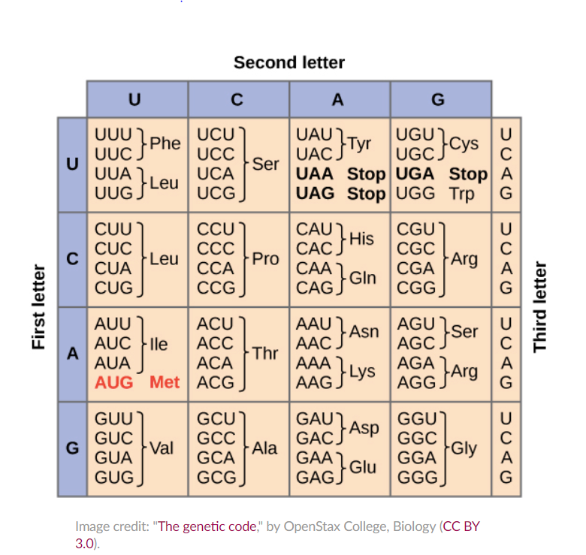🡨mRna table?

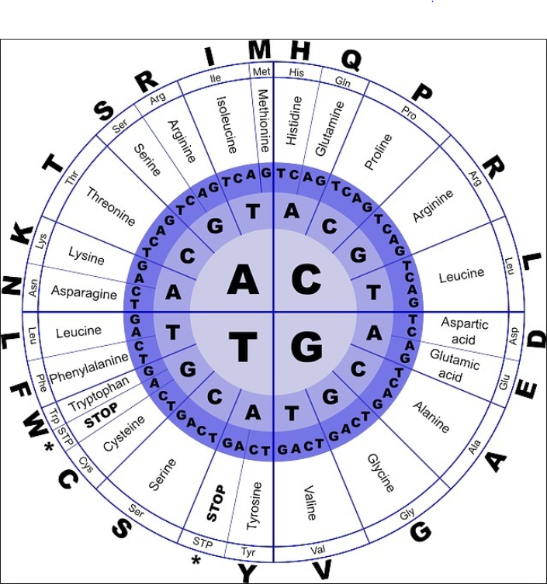

CHEMISTRY PRE-activity problems: SHOW all work and units!

|  |  |
| --- | --- |
| O°C and 1 atm | The balloon on the left is CO2 and the gas has a mass of 2.20 grams.  The Balloon on the right is N2O2 and has a volume of 1.18 dm3 (or, we could say 1.18 L). |

1. What is the molar mass of CO2? 44g
2. How many moles of gas are in the left balloon?
3. How many molecules of CO2 are in the left balloon?
4. What is the volume of the left balloon?

-------------------------------

1. What is the molar mass of N2O2?
2. How many moles of gas are in the right balloon?
3. How many molecules of N2O2 are in the right balloon?
4. What is the mass of N2O2 in the right balloon?

Tueday 10.2.18- https://evansccca.weebly.com/

|  |  |
| --- | --- |
| **BIO Warm up:**  Turn OFF your cell phone and put in bin 😊  How is DNA different for prokaryotes vs eukaryotes? | **CHEM Warm up:**  Turn OFF your cell phone and put in bin 😊  1) A balloon has 2.08 g of oxygen gas in it. Calculate The # of moles, atoms and liters. |

Wednesday 10.3.18- https://evansccca.weebly.com/

|  |  |
| --- | --- |
| **BIO Warm up:**  Turn OFF your cell phone and put in bin 😊  What is a codon and what does it do? | **CHEM Warm up:**  Turn OFF your cell phone and put in bin 😊  From what we know now, how are electrons arranged around a nucleus? |

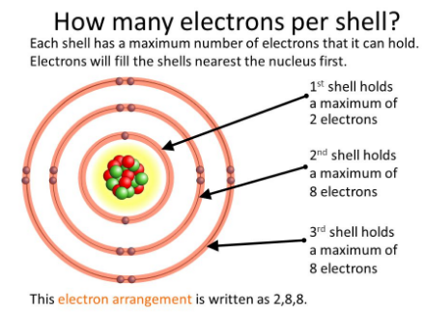

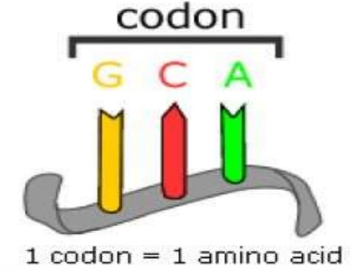 A **codon** is a sequence of three DNA or RNA nucleotides that corresponds with a specific amino acid or stop signal during protein synthesis. DNA and RNA molecules are written in a language of four nucleotides; meanwhile, the language of proteins includes 20 amino acids.

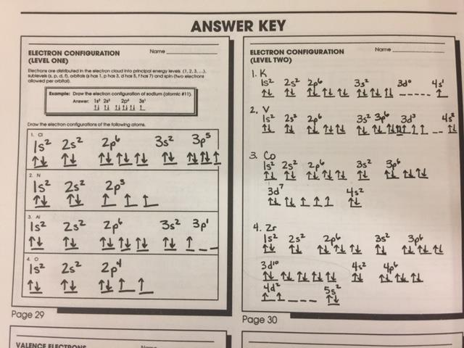

CHEMISTRY PRE-activity problems: **SHOW all work and units!**

|  |  |
| --- | --- |
| O°C and 1 atm | The balloon on the left is SO2 and the gas inside has a mass of 2.85 grams. |

1. What is the molar mass of SO2?
2. How many moles of gas are in the left balloon?
3. How many molecules of SO2 are in the left balloon?
4. What is the volume of the left balloon?

CHEMISTRY PRE-activity problems: **SHOW all work and units!**

|  |  |
| --- | --- |
| O°C and 1 atm | The balloon on the left is NO2 and the gas inside has a mass of 2.85 grams. |

1. What is the molar mass of NO2?
2. How many moles of gas are in the left balloon?
3. How many molecules of NO2 are in the left balloon?
4. What is the volume of the left balloon?

CHEMISTRY PRE-activity problems: **SHOW all work and units!**

|  |  |
| --- | --- |
| O°C and 1 atm | The balloon on the left is C2H2  and the gas inside has a mass of 2.85 grams. |

1. What is the molar mass of C2H2?
2. How many moles of gas are in the left balloon?
3. How many molecules of C2H2 are in the left balloon?
4. What is the volume of the left balloon?

CHEMISTRY PRE-activity problems: **SHOW all work and units!**

|  |  |
| --- | --- |
| O°C and 1 atm | The balloon on the left is CH4 and the gas inside has a mass of 2.85 grams. |

1. What is the molar mass of CH4?
2. How many moles of gas are in the left balloon?
3. How many molecules of CH4 are in the left balloon?
4. What is the volume of the left balloon?

Thursday 10.4.18- https://evansccca.weebly.com/

|  |  |
| --- | --- |
| **BIO Warm up:**  Turn OFF your cell phone and put in bin 😊  What is the difference between DNA and mRNA? | **CHEM Warm up:**  Turn OFF your cell phone and put in bin 😊  Write the electron configuration for Ag. |

<https://flipgrid.com/7595bbbc>

t

TEAM TIMES 1) 10:29 3) 8:04 5) 16:02 6) 7:47

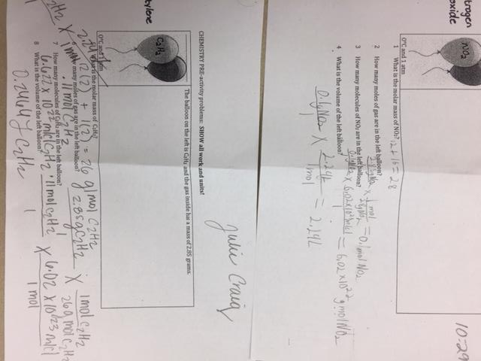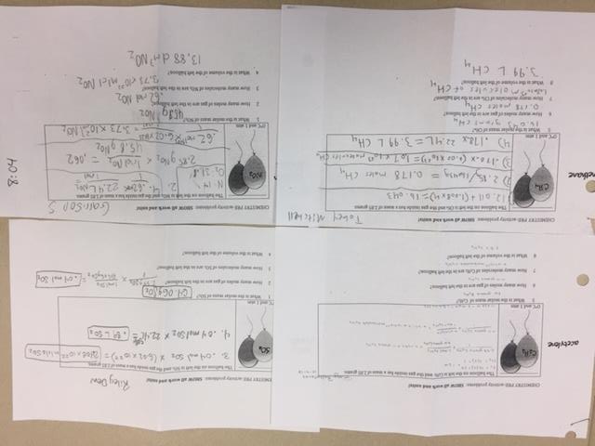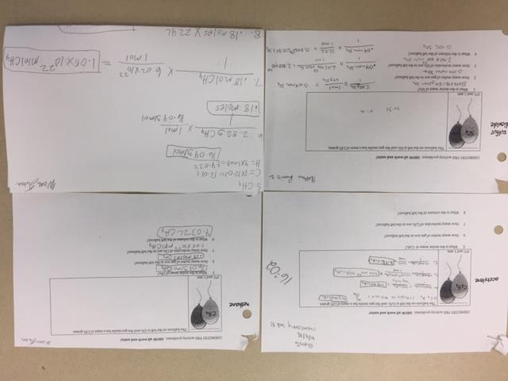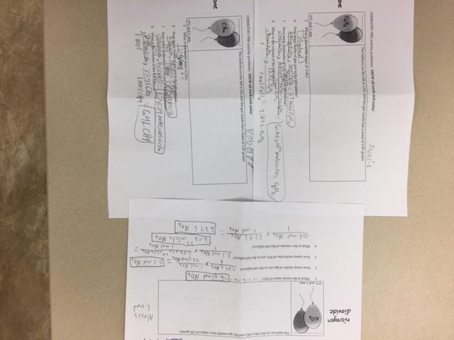

TEAM TIMES 1) 13:33 2)5:16 3) 5:29 5)17:23 6)10:08

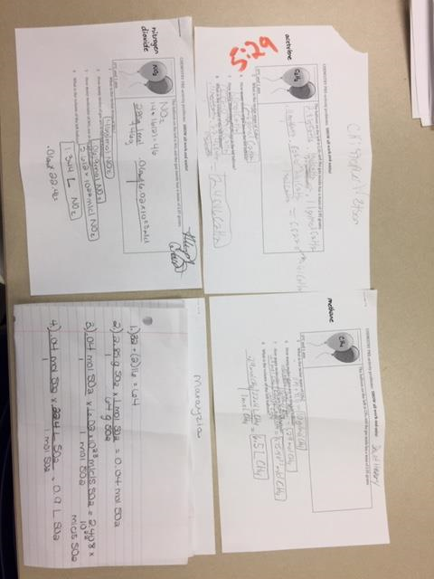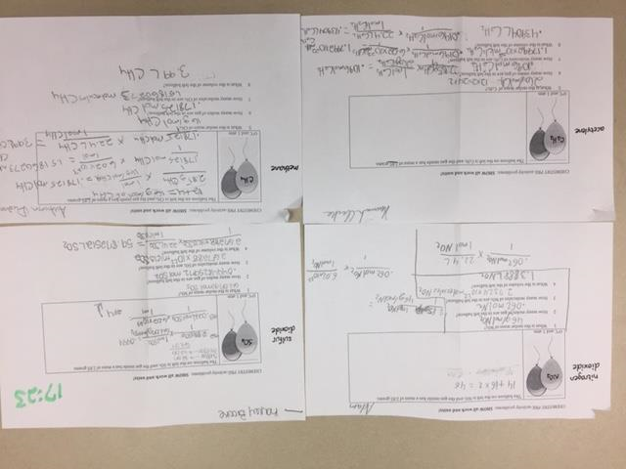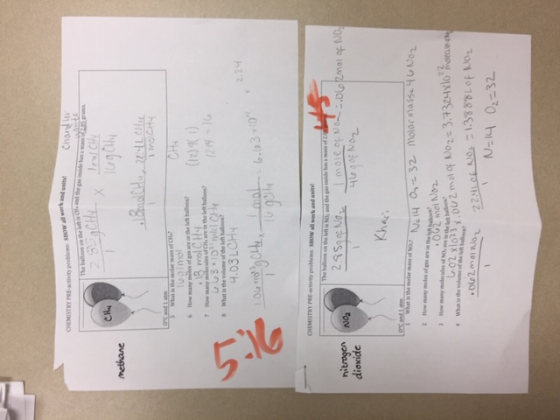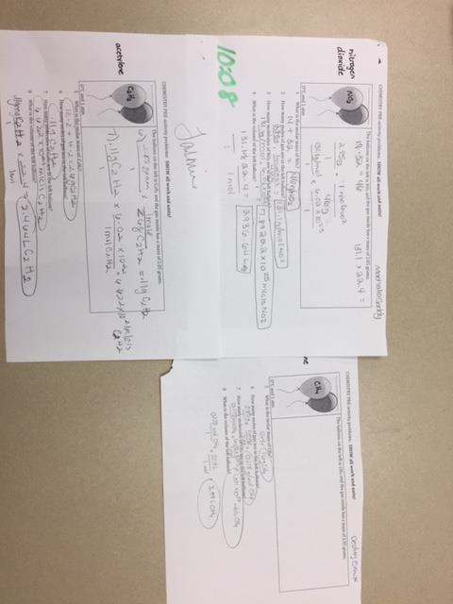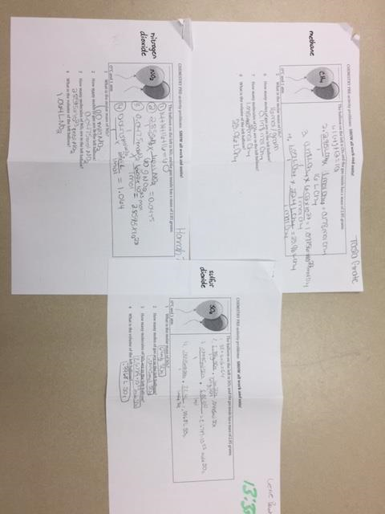

Friday 10.5.18- https://evansccca.weebly.com/

|  |  |
| --- | --- |
| **BIO Warm up:**  Turn OFF your cell phone and put in bin 😊  Describe how recombinant DNA is formed.  <https://www.youtube.com/watch?v=FAMRQz7fOaE> | **CHEM Warm up:**  Turn OFF your cell phone and put in bin 😊  Write just the ending of the electron configuration for the following:  Na  Al  F  Sr  Ti  Yb |

